Berkut master builder James Redmon has just finished up wing/winglet cuffs - here they are in fabrication from various angles:

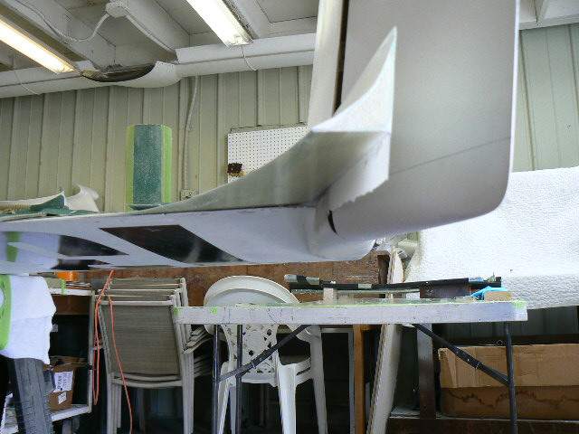

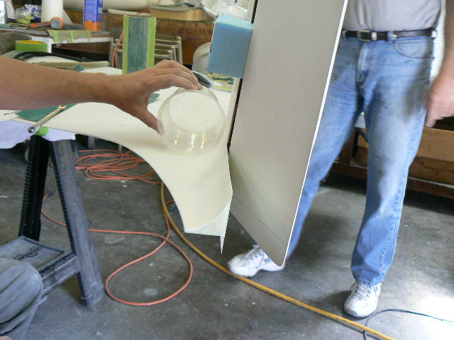

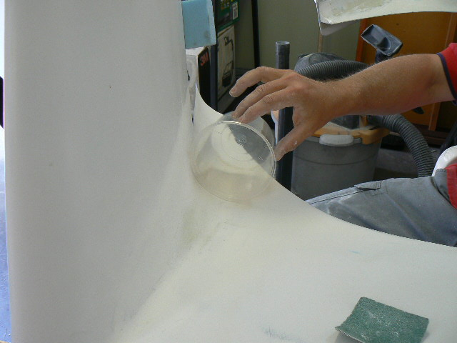

Ronneberg describing the best angle:
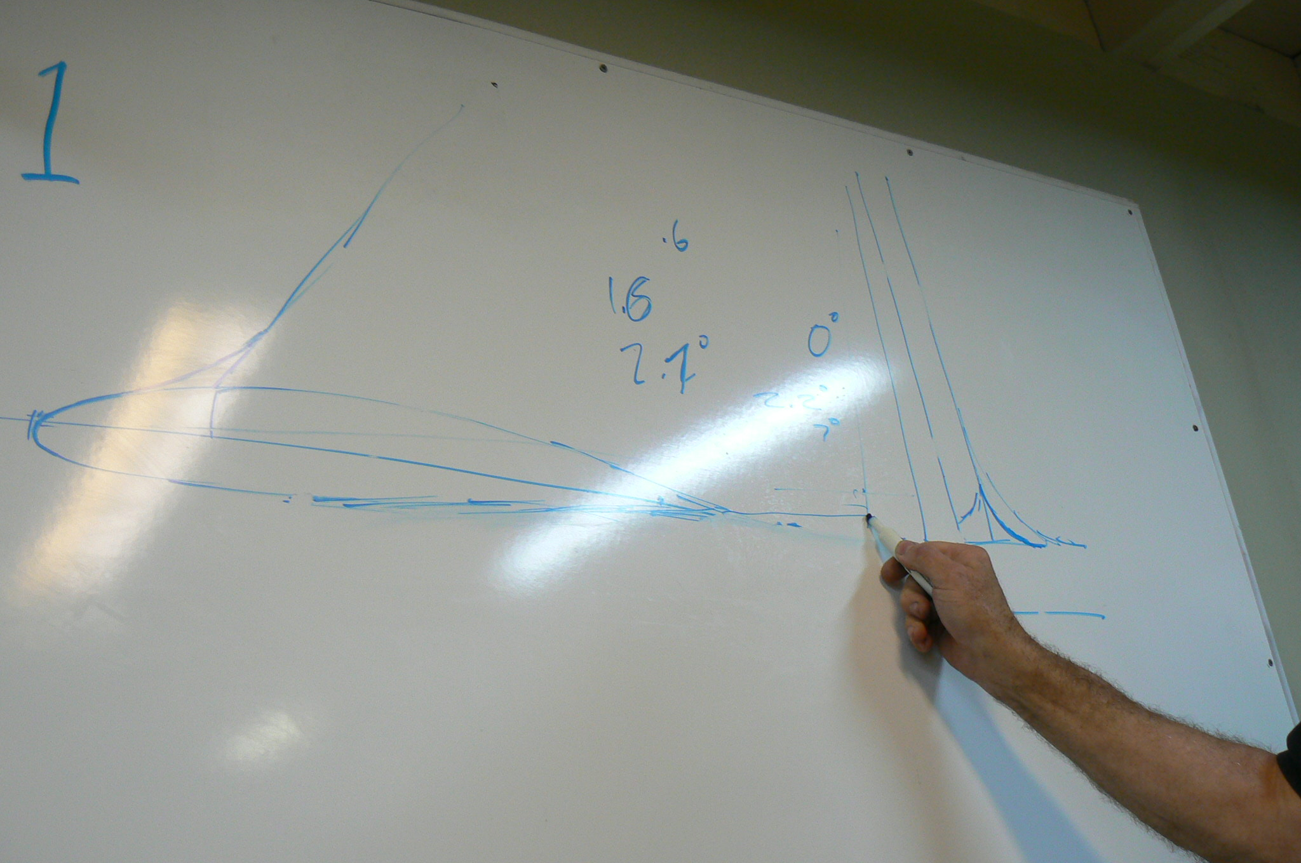

Beagle's later efforts:
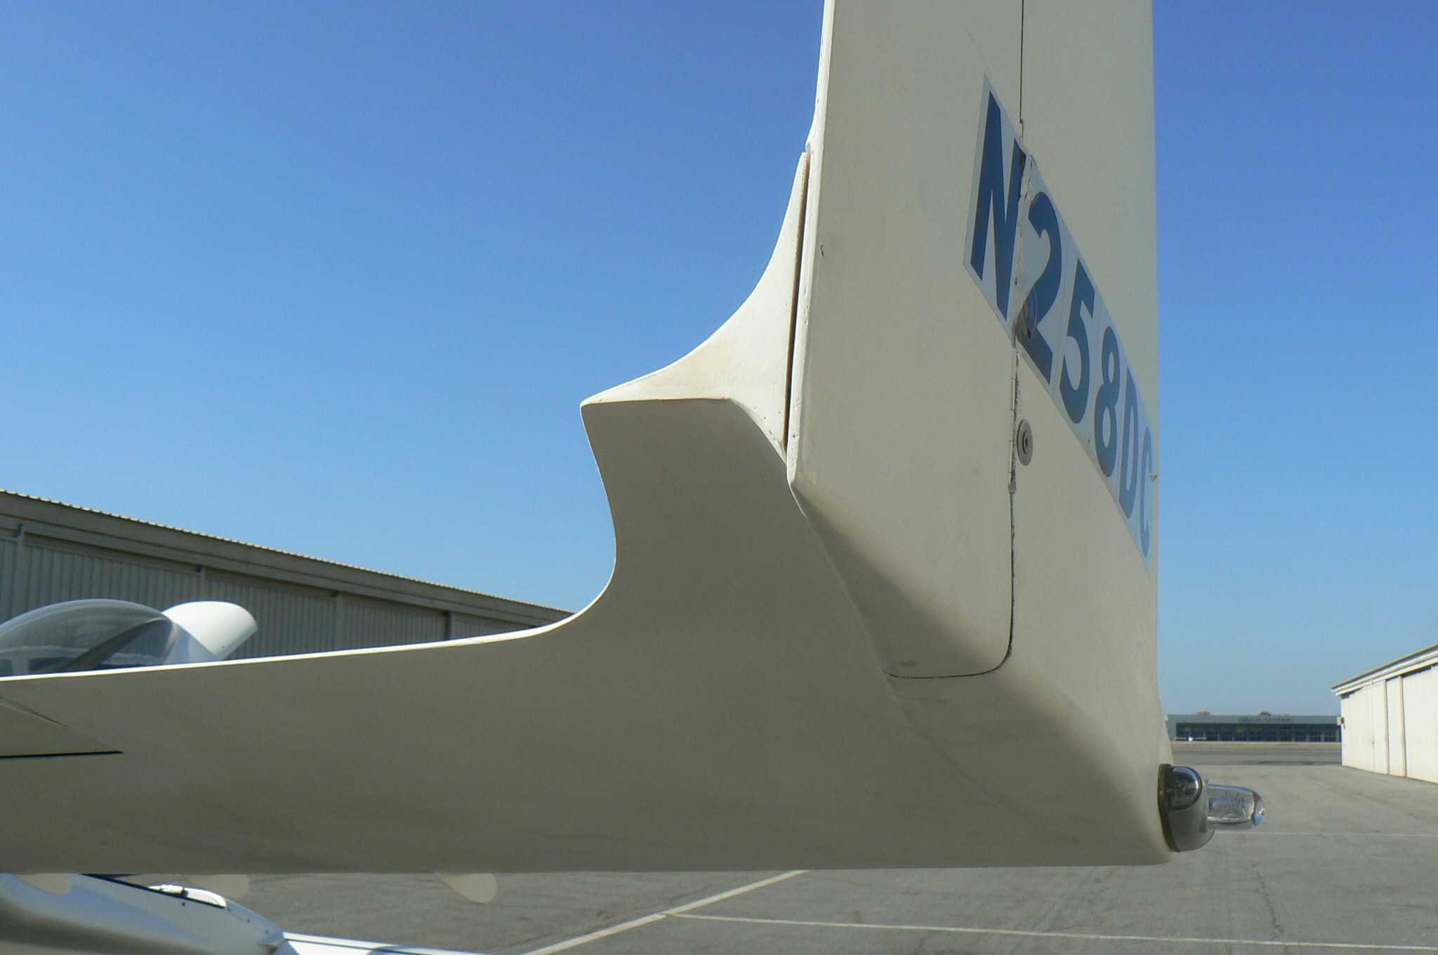
Redmon and Ronneberg differ on the angle of the fillet.

