**Velocity Elite door opening accidents.**

**From:** "Jorge A Bujanda (jorge@jbujanda.com)" <mailer@mail2.clubexpress.com>  
**To:** Main Forum <forum@velocityowners.com>   
**Sent:** Sunday, February 15, 2015 7:50 AM  
**Subject:** [VOBA Forum] Door Open Warning Lights

*View/reply* [*online*](http://voba.clubexpress.com/content.aspx?page_id=2161&club_id=495146&item_id=502478&message_id=1229285)*Reply to forum at* [*forum@velocityowners.com*](mailto:forum@velocityowners.com?subject=re:Door%20Open%20Warning%20Lights%20%3C%3C$122928583898$%3E%3E)*Reply directly to Jorge A Bujanda at* [*jorge@jbujanda.com*](mailto:jorge@jbujanda.com?subject=re:Door%20Open%20Warning%20Lights)

Doors opening in flight shouldn’t happen.  No system is fail proof but we should try to make it so.

1. My doors are either open all the way or closed/latched. The rules are they cannot be partially opened and they cannot be shut without being latched.
2. Doors closed/latched is on my Pre-Takeoff checklist.
3. I have two flashing red lights on my annunciators panel, one for each door.I spent $4 on two lever, snap switches and $1 on the two flashing LED lights, a plastic clothes hanger, and the necessary wiring that provide a lot of security on this issue. Check the following link to my website.

<http://www.jbujanda.com/ConDoors_files/DOORS/doorsswitchinstallation.html>

Jorge Bujanda

Jeff Gerhardt:

One issue I had with my door latched indicator was that it needed some sort of compressible column to push on the micro switch when the door pin was inserted. I had tried a variety of plastic tubes, but they all deteriorated and failed over time and we're not reliable. Then, I came up with this, and my door latched indicators have been very reliable.  I found the right combination of screw and spring that allows the perfect height of the springer column to be set.

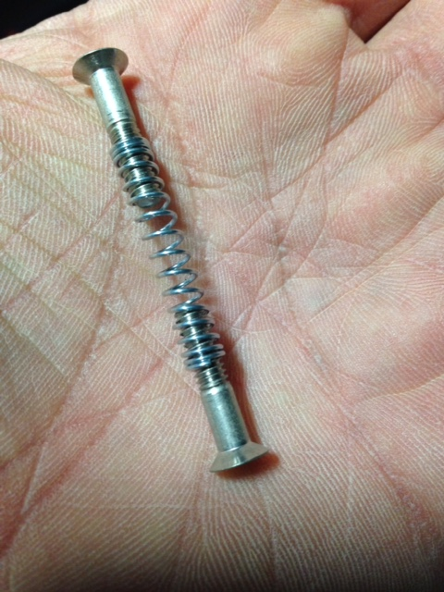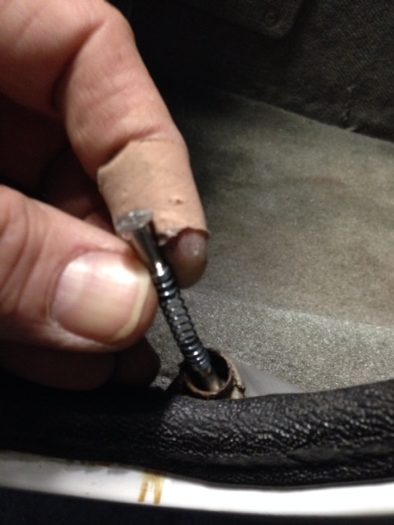

Geoff

Beagle’s comment:

**From:** [mailer@mail2.clubexpress.com](mailto:mailer@mail2.clubexpress.com) [<mailto:mailer@mail2.clubexpress.com>]   
**Sent:** Monday, February 16, 2015 14:25  
**To:** Main Forum  
**Subject:** re: [VOBA Forum] Crash at Sebastian

It is a pity the Elite door isn't hinged on the forward side instead of the top...  
  
Beagle

On 2/16/2015 1:48 PM, Nick Jones ([nick.jones@volvo.com](mailto:nick.jones@volvo.com)) wrote:

Good point Beagle, the Cirrus has a hinged door that lifts forward and up so an open door in flight would be a non-event. Don’t think it would be an easy retrofit though.

Nick and Connie Jones

Velocity XL-RG

N10CN

Ron Needham’s suggestion:

Flip out air dam that forces the door shut when the latch is open.

**Scott at Velocity added:**Rodney Brim operates a Velocity XL.  He is one of the few owners who has experienced a copilot door opening event, having the door remain on the aircraft, and successfully controlled the aircraft to a safe landing.  
(Rodney, if you are monitoring this conversation, please contribute words about your experience).  Rodney said that the had a hell of a time maintaining control.  
Following the incident, he modified the hinge line of the aircraft doors so that the doors had a slightly forward sweep (similar to the Cirrus).  This was his own retro design, and it works. Sorry - don't have any photos.  
Best, Scott B.

**Andy Millen said:**

 Rodney Brimm managed to make [forward hinged doors.](http://wiki.velocityoba.com/index.php?title=Brim_N87BR)

