2/19/14 Dave Nelson:Here's a twist on this topic - I'm pretty close to done on a modification of my landing light that folks might find interesting.

Those that have seen those really bright Cree LED flashlights can appreciate how far LED lighting has come.  And it turns out that Cree makes LED's that are much MUCH bigger and brighter than the ones they put in the flashlights.  Sooo... I got some of the biggest ones Cree makes, cut the filament out of a dead landing light, and replaced the old incandescent filament with three of these bad boy Cree LEDs mounted onto a heat sink (because, yes, even LEDs get hot).

Then, I did some design work and came up with a simple circuit that allows you to either flash the LEDs (for daytime visibility) or leave them on full time (for night landing).

To say that the final result is really REALLY bright is an understatement.  It's blinding.

Anyway, I've just about got this project wrapped up, including design of the required circuit boards.  If there's any interest, I'll publish how I did all this in an instructable.

2/19/14: Tim Spears:

I would be interested.  I want as many lights as a 747 coming in for landing. Although I still have good night vision, I know that will not continue forever.

2/19/14: Terry Schubert:

I'd love to have the article on the LED too.  I've been wanting to put recondition lights on my LEZ.   What great timing! I'm presently helping a former student with his RV-8 project and one of the parts is to make landing/recognition lights in the wing tips.  I probably should have them face backward so fast Velocitys don't rear end them - GRIN

 I think the interest is definitely there.  Thank you for your willingness to share your capability! I'd never thought of the focus problem.  Are you looking for some engineering help on how to do focus or do you have that?

2/19/14: Hiro Umeno

How does that compare to a HID light?  I currently have HID landing light on mine in the nose.  It uses a ballast to turn on and there is no way to blink it.  If I can fabricate a cluster of Crees, then I can maybe make it blink for visibility. I do love the brightness of the HID light.

2/19/14: Randy Thompson:

Landing light mods are a much needed item.  Mine is hardly enough to light the white lines!  I would be interested in this mod!

2/19/14: Dave Nelson:

Sounds like the interest is there! I can't compare the total brightness to an HID light... the limited research I did to try to understand "brightness" lead me to understand that it's a very complicated subject with very few real standards to use in comparison... as an example, look at wikipedia for "candlepower" and you'll see what I mean...  The LED's I use are Cree CXA1304's... which nominally put out around 600 lumens @ 700 milliamps (at 9.6V and 55 degrees C)... for a total of around 1800 lumens @ 2.1 amps.  As I said... these things are bright (and hot!).  I chose to use a dead landing light bulb to preserve the existing form factor (i.e., pretty much a drop in replacement).  That creates a limitation that I haven't thought through yet... the beam focus.  Follow me on this... the old incandescent filament was positioned at the focal point of the parabolic lens... but the LEDs are basically flush with the apex of the bulb.  This results in a more widely spread light than the old bulb.  For the purposes of air to air recognition, this is probably good.  As a landing light, all that 1800 lumens isn't focused directly in front of you.  I've really been working on the electronics of this more than the beam focus, so I haven't worked on that issue.  It turns out that switching 2+ amps of current on and off fast creates some complexity.  So... Any ideas on the focal point are welcome. I'm in the final testing phase... I want to make certain what I've done is highly reliable before I write the article... but I'm nearly there, so it shouldn't be long.  Here are a couple of snapshots.

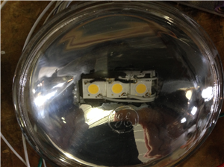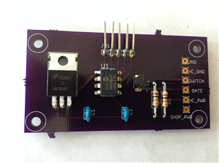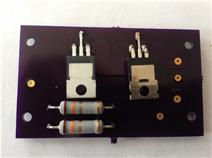

2/19/14: Brian Michalk

Where did you get your circuit boards made?  I've been using Olimex.  Maybe you've found someone cheaper?

2/19/14: Dave Nelson:  
Circuit boards are from Oshpark... about $20 for three cards... pretty happy with Oshpark.

2/19/14: Hiro Umeno

“I did some digging around. It seems that HID and LEDs can be about par when you are talking about 50 lm/W.  Some HID can go up to 100 or so lm/W while others go down to 30 or so.  Mine is 25W HID so I call that about 1250 or so.  If I can figure out a thermal solution to the LEDs, I can probably use something like MPLEZW-A1-R100-0000D040F that is already in a cluster to get a bit better focusing. Interesting idea for re-purposing the old bulb.”

2/23/14 from Bujanda:

While building, I bought a couple of very high intensity LED flashlights ($40/ea) to use as landing lights.  I would have installed them on the canard but my kit was a fast build and did not want to deal with the installation after the canard had been built.  So I made bases to place them on the lower winglet.  My friend Bob Sumoski (RIP) made some measurements and calculations to maintain luminosity as much as possible and keep heat generation under control.  For this, he used resistors.  I used the same flashlight head and part of the battery tube as a receptacle for the resistors and formed the face out of acrylic.  I connected them to both a flasher switch and a landing light switch.  I keep them flashing all throughout the flight and just turn on the landing light (overriding) switch in the pattern.

So far, 120 hours without problems and always seen by other traffic on radio before I can see them.  I made the bases before flying and turns out they point too low for my liking.  I plan to adjust them a little higher but have landed at night without problems.  A photo is attached.    

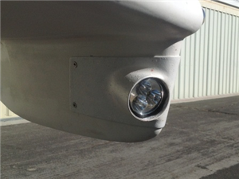

2/19/14:

http://www.vansairforce.com/community/showthread.php?t=105248&highlight=LED+Landing+lights   
  
**New (October 2013) LED wingtip landings light discovered**

I have been working on getting new landing lights on my RV for some time now. Earlier this year I purchased some Cree T6 XM-L LED lights from DealXtreme.com. I ran into issues with keeping them cool as they tended to overheat and burn up. I then was deterred because they discontinued selling this light. I was a bit bummed out about this since I thought I could get these to work.  
  
A few months ago I ran across a company called Baja Designs ([http://www.bajadesigns.com](http://www.bajadesigns.com/)). They make LED lights for dune buggy's and motorcycles. I was quite impressed with the light these LED pumped out. Many forums raved about how bright they were. They also seemed to be just about the right size to fit into the wingtip of the RV. The cost was also in line with what I though was an acceptable price for this technology and the quality of the product. MSRP, the Squadrons run $299.95. However, on Amazon they are $260.   
  
The version I bought was the Baja Designed Squadron in the Spotlight format. The specs on these are quite impressive. Here is the list from their website:

Quote:

|  |
| --- |
| Our Squadron 3" x 3" light is the next generation of LED lighting! This light packs 4,300 Lumens that will truly annihilate the night.  The Squadron exceeds HID output yet weighs only 12oz.  Uses active Thermal Management, Single Layer Solid Core Copper Circuit Board and aircraft grade aluminum housing that maintains LED temperature within the defined operating limits. If you're looking for the ultimate in LED lighting technology the Baja Designs Squadron is your answer!  Features:  Available in four configurations. Combo, Spot, Wide-Cornering, and Flood/Work using precision in house designed optics Weight: 12oz IP69K (Waterproof, Submersible to 9ft) IK10 Compliant (Mechanical Impact Testing) Vibration Rating: 7.7Grms Operating Temperature: -40 Celsius to 80 Celsius Hard coated polycarbonate lens Lifetime Warranty   Specifications:  Total Lumens: 4300 Stainless steel fasteners and mounts. Front Lens: Hard coated Polycarbonate Power Consumption: 42 watts Uses four T6 Bin Cree XM-L2 LEDs at 5000K 49,930 hour LED life expectancy Reverse battery & Transient Voltage Suppressor (TVS) protection  Exceeds MIL-STD810G requirements  Low Temperature Test High Temperature Test Temperature & Humidity Test Thermal Shock Cycling Test Dust Test Random Vibration Test Mechanical Shock Test Low Pressure Test Drip Box Water Test |

On a moonless night, I set up an experiment at the end of my street comparing the three lights I had - my Duckworks 50W HID, DX Cree XM-L T6 and the Baja Designs Squadron. All of these pictures were taken from a digital SLR camera on a tripod and the manual focus settings were the same. I wanted to get an accurate representation on the differences between the lights. As you can see, the Baja Designs light blows the others away!  
  
  
Here is an Isolux Plot I found on the Baja design website. I was torn as to which version of the light to get. Since there wasn't much of a difference between the driving and spot light, I went for the spotlight. It would be really nice to do a side-by-side comparison of all four varieties of the Squadron (Combo, Spot, Wide-Cornering, and Flood/Work).  
  
  
Here are a few pictures of the Squadron. From the front this thing looks mean!!!  
  
  
It is much smaller than I thought it would be.  
  
  
The cooling fins are quite beefy. I believe the housing for the lights is made out of aluminum. They are also lighter than I thought they would be.  
  
  
I decided to compare the weight of the Baja Design Squadron to the Duckworks HID. The Duckworks HID come in at 0.76 lbs.  
  
  
And the Baja Design Squadron is slightly lighter at 0.72 lbs.  
  
  
The next project was trying to figure out how to mount these guys to my wingtips.  
  
  
I took off the previous wingtip light mounts.  
  
  
Next I fabricated a new mounting plate out of 0.063" sheet. The old mounting plate was made out of 0.032" and it was a little on the flimsy side.

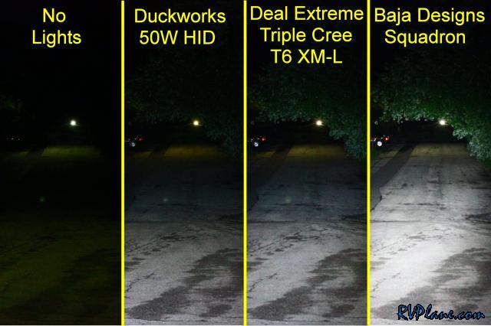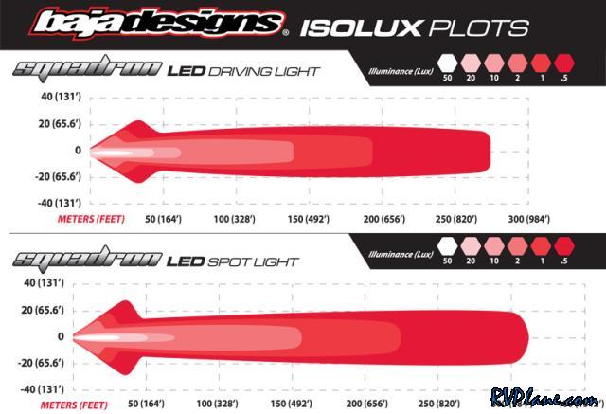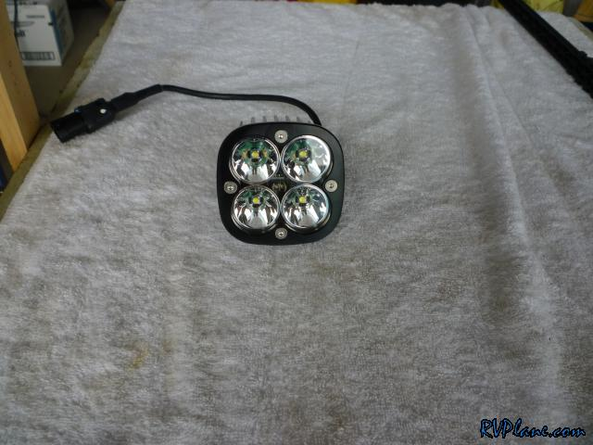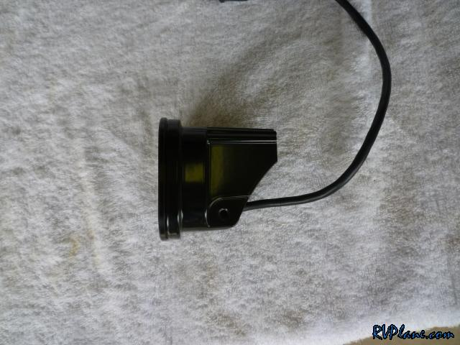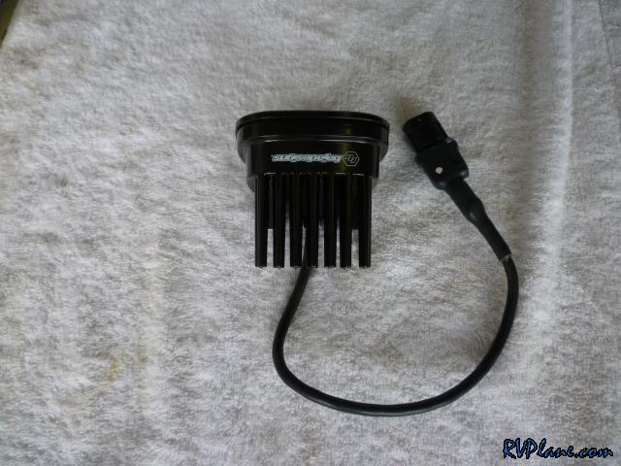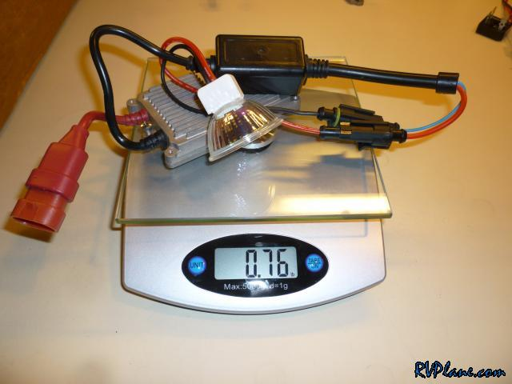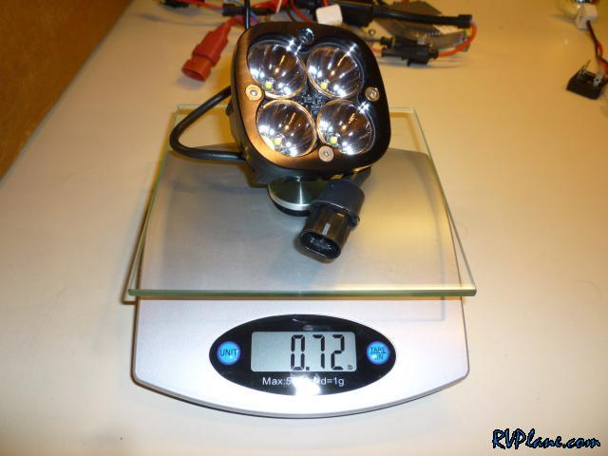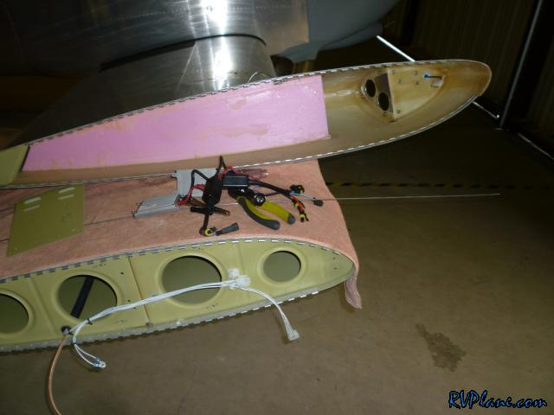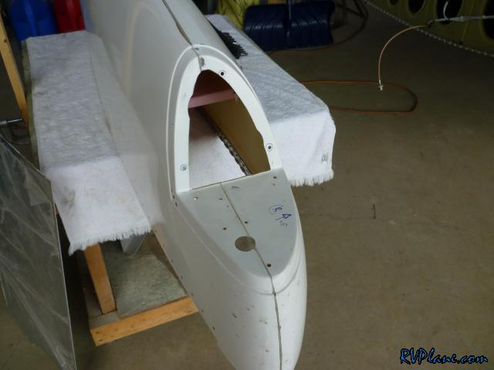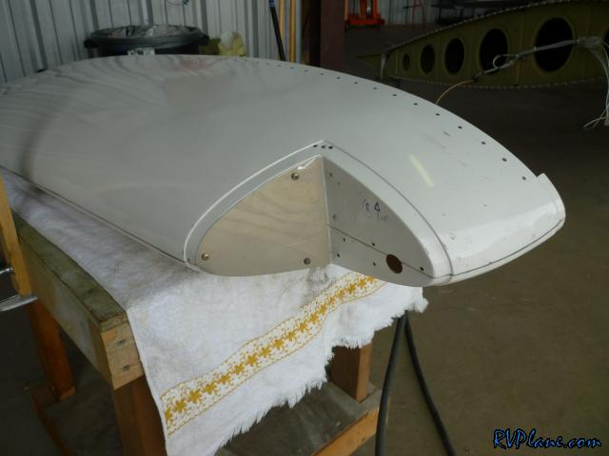

__________________  
Mike Bullock  
RV-7, Flying!  
[http://www.rvplane.com](http://www.rvplane.com/)



|  |
| --- |
| #**[2](http://www.vansairforce.com/community/showpost.php?p=815324&postcount=2" \t "new)**  10-10-2013, 08:03 PM |
| |  |  |  |  | | --- | --- | --- | --- | |  |  |  | Join Date: Feb 2006  Location: Baltimore, MD  Posts: 524 | |
| I did keep the side portion of the old mounting plate where the Nav light is mounted. I figured why do more work than I have to re-fabricating everything.   I wanted to mount the new LED lights as far outboard as possible so they could get as much light closest towards the center line of the RV. It would be awesome if these lights could be used for both taxiing and landing.   I also needed a mounting plate for the light to mount to. The light comes with a mount designed to be mounted to handlebars with a single bolt at the bottom. That mount wouldn't of worked for me. I planned to use the 4 screw holes used to hold the front trim on. I made an appropriate mounting plate (pictured on the lower left).   I didn't think the front trim was necessary. I would replace it with my mounting plate made out of 0.063".   Here is a picture of how the LED light mounting plate is attached to the wingtip plate. This setup is extremely adjustable and very very study. I cannot more the plate at all.   These are the springs I used for the inboard adjustment points. I purchased them from Ace Hardware.   And finally the light mounted.   The light uses metric screws. I bought M4x10's which ended up working great.   And the final product. I used only a single light for a few weeks to test it out. I figured why should I spend twice as much as I needed to for a pair of them if they may not work out. I flew for about 10 hours with this, and it was on all of the time. There was ZERO radio interference, Zero GPS performance interference and ZERO NAV antenna interference. These lights seem to be very well engineered.   After my test of the right wing went so well, I purchased another set and installed it into the left wing. I have to say this side went MUCH faster. It's always easier to build something the second time.  __________________ Mike Bullock RV-7, Flying! [http://www.rvplane.com](http://www.rvplane.com/) |
|  |
| |  |  |  |  | | --- | --- | --- | --- | |  |  |  |  | |
| Doh! When I took apart the right side, I notices some hazing in the plexiglass lens. This is from where I applied loctite like an idiot. I completely forgot that Loctite causes hazing on plexiglass. Luckly, all of this is hidden from view when the mounting bracket is attached.   I needed to finish up dressing the wiring in the left wing. Once I completed that task, it was time to aim the lights. This picture shows a couple of things. Most apparently, take a look at how bright these suckers are! Secondly, you can see the general beam they show and also how I have them aimed. This was as low to the ground as I could get them. The bracket I made is hitting the outboard edge of the wingtip, so this was the best I could get. Since the tail of the airplane is up when it is flying/landing, I wanted the light to be concentrated a little on the high side. Also, isn't it amazing how well a GoPro camera works at night???   Even though the lights are aimed high, there is a decent amount of light that is available for taxiing. I would like there to be a little more, but this isn't bad at all considering they are recessed wingtip lights.   One takeoff, once the tail comes up the lights nicely illuminate the runway.   Approaching the threshold of the runway, this is where the lights start illuminating the runway. I would say this is 500-1000' from the runway.   At about 5-10' off the runway the lights do a nice job of lighting up the runway.   And on touchdown things just keep on getting better. I am very happy with these lights. The only thing I wish was better was the light during taxiing. It's not terrible, but it's not great either. For example, I had a hard time seeing the taxiway lines and the runway turnoffs. However, I have to ask myself how often will I really fly at night? It felt great to get some night flying in, even if it was just in the pattern. It's definitely a surreal experience.    I have no affiliation with Baja Designs and I purchased all of the lights at full price. I have contacted Baja Designs once I completed my test to let them know the results.  __________________ Mike Bullock RV-7, Flying! [http://www.rvplane.com](http://www.rvplane.com/) |