For years, I've been searching for an all-in-one backup instrument that would fit in the 2 1/4" compass hole in the top of the XL panel.
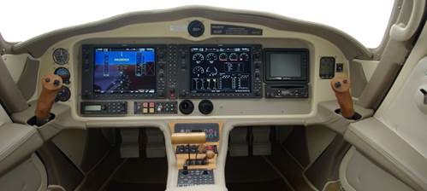
I could find individual instruments, such as a compass, altimeter, or attitude indicator, but I couldn't find one that was all 3.
I finally found it! This is a European company called Kanardia that was founded by Canard builders. They make all-in-one devices that fit 3 1/8" and 2 1/4" round panel slots.
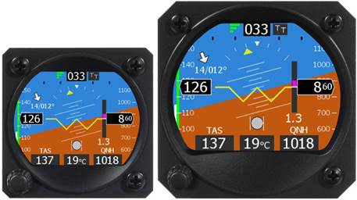
Altitude, airspeed, attitude, GPS ground track, and OAT. Add a magnetometer and get magnetic heading and wind speed/direction. For those who want more than a compass at the top of their panel, this is THE device!
The sensors are all built into the back of the unit. There are no other boxes to install. It comes with the GPS antenna and OAT probe. Power is 5 – 32 volts, and draws just 274ma (155ma for the 2 1/4"). (The optional magnetometer is a separate box.)
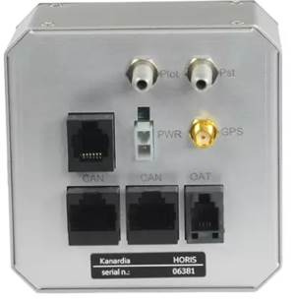
If you prefer a compass display, you can toggle between EFIS and compass mode at any time
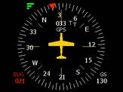
More info at the manufacturer's web site.
Installation and operation manual.
Video review from an RV-10 builder, with aerobatic demonstration.
Pricing for the 2 1/4" is normally € 890, or US $1023.
Pricing for the 3 1/8" is normally € 990, or US $1138.
The optional magnetometer is € 450, or US $ 517.
(By comparison, the RC Allen attitude indicator is $2,500! No altitude, no airspeed, no heading.)
I am going to buy one this week, with the magnetometer.
I have negotiated a discount for VOBA members! Get 10% off and free shipping if you order through VOBA in the next 7 days. Contact me on the Forum or via email if you're interested.
This discount applies to their other avionics, too. Check out their catalog and price list. Use an exchange rate of $1.15 / € 1.00, and take 10% off if ordering through VOBA.
I'm thrilled to finally find the backup avionics that I've been looking for, and glad I can help get a discount to anyone else who wants one!
Amazing stuff out there now.. We don't cross paths with them much, but the sailplane/glider market has some excellent equipment like this too.

This one is new and I also like it... One of the founders of Aspen Avionics jumped ship to do his own thing.

https://aerovonics.com/av-30

This one is their 2.25" model.. looks like it only does attitude in this size though.
https://aerovonics.com/av-20-1

