Putting in a motorized cog-belt Aileron Trim system
Gary Ernest new Velocity owner:
I have put a good amount of thought into whether I should use the linear actuator system for aileron trim and realized it is most likely more of an additional risk point than any real benefit it would provide.
If the wings are straight and true, the plane should fly well without aileron trim, however if I put two large copilot and rear seat behind copilot with just me in the Pilot seat I get it… aileron trim will be handy.
A couple of questions…
1. For now, I am going to put the string system back in (my buddy took it out when we were working on replacing the aileron cables so I need a reference and photos… I looked thru the manuals and find a ton of stuff on the elevator trim but absolutely nothing on the string system for aileron trim. Can someone point me in that direction and if you have some photos that would be great!
2. I have heard some info that changing from the string system to a belt driven system is better, can anyone elaborate on that? Again, is there some documentation and photos you can point me to?
Don Johnston: I didn't go with the string trim system. Heard bunches of stories about having to apply belt dressing to get just the right amount of grab, etc.
So I switched to a spring loaded, cogged belt system. Works great and you can feel/hear when you override it.
Attached is a picture. 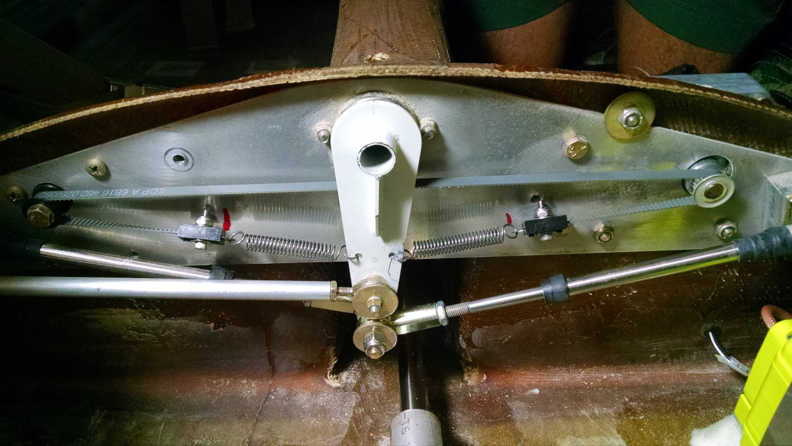
Idler pulley on the pilot side. Drive pulley is attached to the stock trim motor on the co-pilot side.
Ernest again: Did you have to change the motor or just change the pulley to a cogged one?
Could you please provide me the links or part numbers you used for this conversion (Motors, pulleys, belt to spring items, etc?

Paul Amberg: I’d like to jump in here and tell Don that I purchased all the parts he was kind enough to identify for me a few months ago. The vendor was terrific and shipped everything in a couple of days, I think the total cost with shipping was about $50.

It is a very elegant solution.

Don Johnston: Couple of things that might be important to those who are going forward on this upgrade:

I had a trim motor with a slightly larger shaft with a washer welded on to prevent the string from coming off. The weld is very small and was easily removed with a little Dremel work. If you buy the drive cog on Don’s parts list I believe it fits a 1/4” shaft. My trim motor was 5/16” but simple to drill out.

One variable that I had to make a guess was the length of the drive belt. It comes as a continuous loop and needs to be cut and then have special ends attached. Obviously, there is a finite number of inches of travel. The shorter you make the belt will increase spring tension but also limit the effective travel the belt can be moved. Too long of a belt and the springs won’t give you any tensioning.
Perhaps, after a few of these mods start flying we can share experiences and figure out the best setup.
I misremembered. Got the parts from Stock Drive Products.

Drive Belt (1)
Drive Pulley (1)
Idler Pulley (1)
Belt End Clamps (2)
Ron Needham: I have flown with the cog belt trim for years. It works well. I did do a small change though. I ran a wire from on end of the belt to the other. This keeps tension on the cog belt and it does not slip at all. Without it you can over load the grip on the belt and pulley and it will ratchet. Not necessarily a bad thing just something I did not want.
Asked about a position sensor:
Paul Amberg: “I gave it a bunch of thought. Ran it past Don and Ron Needham who fly with this mod and decided not to. I think that once we get up and fly it, it will trim enough or not. Might need to shorten the belt to add more spring tension or get a different spring. Adding more complexity to the electronics didn’t seem to outweigh the KISS mantra. But as I write this, one thing we could do during the flight test period would be to rig up a GoPro and record what’s going on back there. Just a thought. Hope I don’t forget my own advice when it comes time to fly.”
Don Johnston again: “I tried the super KISS method first. Since I never had one in all the previous planes I flew, I left it off entirely. Only took a few flights before I decided it was very necessary.”

