ZAPPED!
Flying Plastic Airplanes and learning to live with Electrostatic Discharge
By Andy Millin and Bill Batten
My Velocity has dual GRT Horizon HX EFIS, dual AHRS, and dual magnetometers. I have a 430W and a Trio Pro autopilot. It has been a wonderful IFR platform.
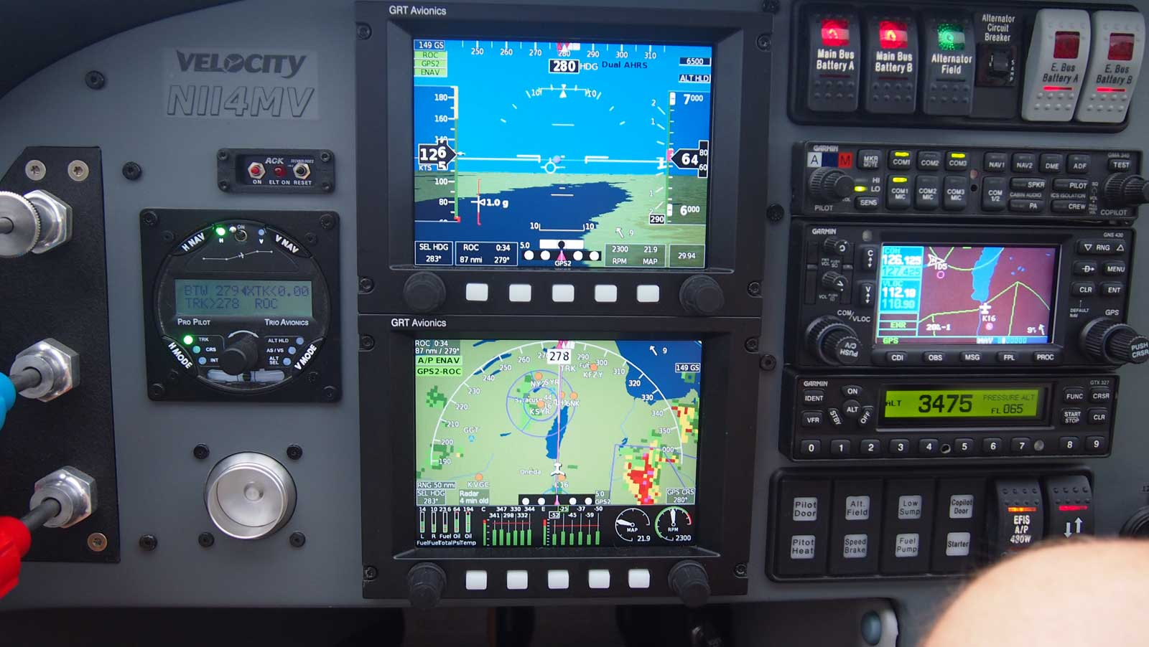We were departing from Michigan and there was a solid layer above. It was snowing lightly. No problem, I have an IFR flight plan on file.
Startup, taxi, and run up were normal. We picked up our clearance in the air then turned on course and entered the clouds. Our flight plan was in the 430W and the autopilot was engaged.
As we climbed through 5,200 I saw messages flashing on my EFIS; something about “AHRS 1 unreliable.” That was followed by “AHRS 2 unreliable.” Seconds later all attitude and air data information disappeared. In solid IMC and I just lost my attitude and airspeed.
The PFD background is normally a 3D synthetic image showing attitude and terrain. The background was black. There was a small inset attitude window showing a climbing bank to the right and a heading that continued to spin in circles. The Altitude and Airspeed had labels “GPS Calculated.”
My understanding of the system was that it will self diagnose, reboot, and realign. I waited and it never came back.
What I did
I lost both AHRS and I was in solid IMC. I assessed my situation. We were still climbing. The 430W was navigating and the auto pilot was faithfully tracking.
This spring I installed an AHRS in my Stratux. I tapped the PFD icon on my iPad. The attitude information was up and working.
My first reaction was to turn around and land. However, I was in a stable climb. I was not in trouble. I wasn’t overloaded. The other systems were operating nominally. Returning to Allegan would require maneuvering in the clouds with a quasi partial panel. The alternative was to not touch anything and continue. I notified South Bend approach I had an instrumentation problem affecting my attitude indicator. They acknowledged, offered assistance and asked me to keep them informed.
We broke out around 6200. We were in the clear on top with a visible horizon. Our situation had improved. We continued the climb to a GPS calculated 8000 feet.
My lovely bride is my copilot. We have been flying together for decades, and we make a pretty good team. She enters the flight plan into the 430W while I’m going through my post-start checklist. She also tunes comm. frequencies and altimeter settings. She is smarter than I am, and I know it.
Though not a pilot, she knows how to read the instruments. Not much gets by her. She saw what was happening and she knew what it meant. When the first error messages appeared she said “I don’t like that.” When the attitude information disappeared, she saw it; she knew what it meant and knew it could be serious.
She also knew I needed to concentrate on the situation. She would have helped if I asked. She didn’t say a word until we were on top and in level flight. Looking back, I marvel at her composure and discipline.
On top, in the clear, in level flight we talked it over. I concluded the AHRS were not going to come back on their own; they needed to be rebooted. I don’t have a separate switch for the AHRS. I needed to shut down the whole panel. We will continue until we were past the cloud layer below. Wait unit it is VFR and we’ll do it when we are passing by a workable airport.
In another 15 minutes we were ready. I called ATC to let them know what I was going to do. They asked me to report back on the frequency.
I must have looked at the magneto switch three times. Don’t turn that one off.
I shut off the master, the EFIS backup bus, and the alternator. The panel went dark and the engine kept humming. I turned everything back on. The systems came back online. Ten to fifteen seconds after the EFIS came back, the AHRS aligned and attitude information was back. Everything was nominal; reassuring, but kinda anticlimactic.
I don’t want to give the wrong impression. When the problem happened I didn’t think “heck, I got this.” I also didn’t feel panic. The situation was stable. My backup was working. No pilot likes to be operating on backup, but I was glad I had it.
I have the ability to select the input source for the autopilot; EFIS or 430W. Normal operation uses the 430W direct to the autopilot. A problem with the EIFS or AHRS can’t interfere. The auto pilot simply continued.
What happened?
My EFIS records data to flash drives every half hour. Because I waited to reset the avionics, the data for the incident was saved. I sent the files to Jeff DeFouw at GRT. His analysis:
Here's what I have for the timeline from the demo files. I used the Drive 2 data because it recorded GPS2's clock. The altitudes are the baro-corrected pressure altimeter reported by AHRS1/AHRS2.
16:03:08 DEMO-20191107-160307 begins
16:16:23 3850 feet, climb has begun
16:17:06 4260 feet, AHRS2 stops sending data
16:17:25 AHRS2 is back. It has rebooted and is in alignment mode. The EFIS turns off Dual AHRS mode and switches to manual AHRS select mode with AHRS1 selected and AHRS2 in the inset.
16:18:59 5360feet, AHRS1 stops sending data and never comes back
16:19:03 5400 feet, AHRS2 stops sending data again
16:19:27 AHRS2 is back, it has rebooted again, and the initial alignment estimate is poor in all axes.
16:20:14 5590 feet, AHRS2 stops sending data for a 3rd time
16:20:29 AHRS2 is back from another reboot and the initial alignment estimate is poor in all axes. The estimates are the same as the last reboot.
16:22:49 7120 feet, AHRS2 exits alignment mode showing roll 24.7 degrees right and pitch 16.2 degrees up. The heading is now spinning. It did not have enough time to correct the bad initial alignment estimate.
16:26:52 7880 feet, GPS2 stops sending data
16:27:01 GPS2 is back without a position, it may have restarted
16:27:02 7890 feet, GPS2 is reporting a position again
16:41:25 8210 feet, DEMO-20191107-160307+2 ends
16:58:36 8530 feet, DEMO-20191107-165835 begins. Both AHRS are in alignment mode. Initial alignment estimates are good.
17:00:31 8360 feet, both AHRS exit alignment mode. Both show level. AHRS1 shows heading 260 and AHRS2 shows heading 249.
AHRS2 was definitely rebooting and it wasn't a communication problem. It rebooted 3 times in about 3.5 minutes. When AHRS1 stopped, it never came back. We don't know if AHRS1 was trying to boot because the log doesn't record that.
There doesn't appear to be any sign of a problem while AHRS1 or AHRS2 was sending data. Whatever happened was sudden and without warning.
AHRS2's air data was working fine each time it came back, but the EFIS probably wasn't using it because AHRS1 was selected. The log doesn't record the AHRS selections.
After looking at the AHRS data, Jeff looked at the EIS data:
I didn't see anything jump around in the EIS data. That's something I looked for because the EIS data can be sensitive to voltage spikes. All the voltages and other data reported by both AHRS and the EIS were stable.
I don't think there's a problem with the hardware. The type of Dual AHRS you have is actually two completely separate AHRS mounted inside one case. They don't share anything. That would mean two of the same type of failure in two AHRS at the same time. A sudden failure and reboot like this in both at the same time is extremely unlikely by themselves. AHRS1 stopped and failed to reboot and AHRS2 rebooted 3 times, but before this event and after they worked without incident.
Jeff suspected an electrostatic discharge. If you aren’t familiar with ESD, here is a definition from Wikipedia:
Precipitation static is an electrical charge on an airplane caused by flying through rain, snow, ice, or dust particles. When the aircraft charge is great enough, it discharges into the surrounding air. Without static dischargers, the charge discharges in large batches through pointed aircraft extremities, such as antennas, wing tips, vertical and horizontal stabilizers, and other protrusions. The discharge creates a broad-band radio frequency noise from DC to 1000 MHz, which can affect aircraft communication.
Jeff has seen this before on Lancairs and Velocities. Composite aircraft are particularly susceptible to it. The signals in the AHRS are very sensitive. An ESD can create enough noise to knock the AHRS offline. If this happens, the only way to bring it back is to power it off and back on. Once rebooted it is must be held straight and level if it is to align. The first 10 seconds after initial boot are the most critical.
Velocity owner Bill Batten had written about his experience with ESD. I reached out to Bill to learn more. He has now experienced it three times. Each time it knocks his AHRS offline.
Root Cause
Let’s start with the root cause. Static buildup and discharge has been happening on aircraft as long as there have been aircraft. Static charge builds on the surface. When the charge reaches a critical level there will be a sudden discharge. You probably won’t hear or see it.
You might have seen static wicks on the trailing edges of general aviation, commercial and military aircraft. For a wick system to work there has to be an easy way for the electrical charge to flow from every point on the fuselage to a wick. To allow this in a composite airframe, a conductive, usually cooper mesh is embedded in the fuselage just under the paint.
The Velocity doesn’t have a conductive mesh, adding static wicks won’t do us any good. Without installing a mesh, there is no way to prevent ESD in a Velocity. Therefore, if you fly in actually IFR conditions with your Velocity, you are likely to have an ESD event at some time.
How to prepare for an ESD event in your aircraft
You can’t prevent it, but you can prepare for it.
- Don’t panic. If you are prepared, an ESD event is an annoyance, not an emergency.
- In Bill’s and my experience, it knocked out the AHRS. It didn’t affect the other instruments. The GRT instruments will automatically default to GPS for altitude and airspeed. You will want to find out what your system will do when your AHRS goes off-line.
- If the auto pilot is flying when this happens, it will most likely continue. The auto pilot does not need an attitude indicator to function. If it is working, think twice before changing or disconnecting it.
- Have a backup. I have a Stratux with an AHRS connected to my iPad. I don’t know how or why it was still working after the primary AHRS went offline, but it was. A Garmin GTX-345 also contains an internal AHRS and will likely be broadcasting to your iPad as well. You should know the capability of your transponder or ADS-B out device.
- If you can shut off the AHRS without taking down the whole panel, then you have the ability to train for this “quasi partial panel”. Get a safety pilot or an instructor and go flying on a clear day. Shut down the AHRS and get familiar with what this situation looks like. Train using your backup. Shoot an approach or two.
- Rebooting the AHRS in flight is also worthwhile. Good to know if it will comeback from a shutdown or not.
  - GRT has a new and improved Adaptive AHRS. I asked if the new unit would have handled this better. It does boot and align faster. However, it uses the same principles as my AHRS. It is just as likely to get knocked offline. It might be a small improvement, but it is not a solution.
- It won’t be comfortable, but knowing how your system will behave can bring confidence.
  - First, on the ground with the engine running, try shutting everything off but the ignition system. The engine should continue to run … right? While the engine continues to run, turn it all back on. Does it come up the way you expect?
  - If it worked on the ground, then go up on a clear day. You don’t have to leave the airport environment. Shut it down while flying. Does your backup work? Does it all come back the way it should? Try turning and/or pitching while the AHRS is aligning (simulate bumps in the clouds).
Conclusion
The key to success when an ESD event occurs is to be properly trained and ready – know your instrument package – and all of the capabilities and limitations.

