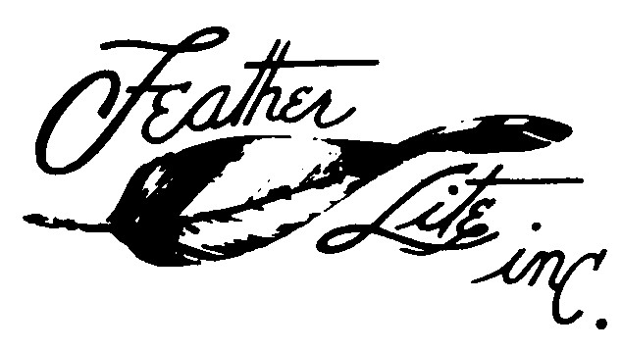

COZY MARK IV PRICE LIST

1327 South State St., Airport,
Ukiah, CA 95482
Phone 707-462-2939 Fax 462-3424f featherlite@pacific.net
Michael Dilley

May 1 2016

Main Landing Gear $ 949.00
Nose Gear 116.00 * Engine Cowl Set Top and Bottom 620.00
Wheel Pants Set 314.00 * Turtleback vacuum bagged prepreg 600.00
* Precut Foam Core Wing & Winglets 1990.00
Precut Foam Core Canard 325.00
Nose Wheel Cover 59.00
Nose Strut Cover 39.00
Sump Blisters [two required per aircraft] 39.00
Nose Cone with Door [forward of N6] prepreg 116.00
Fuel Strake Leading Edges, right and left (NOT AVAILABLE AT THIS TIME)
Arm Rest Kit, left, front, and rear prepreg / vacuum bag 380.00
Rear Keel Cover & Landing Brake Cover 82.00
Carburetor Air Box Kit 239.00
Baggage Pod Set 642.00
Nose Bumper Rubber 22.00

A check or money order is required to process orders.
California residents add 7.25 % sales tax..
Contact us for a freight quote
Substantial delivery fees are incurred for residential truck delivery. Please include a telephone number, a mailing and a street address.
Please allow 30 days for delivery, we will expedite when possible.
We will discuss questions regarding our products by phone mail or email.

*Items must be shipped by truck.

