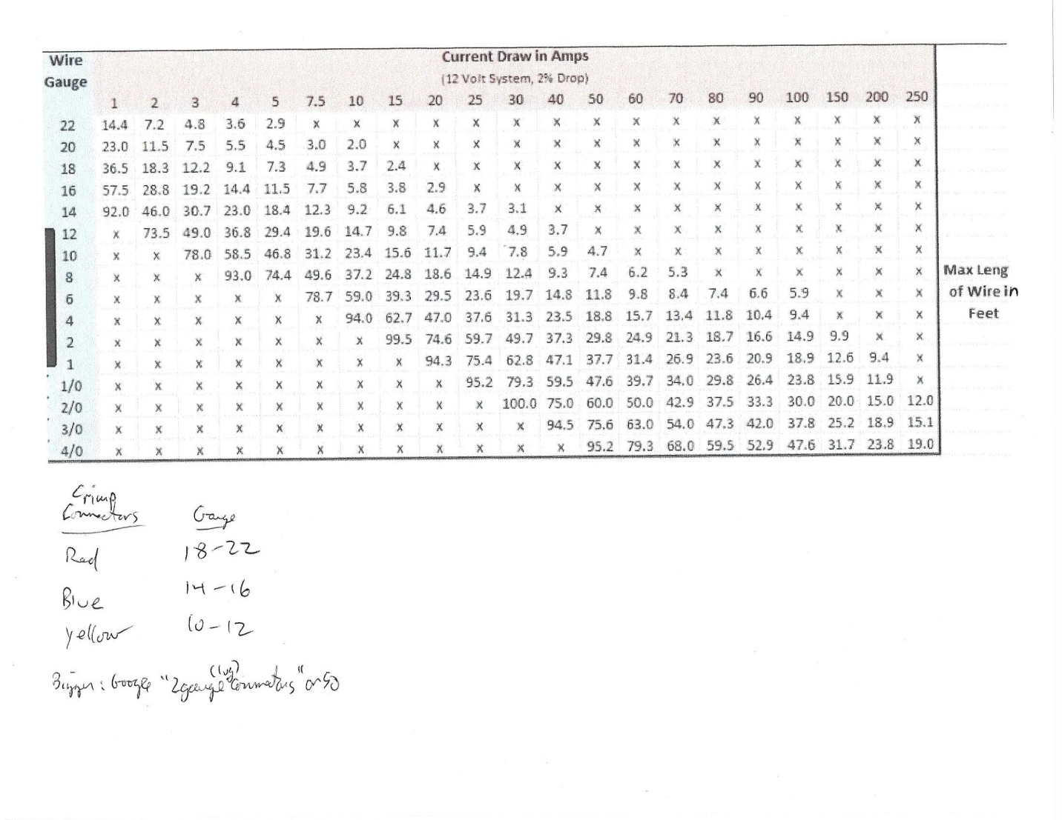
Per Robert Holtaway: “This is a voltage drop chart. The ampacity depends on the temperature rise of the insulation. Different insulation has different max operating temps. Most aviation cable is 103 degrees C. Problem is that in a bundle the wire can’t cool and damage or fire results. AC-43-13 provides guidance.”

