LEG PROTECTION WITH THE REPLACEABLE ALUMINUM PANELS.
With the new thin metal panels, comes the need for leg protection in the form of coamings. I’ve seen partial protection offered by riveting angle brackets across the top of the leg holes in the panel, but that doesn’t protect you from side impacts.
Dave Ronneberg, seeing the trend toward aluminum panels, and having incorporated them in upgraded Long EZs and the Berkut, suggested we need better leg protection – he told me to buy a couple of feet (more for side by sides) of 2”x6” wood. He outlined the shape of the leg cutouts on the wood, 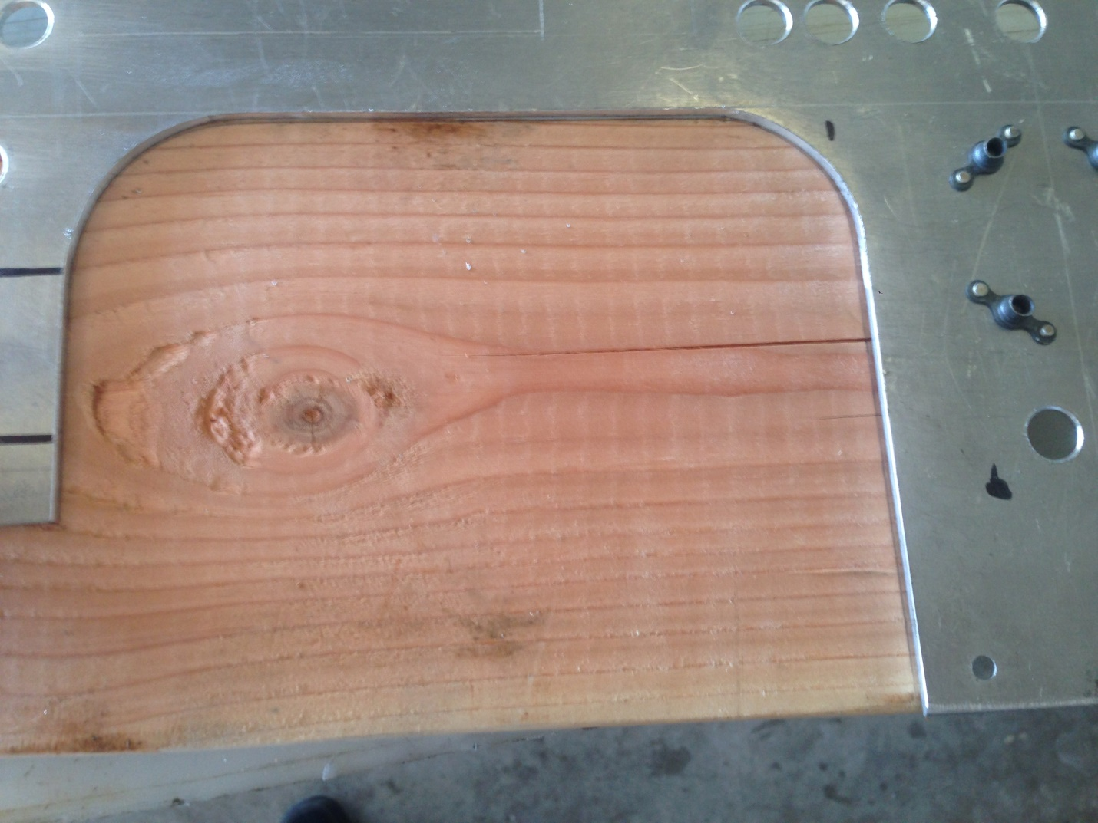

cut them on a band saw and smoothed the wood cutouts on the grinder and checked – keeping track of which block belonged to which leg hole – the outboard side of his leg holes ride higher on the arm rests than the center console section.
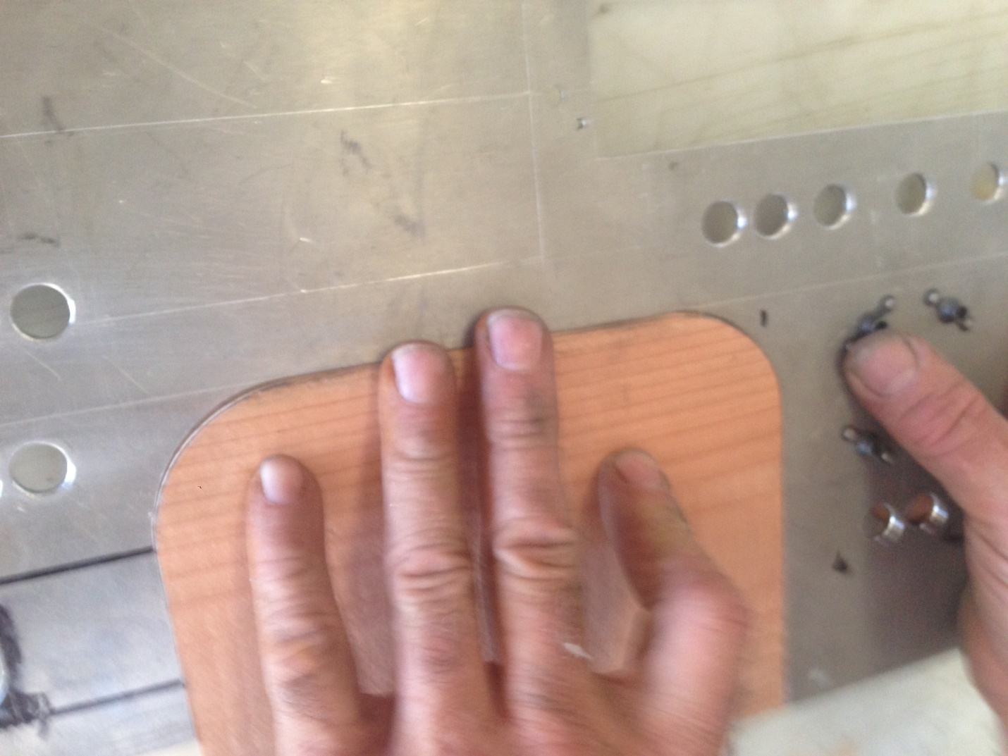
He then added silver tape around the 2” circumference except the bottom of the wooden block.
He then clamped the wooden blocks down on a plastic table, basically panel side down – you could do it on a stiff aluminum block – anything that will release easily. He then waxed the table out an inch and the silver tape.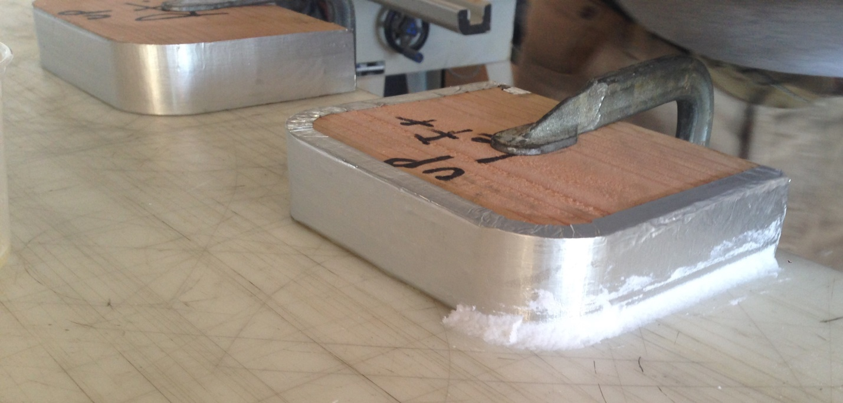
He then squeezed flox into the table/silver tape intersection – shown started above. He then cut 2” BID strips that would allow six plies of BID on the table/silver tape.
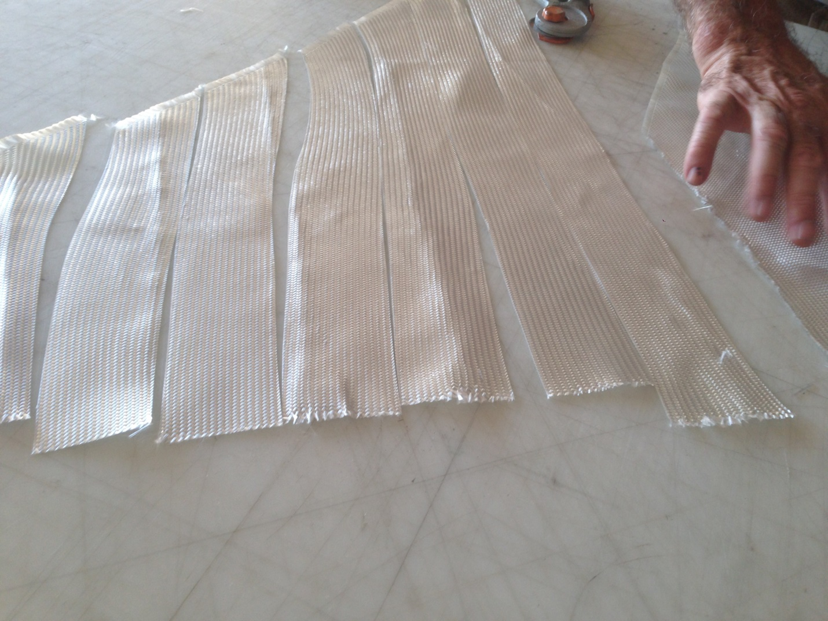
Wet the tape out, don’t make it dry – we used West System. 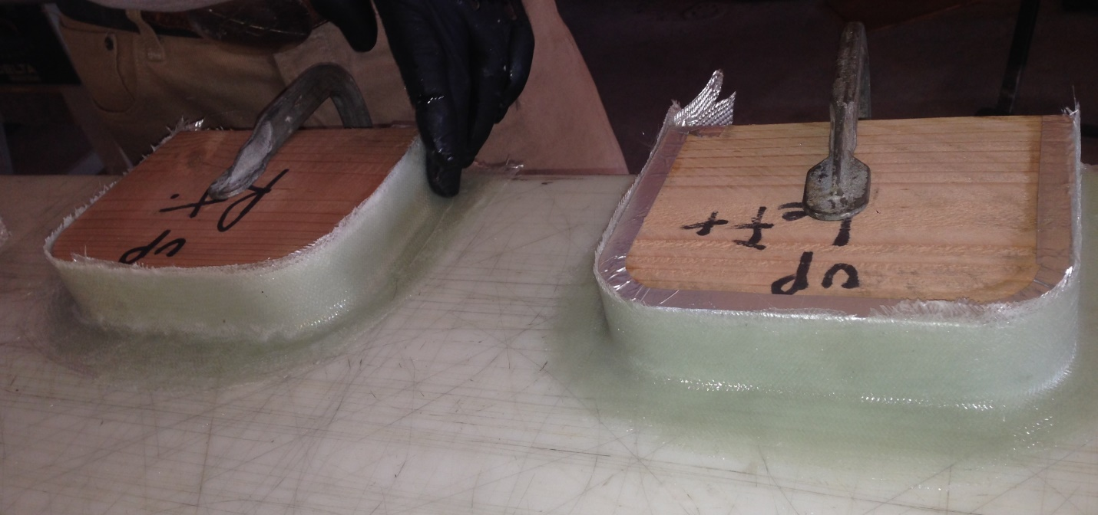 At trim time, trim the table side at ½” all around, leave it longer than the point where the armrests are on the leg hole, trim the silver tape side at about the same – about ½”. 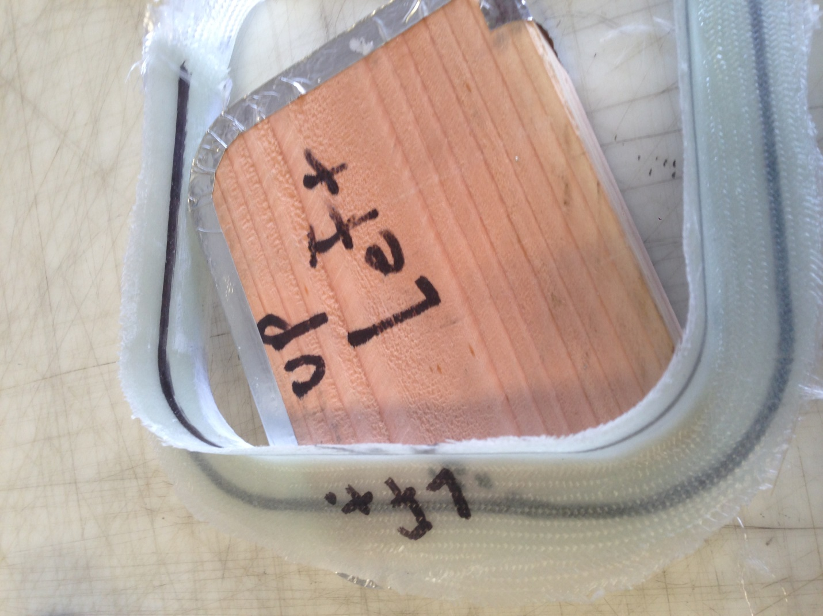Be sure to mark which leg protector fits which leg hole. 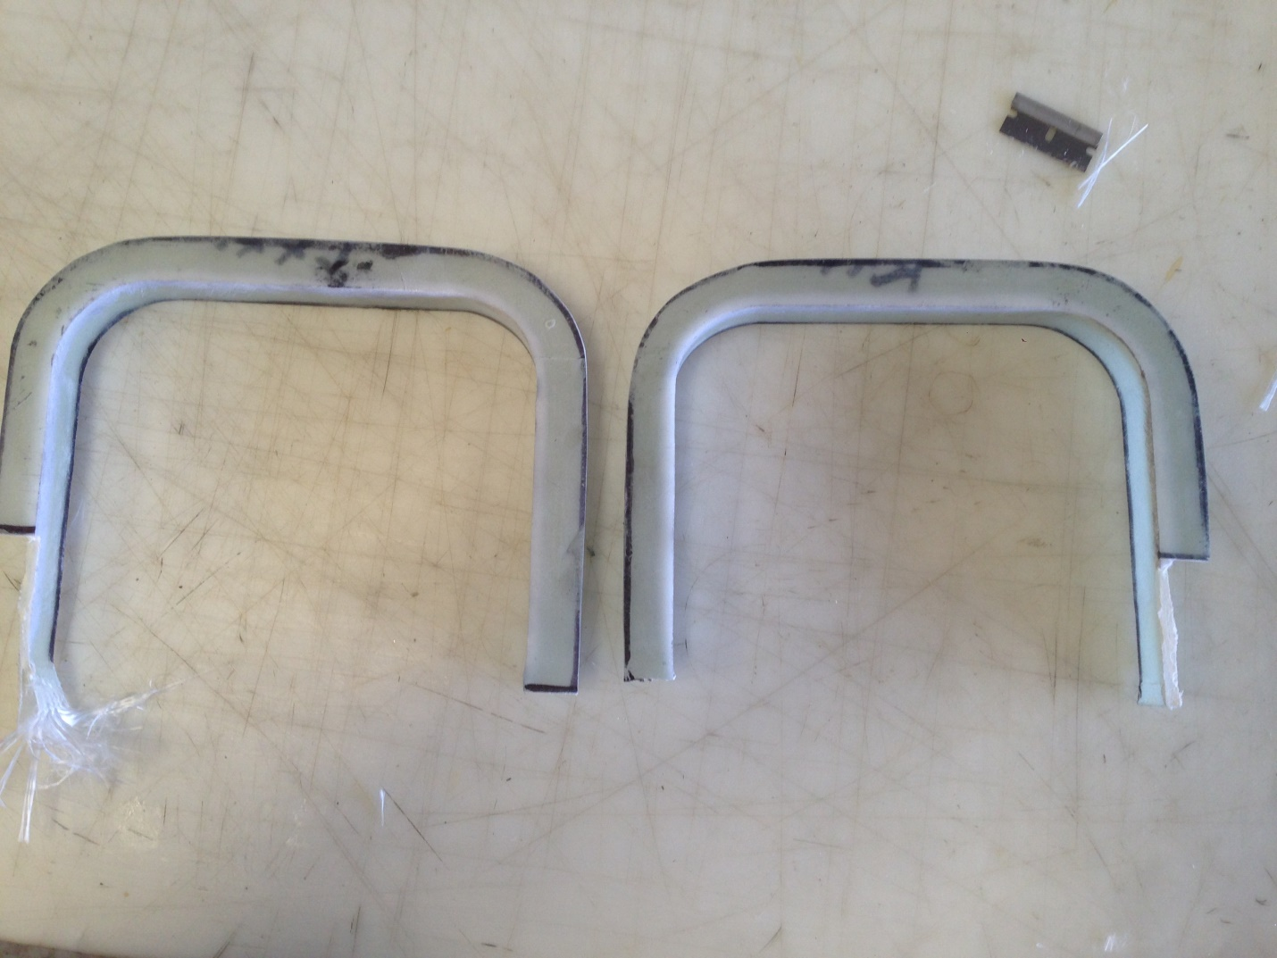
Then you need to prepare the back of the panel to use very strong glue to set the leg protectors firmly and finally. You outline the area where the leg protector will “lie” on the back of the panel, then use a mill to remove the amount of the panel that the leg protector absorbs so it is flush so that various instruments – in our case we milled half an inch of panel around the leg holes down about half the panel thickness – leave the excavation surface rough so that the special glue will attach better. Organize clamps to be sure the leg protectors stay flush on the back side of the panel – instruments and other devices ride on that surface – so you don’t want any raised items back there. There are expensive glues to bond glass to aluminum, but he used J-B Weld quick. He says the large tubes of it are not that much more than the little tubes that are on display everywhere. Now – you may want to put it aside until you have finalized the panel holes for avionics and switches/C/Bs, and then consider final paint or aluminum treatment – one of the considerations, according to Dave, is that the glue might get onto the front of the panel if you are not careful…but in my case we decided to glue the leg protection on the back of the panel after it had been completed in final form.
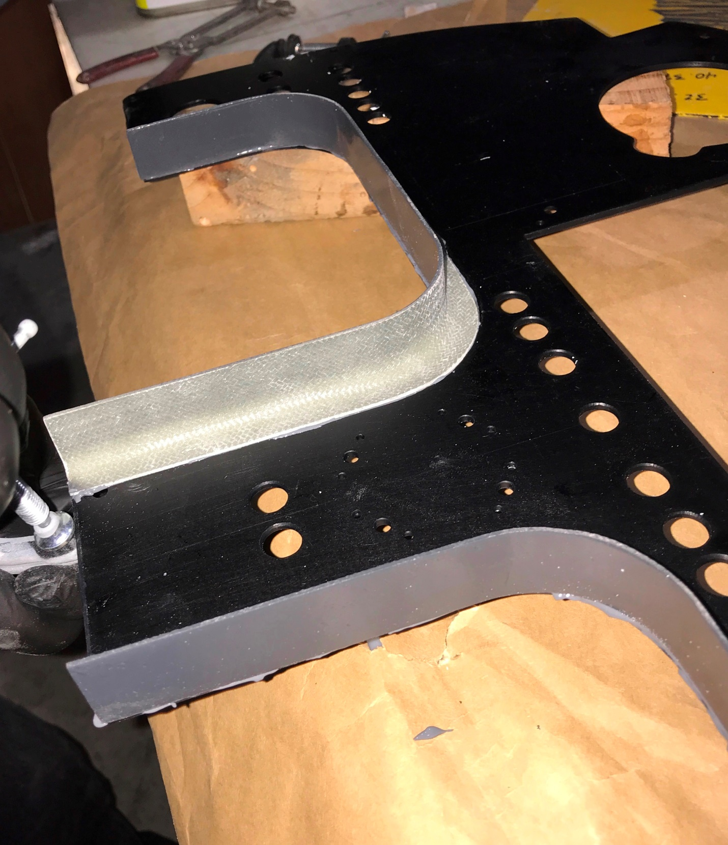Two provisos – you have to have something standing by to take the glue off the front face of the panel as you glue it down – in this case the panel was anodized black and you can simply wipe anodized aluminum clean before the glue sets with gasoline or solvent. In the case of painted panels, as you may have to touch up your paint if the glue stains it – you might instead consider installing the leg protection before you paint the panel.
Secondly, Dave, to protect the front face of the panel, painted the “exposed side” of the leg protectors – Dave calls them Coamings – before we attached them to the panel. Lycoming engine paint was available.

