Some words on nose wheel alignment and “foot”
I believe Bill Ortel came out with a unit for the VEZ/LEZ on the west coast but I'm the one who designed and made the first Cozy electric retract system in 1995 and published the instructions and plans in Terry's Central States Newsletter.... Steve Wright asked to take it over later on and improved the unit and making standard parts available.
When designing this unit I watched the nose gear strut carefully while being retracted and extended and discovered the unit actually drags and then pulls the nose strut across the tarmac a slight amount during its cycle.
Thus the need for a "foot" I also discovered if the foot is not made correctly (height and angle) it will not allow the wheel to pivot. So it must be made as shown in the picture below...Note the ANGLE .....it slants toward the fuselage and not the ground),
You can disregard the lines and measurements in the picture as they show how to correctly align the fork casting for no shimmy no matter the angle of the nose gear strut exiting from the fuselage.
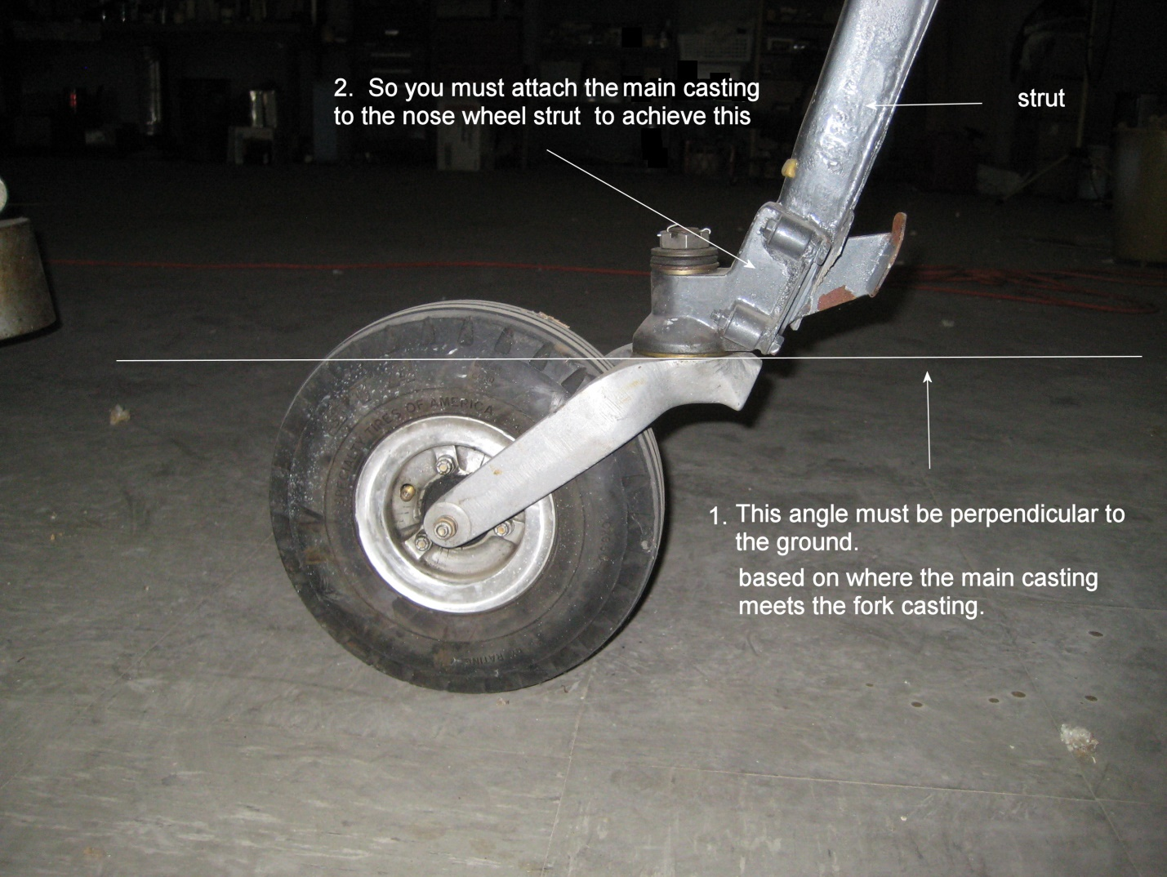
Vance Atkinson

