Dual Lightspeed Plasma III’s on TNIO-550N with 1300+ hours on them. I highly recommend them and think it is the highest performance CDI available.

Early on I had lots of problems with coils arcing over internally and only firing one of the two (lost spark) cylinders. Eventually Klaus decided it was due to the high altitudes, since most of our hours are long distance cross countries flown in the low flight levels. Klaus said the ‘GM’ coils were indestructible and so we switched to them and haven’t had any coil failures now in the last 1000+ hours.

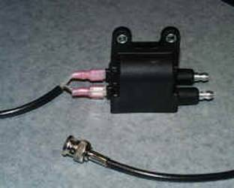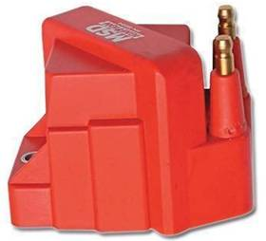
Original LSE Coil ‘GM’ Coil (MSD 8224 ‘Blaster’)
https://www.amazon.com/MSD-8224-Blaster-Ignition-Coil/dp/B0006306XM/ref=asc_df_B0006306XM/?tag=hyprod-20&linkCode=df0&hvadid=312061942313&hvpos=1o3&hvnetw=g&hvrand=17544618685237431393&hvpone=&hvptwo=&hvqmt=&hvdev=c&hvdvcmdl=&hvlocint=&hvlocphy=9012420&hvtargid=pla-472210685930&psc=1&tag=&ref=&adgrpid=63195598318&hvpone=&hvptwo=&hvadid=312061942313&hvpos=1o3&hvnetw=g&hvrand=17544618685237431393&hvqmt=&hvdev=c&hvdvcmdl=&hvlocint=&hvlocphy=9012420&hvtargid=pla-472210685930

The other welcome and big change from his original Plasma III design was to the new machined aluminum timing plate. Originally, the magnets were on a timing plate bolted under the prop, and with the Hall Effect transducers on a large, circular PCB board mounted to the engine. It was harder to set and maintain the alignment of the PCB board with the proper magnet gap, and if the magnets ‘crashed’ into the board it could damage the Hall Effect senders.

The new design uses a circular machined aluminum plate bolted under the prop, with the magnets now embedded into the plate and the two (if you have dual CDI’s) Hall Effect pickup sensors mounted to the engine. This is a sturdier, more reliable (and professional-looking) design. I don’t think the remote CDI control box has changed much over the years and the new pickup design has been working great so far in the ~100 hrs since installation last year.

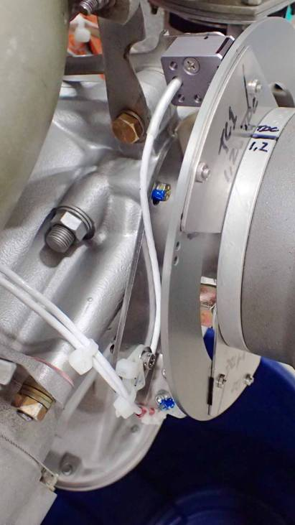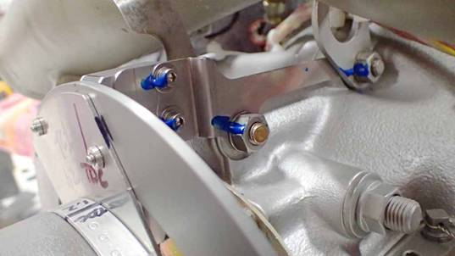

Bob Jackson
N2XF Velocity XL/RG/XC
TNIO-550N

