Accommodating your shorter half:
The Berkut is a little different from the Long EZ in a number of ways – the fuselage is wider and there is an extra foot in the spar to canard length – mostly taken up with the main gear box in the back of the rear cockpit.

Please realize that unless you have a 5 point seat belt that the thigh support provides added anti-submarining functions – so if you have a flat or nearly flat rear floor with the cushion on top, you are inviting the rear seater to slide their hips under the lap belt and the effect in a severe frontal collision would be to “gut” them. The thigh support keeps the butt planted and raises their hips up as they drive forward into their lap belts. This danger is recognized in every modern car – the lap belts are no longer mounted back at the bite of the seat as they were in the 50s and 60s, but are mounted nearly vertically so that the lap belt loop will shorten and pull down and tighten into the iliac crest of your hips as you load forward into them. Small kids don’t have much of an iliac crest, which is why boosters are so important in placing the restraints in cars.

The stock Berkut rear seat has a thigh support which I’ve cut out and mounted to a little platform that I laid up in the bottom of the fuselage with a front edge that is trapped in place under load. It has a little storage space in it. In fact Ronneberg has used a much deeper thigh support to locate an oil cooler for cabin heat in some Berkuts rather than running oil lines to the front of the plane as some Cozy guys do. You could also place some hidden anchor nuts which could be used as an anchor for a couple of bolts attached to the seat. Here’s the removable thigh support in place:
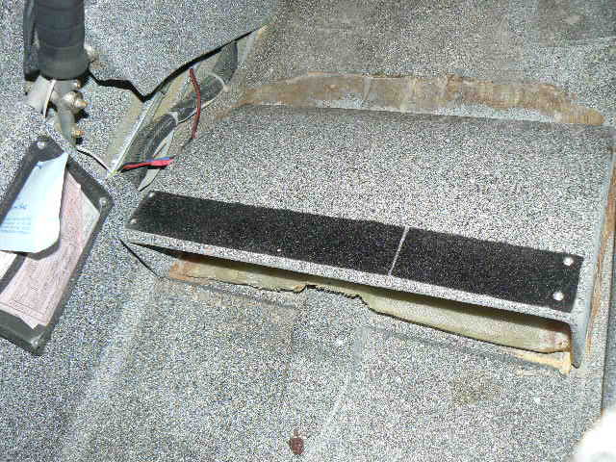
The curved profile of the thigh support is much like the front seat of the Long EZ – maybe more curved. I also added foot rests leaning against and bolted to the front seat back for the passenger’s feet to fit comfortably – having good foot support for a short person will make them feel a lot more comfortable – the foot support could be just big enough for their heels – although you could also make a storage box or an open package section for bags.

Here’s how the seat cushion looks when the “standard” thigh support is in place (note the exposed bulkhead above cushion) (where the spar would be in the Long EZ:
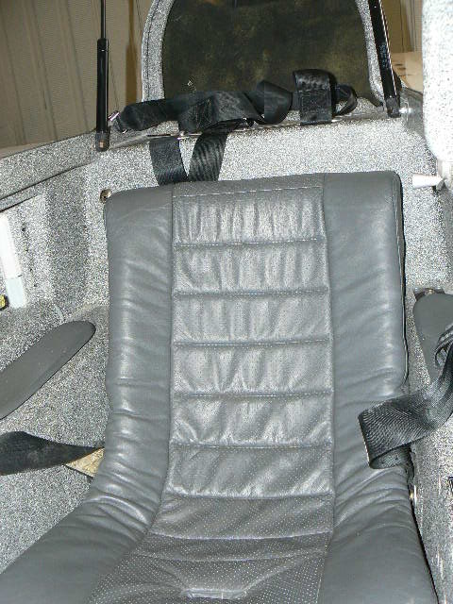

However, the reason I made the Berkut thigh support removable was that I had a booster box for my wife that my son - the engineer - made – He started with blue foam, and Dave Ronneberg showed him how to create sophisticated hinges, etc. Dave’s the master of fast built structures.

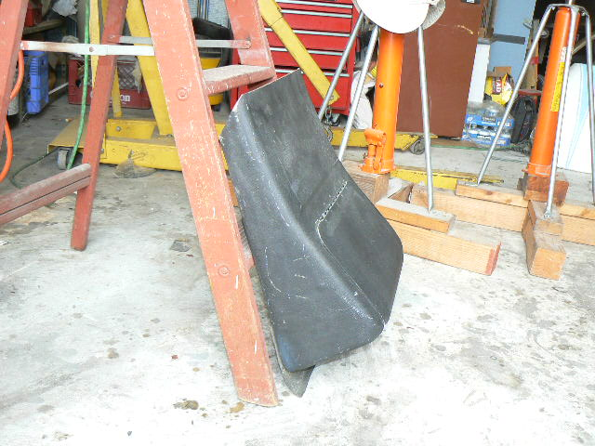

The box was too long initially and the thigh support hit her calves so I shortened the box about 4” at the same angle as the rear seat back, the cut is at the top of the photo above. Here it is in place in the Berkut – which has different seat belt mounts – it worked the same way in the Long EZ, but the belts have to be routed carefully after the cushion is installed so there is no hidden slack:
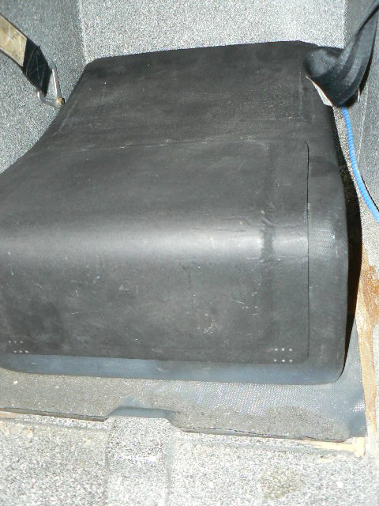

Trevor made the hatch quite functional and the box is quite useful for small bags, and I think it would fool a thief who gets access to the cabin:
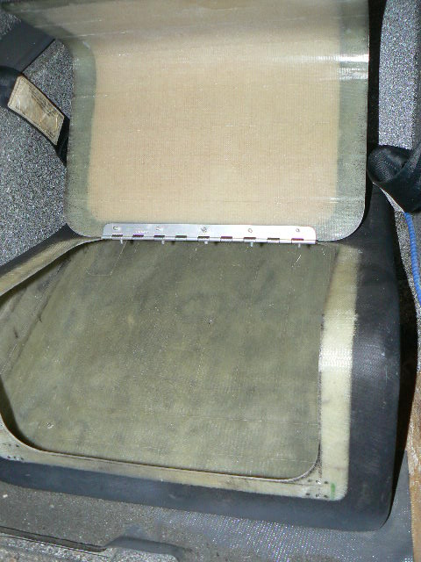

I had holes in the floor of the box for bolts to mount it to nuts buried in the floor of the Long EZ – Dave Lind had two mounting lock nuts in the floor skin of that Long EZ for his Pacific Ocean extended fuel tank – much like the anchors put in the wing for baggage pods.

Here is a photo of the seat cushion on top of the box in place (note the cushion is now above the seat back):
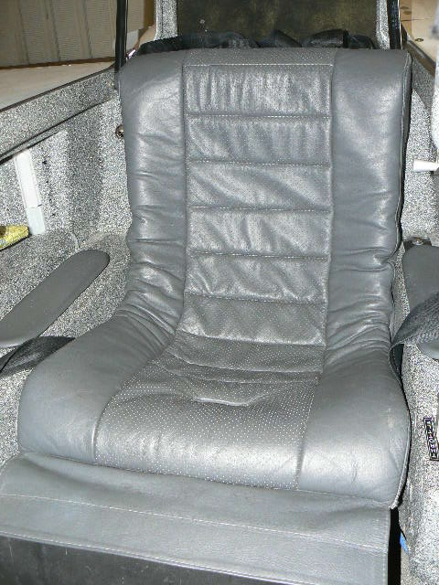

The butt pocket is raised about 4” for my wife who is 5’5” tall. The front of the box is more like 7” tall. I can’t sit there with my head under the canopy comfortably at 5’5” – women have shorter upper bodies, generally, longer legs – viva la difference. Initially, in the Long EZ, I also would pad up the back of the seat cushion so she could sit more upright – she doesn’t seem to need that with the raised thigh area, although the seat back of the Berkut has a longer vertical aspect. If you are experimenting in blue foam, I’d be conscious of the fact the seat box should not be too long unless you also use a back booster to push the back of the cushion forward too, a booster like Emons’ below.

The approach Jim Emons took for my Berkut front seat (again I’m 5’5” and had to move the brake pedals aft some) – this was installed back when I had what I call my front Beluga canopy on the Berkut. The booster essentially tilts the front seatback forward about 4” at the top and 2” at the bottom. (My permanent seat back in my first Long EZ was 8” forward at the top and 4” forward at the bottom – and I’ll admit I looked like I was riding on some hidden person’s lap with my head was so far forward in the canopy – it looks a bit like that in the Berkut too. This Emons seatback booster also fit in the Long EZ, although it was a little too tall – the canopy edges would impact it if even slightly askew, disconcerting when you were trying to accept takeoff clearance and couldn’t lock the canopy – here it is installed in the Berkut – the seat cushion tilted forward:
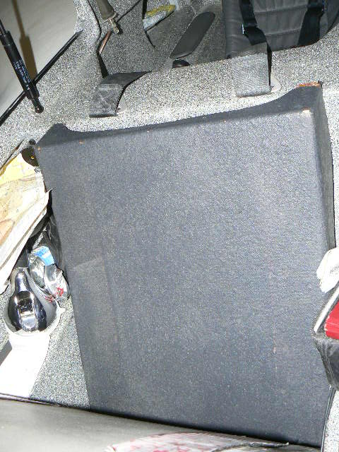

And here you can see it out of the plane in profile:

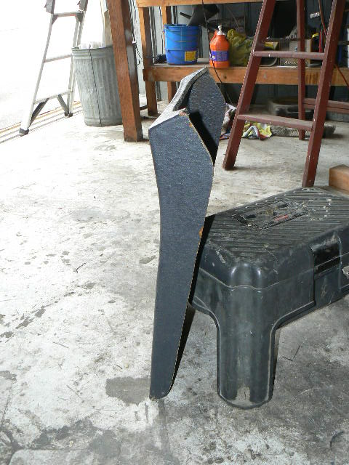
As this Berkut has no head rests, I could have added some head rest structure to this box. Oddly enough, when we put in a more streamlined front canopy last month, I actually had to cut this box down some to give myself more head room.

Here the seat is in place with the front booster…
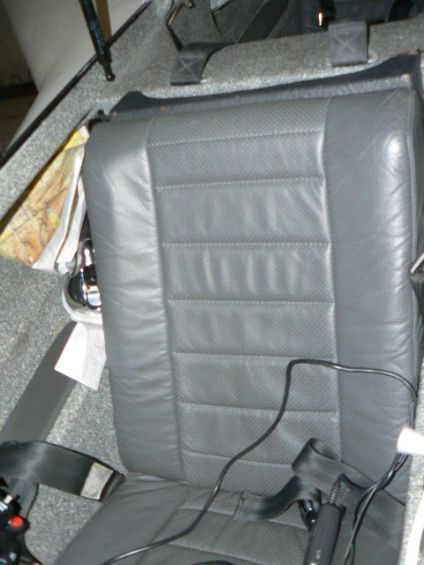

Emons also raised the stock Berkut thigh support (a kind of curved bridge) about an inch in the rear by inserting wooden blocks under it, simply using longer bolts to attach the thigh support through the blocks to the floor.

