Dave Kilbourne who moved to NZ where Grass is free, pavement often taxed: 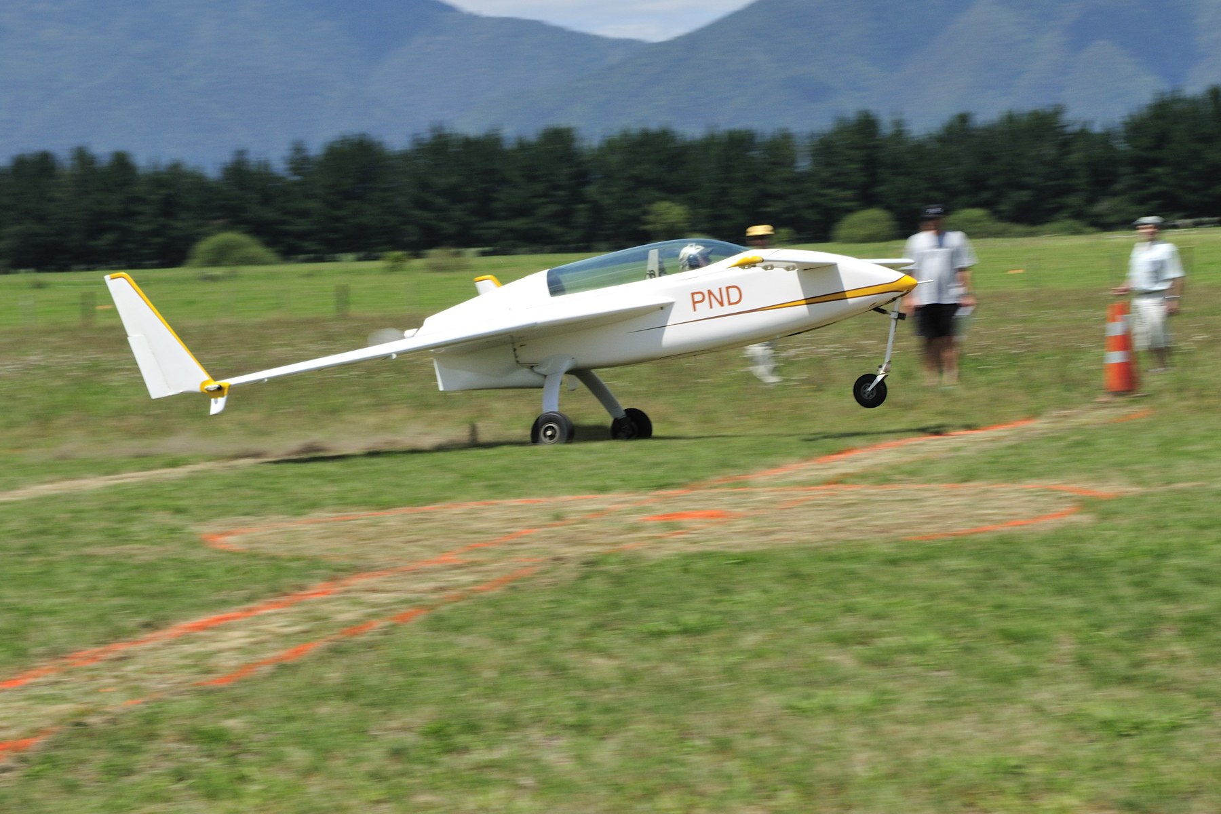

Note his lack of wheel pants: “I haven't heard from anyone in NZ about Rutan Canards on grass. You are right though that he (buyer on a grass runway) would be better off with an RV. I think that I have proven that the landing gear on the VE is up to the task with larger tires installed. The problem though is the high landing speed. If I slow to 80mph (min sink) the nose is too high to see where in the heck I'm going. The approach I use is to trim to 80 mph then use a continuous 180 degree turn to final at about 90 to 100 indicated then over the fence (flax at Waihi Beach) at 80 to 90 and a quick flair and plant the mains solidly to get some rolling resistance as soon as possible. Then hold the canard high for aerodynamic drag and come onto the brakes when the canard falls through. If I do it right I need very light braking to slow to taxi speed on this 540 meter (1755ft) grass field.” (Beagle:Not a field length many of us would be happy with.)

R Ryszard Zadow ryszard@earthlink.net on Grass Runways:
“Well, I pretty much discourage it too. My situation was different in that I was only seeking to fly off my strip. I knew it very well and did a lot of number crunching to find my results. I laid out the whole place on paper and would walk off distances with one of those wheeled measuring things so I was sure I was getting things right. Keep in mind the condition of the runway has a lot to do with it. At one end of the spectrum you can have a grass runway as smooth as a golf green. At the other end you have the one I live on.

The airplane will do it just fine.. but at a price. I'd have to dig into the logbooks to find out for sure, but in that period I think I probably only put about 300 hours on the airframe. After that short period of time, the abuse on the main gear attach fittings was tremendous. I had the larger bolts installed years before this and every bolt hole still got elongated. The heat from hard braking started deteriorating the lower part of the strut. You might wonder why I was braking hard on 3000 feet of grass, but it's because I didn't have all 3000 feet to work with. There is an area in our runway that is very rough and I was trying not to roll into it. In the other direction I would have to float over it. In reality I was dealing with about 1500 feet of suitable stopping surface. Vg's helped a lot but cost me top end speed.

I wound up replacing the main gear with a Long gear and heavier attach fittings. Rob and Valerie Harris did it for me and he used 5/16 extrusions and AN-5 bolts. (might be bigger, I don't remember). I continued to fly off our runway for a while longer until I started to take a real good look at my nose gear. The nose strut pivot casting was shot and the nose strut had about a half inch of side to side play at the axle. Back then I had the old Johnson bar retract system with no strut spring. It took all the beating right into the pivot casting and even bent the pivot shaft of the nose wheel fork.

A friend made a new pivot casting using preloaded tapered roller bearings and after going through all the work to replace it I gave up flying off our runway. Now my VE is at West Houston where it gets to fly off nice smooth 4000ft of asphalt.

If the runway is smooth, then an EZ will handle it just fine, especially a Long. It's harder to tell if there are any hazards on a grass runway. Mole mounds and gopher holes can get ya! In Texas we have fire ant mounds. I hit one one day by accident. It was a little wet and the ground was soft. When I landed I drifted a little and got into the taller grass off the crowned part of the center. I felt the airplane get tugged sideways and there was a bang. I had no idea what happened. I fought it back to the center, came to a stop and started to turn off the runway. When I looked back I saw pieces of something white all over the place. A big chunk of it was kind of round and from a distance looked like part of a 5 gallon bucket. I really thought some a-hole left a 5 gallon bucket out there that I didn't see. As I taxied back for another takeoff and passed the pieces if "bucket" I realized it was one of my wheel pants! My right wheel pant hit a fire ant hill that was about a foot tall and 18" in diameter. The wheel pant looked like it had been hit by a 20mm! There was the one big piece that looked like the 5 gal bucket and a couple of other big pieces but the rest was all shards of fiberglass all over the place. It was kind of funny actually.

If the grass is long or wet, or worse both and you have a strut spring, one more very important thing can happen. The drag on the nose wheel will cause the nose strut spring to compress and the canard might not be able to get enough angle of attack to rotate. This happened to me and a friends Long a couple of time. He couldn't get airborne a couple of times and had to abort! The nose goes down, the canard gets a negative angle of attack and that's it! I started bouncing the nose and finally got it to jump up and hold the nose up and was able to rotate. That was a fun experiment!

As far as things going through the prop.. I solved a lot of that with a nose wheel fender. You'll always have a chance of a rock I guess, but flying grass didn't seem to be a problem. Tall. Un-mowed grass is like an abrasive though. You should see the prop on my Mooney. Every annual I'm having to put paint back on the tips. Our props sit up high and I never really saw that much grass abrasion. But if the runway hadn't been mowed in a while I didn't take the EZ out until I got on the tractor.

Sorry I rambled. The bottom line is you really have to know the runway.”

Bill Hunter: “Not being a velocity builder or flyer at this point I can only add to this discussion my ignorance. With
respect to unimproved air strips I see two problems with the velocity. The first being that any debris getting kicked up from the wheels will fly into the prop and damage the prop and possibly the underbelly of the airplane. Fixed gear airplanes should have a bearing overall of the wheels . With respect to the retractable airplane the nose wheel debris issue can be readily solved by installing a nose wheel fender as discussed in a different thread and ensuring that the back flap of the nose wheel fender extends down almost to the runway surface. This would greatly reduce the amount of FOD being thrown up into the propeller. The two main wheels also will pick up debris and are within the prop arc so therefore damage to the propeller tips can occur from flying debris. I cannot see that a fender can be readily installed on the main wheels because the well in the wing that they retract into is not a wide enough diameter to accept both the wheel and the fender.

Another problem I see with the retractable gear velocity flying into and out of unimproved strips is the main gear and its attaching point in the aircraft structure period any unimproved strip will have lots of bumps and these jolts will do a huge number on the landing gear attaching points, bearings, and structure.

Airplanes that are designed for landing on unimproved strips will normally have very large low pressure tires and either strong metal landing gear fixed to the aircraft or for retractable gear airplanes a trailing link landing gear is the best design to reduce damage and the velocity does not yield itself to such features.

A Velocity guy added: “In my opinion, if you are on a grass strip, you should opt for a taller nose. Get the AOA of the nose a bit higher to allow you to lift the nose wheel off the ground at a lower airspeed.”

Vance Atkinson: “About a year or so ago a doctor bought Bulent Aliev's very nice Cozy 4 that was based in Florida. I ferried it to Houston TX for Buly and checked out the owner, who had no experience in EZ types but was very current in Cherokee he owned. He had a house on a grass field and wanted to base it there. I checked him out on hard surfaces and told him about the perils of grass field Ops. He went ahead anyway. Haven't heard how he fared but months later, did see a picture that Buly sent me of the plane sporting a brand new aluminum nose gear strut. Looked like it was milled out of a solid billet and it looked really nice... and probably cost a small fortune.

Buly Alieve: “I did hear from the buyer, complaining that by the time he gets to take off line, the engine overheats. He wandered why? 🙄 I explained to him that taxiing at high power in the grass, with minimal forward motion, the engine has no way to shed the extra heat. Then he asked how come the nose dives down too much on takeoff roll? Again, the small nose wheel bogs down in the grass and the thrust of the engine pushes the nose down I told him. Than he altered the NG strut. I was very much against him flying from the grass strip, but the doctor was persistent.”

Curt Smith, now in Ohio: “I bought a home on a grass strip 3 years ago. Sold the cozy and used the proceeds to build a nice hanger for my Cub. I would never consider operating a Cozy off of grass - the nose gear is too fragile. I once landed my Long on a 4000’ grass strip to meet friends. Mistake. Long story, but it took 4 tries to get it out only after offloading fuel and camping gear and having them mow the grass. Never again!
Build an RV something.”

Del Scheir: “Grass is almost out of the question for takeoff, but should be good for an emergency landing. As far as I know Leeward Air Ranch is the only airpark in FL that has a canard operating off of grass, but it is very smooth, wide and 6000’ long. My airpark has both a 3000’ grass and 3000’ paved and as I said; no way would I try and take off on the grass. My neighbor with a Cozy III tried one day light and cool out and said he would never try it again. He remembered being airborne but seeing the TV set in the last house past the end of the runway and 200’ from the car road at the threshold. He started his takeoff roll on the displaced threshold and did not lift off until he had used 3600’ of grass. Our grass is well mowed and fairly smooth.”

