NOSE LIGHTS?: Matt Stecher, Katy, TX asked: It was great to finally meet you and spend a minute getting to know you (at TexasGIG). I am thinking about my options for landing/taxi lighting and liked what I see on the nose of your bird. Do you have that design sketched up somewhere? And who’s lights have you used?
Beagle built a nose light into his initial BD5 nose on his Long EZ – it was plexiglass over an old fashioned landing light – the LA Basin is a see and be seen environment and the EZ is particularly hard to see in the air…then when he was convinced how ugly the nose was, Beagle had Eric Cobb, the first builder of the Ronneberg nose, to build a new nose around a light bulb facing down the final approach line – and Eric built a pretty good nose:

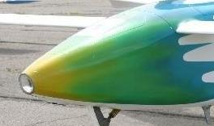
So I really don’t like the hang down landing light – which most people don’t put down until absolutely necessary. I could fly all day with the light on – no extra air source, no extra drag, no handle on the instrument panel. (I have some of these Brock parts if you want them). However, here’s the Berkut assembled as I got it and I think the windows are too small, frankly – I’d built them bigger than this, were it me:
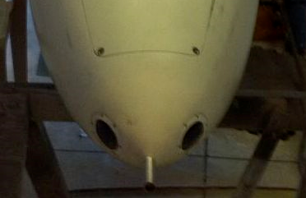
Believe it or not the Varieze came with a plexi nose light option, I'd suspect it would help you get a good light. Squadron Library Item 13MS2 for the full specs.
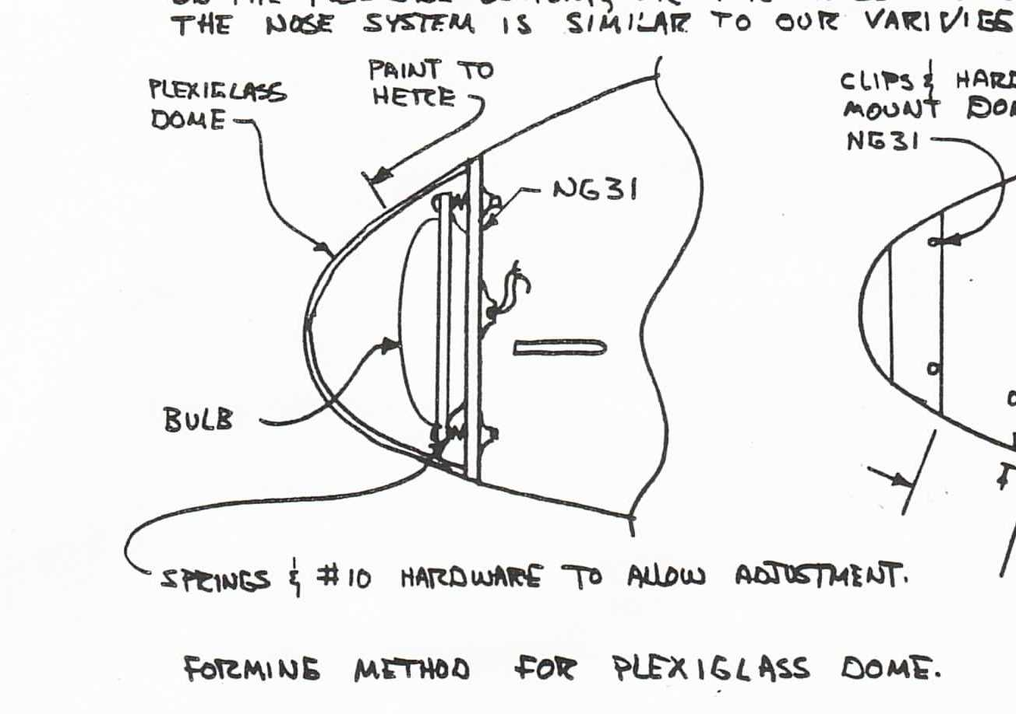
But the Light Source!:
My Berkut came with blue light bulbs in 2” gray plastic fittings - they were very bright and they got very hot, so I tried to turn them off quickly when I used them - they had no cooling air source. Instead, the cases of both lights actually started melting, one actually had the lens fall off while working - exposing the wiring inside the nose cone, the other getting so hot that the reflector actually disintegrated... so I looked for cool lights or at least lights that have cooling fins. I tried a RIGID 6 bank light - but in my dark hangar it was pretty obvious that the light was spread way too far - great for taxiing, I guess. This one, by the same maker, is made by Rigid Industries LED Lighting model D2 - High powered LED light, 1,760-3096 Lumens...it is the Hyperspot version with a bank of 4 lights that take 1.45 watts. (single part # 50371) I might get a driving version which is wider and actually puts out more light (part # 50131) for taxiing and aircraft avoidance (people seeing you) and the spot for landing - if I were to place two, you can get them in kits of two, but I’d bet you can’t get them mixed – they come with a fancy bright switch that might look good on a Jeep’s dashboard. They are putting light around the inside of the nose box that doesn’t go out the plexi lens. The Off-Road truck/cycle industry is a good resource for the latest stuff - in fact, the Motorcycle spots look to be much more compact - round, something I didn't find at the 4x4 truck store. www.RigidIndustries.com – now I have a light I can leave on around the LA Basin – indeed anywhere. Now to buy my 4th Wheelen strobe light bulb…those who put the lights out on the main wings have to guard against light in the cockpit – Atkinson’s Cozy IV reminded me of this just this week.
