Discussion on new fuels and composites:
Wilhelm Percival:
“David, I thought you might be interested in this email I got from EAA. I had asked them if the PAFI testing had considered the impact of proposed 100LL replacements on composite fuel tanks. Short answer is yes, although fuels outside PAFI process are unknowns.
Regards,
Bill”

From: Doug Macnair <dmacnair@eaa.org>
Date: Wednesday, September 12, 2018
Subject: PAFI Materials Testing
To: Wilhelmfp <Wilhelmfp@aol.com>
“Good morning Wilhelm,
Thank you for your question regarding the testing of composite materials under the Phase I Materials Compatibility Test procedures of the Piston Aviation Fuel Initiative (PAFI). Your question is a good one and is one that EAA anticipated in the development of the fuel evaluation program. All of the fuels that entered the Phase I tests under PAFI were subjected to extensive materials compatibility testing as this is a source of considerable question and concern with the potential introduction of new chemical compounds to aviation fuels. There is no question that some of the contemplated chemistries had the potential to be aggressive toward certain materials, especially sealants, gaskets, bladders, hoses, etc. But there was also question about the impact on resins and other similar compounds found in composite materials.
Accordingly, some composite systems were evaluated as part of the initial screening of the Phase I PAFI fuels. This was not necessarily an exhaustive evaluation of every possible resin system in existence but it was an attempt to cover the general landscape. I am attaching the test protocol used for conducting this evaluation including a list of the resin systems evaluated. The remaining fuel in PAFI which is being developed by Shell did not show adverse results with these materials and in fact as the fuel development has progressed, the level of chemical compounds that could be deemed to be aggressive to materials has been dramatically reduced since the initial testing. Composite materials did not appear to be effected even at the higher concentrations.
For your background, I am attaching an explanation of the test protocol but cannot share the specific data of the test results as that is proprietary data belonging to each of the various fuel developers. That said, while there were some findings relative or some of the soft materials I mentioned above, composite materials did not appear to be impacted. Much of the work that has been ongoing in PAFI has been to mitigate the chemistry that might impact the softer materials and is well underway. Obviously, any fuel that eventually makes its way into the marketplace cannot be deleterious to the aircraft it is approved for.
EAA fully understands that any future unleaded fuel must be compatible not only with the performance but also the materials in the existing aircraft fleet. This is especially challenging in the amateur built fleet where there is not necessarily documentation or control over what materials have be used. The possibilities are endless. That said, we have been doing our best to try to anticipate areas where there might be question or concern to the experimental community.
The chemistry of each fuel being evaluated both in and out of PAFI is often radically different from that of 100LL. This is greatly complicating the evaluation process. That said, one of the reasons that a robust evaluation system such as PAFI was stood up by industry was to ensure that adequate and complete testing was both anticipated and carried out. This is not necessarily happening for fuels that are seeking FAA approval outside of PAFI. We do not have either visibility or control over those fuels. Hence, the significant industry investment in PAFI, and ultimately why so many fuels have been eliminated from further consideration due to findings along the way. Ultimately we want to ensure that a safe, capable, and cost-effective unleaded aviation fuel eventually makes it to market. Above all, we do not want any fuel to find its way into the market that does not satisfy those needs or without having been fully vetted by industry.
Thank you for the inquiry and I hope this answers your questions and concerns.
Regards,
Doug
Douglas C. Macnair, EAA Lifetime #655354
Vice President, Government Relations
EAA—The Spirit of Aviation….

Composite Testing
Composite testing was performed using composite test specimens built to standard industry specifications for five different industry tests from six different composite systems. To facilitate production, most of the samples were prepared as uniform squares and then put into jigs and cut to prepare actual specimens. Test tabs were added by preparing the surface of the sample and gluing the tabs to the panels.
Composite test specimens were prepared from six (6) composite systems:
- TC275-1 – (Epoxy prepreg on carbon, a toughened 250F cure prepreg)
- BT250E-1 - (Epoxy prepreg on E-glass (fiberglass), a non-toughened 250F cure prepreg)
- Hexion 285-Slow - (Bis A epoxy system on E-glass fabric (fiberglass) with a slow curing agent)
- Hexion 285-Fast - (Bis A epoxy system on E-glass fabric (fiberglass) with a fast curing agent)
- H8014 – Description TBD
- Derakane - (Vinyl Ester system on E-glass fabric)
Following the preparation of the specimens, each of the individual specimens were inspected using X-ray and ultrasonic non-destructive testing to confirm the absence of cracks or voids, which would interfere with later testing. After exposure and prior to destructive testing, each specimen was again evaluated using X-ray non-destructive testing. After confirming there were no visible internal failures, the specimens were subjected to the individual destructive tests.
Exposure testing was performed by placing the specimens in glass containment and submersing the specimens in test fuel for the specified duration. Wedge testing was performed over a 16 week period. The wedge specimens were removed from the fluid every 30 minutes for 4 hours. After the first 4 hours, tip of the crack was marked once a day for 16 weeks total. All other specimens were exposed for 28-days.
Five (5) industry tests were performed; modified wedge testing, tensile/strain/modulus, short beam cantilever, V-notch shear strength, and lap shear (adhesion strength). Each of the tests except wedge testing, were run per standard ASTM test methods. Wedge testing was performed per an industry developed method.

Fabric Testing
Fabric testing was performed using a standard industry fabric training aid frame. The frame was designed to provide smooth edges that would not tear the fabric and provided uniform and sufficient contact area for the adhesive joints. A cross member was added to the standard training frame so a seam, both attached and unattached to structure, could be tested.
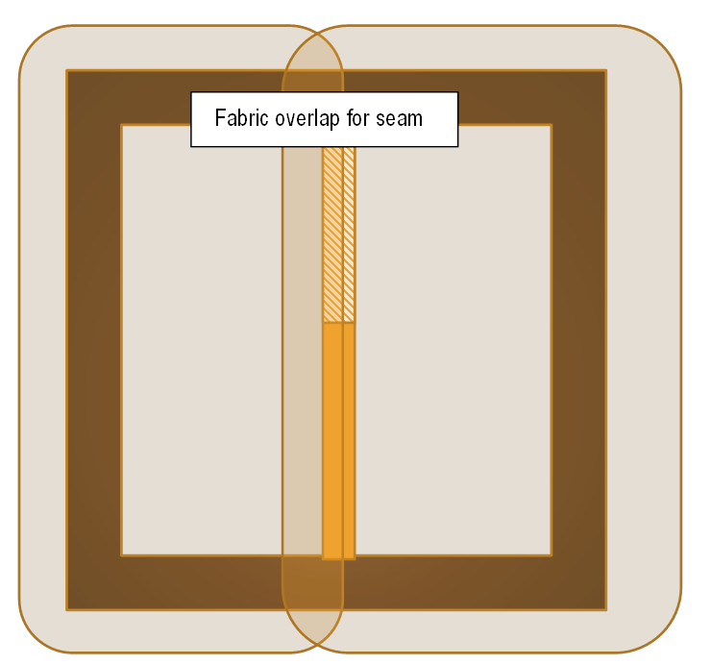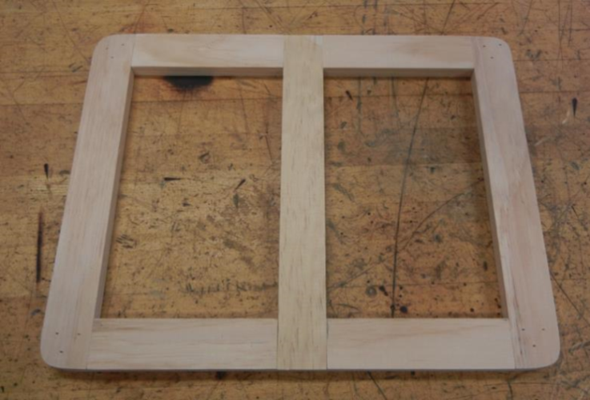
For production of a fabric system, a calibrated iron was used to shrink the fabric. In addition, the iron was calibrated each time it was used, at each temperature and for each system. This assured an accurate iron temperature throughout the entire construction process.
Fabric panels were prepared from five (5) fabric systems using standard industry practices. The systems evaluated were:
- Stewart system on Superflite fabric
- Superflite system on Superflite fabric
- Ceconite/Randolph system on Ceconite fabric with butyrate dope
- Ceconite/Randolph system on Ceconite fabric with nitrate dope
- Polyfiber system on Polyfiber fabric
None of the panels had a final UV or finish coat. The goal was to test the resin systems, fabric, and adhesives. The finish coats would provide a protective layer, interfering with the exposure assessment.
Exposure testing was performed using an industry standard exposure test which involved inverting a filled metal test can onto a cotton fiber cloth. Three (3) areas were exposed; a seam glued to structure, a seam unglued to structure, and an open flat area. At each timed test point, the cloths were lifted and the surface inspected for attack, discoloration, or other noted changes. A rub test was done with a clean, dry cotton fiber cloth to look for color transfer, indicating removal of the coating.
Timed test points were: 30 minutes, 60 minutes, 4 hours, 8 hours, 24 hours and 48 hours.
Specimens were cut from the three exposed areas; seam glued to structure, seam not glued, the soaked open area, as well as from an unexposed open area. Specimens were cut from the panel by supporting the fabric with a wooden insert placed behind the fabric surface and cutting the specimens using a metal straight edge and a razor cutter. For the specimens glued to the cross support, the fabric was cut with the razor cutter and then the wooden support piece with a vibrating cutter. Similar specimens were cut from a panel which had not been exposed at all. This data was used to monitor change in tensile properties. After the specimens were prepared each specimen was installed into the Instron UTS tensile tester and the tensile in pounds per square inch measured.

