Finally Rid of Those Magnetos
Installation of a EFII Electronic Ignition in a Velocity XL

Forward

Magnetos have always been a source of trouble in airplanes. My personal experience with them has them topping the list of mechanical problems I have had on multiple aircraft over many years. They are crude from the standpoint of engine operation in that they don’t adjust for operating conditions such as timing advance, temperature and atmospheric pressure. They suffer from the problems associated with mechanical wear, age, altitude and temperature. They can sometimes arc at high altitude. So why do we persist in continuing their use? Why the claim they are dependable and the best idea? That discussion is left to those that want to defend the old ways.

I lost yet another magneto to wear and arcing last year on my Lycoming IO540 engine in my Velocity XL. The company (Slick) that made the magneto no longer recommended rebuilding of the magneto. The only option was the replacement of the magneto with a new one. The decision (after much study) was to replace both magnetos with a dual electronic ignition. The system chosen was the EFii. Link: http://www.flyefii.com/

The system consists of two CPU/ignition modules, two pressure sensors, a coil block, spark plugs with adapters, spark plug wires, magnetic flywheel position sensors and associated wiring harness. The wiring harness is standard except for the length of the wires which are measured to fit the installation of the system. The wires are longer for a Velocity because the CPU/ignition modules were installed in the rear of the cabin. The link above provides very useful information as to the details of the installed system.

Installation

The installation requires that the power to the two CPU/ignition modules always be available. The power on my Velocity comes from the main battery, a 60-amp main alternator, a backup 20-amp alternator and a small essential battery that was added just for the electronic ignition system. This means that the power redundancy is 4 levels deep and the ignition electronics are two levels deep. This makes the installed system as redundant or more redundant than the magneto system in replaces.

The Velocity was built with the typical OFF-RIGHT-LEFT-BOTH-START key switch. It was decided to continue with the switch because of familiarity and panel space. The design of the ignition system requires that it behave is a safe fashion in the event of a single component failure. To that end, the relays have two sets of contacts and operate in the normally closed position. Two diodes in parallel supply the charge current to the essential battery.

The testing of the individual CPU/ignition modules is accomplished by switching off the power to each of the modules by moving to the RIGHT and LEFT positions on the ignition switch. The system is operated in the BOTH position. A button and panel light is used to test the level in the essential battery before engine start. The electronics are housed in a small box behind the co-pilot kick panel.

The following schematic was developed to power the electronic ignition system, implement the proper circuit breakers, charge the essential battery, test the essential battery and allow for the testing of the individual CPU/ignition modules:

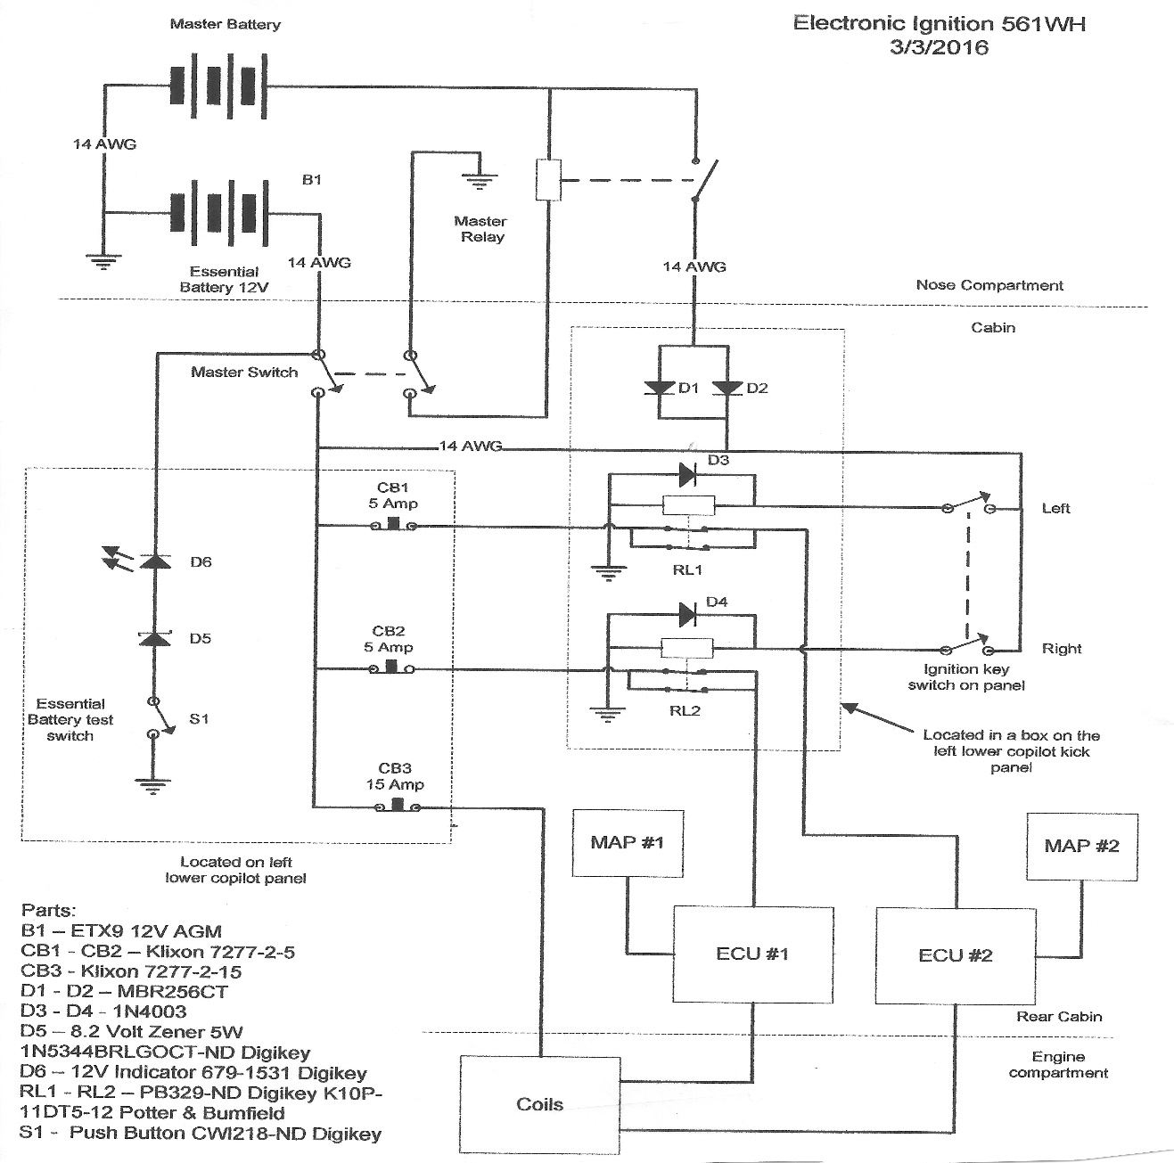

Two CPU/ignition modules and two MAP sensors are installed on the inside of the cabin on the rear firewall. Cables to the coil block and flywheel sensors penetrate to firewall near the modules.

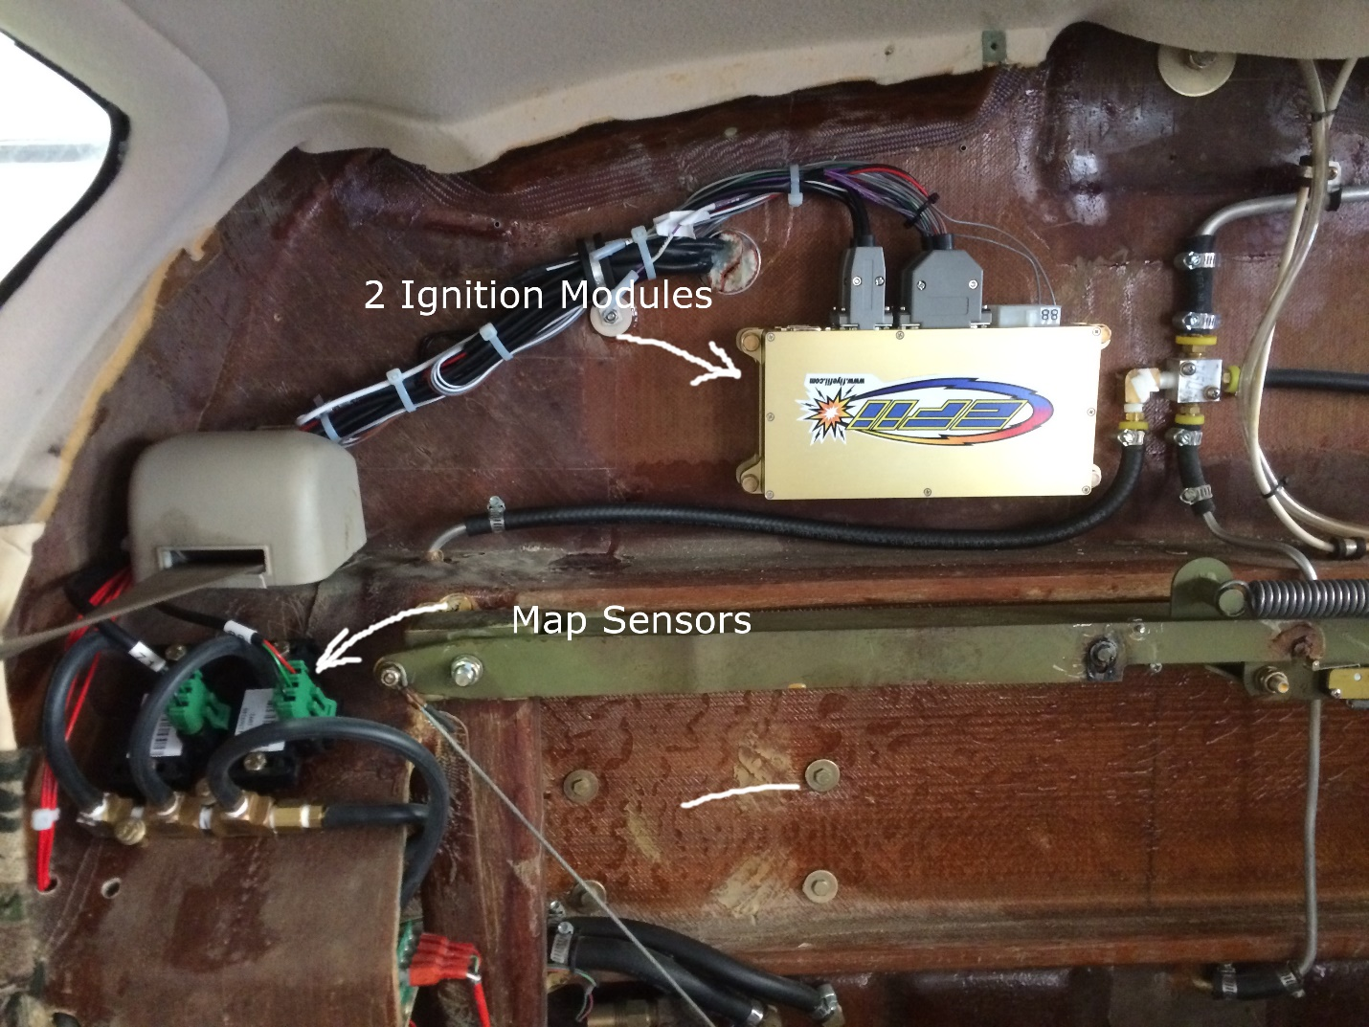Picture of inside rear firewall

The coil block is mounted on the top of the engine mount on an aluminum plate supplied by manufacturer. New plugs and wires are part of the installation. Wires are routed in the traditional fashion to the new spark plugs. Position sensors are mounted under the flywheel. The flywheel is sent to EFII to have the magnets installed.

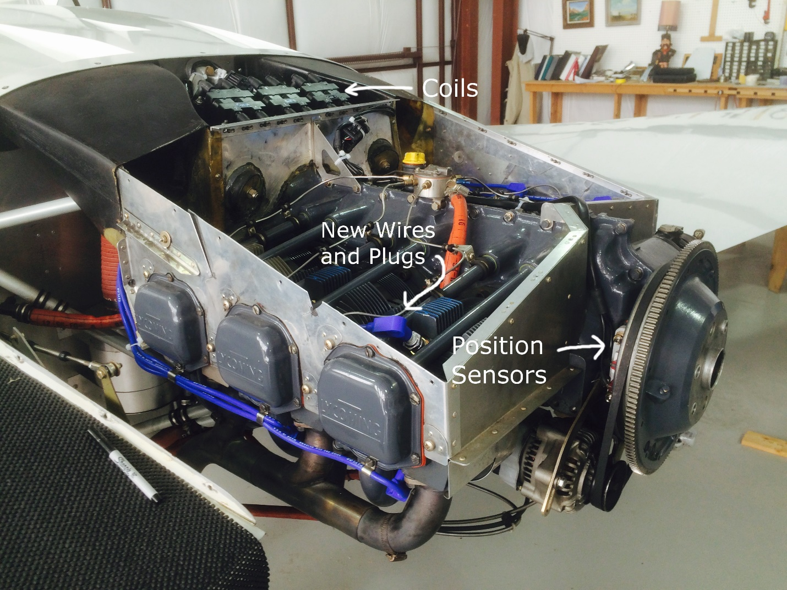
Picture of Engine compartment

Results

Something felt different when I test flew the new ignition system about a year ago. The airplane felt and sounded different. It was difficult to describe the difference. The airplane was developing full power. With an abundance of caution, I landed the airplane and inspected to installation. All appeared as described in the instructions. The flight testing continued with an eye to determining the difference. The next flight reveled the difference. The engine was running smoother than it ever did with the magnetos. This changed and feel of the airplane for the better.

Other improvements include evener EGTs, much easier hot and cold starts and increased power. I pulled the spark plugs during the current annual and found them clean. This removed the need to clean the plugs like was always be required with the magnetos using the massive electrode plugs. Timing of the magnetos is no longer required. The result is a simplified annual.

Overall the electronic ignition advanced my engine into the 1990s from the 1940s. I would advise that owners consider the advantages of a dual electronic ignition system over magnetos moving forward.

