More on the ICAO Flight Plans from Greg Haack, Signal Hill, CA: “Regarding the ICAO flight plan and the equipment descriptions there's a HELP document attached. The two biggest changes seem to be for the navigation equipment and the ADSB equipment. For those who have upgraded they can usually get the appropriate suffixes from the equipment manual(s) or by contacting the manufacturer's support group. My airplane now has a rather long list of suffixes that describe its capabilities. Those would be included in the OTHER INFORMATION box.

For a "typical" canard airplane that has a navcom the info to put in the AIRCRAFT EQUIPMENT box is "S" for standard VOR/ILS.
For a "typcial" canard that has a transponder with altitude encoder, in the SURVEILLANCE EQUIPMENT box put "C" for modes A and C.

I also have a number of slides from a LEIDOS webinar I joined several months ago that I'll attach that should provide more explanation. If you file flight plans with LEIDOS (i.e. 1-800-WXBRIEF) most of the flight plan can be filled in using drop down boxes that provide some guidance. There's also information on the LEIDOS website (1800WXBRIEF.COM).”
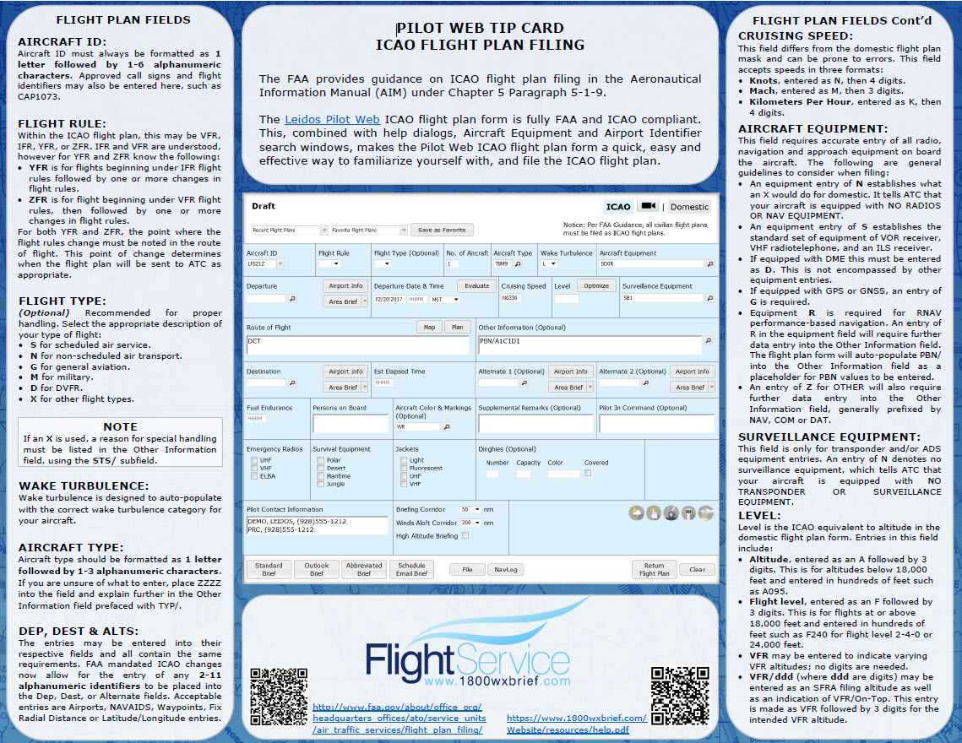
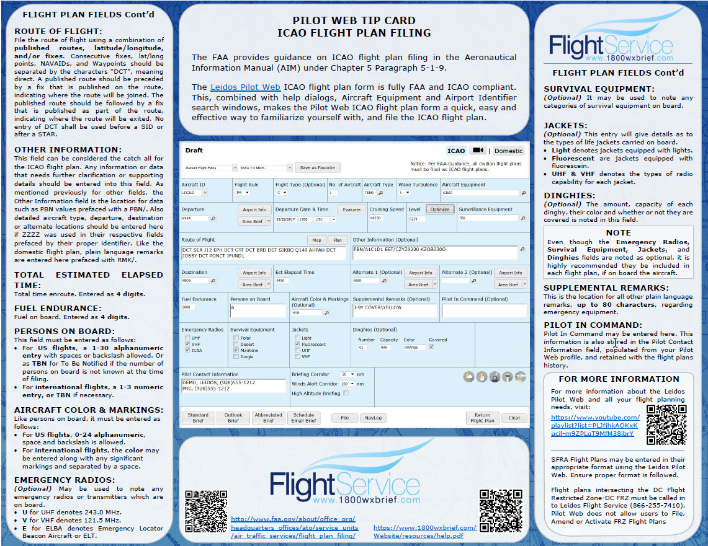
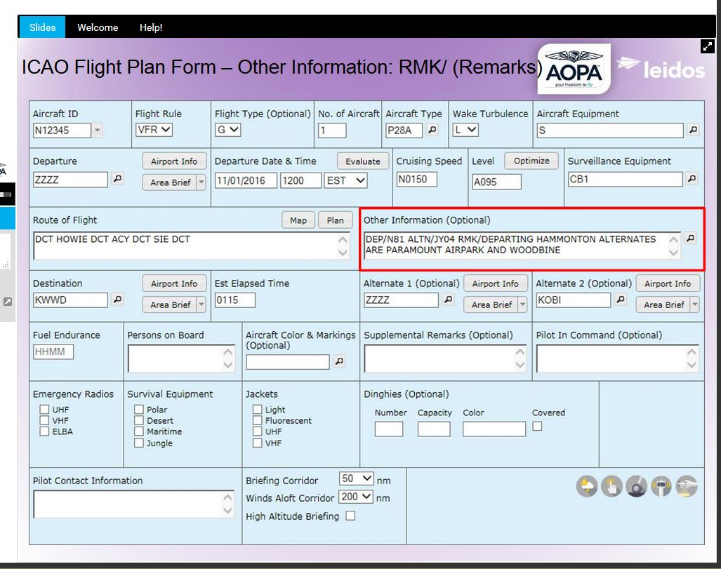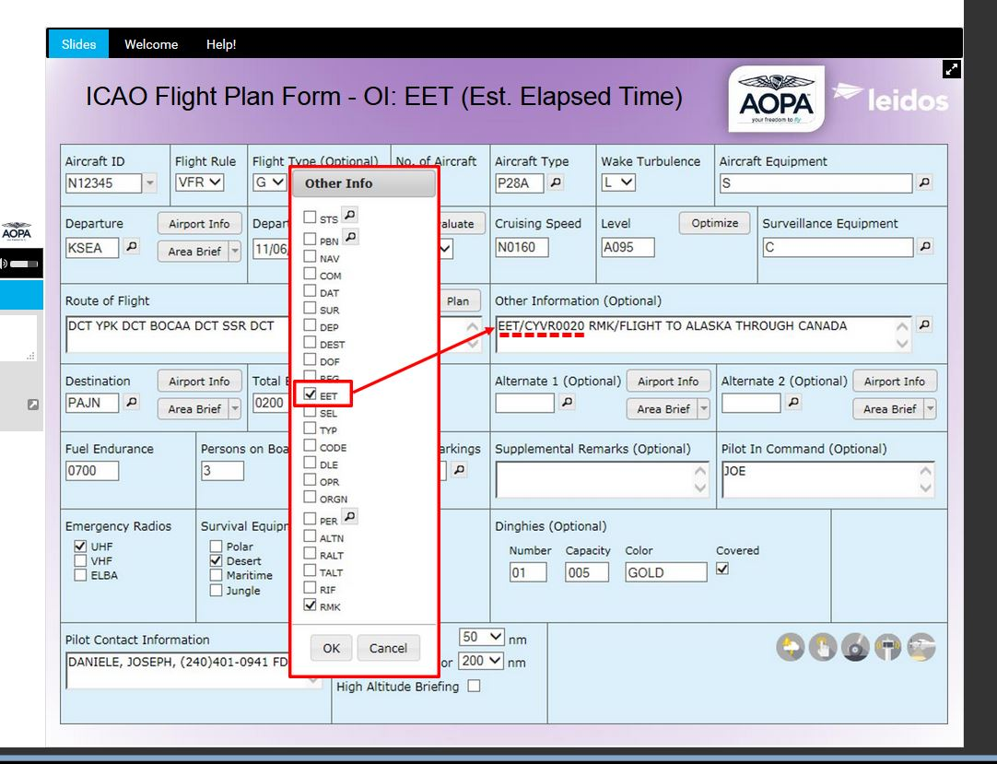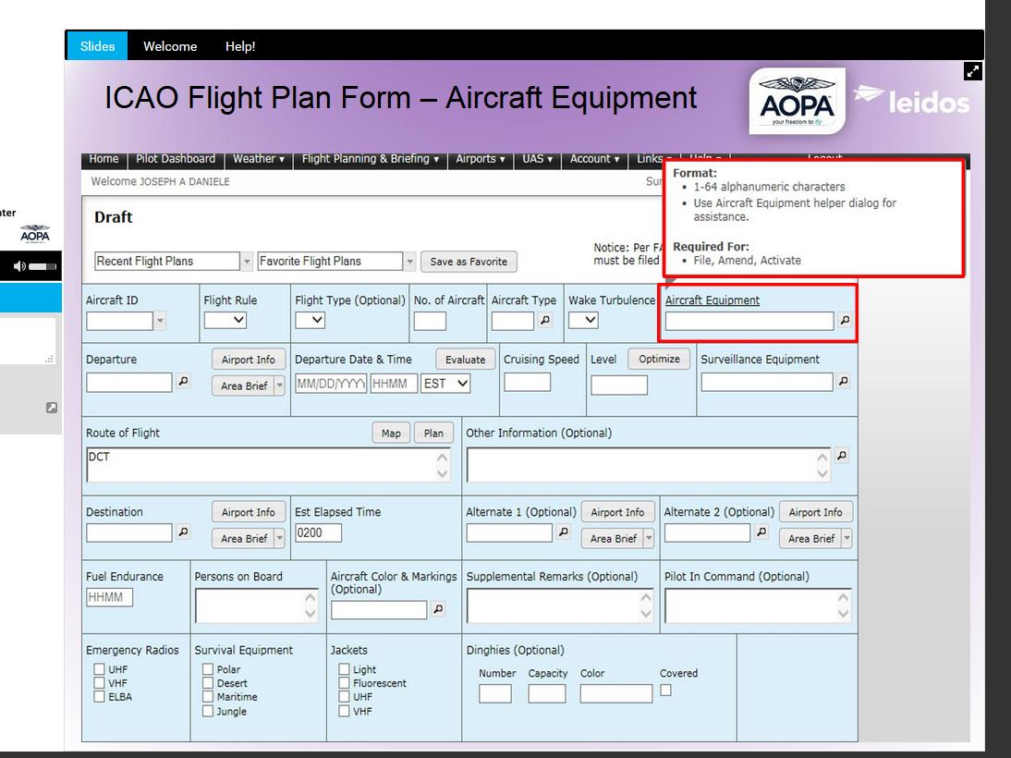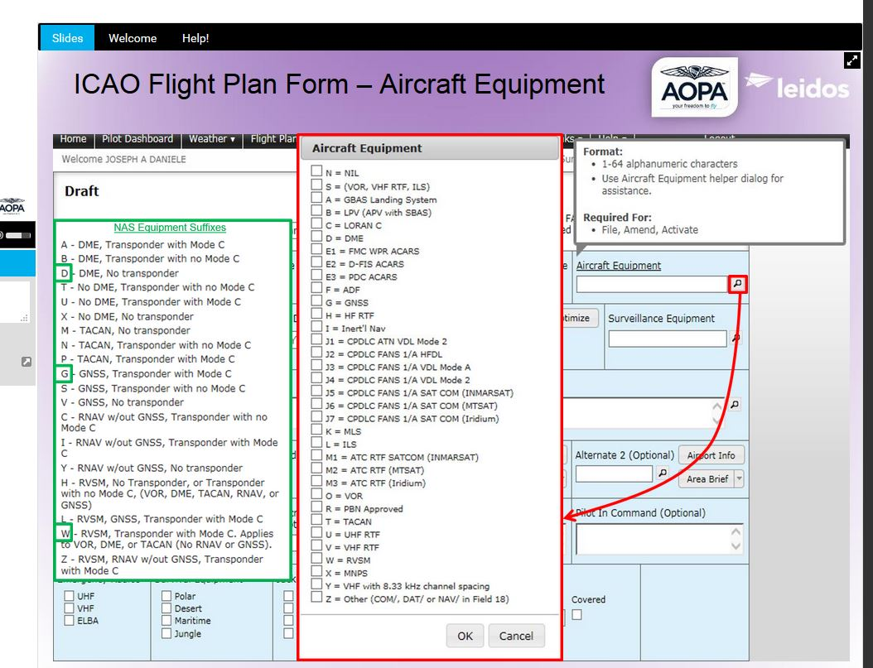
- 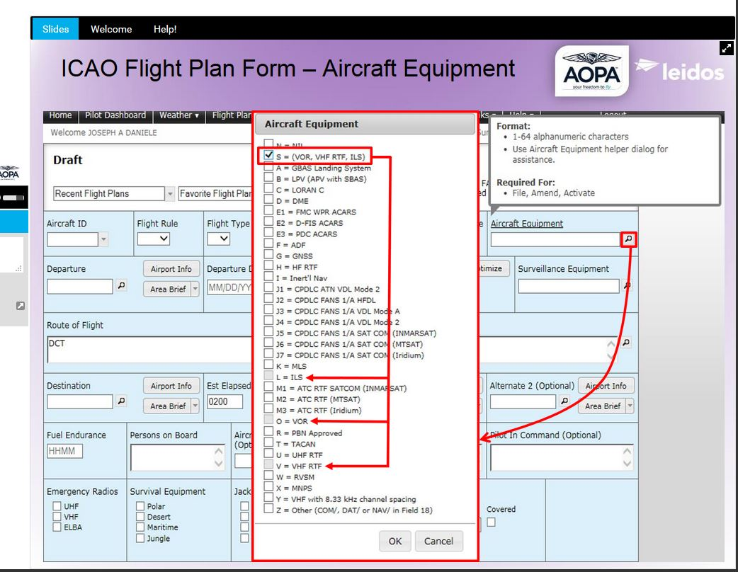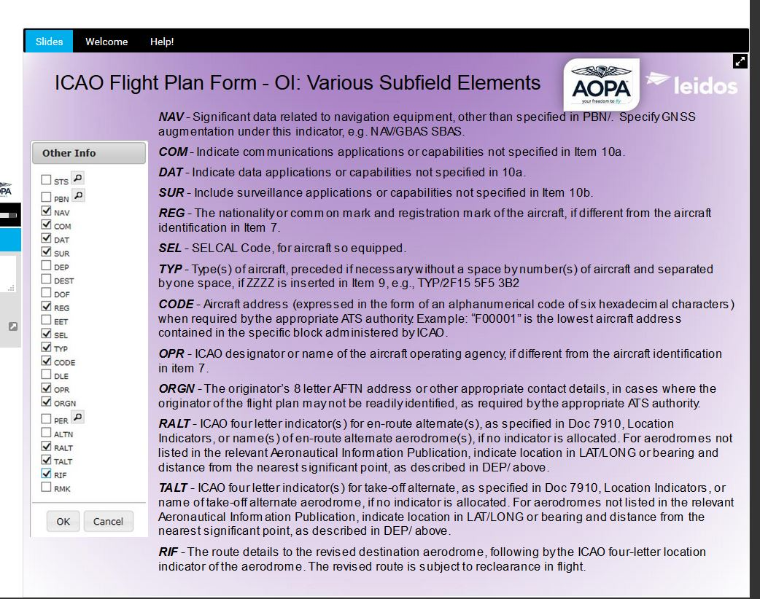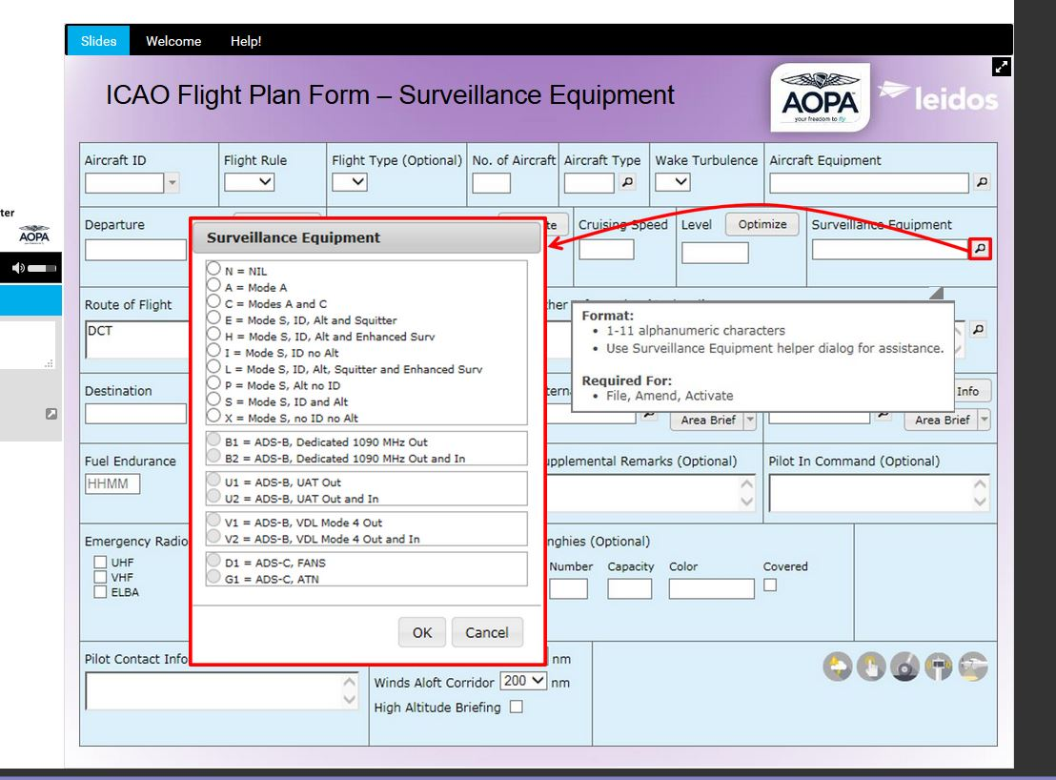Article
- Edit
- Discuss
Edit Article

How to File a VFR Flight Plan in Canada
A flight plan describes a trip an airplane will go on. The completion of a flight plan is simply a matter of inserting information into the appropriate spots on a form then relaying the message on to the appropriate FIC (Flight Information Center). This set of instructions describes how to file a VFR (Visual Flight Rules) flight plan in Canada or from flights from Canada to the United States.

Steps

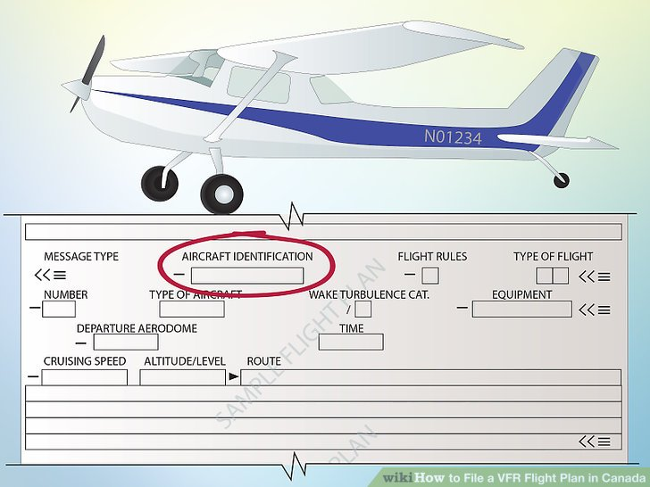
<img alt="Image titled File a VFR Flight Plan in Canada Step 1" src="https://www.wikihow.com/images/thumb/6/66/File-a-VFR-Flight-Plan-in-Canada-Step-1.jpg/aid692677-v4-728px-File-a-VFR-Flight-Plan-in-Canada-Step-1.jpg" width="728" height="546" class="whcdn content-fill" onload="WH.performance.clearMarks('image1_rendered'); WH.performance.mark('image1_rendered');">
1
The aircraft identification (aircraft registration) you will find this on the side of the aircraft

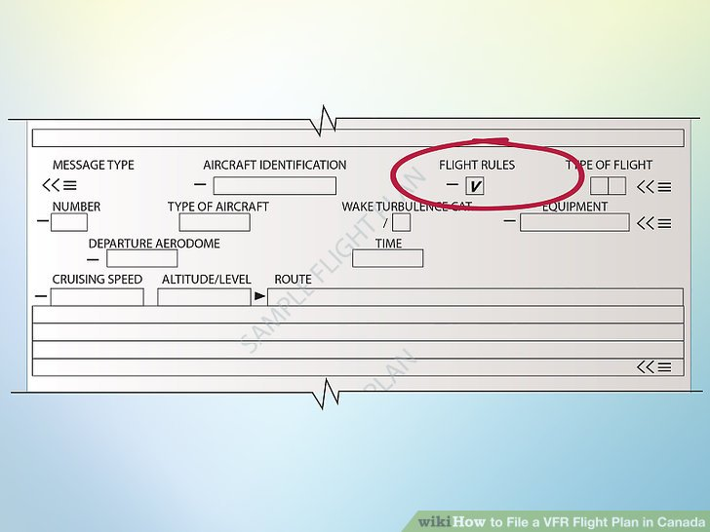
<img alt="Image titled File a VFR Flight Plan in Canada Step 2" src="https://www.wikihow.com/images/thumb/6/63/File-a-VFR-Flight-Plan-in-Canada-Step-2.jpg/aid692677-v4-728px-File-a-VFR-Flight-Plan-in-Canada-Step-2.jpg" width="728" height="546" class="whcdn content-fill">
2
Flight rules select VFR by placing a v in the box
  - I for IFR

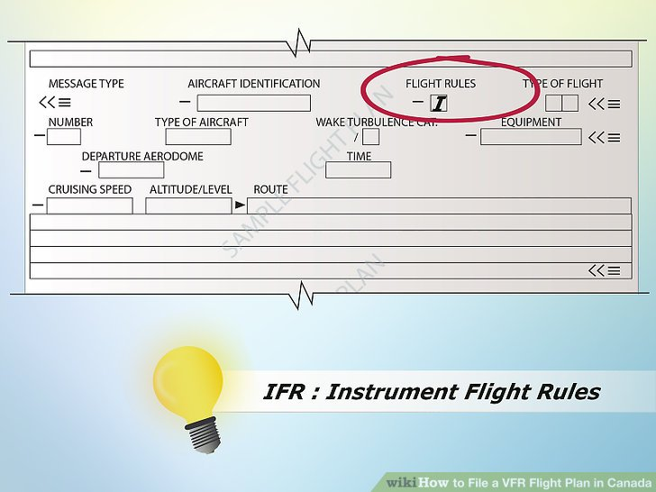
<img alt="Image titled File a VFR Flight Plan in Canada Step 2Bullet1" src="https://www.wikihow.com/images/thumb/4/45/File-a-VFR-Flight-Plan-in-Canada-Step-2Bullet1.jpg/aid692677-v4-728px-File-a-VFR-Flight-Plan-in-Canada-Step-2Bullet1.jpg" width="728" height="546" class="whcdn content-fill">
  - V for VFR

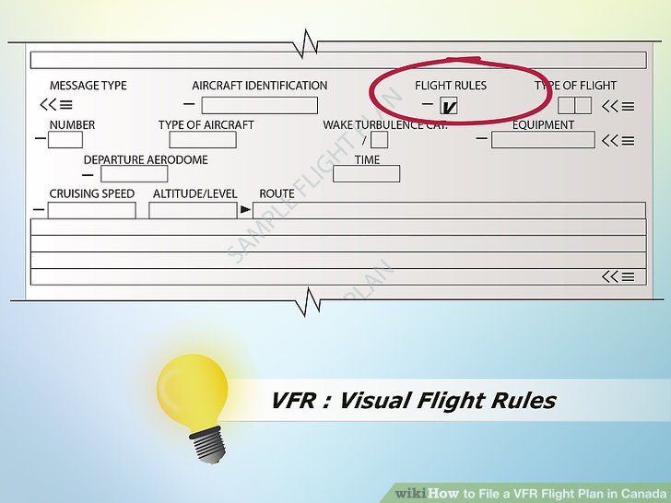
<img alt="Image titled File a VFR Flight Plan in Canada Step 2Bullet2" src="https://www.wikihow.com/images/thumb/5/5d/File-a-VFR-Flight-Plan-in-Canada-Step-2Bullet2.jpg/aid692677-v4-728px-File-a-VFR-Flight-Plan-in-Canada-Step-2Bullet2.jpg" width="728" height="546" class="whcdn content-fill">
  - Y for IFR first, then VFR
  - Z for VFR first, then IFR

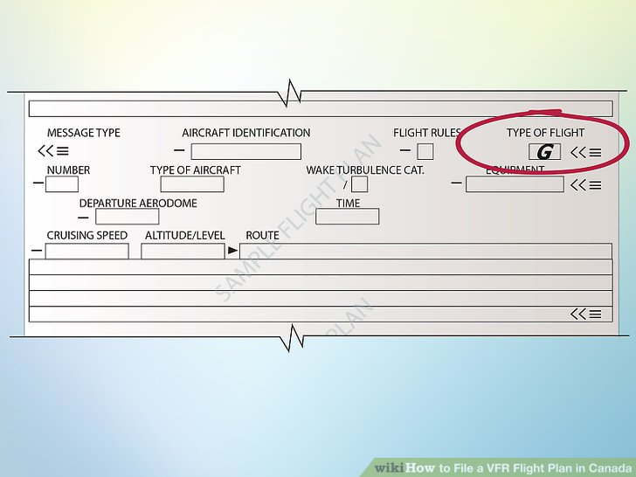
<img alt="Image titled File a VFR Flight Plan in Canada Step 3" src="https://www.wikihow.com/images/thumb/f/f7/File-a-VFR-Flight-Plan-in-Canada-Step-3.jpg/aid692677-v4-728px-File-a-VFR-Flight-Plan-in-Canada-Step-3.jpg" width="728" height="546" class="whcdn content-fill">
3
Type of flight place a g in the box
  - S for Scheduled Air Service
  - N for Non-scheduled Air Transport Operation
  - G for General Aviation
  - M for Military
  - X for other than the preceding categories

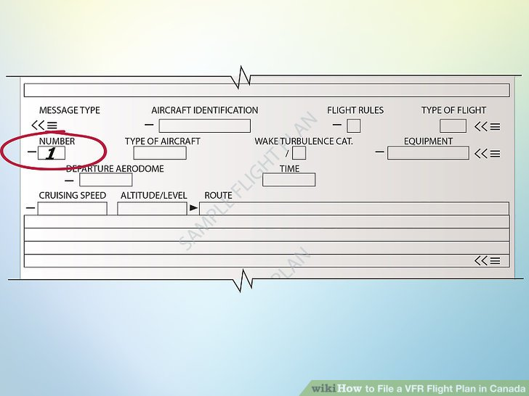
<img alt="Image titled File a VFR Flight Plan in Canada Step 4" src="https://www.wikihow.com/images/thumb/c/c2/File-a-VFR-Flight-Plan-in-Canada-Step-4.jpg/aid692677-v4-728px-File-a-VFR-Flight-Plan-in-Canada-Step-4.jpg" width="728" height="546" class="whcdn content-fill">
4
Number of aircraft select one unless you are completing a flight plan for more than one plane

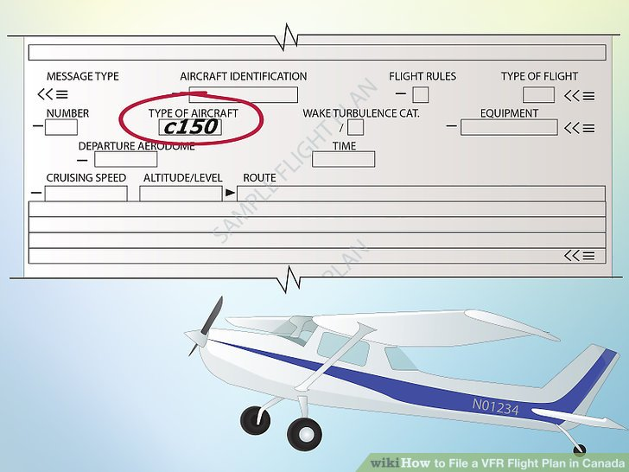
<img alt="Image titled File a VFR Flight Plan in Canada Step 5" src="https://www.wikihow.com/images/thumb/d/df/File-a-VFR-Flight-Plan-in-Canada-Step-5.jpg/aid692677-v4-728px-File-a-VFR-Flight-Plan-in-Canada-Step-5.jpg" width="728" height="546" class="whcdn content-fill">
5
Type of aircraft record the type of aircraft completing the flight ex. c150 (Cessna 150)

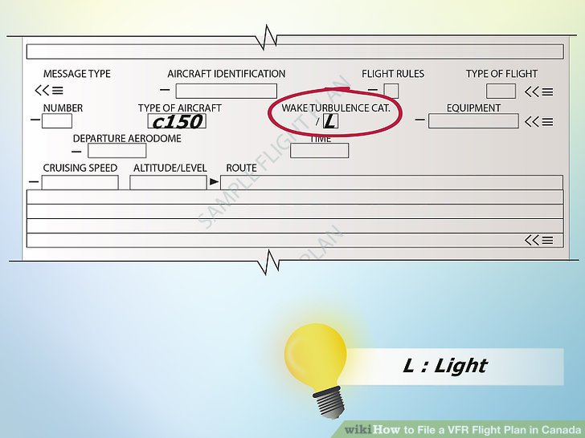
<img alt="Image titled File a VFR Flight Plan in Canada Step 6" src="https://www.wikihow.com/images/thumb/f/f6/File-a-VFR-Flight-Plan-in-Canada-Step-6.jpg/aid692677-v4-728px-File-a-VFR-Flight-Plan-in-Canada-Step-6.jpg" width="728" height="546" class="whcdn content-fill">
6
Wake turbulence select the one which applies for a C150 select L
  - H – HEAVY, to indicate an aircraft type with a maximum certified takeoff mass of 136 000 kg (300 000 lbs) or more.

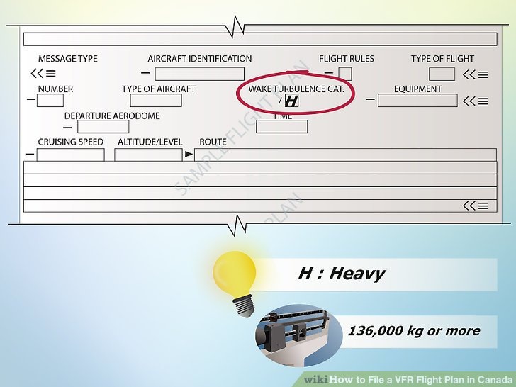
<img alt="Image titled File a VFR Flight Plan in Canada Step 6Bullet1" src="https://www.wikihow.com/images/thumb/7/7e/File-a-VFR-Flight-Plan-in-Canada-Step-6Bullet1.jpg/aid692677-v4-728px-File-a-VFR-Flight-Plan-in-Canada-Step-6Bullet1.jpg" width="728" height="546" class="whcdn content-fill">
  - M – MEDIUM, to indicate an aircraft type with a maximum certified takeoff mass of less than 136 000 kg (300 000 lbs), but more than 7 000 kg (15 500 lbs).

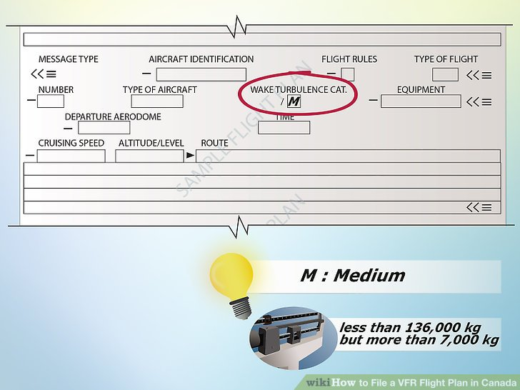
<img alt="Image titled File a VFR Flight Plan in Canada Step 6Bullet2" src="https://www.wikihow.com/images/thumb/b/b5/File-a-VFR-Flight-Plan-in-Canada-Step-6Bullet2.jpg/aid692677-v4-728px-File-a-VFR-Flight-Plan-in-Canada-Step-6Bullet2.jpg" width="728" height="546" class="whcdn content-fill">
  - L – LIGHT, to indicate an aircraft type with a maximum certified takeoff mass of 7 000 kg (15 500 lbs) or less

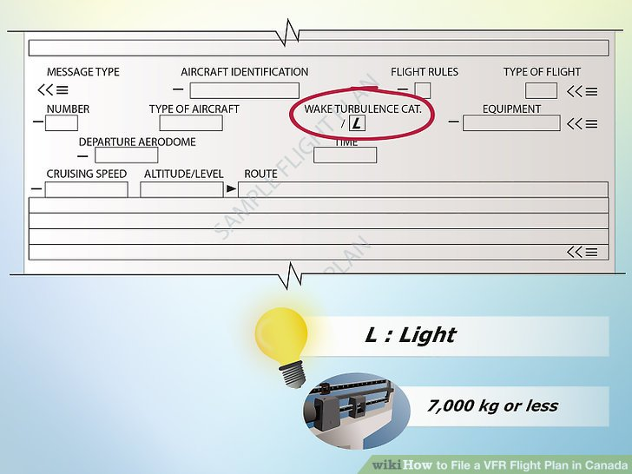
<img alt="Image titled File a VFR Flight Plan in Canada Step 6Bullet3" src="https://www.wikihow.com/images/thumb/a/a4/File-a-VFR-Flight-Plan-in-Canada-Step-6Bullet3.jpg/aid692677-v4-728px-File-a-VFR-Flight-Plan-in-Canada-Step-6Bullet3.jpg" width="728" height="546" class="whcdn content-fill">

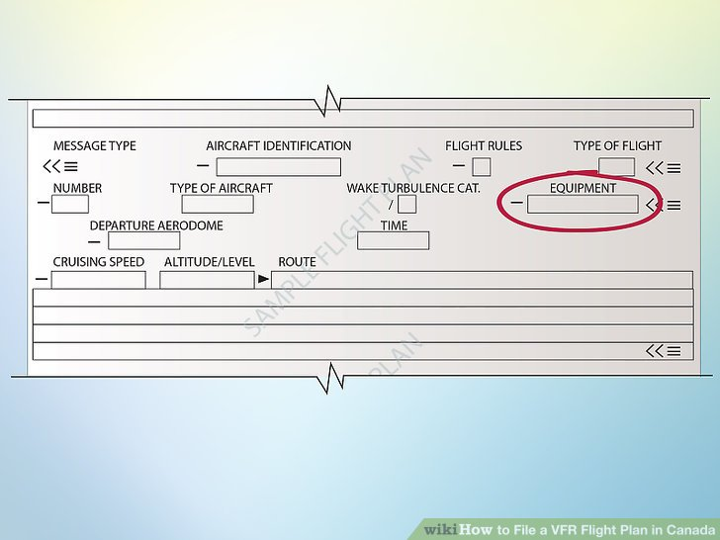
<img alt="Image titled File a VFR Flight Plan in Canada Step 7" src="https://www.wikihow.com/images/thumb/b/b3/File-a-VFR-Flight-Plan-in-Canada-Step-7.jpg/aid692677-v4-728px-File-a-VFR-Flight-Plan-in-Canada-Step-7.jpg" width="728" height="546" class="whcdn content-fill">
7
Equipment select all which apply (you can find this information from the plane
  - I INS
  - R RNP type certification
  - J Data Link `
  - T TACAN
  - C LORAN C
  - K MLS
  - U UHF
  - D DME
  - L ILS
  - V VHF
  - W RVSM certification
  - F ADF
  - O VOR
  - X MNPS certification
  - G GNSS
  - Y CMNPS certification
  - H HF RTF
  - Z Other equipment carried

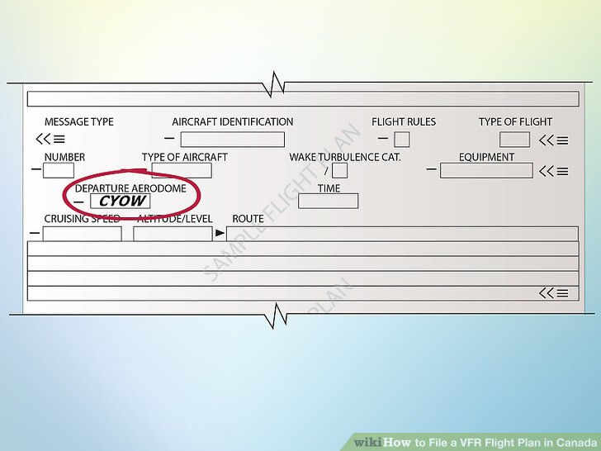
<img alt="Image titled File a VFR Flight Plan in Canada Step 8" src="https://www.wikihow.com/images/thumb/7/7f/File-a-VFR-Flight-Plan-in-Canada-Step-8.jpg/aid692677-v4-728px-File-a-VFR-Flight-Plan-in-Canada-Step-8.jpg" width="728" height="546" class="whcdn content-fill">
8
Departure aerodrome use location indicators for aerodrome found in the CFS (Canada Flight Supplement) ex. CYOW

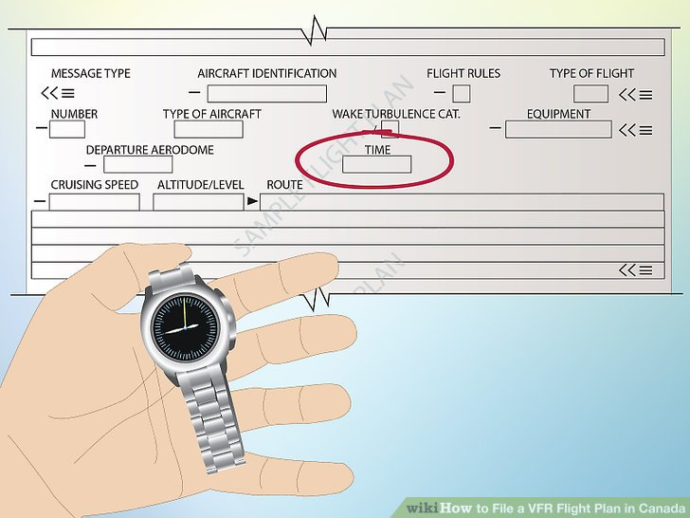
<img alt="Image titled File a VFR Flight Plan in Canada Step 9" src="https://www.wikihow.com/images/thumb/9/9c/File-a-VFR-Flight-Plan-in-Canada-Step-9.jpg/aid692677-v4-728px-File-a-VFR-Flight-Plan-in-Canada-Step-9.jpg" width="728" height="546" class="whcdn content-fill">
9
Time this is the time you are departing in UTC

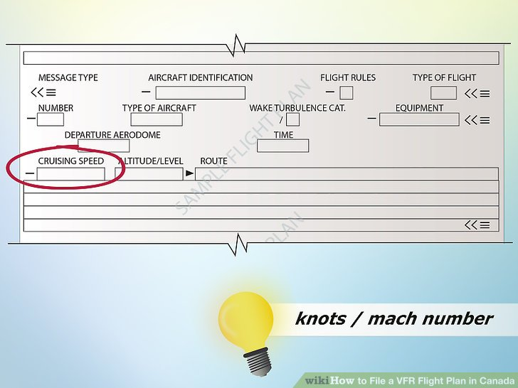
<img alt="Image titled File a VFR Flight Plan in Canada Step 10" src="https://www.wikihow.com/images/thumb/f/ff/File-a-VFR-Flight-Plan-in-Canada-Step-10.jpg/aid692677-v4-728px-File-a-VFR-Flight-Plan-in-Canada-Step-10.jpg" width="728" height="546" class="whcdn content-fill">
10
Cruising speed determine your cruising speed then enter it in knots or as a mach number

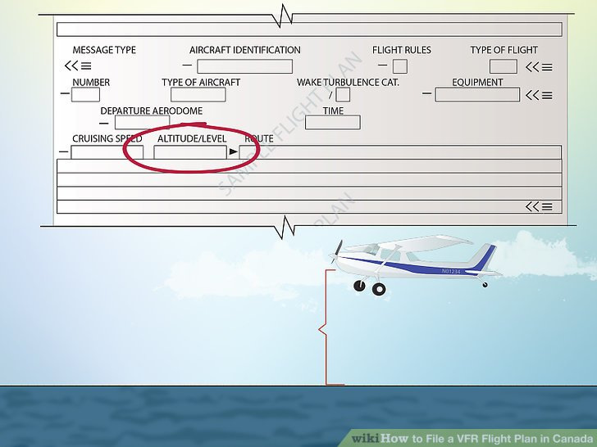
<img alt="Image titled File a VFR Flight Plan in Canada Step 11" src="https://www.wikihow.com/images/thumb/b/b3/File-a-VFR-Flight-Plan-in-Canada-Step-11.jpg/aid692677-v4-728px-File-a-VFR-Flight-Plan-in-Canada-Step-11.jpg" width="728" height="546" class="whcdn content-fill">
11
Altitude record in ASL (height above sea level)

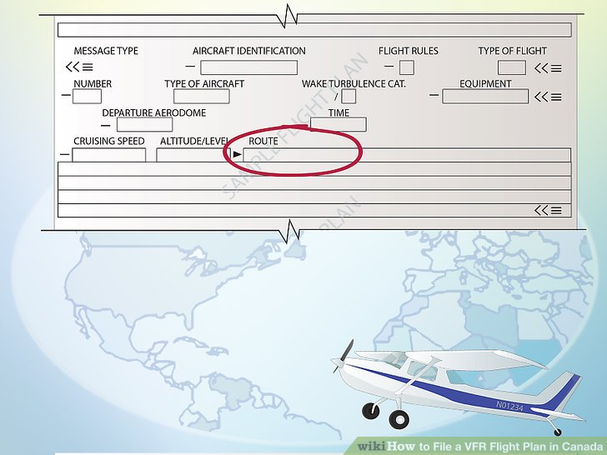
<img alt="Image titled File a VFR Flight Plan in Canada Step 12" src="https://www.wikihow.com/images/thumb/4/43/File-a-VFR-Flight-Plan-in-Canada-Step-12.jpg/aid692677-v4-728px-File-a-VFR-Flight-Plan-in-Canada-Step-12.jpg" width="728" height="546" class="whcdn content-fill">
12
Route this is very important for search and rescue you must fill in the identifying letters for the aerodromes on your route. This will let people know were you are going.

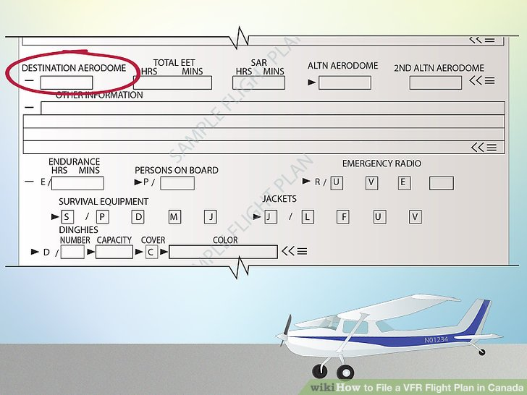
<img alt="Image titled File a VFR Flight Plan in Canada Step 13" src="https://www.wikihow.com/images/thumb/4/41/File-a-VFR-Flight-Plan-in-Canada-Step-13.jpg/aid692677-v4-728px-File-a-VFR-Flight-Plan-in-Canada-Step-13.jpg" width="728" height="546" class="whcdn content-fill">
13
Destination aerodrome this is your destination or were you want to end up

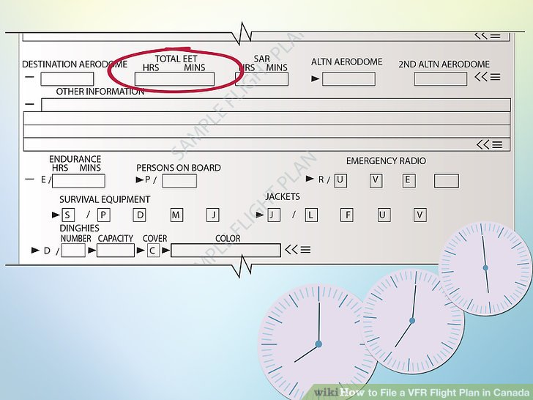
<img alt="Image titled File a VFR Flight Plan in Canada Step 14" src="https://www.wikihow.com/images/thumb/9/9d/File-a-VFR-Flight-Plan-in-Canada-Step-14.jpg/aid692677-v4-728px-File-a-VFR-Flight-Plan-in-Canada-Step-14.jpg" width="728" height="546" class="whcdn content-fill">
14
Total EET (estimated elapsed time) fill in using numbers deduced from your pre flight calculations

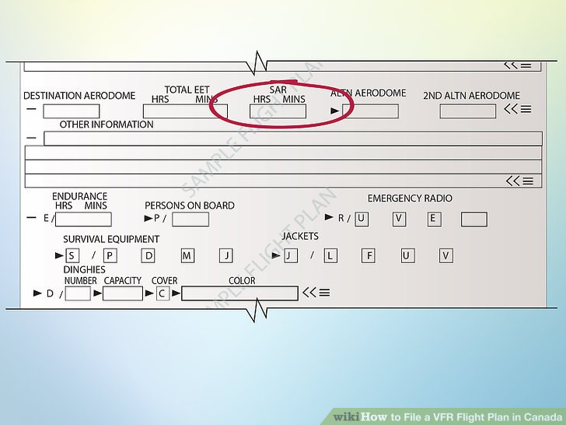
<img alt="Image titled File a VFR Flight Plan in Canada Step 15" src="https://www.wikihow.com/images/thumb/f/fe/File-a-VFR-Flight-Plan-in-Canada-Step-15.jpg/aid692677-v4-728px-File-a-VFR-Flight-Plan-in-Canada-Step-15.jpg" width="728" height="546" class="whcdn content-fill">
15
SAR this is the amount of time from when your EET expires to when you must close the flight plan. If the flight plan is not closed search and rescue will come looking for you.
- 16
Note* must not be more than 24 hours from total EET

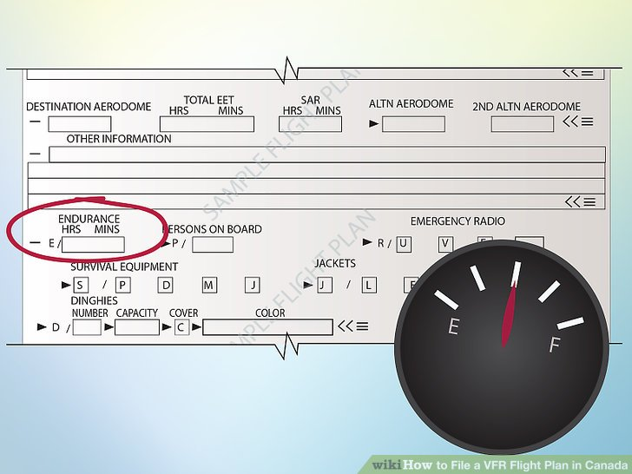
<img alt="Image titled File a VFR Flight Plan in Canada Step 17" src="https://www.wikihow.com/images/thumb/9/92/File-a-VFR-Flight-Plan-in-Canada-Step-17.jpg/aid692677-v4-728px-File-a-VFR-Flight-Plan-in-Canada-Step-17.jpg" width="728" height="546" class="whcdn content-fill">
17
Endurance is the amount of time the airplane can stay airborne found from fuel on board and the amount of fuel burn

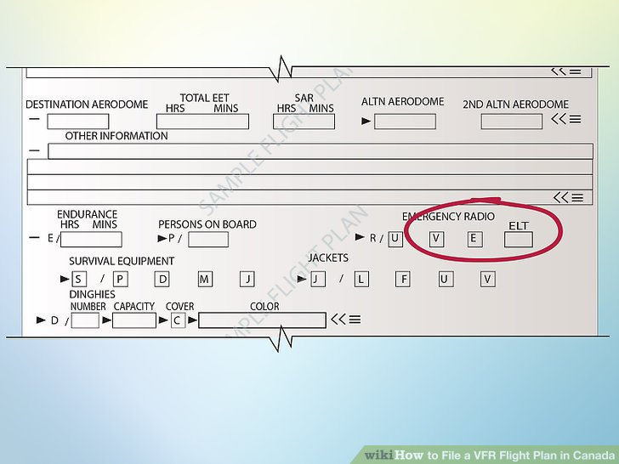
<img alt="Image titled File a VFR Flight Plan in Canada Step 18" src="https://www.wikihow.com/images/thumb/a/ad/File-a-VFR-Flight-Plan-in-Canada-Step-18.jpg/aid692677-v4-728px-File-a-VFR-Flight-Plan-in-Canada-Step-18.jpg" width="728" height="546" class="whcdn content-fill">
18
ELT what kind of ELT is on board
  - A or AD = automatic ejectable or automatic deployable
  - F or AF = fixed or automatic fixed
  - AP = automatic portable
  - P = Personal
  - W or S = Water activated or Survival

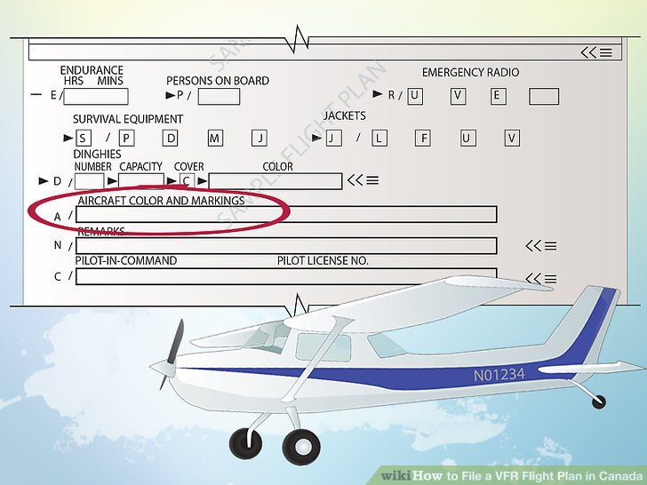
<img alt="Image titled File a VFR Flight Plan in Canada Step 19" src="https://www.wikihow.com/images/thumb/a/ae/File-a-VFR-Flight-Plan-in-Canada-Step-19.jpg/aid692677-v4-728px-File-a-VFR-Flight-Plan-in-Canada-Step-19.jpg" width="728" height="546" class="whcdn content-fill">
19
Aircraft colors and markings, what the plane looks like and any distinct markings ex. pink tail

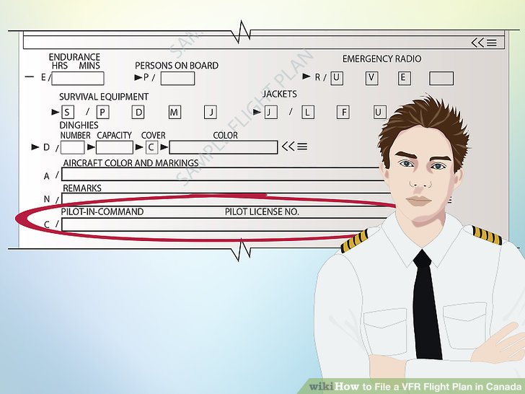
<img alt="Image titled File a VFR Flight Plan in Canada Step 20" src="https://www.wikihow.com/images/thumb/0/02/File-a-VFR-Flight-Plan-in-Canada-Step-20.jpg/aid692677-v4-728px-File-a-VFR-Flight-Plan-in-Canada-Step-20.jpg" width="728" height="546" class="whcdn content-fill">
20
Pilot in command and pilots licence number, who is flying the plane and their licence number

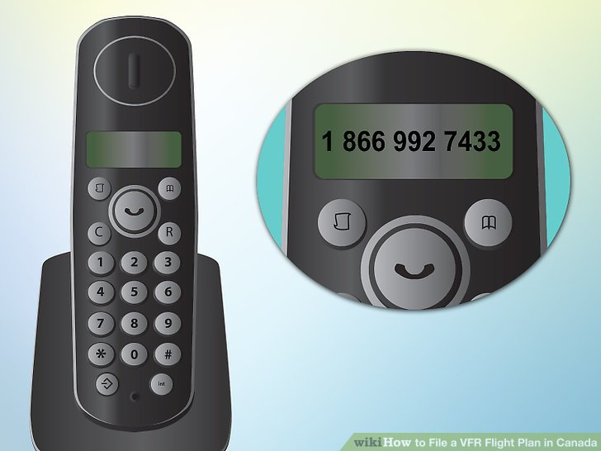
<img alt="Image titled File a VFR Flight Plan in Canada Step 21" src="https://www.wikihow.com/images/thumb/f/ff/File-a-VFR-Flight-Plan-in-Canada-Step-21.jpg/aid692677-v4-728px-File-a-VFR-Flight-Plan-in-Canada-Step-21.jpg" width="728" height="546" class="whcdn content-fill">
21
Call 1 866 992 7433 talk to person

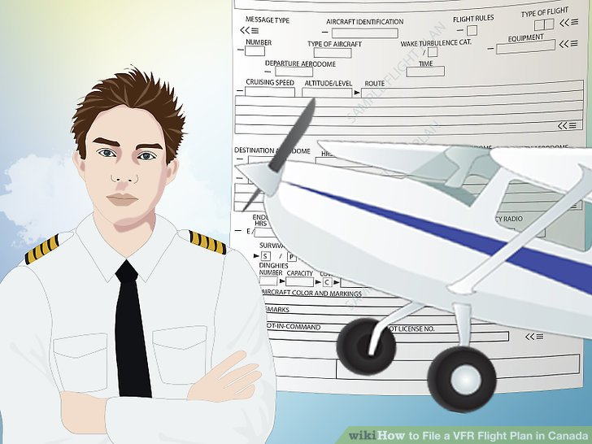
<img alt="Image titled File a VFR Flight Plan in Canada Step 22" src="https://www.wikihow.com/images/thumb/f/fc/File-a-VFR-Flight-Plan-in-Canada-Step-22.jpg/aid692677-v4-728px-File-a-VFR-Flight-Plan-in-Canada-Step-22.jpg" width="728" height="546" class="whcdn content-fill">
22
Go flying

You're helping people by reading wikiHow
wikiHow's mission is to help people learn, and we really hope this article helped you. Now you are helping others, just by visiting wikiHow.
826 National is the largest nonprofit youth writing network in the country. 826 encourages under-resourced students to ignite their creativity, explore identity, advocate for themselves and their community, and achieve academic and professional success - all through the transformative power of writing.
Click below to let us know you read this article, and wikiHow will donate to 826 National on your behalf. Thanks for helping us achieve our mission of helping people learn how to do anything.

Yes, I read the article

Community Q&A

Add New Question
- Is there a faster way to do this?
wikiHow Contributor
You could file a flight itinerary. This means that you tell a responsible person where you're going, what you're doing, the color/registration of your plane and finally what time you'll land. If they do not hear from you 24 hours after your landing time, then they contact SAR. This is only for flights inside of Canada.

YesNo
Not Helpful 0 Helpful 2
- How do I close the flight plan?
wikiHow Contributor
Just call NavCanada to inform that you've landed safely. Remember, if you don't, they will send the SAR, which will cost you a lot!

YesNo
Not Helpful 0 Helpful 1
Ask a Question

Submit

Tips
- You can ask ATC(air traffic control) to file the flight plan or close it
- You can file this plan over the radio or by phone

Warnings
- REMEMBER TO CLOSE YOUR FLIGHT PLAN if you forget and a search and rescue mission is launched you will have a large fine to pay

EditRelated wikiHows

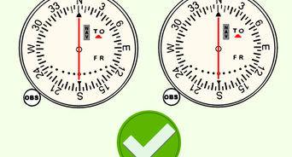
<img>

How to
Navigate Using a VOR

<img>

How to
Fly a Holding Pattern

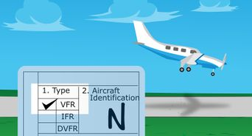
<img>

How to
File an FAA Flight Plan

<img>

How to
Communicate with an Air Traffic Control Tower

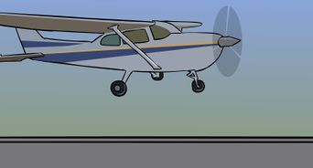
<img>

How to
Takeoff and Land on a Short Runway

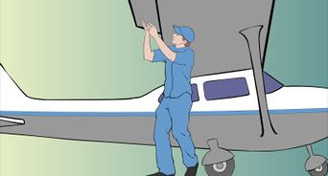
<img>

How to
Pre Flight an Aircraft

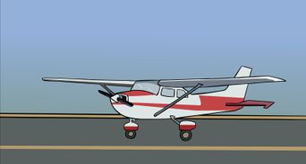
<img>

How to
Takeoff and Land on a Soft Runway

<img>

How to
Navigate in Flight Using an Automatic Direction Finder

Article Info
Categories: Flight Phases
- Print
- Edit
- Send fan mail to authors
Thanks to all authors for creating a page that has been read 21,758 times.
Did this article help you?
Yes No

