Picture of the Month:
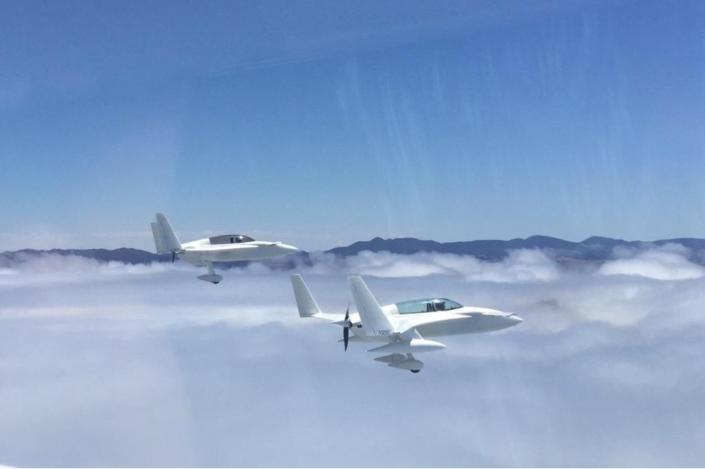
Eric cobb

FAA Developments:
Ric Lee supplied this video to show the power of Windy – an amazing planning tool:
https://pilotworkshop.us17.list-manage.com/track/click?u=5146209990d253add0ccf45ba&id=a73403e6ba&e=5f908e6675

Dick Rutan supplied this recent Slick Magneto Service bulletin SB1-19 for Impulse Coupling Magnetos : “The following magneto models with serial numbers between 16010001 and 18050664: 4301, 4303, 4316, 4330, 4333, 4346, 4354, 4371, 4372, 4373, 4374, 4381, 4392, 6310, 6314, 6320, 6324, 6331, 6351, 6352, 6355, 6361, 6362, 6364, 6367, 6377, 6379, 6380, 6382, 6399 NOTE: 16010001 = SN manufacture date of January 2016 and 18050664 = SN manufacture date of May 2018.”
I would log the fact that your mags were mfg before that date and cite the SB or list the actual serial numbers, if true. If you have a very new Slick mag with the 16 to 18 million part numbers, I have the full Service Bulletin as library item: 23MS80

“There have been limited reports in which impulse coupling stop pins have moved relative to the factory placement within the magneto frame of Slick magnetos. There has been one report of a liberated stop pin. A liberated stop pin could potentially enter the gear train of the engine, resulting in damage to the gear train, damage to engine accessories and could ultimately cause catastrophic engine failure. Inspect affected magneto models for movement of impulse coupling stop pin at the next convenient maintenance interval, not to exceed the next 100 hours or 400 hours Time in Service (TIS), and every 500 hours thereafter. Alternatively, replace the affected magneto with an approved model magneto, outside the above serial number range, or compliant with the SB1-19 dimensions herein for the stop pin. Document service bulletin compliance as written entry in the applicable Aircraft and/or Engine logbook.”

Rick Lee, Sandy, UT added this kicker: “I believe this happened to me in 2018. Replaced our left mag early in 2018 and had it destroy the gear train in 67 hours since new. Had to rebuild the entire engine. Right one was about to go as well.”

All this brings on the topic of type of electronic ignition and whether you go for one electronic ignition or two. Ignoring the fact that mags go bad quite regularly and should be changed out at 500 hours, it was Klaus Savier’s suggestion that engine failure due to magneto failure is a noticeable share of engine failures (meaning forced landings in singles, non-practice single engine landing in twins). So if you plug another mechanical thing into the accessory case – as some of these ignitions are, you are reintroducing a source of engine failures that the non-accessory case driven electronic ignitions don’t have. I asked Klaus about his Hall Effect sensors which fit in a Magneto hole. “First there are no impulse coupling parts to fall into the engine and second, because I was aware of the occasional shaft failure on magnetos, we used Boeing landing gear steel to make the shafts from. 17-4 SS is then hardened and precision ground. The latest batch even has a Ti coating for better seal wear. This is all very expensive but as a result we had zero shaft or bearing failures on almost 2000 Hall Effect modules over 20 years. I rescinded the need for bearing inspection in the manual as well.”

RUTAN TIME:

To the topic of a Variviggen going to the Smithsonian, Burt commented: “Nice. The EAA museum has the prototype VV. I flew it to a grass field near Hales corners in the 70s, where EAA had their Original museum. In 2010 I offered the Boomerang to the Smithsonian. They refused, saying it was not historical.”

Reminiscences on epoxy fillers: “In 1975, just after the media reported the hazards of asbestos, RAF switched from asbestos fiber to flocked cotton to thicken epoxy for bonding. Actually, Aircraft Spruce was ready to ship out asbestos fibers and I stopped them just in the nick of time. So, no homebuilder kit ever got asbestos.

My first composite airplane, the proof-of-concept Varieze was built using asbestos fibers. In those days we would do the sanding without a dust mask! If you wear white cotton T-shirts and every day collect what’s in your belly button, it looks and works exactly like the flocked cotton you buy from the supplier Aircraft Spruce. For bonding foam, the homebuilder uses epoxy mixed with glass micro balloons to save weight over the cotton-thickened epoxy. I made up the shortened names Micro and Flox.

I think it was voyager who had two cats in the shop. One white and one grey, named micro and flox. Or, was it one black and one white named Carbon and Micro?”

Burt sent an e-mail chain of his and Dick Rutan’s discussion of the Voyager takeoff damage, how it related to Angle of attack, range – too big for the mailing – but in the library: 30MS61

Burt wrote an article in 2002 on the Voyager program, library item: 30MS62

Promoting the Breed:
Augustin Millan Garcia, Barcelona Spain: “This is some footage of my last display during an airshow in Spain. HD 60 fps so enjoy!” https://m.youtube.com/watch?v=PqwLOXiSqos

Gear Legs, Cowls and Solitaire? Available:
Aerocomposites was called Featherlite and can still build all your gear legs from their molds. I’m guessing with the prices of materials going up, those prices will increase.

Greg Andronaco: “Oh BTW, we have a new website up. Still in baby stages yet check it out https://aerocomposites.aero new price lists will be posted on it soon.”

CALENDAR - Canard Events in RED:

APRIL 2020:

Sun-N-Fun moved to May 2020

Apr 5, 2020 The Bahamas Bash is moved to 2021 and will be set for Cape Eleuthera Resort (MYER)
Be sure to check all events for cancellation due to Covid 19.
Apr 30 - May 3, 2020. USPA Flyin to Branson, MO “Join your fellow pilots for a weekend of fund including an aquarium, guest speakers, and our annual meeting.” The last one was great for wives, not just pilots. https://www.uspilots.org/

“Each year, millions of visitors are drawn to Branson, MO to experience live entertainment, family-oriented attractions, and the stunning beauty of the Ozarks. With over 50 theaters and 100 running shows, come join USPA members as we enjoy a sampling of the best of them. Activities will include a day in nearby Springfield, MO at Johnny Morris’ Wonders of Wildlife National Museum and Aquarium. The 350,000 square foot experience features more than 1.5 miles of immersive trails and exhibits, and is rated among the top U.S. aquarium/museum attractions.
USPA Safety Meetings are open to everyone and we encourage local pilots to attend, whether they are USPA members or not. Safety Meetings normally involve a guest speaker on a safety related topic of interest and are eligible for WINGS credits.

MAY 2020:

NEW DATE: May 5 – 10, 2020, Sun-N-Fun Lakeland, FL

Per: SunNFun: Homebuilt Parking will be moved forward to the area west of TWY E1 and south of TWY E just east of the approach end of RWY 5. We are making this move as step one, then next year we are relocating an area south of this as well to allow for expanding the homebuilt area and adding resources and facilities.

Homebuilders built SUN 'n FUN, and getting them a priority location on the field is a major need. You will be able to sit at your aircraft and even have limited display materials that can be set up to show more content about your project. We will be advertising this new location in just the next few days, and I encourage you to share this information with your network. I have attached a map at this link that depicts our location for XXXX: https://1drv.ms/b/s!Aptoc20RXr0bhZNFOxAs4SBs-btqQA.

There is a second move planned for a larger area adjacent to the south for 2020 once we relocate the campers that occupy that area now. It takes time to get all these moves made, so please bear with us while we transition. I think you'll be impressed and pleased with the results.

Thank you for your support of SUN 'n FUN, and we hope you will be able to attend this year and help us rebuild the canards and other groups that have gone away due to a poor experience.”

Originally planned for April. Tony Warnock, Harvey, LA: “Maybe with a mass canard flight to Sun N Fun ? The date does conflict with the Bahamas fly in so it may not work but for those who couldn't make the Bahamas or are driving this may be an alternative. Seafood would be the dinner for sure at a local spot where we could reserve a section of the restaurant for our group.” James Ealey 251-533-6480 ealey.jame@GMial.com c/o: Tony Warnock tony.warnock@yahoo.com or Victor Taylor 251-377-5216 velocityoner@yahoo.com

May 16, 2020: Mojave Airport’s museum Plane Crazy Saturday!10 a.m. – 2 p.m. Free admission! 3rd Saturday of every month.

May 21-24, 2020 Canard Meeting at
MONTLUCON
As translated. “Since 2009, the "palmiped" have used to meet each year for their traditional "CANARDS" fly-in.
This year, the chosen period for the traditional migration is the “Ascension” weekend (21st to 24th May 2020), starting point airport is at Montluçon-Guéret (LFBK).
Fly-in arrival could start on Wednesday 20th May along the day. The plane will be on static display on Thursday 21st for the arrival of the latest participant from all over Europe. During Thursday, we will have time to talk with old friends and make new one but also time to admire our fantastic flying machine and make plan for future modification. As usual, lunch will be very simple, sausage patties or ham sandwiches with various drinks. The evening will begin with an aperitif followed by the local specialties and a film of our canard plane from the previous events. (Please send me all your cinematographic masterpieces by email). For the rest of the weekend, you can choose to join the RSATWR, which this year will fly over the South West of France (Toulouse-Le Muret with the visit of Airbus museum, Biarritz-St Jean de Luz, Arcachon Bay, Bordeaux-Libourne, Ré and Oléron Islands, Fontenay le Comte and back to Montluçon), or discover the region during this long weekend.”
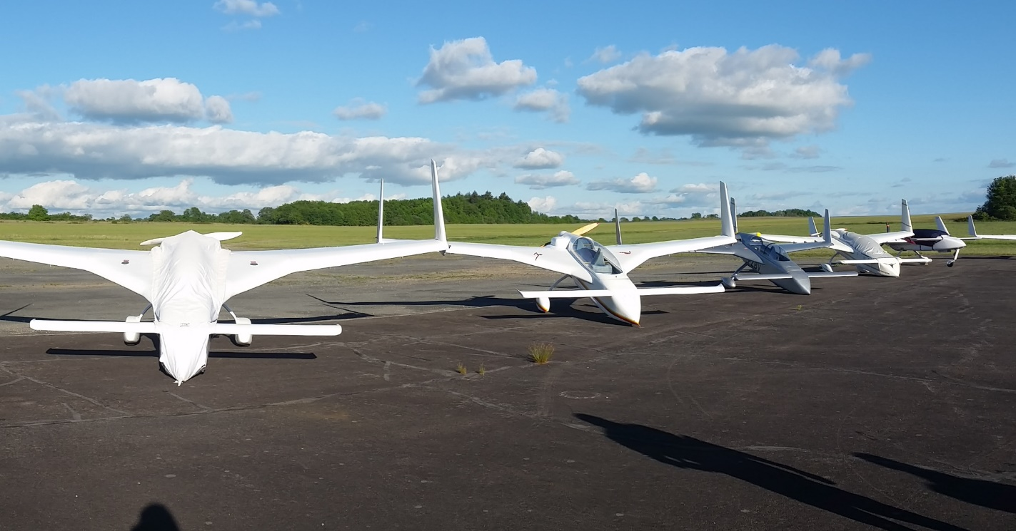

May 29-30, 2020 AOPA Flyin at San Marcos, TX (KHYI)

Jun 5-7, 2020 CANARDS WEST – At (O22) COLUMBIA CA http://www.canardswest.org Tim Fisher 209-996-9919

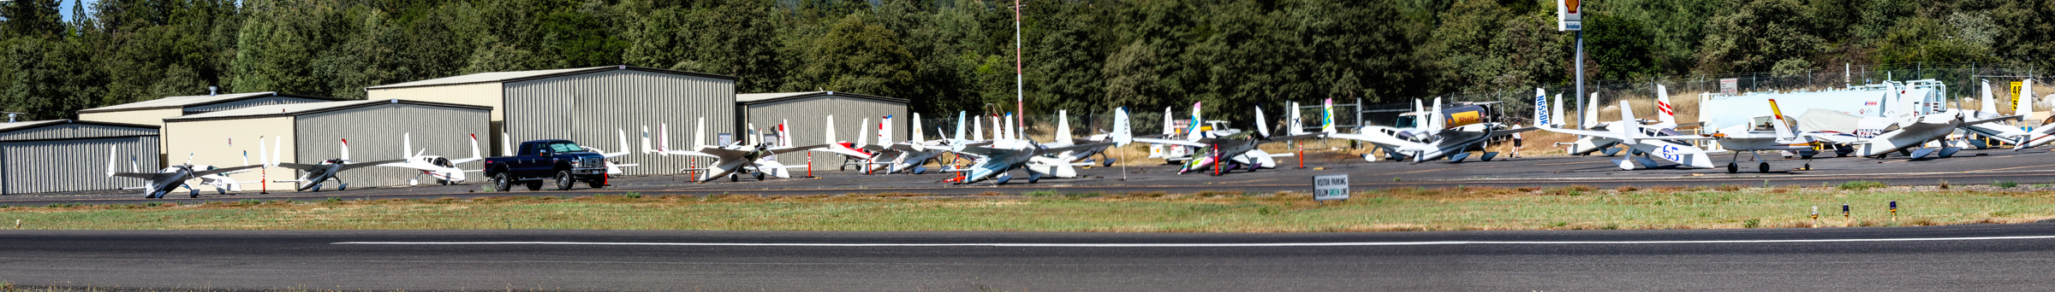Patti Pitzer’s photo

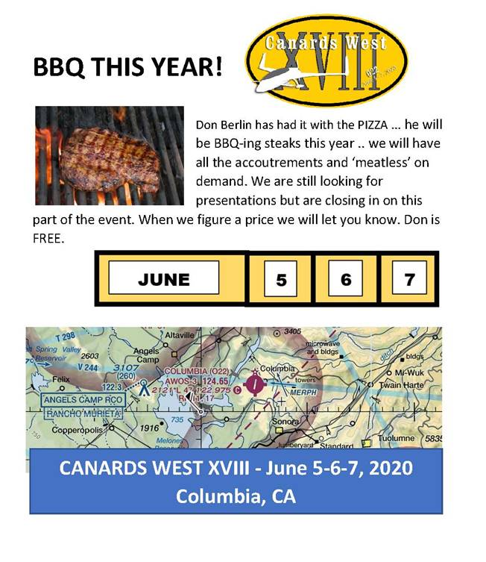
If you arrive on Friday, as many do, you can walk to dinner at El Jardin Mexican Restaurant on the near side of the historic town.

Non-Builder owner advice: I'm hearing someone lost his nose wheel and more recently, I’m referring to everything at the bottom of the nose gear leg. The result will be the nose gear leg getting ground down. Unfortunately, not only can you lose the parts on the runway or even further afield, but the hardware can strike the speed brake if it happens while taxiing or landing or it can destroy the propeller. We learned this early in the days of Squadron I and II, and simply added a bolt through the casting with a nut to retain it, drilling right throughusing the nose gear leg, or a roll pin, you don’t need a big bolt.

Congratulations: Member Geoff Danes - a long experienced EZ guy at Minderie, Western Australia is flying his jet powered Varieze: "My Eze flies so beautifully hands off… (especially now it’s vibration free with the jet engine).”
In Memorium:
Burt sent photos of Nashville Airport damage – I’ll share one:
Nashville Airport

FedEX is located at this airport and sustained a lot of facility damage too. Tornado and hurricane airport damage usually results in lots of salvage engines coming available…too sad. The tornado was apparently on the ground for 50 miles of destruction, Pat Reina lives 15 miles south of the track. Member Pete Aberg is helping feed the suddenly homeless and start the cleanup and says the destruction is much heavier than that shown on TV.

Builder’s Help Desk:
Filling Pin Holes:
Dave Ronneberg has just primed a molded wing and explained something he learned from a British Lotus racecar builder. Molded parts (like cowls) often have pin holes, and the Brit suggested lathering on a layer of plasterer’s wall board mud instead of epoxy with micro we all used; he leaves the layer thin but covering all (Dave uses a squeegee to be sure it covers all, the Brit used a simple rag to apply it). The stuff dries very fast and the molded part can be sanded easily, much easier than an epoxy filler of any type. An epoxy primer will invade the mud down in the pin holes and solidify – improving the primer’s grip.

Key Maintenance Tip:
Member Ron Montgomery, Contonement, FL: Tank Leak repair:
“I would like to share how to detect a leak in a fuel tank that will not hold pressure. After flying my Cozy MK-IV for a little over 225 hours I developed a fuel leak that would only show itself when I would top off my fuel in preparation for an extended cross country flight. I'd top off my fuel the night before departure so this process would not have to be done the following cold, dark morning. When arriving the morning of departure, there would be a strong odor of fuel in my hangar. There was no visible fuel anywhere but an odor was permeating from the right strake. I was able to track the leak down to the outboard strake bulkhead. It would only leak with max fuel load. When I removed the right wing I was able to see blue fuel stains on the underside of the top strake skin. The stain completely covered the underside skin between the outside fuel bulkhead and the angled outboard rib.
I built a hydrometer that would show up to 22 inches of water column. I sealed off the tank filler with tape, closed the fuel valve, and connected one vent line to the hydrometer and another hose to the other vent line in the tank so I could apply pressure. I then applied 22 inches of pressure to the tank. The tank did not hold pressure and lost about an inch of pressure every 25 minutes. I then sprayed soapy water on the underside of the strake skin expecting to see where the leak was located. No such luck. After many hours of searching with soapy water I simply could not find the leak. I then resorted to drilling 3/16 inch holes in the top strake skin and into the foam core, but not breaking through the bottom skin. These holes were on the fuel tank side of the outboard tank bulkhead. I cleaned out the foam from each hole exposing the lower glass layup over the tank then began filling all the holes with soapy water. This procedure showed four out of fifteen holes had bubbles coming up. I removed the soapy water and allowed the holes to dry over night. It was obvious fuel was getting into the upper strake skin over the top hat area of the rib. When I built the tanks I sealed the entire tanks with Jeff Kote Sealant. The only place that did not have sealant was over the strake top hats.

The next day I applied 22 inches of vacuum to the tank and filled the leaking holes with raw epoxy plus a few holes around the leaks. The epoxy level that was in the leaking holes would drop and I would refill as needed. I also applied heat with a heat gun to the surrounding area to enhance the epoxy flow. I could tell the heat helped because all of a sudden I was getting air bubbles coming from the epoxy filled holes. This is because the air trapped in the foam was expanding and expelling the air. After heating the area for a few minutes I placed a fan blowing cool air on the strake skin which allowed the epoxy to be sucked deeper into the foam around the fuel leak. I removed the vacuum and let the tank set for 24 hours. I was sure the leak was fixed. NOT!!
The tank would now hold pressure most of the day, but would not hold pressure overnight. Back to the soap and water trick. I searched for two days for the extremely small leak with no success. I finally resorted to using Freon 134a to look for the leak. I purchased a Freon sniffer at Amazon for $25 and for another $25 I bought a can of Freon along with a cheap Freon charging adapter at an automotive parts store. I connected the charging adapter to one of the vent lines and applied 22 inches of water column pressure to the tank with the can of Freon. I drilled more holes in the top skin, cleaned out the foam and used the sniffer to test the holes. Within a matter of minutes I had located numerous holes expelling Freon. I removed the tank pressure, applied 22 inches vacuum, filled all the holes with raw epoxy, applied heat to the top skin and rapidly cooled the skin to suck the epoxy deeper. Twenty four hours later there were no more leaks. I was very surprised at how well Freon showed the leaks whereas soap and water did not. For a fifty dollar investment, Freon is for sure an inexpensive method to have at your disposal.”
Requests to Individual Members:

What the flyers are doing:

Mark Reiger, San Juan, Puerto Rico: “Still in PR. Working on selling the company now. If it goes according to plan, we will be moving back to California in September. Then I get to work full time finishing the Cozy. Amy and I look forward to seeing you in the Bahamas.”

Ed Masterson, Hanscomb AFB, MI: “So long story short, I finally got around to retiring from the Air Force in 2018 and settled down nearby in Westford. This is the area I grew up and have many relatives around here. I kind of thought we might go back to Albuquerque where my Wife is from (or Colorado where she has family), but with teenagers in the house we picked the better school districts around here. I haven't flown my Varieze since I retired -- another long story, but once we decided to stay in the area I put it on "ignore" and now I am working through more of a restoration (e.g., replacing 20 year old oil & fuel lines). 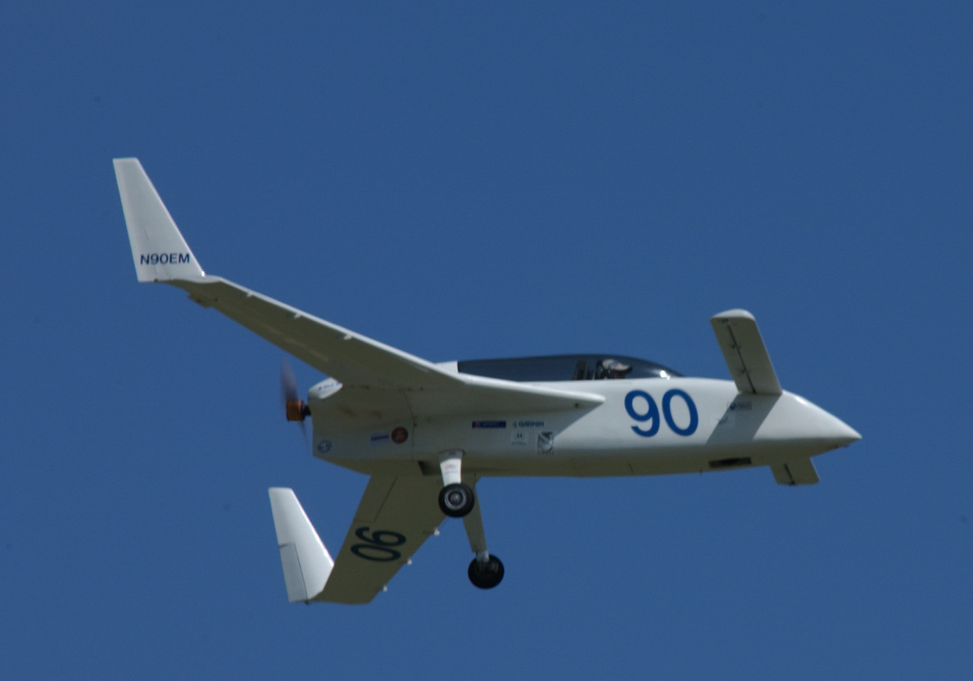
Plus I need to put ADS-B in since I'm within Boston's Mode-C veil. I think the number on the Hobbs meter is about 334 hours. First flight was in 1998 from Double Eagle II airport in Albuquerque and I've kept it at various other airports as I've made military moves. It is now at Lawrence, MA (KLWM). I hangar there with Jose Velez's and Joel Ventura's Long-EZs.”

Todd DeVito, Reno, NV: “I didn't get as much done as I had hoped this winter. I have one project left in my garage to complete to free up space so I can get back to work on my Varieze. Unfortunately, my wife put two house projects at the top of my list this winter, and her projects take top priority in order to promote domestic tranquility. I still plan to get back to work on my Eze in the next month or two.”

Tom Landgrebe, Mishawaka, IN: “I’ve been back to work on my

bird! It is the first Varieze will Long-EZ wing attachments I

think! I saved the spar jig. [This for building a Varieze spar

in the Long EZ method.] I’m open to discussion on the build as

well.” Tom has load tested his wing/spar sections.

Joe Heagerty, soon from Rancho Cucamonga, CA: “Nothing for

the canard world from me. Well... I did see two (different times)

in the pattern at Cable Airport over the last couple of weeks.

We are moving to Fresno before the end of the year. We’re

expecting daughter to move there from NYC with husband and the

two grandbabies. We have been house hunting in and around

Fresno/Clovis with a realtor that just happens to be a niece. I

know, not canard related, but forced boredom requires outlets. I

retired in December. So you would think I have more time for Cozy

construction. Planet Earth has thrown a curveball at

anything resembling personal future plans.”

Keith Moore, Oxnard, CA has sold his BerkEZ: “I'm very active at Camarillo - EAA Chapter 723, instructing in the Redbird simulator and as EAA 723 VMC/IMC Club coordinator. I always enjoy your newsletter.”

Member Mark Wood, Fresno, CA: “…I've been making some changes to the Long-EZ that I've wanted to do for a long time: I let a supposed friend fly it to Texas and back from Fresno and made it clear I didn't want him using auto fuel which he disregarded and when he came back I found a couple pinhole leaks under each strake. I cut major holes in the strake tops, sanded the insides and installed a new layer of glass then put the tops back on all done per Rutan Long-EZ plans. It’s a big job to say the least. Since I had it in my garage I decided to do some things to it that I had wanted to do ever since purchasing it. Pulled the Lycoming O-235-L2C and replaced most parts attached to the engine including 3 cylinders, removed and replaced all the engine cooling baffles and sealed it all up really tight. Designed, made and installed a different oil cooling system than any I've ever seen on Long-EZs. Designed, made and installed nose wheel gear doors, installed Lightspeed electronic ignition, rewired the plane, added Lightspeed main gear fairings and wheel pants, designed and installed a landing light in the nose, JPI830 and few other gauges, Prince prop, eliminated nose gear strut play, been sanding and filling for a year and a half and have the final coat of primer on it and almost done sanding with 320. Been on this for 6 years now and getting ready to have it painted hopefully in a month or so. Maybe I’ll make it to Oshkosh this year.”

Virus Effects:
I'm going to put things here that I've not heard in the news:
Filipe Rosa, Alcochete, Portugal: “Yes, but we have been stuck at home for the last two weeks. For me it is good because I am building, but getting fed up with staying at home. The most affected in Europe is Luxembourg, however it has a low population, so not much in the news. After Luxembourg, Italy and Switzerland. Spain is also in chaos. [In Portugal] the government set quarantines before Spain so we are holding up but already have 14 dead people - all old. Problem is that we have a ton of old people, here.”

Consider the single pilots - it must be a bit more difficult in these times.

Desser Tire Open: I got an e-mail from Desser Tire saying they were considered an Essential US Business so are staying open to distribute tires. ken@desser.com If you have others our guys would possibly use, just get in touch.

Greg Norman lost job in Detroit

From Member Patrick LeFevre, Castelvau Le Lez, France: We had some warning, from Bill Gates of all people: https://www.youtube.com/watch?v=6Af6b_wyiwI&feature=share

My local airport John Wayne (KSNA) is a major airport, and I got this news on March 27, 2020: “Unfortunately one of the controllers at the KSNA tower has been tested positive and may have infected the rest of the controllers. As of this writing, the KSNA tower has closed indefinitely. Class Charlie will no longer be in effect and traffic is being handled by SoCal and clearances by tracon via the phone. Try calling ATIS at 714-546-2279 it makes for an interesting listening. I’m sure more news will follow from our own retired KSNA (former)controller Brian.”

My AME sent this news: “Recent events regarding the COVID pandemic have led to significant access problems to Aviation Medical Examiners and other medical specialists. In response, the FAA will not enforce airman medical certificates which expire between the dates of March 31, 2020 and June 30, 2020. The period of non-enforcement will be in place thru June 30, 2020. The specific language for this enforcement policy was published in the Federal Register and will be available online.”

Pilot Safety suggested this way of passing the time among others: “Give Blood, there is a critical shortage in many areas.” As encouragement, Beagle passed the 5 gallon mark this year, once you get in the habit, you get to realize how important it is.
“If you are able to safely fly your airplane, consider calling your local hospital, or first responders to offer transporting critical supplies. Remember, you should comply with any local registrations and make sure you call ahead to make sure self-serve fuel is available. I recommend that you offer cargo only, not people or patients. There are organizations like Angel Flight and professional air ambulance companies are trained for that.”

New members:

New area code in the address list:
AREA CODE 440(OH) added
Already a member:
90 SCHUBERT, TERRY L. “NEWSMAN” & JAN 9283 Lindbergh Blvd. Olmsted Falls, OH 44138-2407 440-826-3055(H) jschuber@juno.com Long-EZ:N9TS 4480 hrs O-320-E3D ran CSA Travel Club and Taxi Lorain County Regional Airport (LPR)

Already a member:
97 STAGE, GEORGE A. 10484 Grandview Dr. Kirtland, OH 44094-9779 440-622-5954 216-256-1661(H) GStage@GMail.com Long-EZ:N946GS 70 hrs O-320-E2A (KHZY)or (7G8)

Already a member:
18 OLAR, HARRY 12387 W Sprague Rd., North Royalton, OH 44133 [440-] harry.olar@gmail.com an engineer at NASA GLENN non-pilot, Bought vandalized Cozy III, reworking it

Joining:
92 CHAMBERS, SAMUEL C. & PHILA 3113 Southfork Rd., Glasgow, KY 42141 270-646-0516 schambers@scrtc.com Emeritus, sold Long-EZ Instructor, Inspector, Glasgow Airport (GLW)

Joining:
93 SMILEY, LAWRENCE & RACHEL 2424 East 91st St. Indianapolis, IN 46240-2010 317-431-2173(Cell) Lawrence.K.Smiley@GMail.com Long-EZ:N724SM/ch26 Rotax turbo915 water cooled with MT prop. Metropolitan Airport (KUMP)
“Yes, I am building a Long-EZ: N724DT. I, most likely, will hold the record the longest build time (now 43 years and counting!), since I started building a Varieze following Oshkosh 1976 when Burt first introduced Varieze Plans. I updated to a Long-EZ in 1978. By that time I had the canard completed. With a couple inches sawed off each tip, it was right for the Long-EZ.

Since I had four kids, three businesses, church ministries (youth group, Sunday School) teaching, Soccer, Basketball and Springboard Diving Coach and BSA Scoutmaster and with one wife, family always came before my plane building, so I'm still at it.

I've decided to use a Rotax 915iS 140hp, Turbo-Charged, Water-cooled Engine with a 3 blade, Variable pitched MT propeller. After I designed a new engine mount in SolidWorks, I awarded a fabrication P.O. to Aerospace Welding, Inc. near Minneapolis, MN. I am also designing two armpit diffusing inlet cooling ducts to cool the Inter-cooler and water-cooling Radiator. A NACA belly-mounted inlet will cool the Oil Cooler. More details can be found on our website: www.OnWingsofGlass.com.”

Joining:
19 RADFORD, DREW 8112 39th Ave SW, Seattle, WA 98136-2306 206-459-9226(cell) DrewRadford@Gmail.com Long-EZ:N81DN 600 hrs IO-320, Auburn Airport (S50)

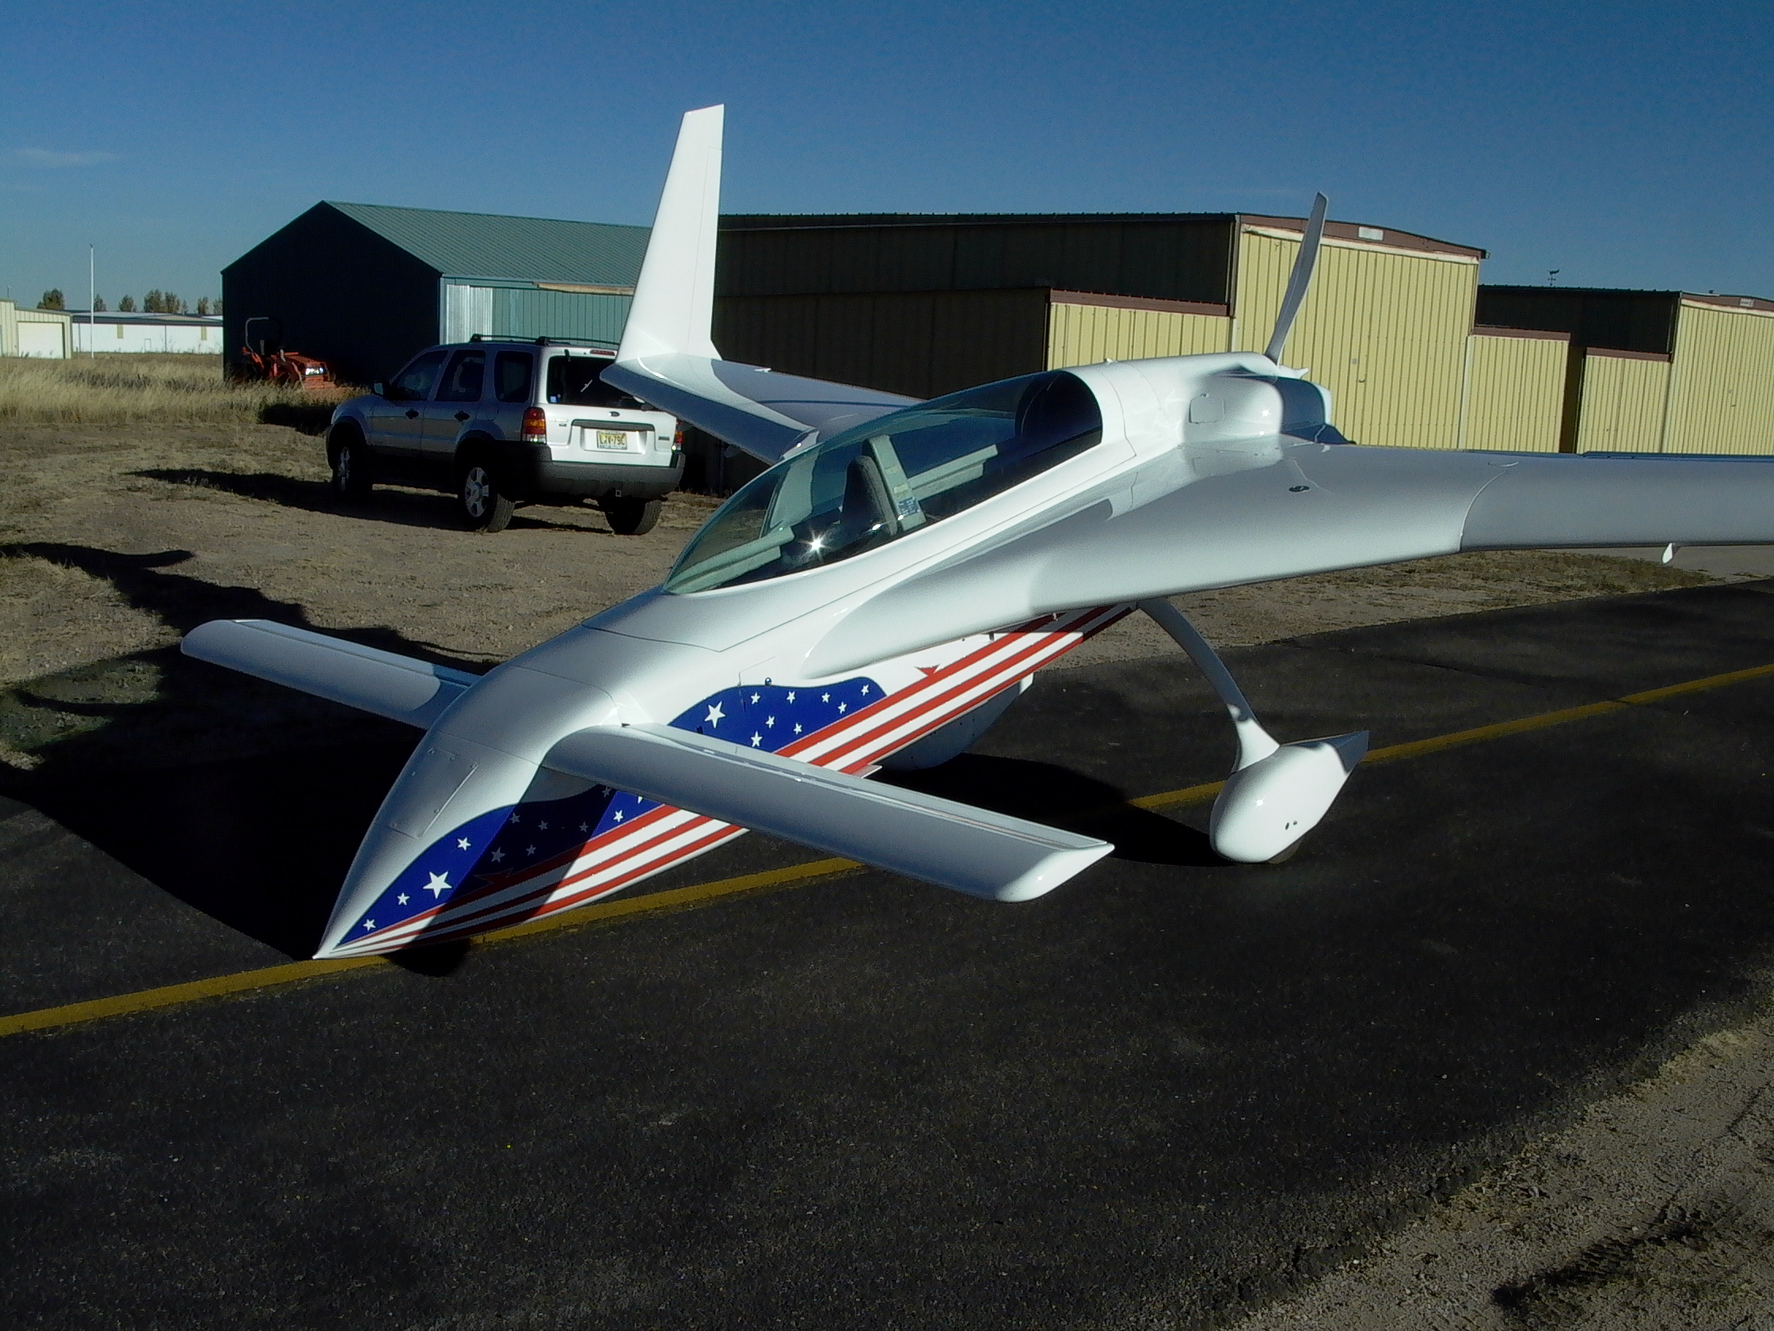
Joining:

97 LAMP, TERRY “LAMPO” & JILL 514 Winton Ave., Zanesville, OH 43701 740-704-2980 tlamp@columbus.rr.com Emeritus, sold Long EZ www.bootkeyharbor.com/TerryLamp/ CS State Rep. Zanesville Municipal Airport (KZZV)
Joining:

19 MANCEAU, RICHARD 1186 Crystal Ln., El Cajon Ca 92020

619-729-8861 rrmanceau@yahoo.com Composites Engineer

Building Berkut like aircraft based on Robert Setzer’s

molds, adding Infinity Gear.

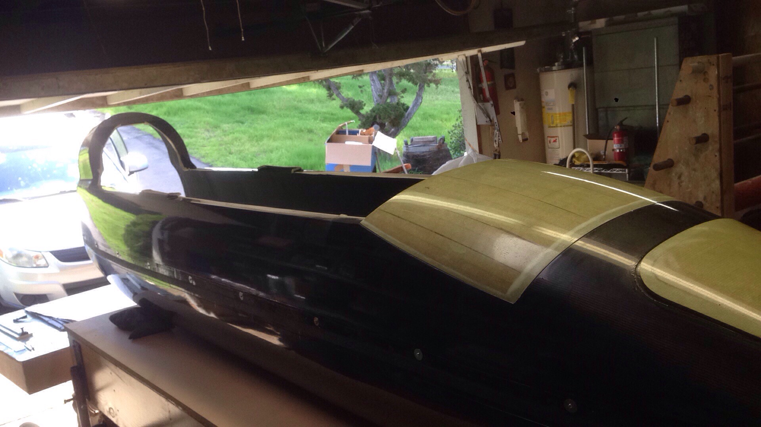

Joining:
19 SEIDE, CHIP Oracle, AZ 520-896-9050 chip.seide@att.net
Emeritus, Interested in an EZ.

Joining:
88 JANVRIN, SIMON & JULIE Broxmead Lodge, Broxmead Lane, Cuckfield, West Sussex RH17 5JH UK 44 1444 417955 SimonJanvrin@BTInternet.com Long-EZ:Ch18 O-235
“Started Long-EZ 30 years ago, built for a few years, then stopped, now started again. Will be mostly plans built with 0235 (also 30 years old).”

Joining:
20 BLOOM, ZACH 702 Spofford, Austin, TX 78704 248-229-8031 [512-] ZackBloom@GMail.com Wants to buy Velocity XLRG Continental 550

Joining:
04 GOODMAN, TIM & JODI 2124 S. Bay Rd., NE, Olymbia, WA 98506 360-259-2755(Cell) TimGoodman63@Gmail.com Cozy IV:Ch 14 O-360 Olympia Airport (KOLM)

Joining:
20 FRITZ, DANIEL San Diego, CA Dfritzj@hotmail.com Velocity Project – wings done.

Joining:

19 WATTS, JULES “DOC” Hangar 1 Aviation inc., Attleborough Hall Farm, 31 Norwich Road, Attleborough NR17 2AJ UK bewildereddrwatts@hotmail.com Long-EZ:G-PUSH Seething Aerodrome? (EGSJ)

“…I have…listed my home airfield as Seething (EGSJ) as this is where I hope to base G-PUSH once flying. As you can see she's basically complete though I am just getting started on building new ailerons, elevators and canard. Practice runs etc. at the moment. I hope to make the most of this lock down period to make some progress. 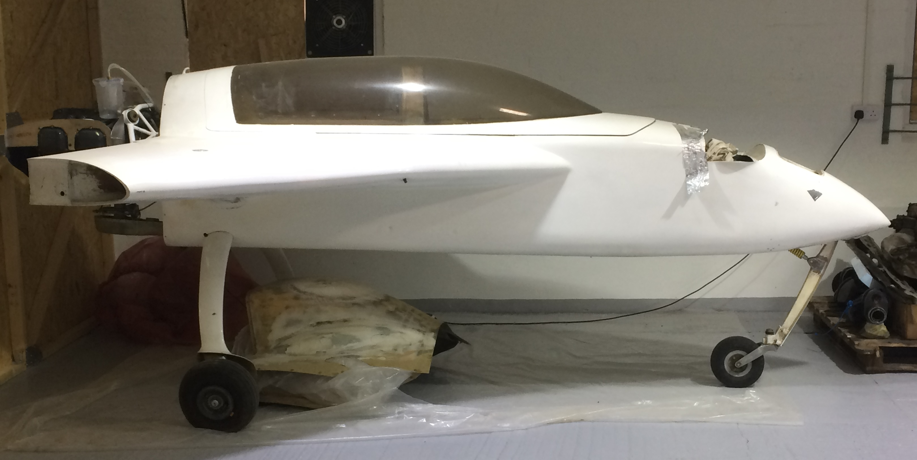
So far as I know G-PUSH never quite made it into the air after initial build in the 80's. Since then she's changed hands a couple of times. I bought her from Bill Allen last year. All of the UK canard builders/flyers I know seem to already be on your list including Keith Taylor and Dan Gay. Seething airfield normally hosts a UK canard fly-in each summer. I'll send out details if this year's goes ahead.”

Joining:
03 FIFE, DAVID 428 N. Linwood Beach Dr., Linwood, MI 48634 248-505-8176 248-627-4367 aircrafttips@yahoo.com Long-EZ:N12LZ 180 hrs O-320 Parner with Curtis Martin Pontiac Airport (KPTK)

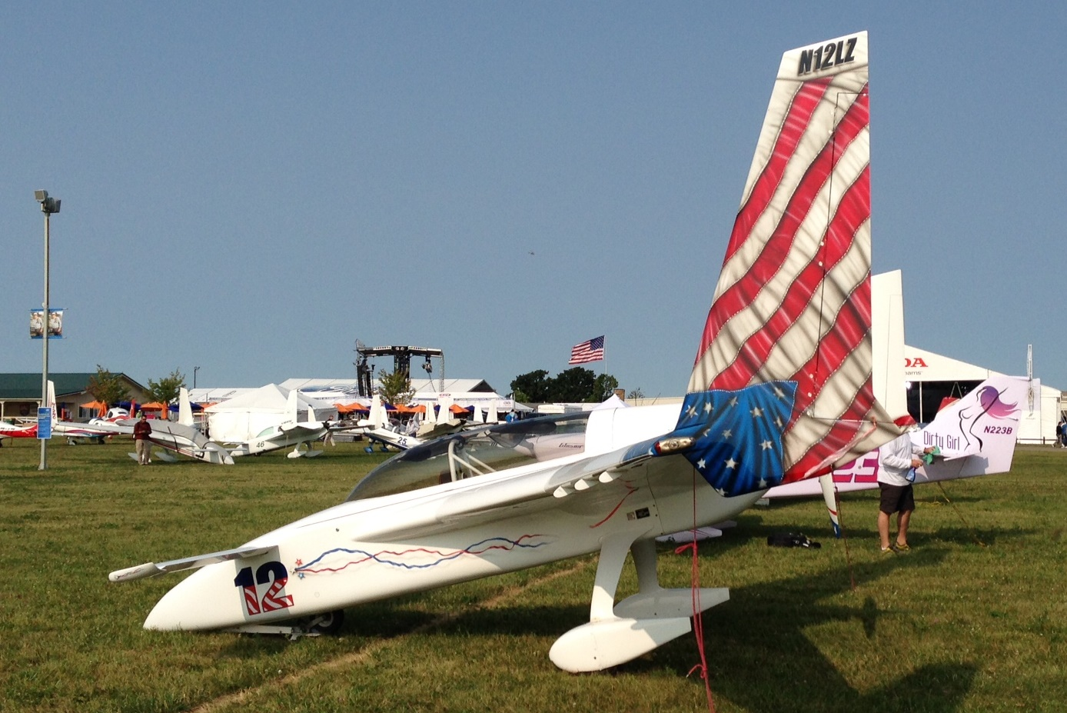Photo by Ed Berlin

Joining:
85 COLLINS, PHILIP J & LAURA N192W5053 One Mile Rd., Manomonee Falls, WI 53015 847-323-1020 N721PC@GMail.com Long-EZ-RG:N721PC IO-360-B1E (KMWC)

Belated welcome:
I signed him up as a member a while ago but didn’t introduce him to the Squadron – his Lancair IVP will be a stunner – see his Varieze, below: 97 BASSEN, GERALD R. 1563 W. Heatherglen Dr., St. George, UT 84790 435-216-7536 bassengerald@yahoo.com Varieze:N450EZ 810 hrs 0-235-L2C Building Lancair IVP. St. George Airport [KSGU]
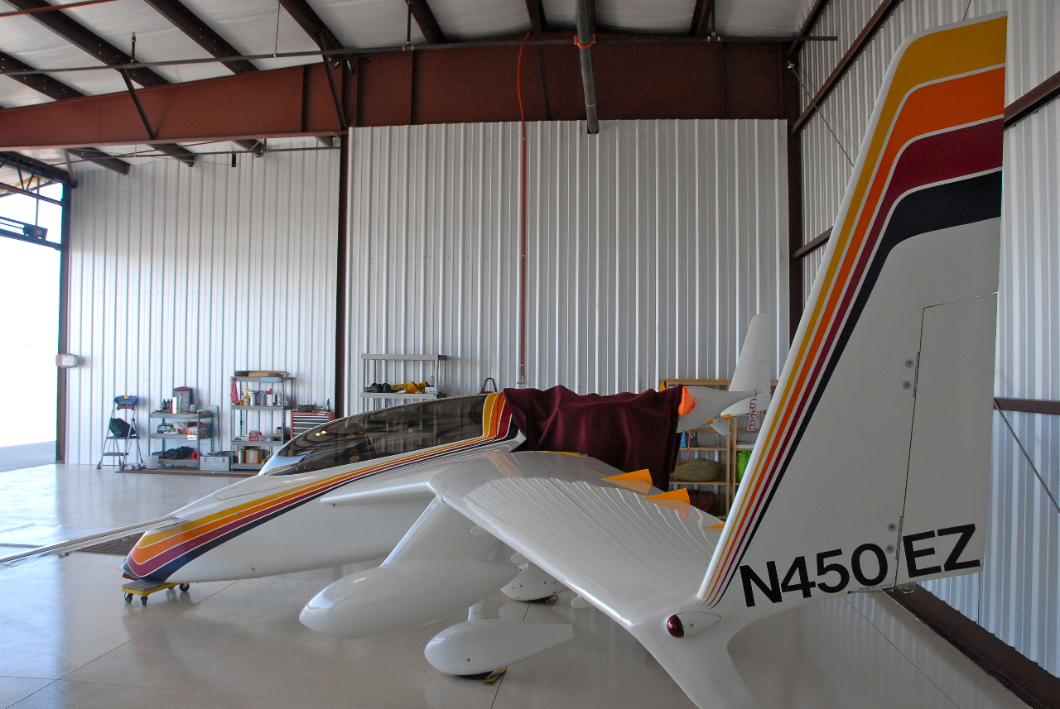
Cowl looks a little lumpy…

Changes in E-mail:
Mark “Hickory” Buxbaum mbuxbaum421@gmail.com
Gary “Freebird” Scott: Gary@AwSincline.com
Robert “BONDO” Setzer: rsetzjr@gmail.com
Bruce Sinclair: ozlongez@gmail.com
David “Dutchy” Schilder: david.schilder71@gmail.com

New Address:
85 SOWER, JIM “HOSTAGE” & MILENE 28 Sophie Ave., Dunedin, FL 34698 931-510-3338(cell) [727-] jimsower@gmail.com Sold Long-EZ sold Velocity MIL, USMC pilot Columbia County Airport (1B1)

96 WALSH, KEVIN “BIG BRAIN”, JERI 2156 San Antonio Ave.,
Alameda, CA 94501 415-861-9617(Cell) 415-282-3494(H)
krwalsh@gmail.com krwalsh@alum.mit.edu partnership with
Michael Antares. Cozy IV:N753CZ “Glass Transition” San
Carlos Airport (KSQL)

07 PROCK, JACK “BOOGEYMAN” 23567 Acacia Ct., Auburn, CA 95602 916-284-5225(Cell) jackprock924@gmail.com Mex Velocity XL RG:N924JP O-540 260 hp 60 hrs Auburn Aiport(KAUN)

One Off Canards:
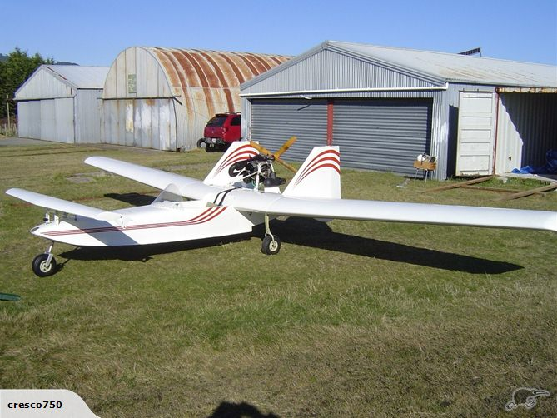Diehl Dart - amphibian
Added to the Electronic Squadron library:
9MS16 Mar’20 VOBA supplied Oildyne repair kit for retracts
10CZ5 Mar’20 Discussion on Dihedral in Aerocad Cozy and reasons for Dihedral, primarily by Marc Zeitlin.
19MS14: Mar’20 G-VEZE wing loading test data provided by David Young 21CZ12 Mar’20 Discussion on Pressurizing the Airplane to keep out the leaks by Ugolini, Ashton & Norman
23DO9 Dec’03 Doing a Top end yourself by David Orr
23KP16 Dec 2000, page 107: “Big Engine, Little Airplane - Calculate the power required for best performance.” by Bill Welch.
23LP1: Jan 1988, page 10: "Upgrades for the Lycoming O-320".
23LP2: Jul 1986, page 14: "Lord Mounts, The Shocking Truth".
23LP5-2: Mar 1989, page 20: "Q & A" on Lyc O-235 low compression & pushrod problems.
23LP3: Jul’91 pg 19 The Engine Clinic on Carb. Idle-Mixture issues, difference in summer/winter.
23LP4: Mar 1989, page 7: "Squawk Talk" on IO-360 modifications.
23LP5-1: Mar 1989, page 20: Q&A Issues with piston Pin bushing wear on TSIO-520
23LP5-2: Mar 1989, page 20: "Q & A" on Lyc O-235 low compression & pushrod problems.
23LP6: Mar 1989, page 14: "Common Overhaul Mistakes (and How to Survive Them).
23LP7: Nov 1988, page 23: "The Engine Clinic" (Lycoming piston rings described).
23LP8: Nov 1987, page 20: Converting Lyc 0-235-L2C for homebuilt, leaning.
23LP9-1: Oct 1988, page 20: Winterizing Lycs.
23LP9-2: Oct 1988, page 20: Upgrading L2C to 125hp.
23LP10: May 1988, page 10: "Overhauling the S-1200 Magneto".
23LP12: Feb 1988, page 13: "Slow Cranking: Causes and Cures".
23MS76 Feb’20 TurbAero’s CEO comparing his turbo prop to the O-360/O-540.
23MS77 Dec’13 Lycoming Certification Aircraft Engine (description of engines) SSP110-1
23MS78 Jun 2012 Pipes short of cowl trailing edge and educator built into the cowls to send cooling air out (in top down cooling) by Nick Ugolini, Terry Schubert, John Lambert, Al Wick, Dave Adams
23MS80 Feb 2020: Slick Mag Service Bulletin for Jan16-May18 mfg mags Ser#s: 16010001 to 18050664.
27LP5 May’88 pg 9 Calculating Percent of Power by Kas Thomas
28LP6: Dec 1997, page 5: "The Annual Inspection", a Tale of Two Engines and The Top End Time Bomb that Took Two Years to Show Up.
29MS75 Nov/Dec’19 pg 7 So You Want To Fly in New Zealand part 1 by Gary Schank So Cal Pilot’s Association
29MS76 Nov/Dec’19 pg 7 So You Want To Fly in New Zealand by Gary Schank So Cal Pilot’s Association
29MS77 Nov/Dec’79 pg 12 “One Approach, Three Landings, Sightseeing, and Lunch! By Ray W. Stratton about Sountern California Logisticcs Airport (KVCV) (former George AFB)
29MS78 Jan’20: pg Glad to be back in the US (after NZ) by Gary Schank So Cal Pilot’s Association
30MS61 3/20 Discussion between Burt & Dick Rutan on the factors concerning the Voyager AOA and the wing tip damage’s effect on the flight.
30MS62 2002 Summary on the Voyager program by Burt Rutan
Oh and Trivia:
From our Emeritus Member in Cold Lake, Tim Cramb:
Flight Planning: https://youtu.be/nzbAHIaITkw
Aerobatics: https://www.youtube.com/watch?v=U-qaJMTW6pc

