NOSE GEAR PIVOT ASSEMBLY (NG6):
Engineer Jim Emons wrote up notes on the non-Velocity pivot assembly based on several he has repaired…

Problem: Your nose gear strut is starting to wobble from side-to-side - Don't you check this in your condition inspection? Elevate the nose (Wheel off the ground) and check the lateral play of the strut.

What is happening?: Your NG6 pivot is developing some wear in the mounting area - specifically the NG8 plates in the NG30 gear panels (which also hold the gear retraction system.)

If you examine the nose gear schematic;
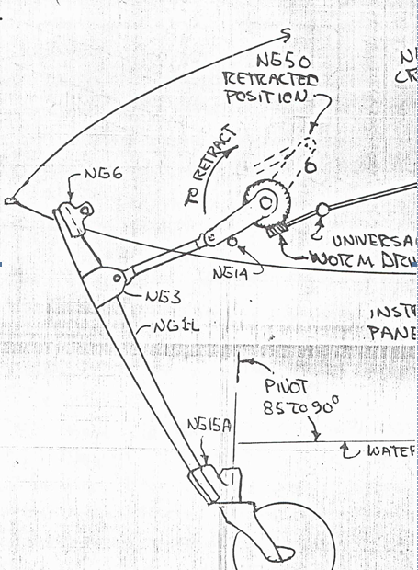
the nose wheel can take an 300-400 lb "hit" with a "firm" touchdown of the nose on landing. The leverage of the strut can generate 1000-1200 pounds of down force on the NG6 pivot as a reaction to WONG (Weight on nose gear). This shock load (repeated every landing) eventually causes a "Brinelling" of the NG8 aluminum mounting plates in the nose gear well. These plates are only 1/8" thick and support the 5/16" through bolt of the NG6 nose gar pivot fitting.

The low-friction 1/2" axle and bronze bushings in the NG6 don't get much wear and can handle the shock loads easily - load distribution into the NG6's bronze bushings is not a wear issue.

What really takes the hit is 5/16" pivot bolt riding in two 1/8" thick NG8 plates (and the multi-layer glass inserts) in the NG30 structural nose gear panels. Hit hard enough and the bolt bends. Then you must hammer it out to replace it (or saw it out like some of you have!). But the real wear points are the NG8 bearing plates - getting ovalled out.

The Fix: Drilling the NG8 bearing points for a larger through-bolt is a simple adjustment to reducing the slop in the pivot and restoring the nose gear pivot to new-construction accuracy. You are blowing extra bucks if you think you need a $300 roller-bearing nose pivot.

Start:
1. by removing the NG6 pivot bolt. You probably will have to cut a hole In the nose to remove it (you may have to hammer it out). (later instructions suggest this should be on the left side of the plane. Open the side-hole up to about 3/4" diameter so you can see what you're doing.
2. Drop the gear strut from the nose - disconnect he retraction pushrod. It will make things easier if you pull the nose wheel/fork/pivot from the NG15 (Don't lose the friction-adjusting parts!!)
3. Remove the 1/2" axle, washers an old bushings from the NG6 assembly [Measure the total dimension of you’re axle "stack" - it should be 2.75" between the NG8 plates].
4. Install the new 3/8" id bronze bushings and the tubular spacers into the NG6 casting. (Emons will supply a kit for this.) This is a light press fit and the outside dimension on the bronze bushing faces should match the old stack dimensions. Work the spacer thicknesses to bring the new assembly to a very snug fit in the gear well. (No more washers)
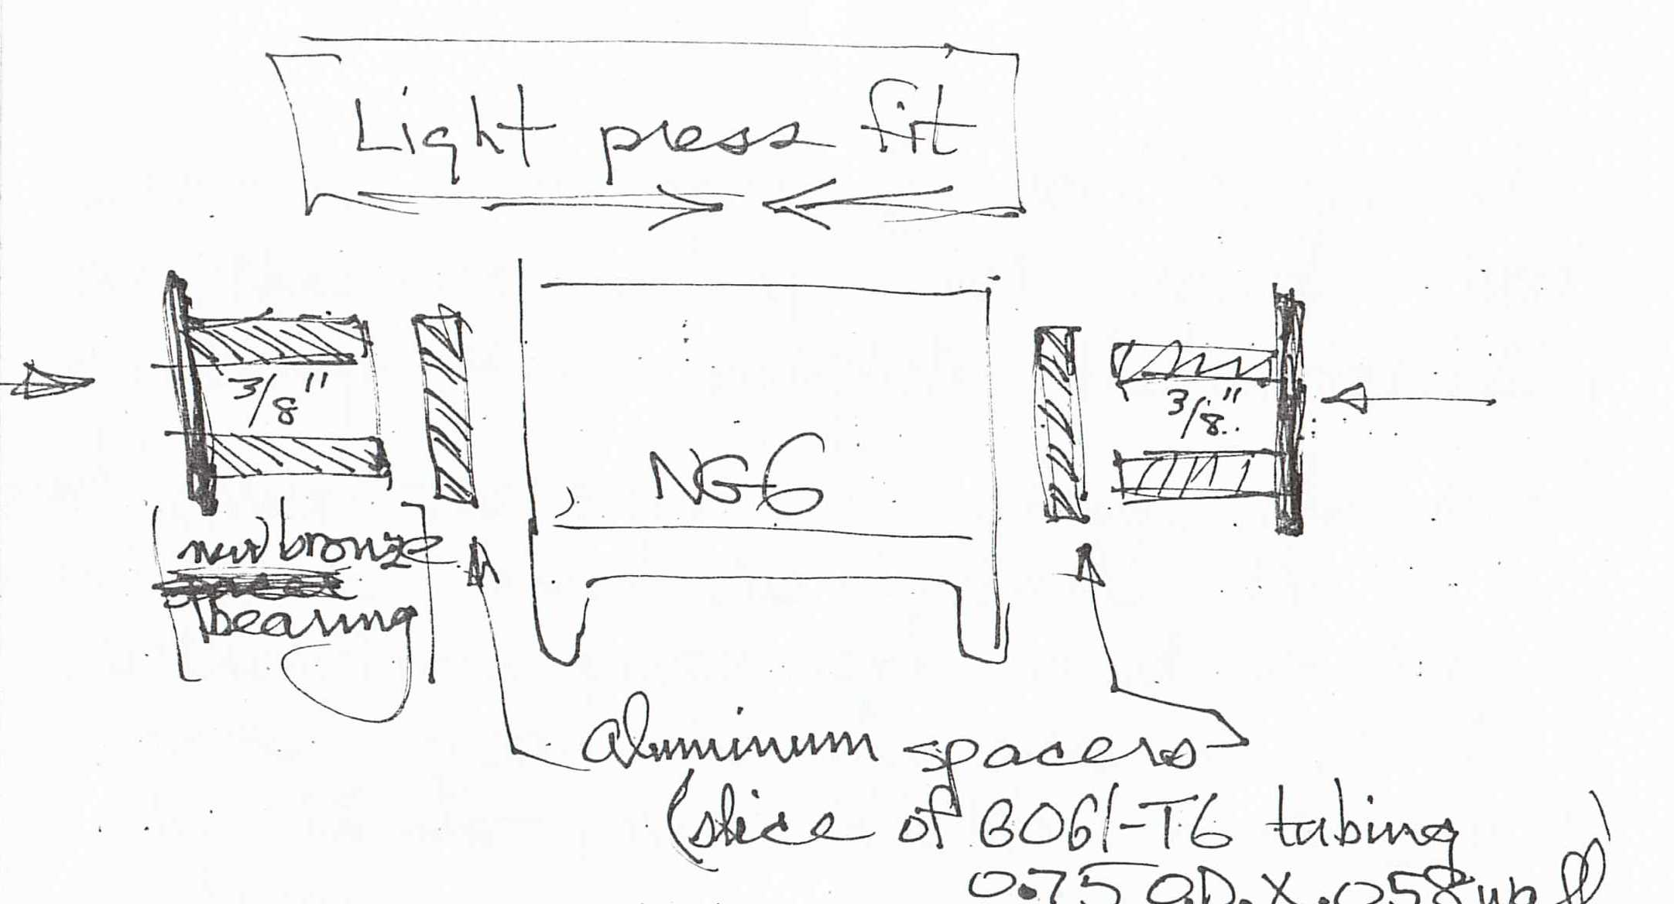
*Note that we're dumping the old bushing/axle/washers thing.

Using a 12" long 3/8" drill bit - carefully (slowly) drill out the left-side NG30/NG8 plate in the nose structure.(presuming you drilled a 3/4" hole in the left side of the fuselage). Do not heat up the glass layers or you will gum things up considerably.

Wedge the nose gear strut up in the gear well until you can align th gear bushing with the newly drilled hole.

Using the long drill like an axle, retract the strut almost into the well and using the gear pivot assembly for alignment of the drill into the right-side bolt hole, drill out the right side NG8 carefully and accurately.

Install the new 3/8" bolt (Emons kit supplied) in the assembly and tighten just enough to complete the installation. Raise and lower the strut to check the pivot friction and re-install the retraction pushrod and lower nose gear hardware. Adjust the for-pivot friction and you are done.

Note: I usually use a 7/16" bolt and bushings when I repair the crashed canards that come into my shop because I anticipate further hard use down the line. The 7/16" kit will also be available if you want amore robust gear pivot and/or you are planning to install one of the available powered nose-lifts on your Long EZ/Cozy, etc. Lifting two people from a "kneeling " position puts a lot of fierce strain on the strut, pivots, et al. Jim Emons 909-239-2706(cell) Jim is in California 7 days a week but is a late riser and works in the Hawaii time zone. He is at his shop or at Chino airport and Bill Oertel or David Orr can reach him if you e-mail…if he doesn't answer his e-mail.

