Subject: Re: [c-a] Ugliest oil flow pics.
Date: Tue, 12 Jun 2012 10:47:23 -0400
From: Nick Ugolini <unick3@gmail.com>
To: Marc Borom <borommarc@earthlink.net>
CC: Canard Aviators <canard-aviators@yahoogroups.com>

...I modified my cowl last year to lengthen the cowl and incorporate eductors into the design as Marc has. The cowl length on the outboard points was the original length (for prop efficiency), the sweep forward (in the center of the eductor area) was about 1/2" and then it was lengthened to about 3/4" from the prop at the spinner with 3/4" clearance around the flow guide. ...worked exceptionally well. I could measure a -55 mph in the cowl area with my ASI (cowl to static) on the ground at 2200 rpm.

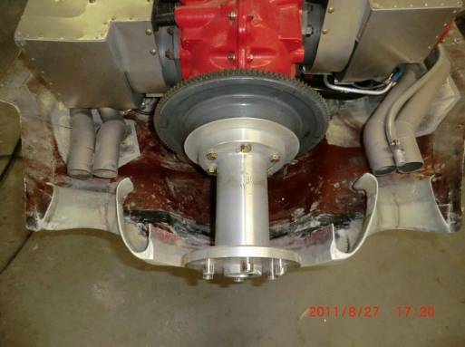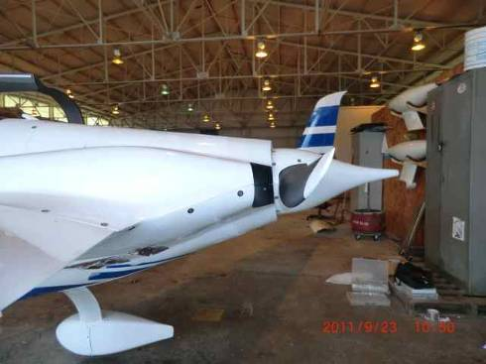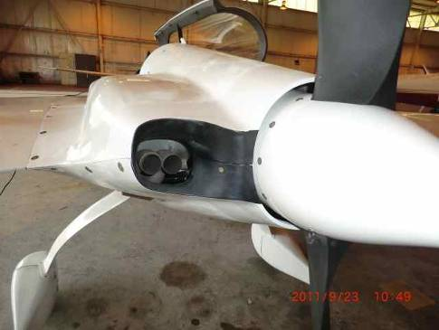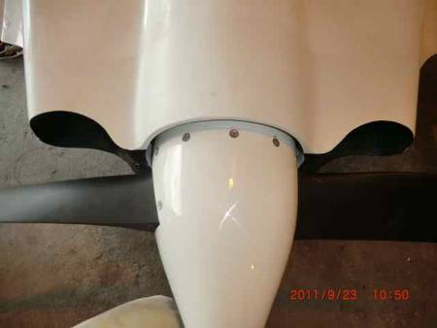

-------- Original Message --------
Subject: Re: [c-a] Ugliest oil flow pics.
Date: Tue, 12 Jun 2012 12:39:25 -0400
From: Nick Ugolini <unick3@gmail.com>
To: Al Wick <alwick@juno.com>
CC: Canard Aviators <canard-aviators@yahoogroups.com>

...I only tested one design as there is limited space in an EZ cowl for design optimization. I just followed a couple of design rules as discussed with Chrissi. The exhaust is 3/4" from the inlet (next time I will try for 1.25 to 1.5" and the narrowest part of the throat was about 4-5 times the size of the exhaust pipe area. Lastly have a nice roll lip on the inlet to smooth the air going into the eductor. Not much room to work in there. I am absolutely convinced that the air flow coming out of the cowl ahead of the prop is highly disturbed and doesn't flow well.

Here is picture of my first eductor design and you can see the oil drop traveling down vertically on the back wall after the test flight. I would have thought there would have been some horizontal movement of the drops but it was the same on the entire back cowl wall. There appeared to be no interaction from the prop on the air. Just a sort of dead zone.

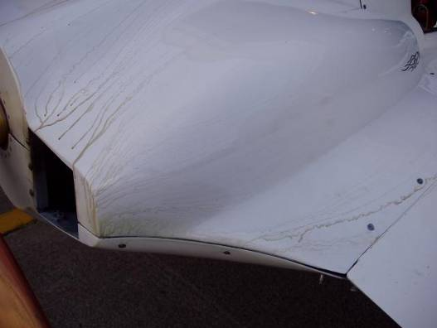

Eductors greatly help shorten (or eliminate) the time one usually spends trying to optimize the cooling of the engine. In my case I only had to reduce the size of the baffling a bit to balance the cylinders.

As far as your designs, Jack Wilhemson came up with a clever test apparatus after our discussions and seeing mine (he lives 5 miles from me). He built a box with his eductor design and using a shop vac, blew air through the eductor and measured the pressure drop in the box.

This approach may work best for your analytical mind set ;-) an allow you to test a number of designs before you commit to actual building on the plane. You could only measure the absolute drop in a limited setup, but it might be somewhat predictive of your design in an installation.

I have installed eductors in two planes now and am very pleased with the results and have great cooling on the ground, 395 f max for 20+min at idle with a hot engine but normally for a long taxi to the runway with a cold engine I only get up to about 350f max. Rarely on climb out do I go above 400. In flight temps are 330-375f with DD cooling. I need to downsize my inlets a bit to raise temps.

Good luck with your design and let us know what you come up with! BTW there are pictures of the latest build of the eductors on my website...

Nick Ugolini
Subject: Fw: RE: [c-a] Ugliest oil flow pics.
Date: Thu, 14 Jun 2012 20:04:53 GMT
From: jschuber@juno.com <jschuber@juno.com>
To: varieze@conwaycorp.net, canard-aviators@yahoogroups.com, alwick@juno.com

...exhaust augmentation I did on my O-320 Long-EZ some years ago. I've attached the pages from a back issue of the CSA Newsletter.
Terry Schubert
CSA Newsletter Editor

----- Original Message -----
From: John Lambert <mailto:varieze@conwaycorp.net>
To: 'Al Wick' <mailto:alwick@juno.com> ; 'Nick Ugolini'
<mailto:unick3@gmail.com>
Cc: 'Canard Aviators' <mailto:canard-aviators@yahoogroups.com>
Sent: Thursday, June 14, 2012 8:54 AM
Subject: RE: [c-a] Ugliest oil flow pics.

...Make them as separate pieces that conform to, and fit tight against the inside of the cowl bottom / top (using a mold release – duct tape / Saran cling wrap / whatever) to make it as a separate piece. Use counter sunk screws from the outside of the cowls to hold the temporary test piece in place with K-1000 fasteners or lock nuts (so things don’t go thru the prop)on the test pieces, and go fly, to take data. Can quickly pull it / them off to fly with minimum down time while doing a comprehensive test program. Make other shapes or modify the piece off the airplane, screw it quickly in place and test fly. Match drill the new pieces to use the holes already drilled in the cowl . When you at last find the best solution, permanently epoxy it in place (filling the temporary hardware holes that were drilled in the cowl).

-------- Original Message --------
Subject: Re: [c-a] Ugliest oil flow pics.
Date: Thu, 14 Jun 2012 19:22:54 -0700
From: Al Wick <alwick@juno.com>
To: John Lambert <varieze@conwaycorp.net>
CC: 'Canard Aviators' <canard-aviators@yahoogroups.com>

John says: <Make them as separate pieces
....I used similar method on my last installation. Tested various shape converging duct inside cowl. Modular duct where I could remove sides, replace with different shape. My baseline numbers, with no converging duct, out performed the duct shapes I tried. Unexpected and a bit puzzling, but I trust data, so removed converging duct. I don't arrive at any conclusions. Didn't test enough options. I really like the idea of testing this outside of the plane, as Nick mentioned. There are also commercial products that use compressed air to accelerate, cool or heat, surrounding air. They are very effective, used them a lot in my occupation. A great resource.

-------- Original Message --------
Subject: [c-a] cowl outlet / exhaust augmentation
Date: Sat, 16 Jun 2012 02:45:43 GMT
From: jschuber@juno.com <jschuber@juno.com>
To: canard-aviators@yahoogroups.com, CozyGirrrl@aol.com

I measured the end of the exhaust pipes' distance to the smallest part of the restriction in the cowl outlets. They range form 1" to 1-1/2" forward of the smallest part of the restriction. The exhaust gas contact with the venturri restrictions suggests that 1-1/2" would be better than the 1". If I ever build that again, that is the distance I'd make the pipes' location. ...

-------- Original Message --------
Subject: RE: [c-a] Distance between Prop and cowl
Date: Fri, 17 Aug 2012 22:19:34 -0500
From: Dave Adams <long83dt@charter.net>
To: 'bobcandrews' <bobcandrews@yahoo.ca>, <canard-aviators@yahoogroups.com>

[Distance from cowl to prop] The closer the better if and only if ground cooling is a problem for you. For efficiency and lower cockpit noise, you should increase the distance as you go from extension outboard. There is a pressure wave that builds up ahead of the prop. It is negligible near the extension. As you approach the prop tips, it is significant. You don’t want that wave slapping into the aft portion of the cowl. It decreases prop efficiency and increases cockpit noise. I can’t tell you exactly how much distance is proper. It is subjective at best. I had mine too close and Klaus suggested that I trim the aft portion of the cowl away from the extension. I ‘d have to measure to tell you exactly where he had me to increase the gap to. Any drop in ground cooling has not proven to be problematic.
Dave Adams Long EZ N83DT Race 83

-------- Original Message --------
Subject: Re: [c-a] Down draft cooling
Date: Wed, 29 Aug 2012 00:28:08 GMT
From: jschuber@juno.com <jschuber@juno.com>
To: ezdriver@sbcglobal.net, canard-aviators@yahoogroups.com

...Mount the engine first and then you know where to go with the inlet ducts.
Terry Schubert Long-EZ N9TS 3700+ hrs and 1300+ with down daft cooling.

