Request from Wyckaert c. Same questions for the Removable back seat section (this is a structural part as well). Yes it is structural, very important for the strength of the gear and the fuselage. That one is harder for me - but he's dictated to me, looked at some of my writing and has sent me photos.

This entire bulkhead goes in before the arm rests – or you need to do what he did, get the entire bulkhead in and prepare the rear seat arm rests to attach to the seat back. The arm rests might need to be shortened if already installed – because the new entire bulkhead rides a little further forward than the old bulkhead would.

Introduction: The Sequence:
The first steps are to make yourself a Male Mold to be used 3 times as the base of a vacuum bag effort, then make both the 1. fixed Outer Frame and 2. Removable Section and 3. Toilet Seat on the same Male Mold so they are perfectly aligned, when the vacuum bagging effort ends, nutplates and screws secure the parts together before trimming their outside edges to go into the fuselage. I call the combination of parts 1 and 2 above the Entire Bulkhead. During fabrication, you prepare foam, taper foam, prepare reinforcement pieces. You lay down the parts in stages – everything a little wide of the fuselage lines on the mold.
The Male Mold:
Dave suggests you build the Male Mold from 1" alum honeycomb bent at one point and joined at a second (Steel would be too less dimensionally stable, heavy to work with and changes shape with temperature, I guess thick aluminum will suffer the same problems.) (Please tell me what you may need to substitute for honeycomb and I'll ask Dave about it), it is large enough to make the whole fuselage wide part (the Outer Frame and Removable Section including the overall seat, the short vertical section and the Upper Deck in which the toilet seat fits). There are two bends in the final Male Mold sealed at those bends, no open honeycomb. Before you lay glass, you draw lines and prepare the front face of the entire Male Mold with mold release.

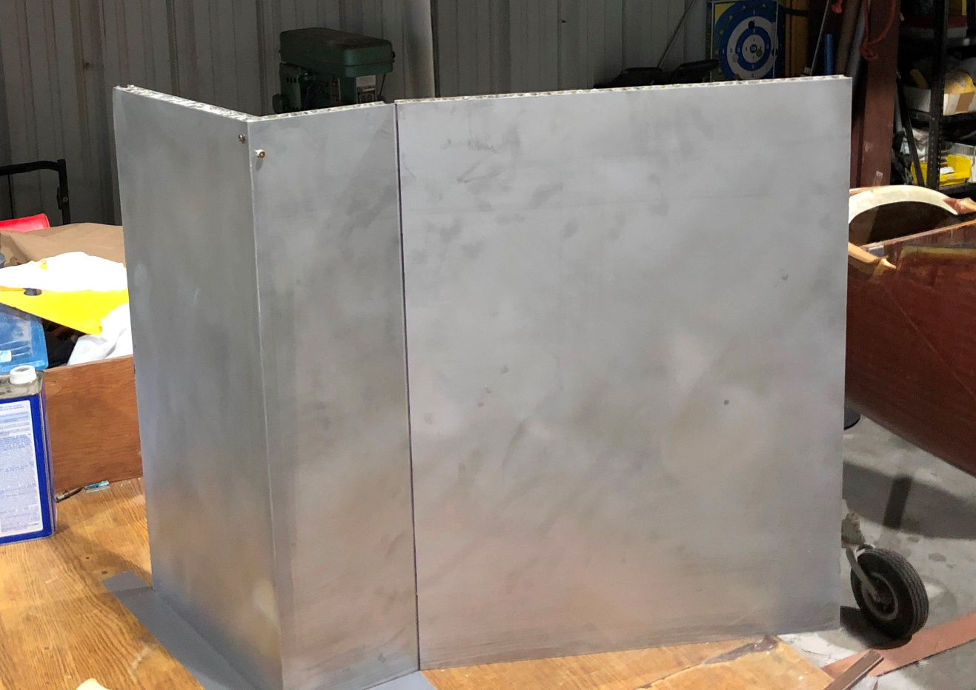
1. Male mold, spar to the left edge, Upper Deck, vertical section, seatback, fuselage floor to the right – Dave used screws to hold the parts together for Bondo fill and added a reinforcement on the back.

I’ve mailed (7/24/19) you a Velum tracing of the Male Mold– it comes in two parts 1. a cross-section tracing of the entire Male Mold – Dave made it a little bit longer than the one photographed to accommodate easier vacuum bagging. 2. A larger velum tracing of the entire bulkhead including guide marks for the Outer Frame and Removable Section and Toilet Seat. I asked if you could do a wet layup without vacuum bagging and he said “certainly not”. The seatback section is the longest section of the Male Mold – he then bent the last ~7” about 30 degrees basically to the vertical, reinforced that with a 1/8” inch aluminum reinforcement on the back that looked to be about 3” wide and riveted that to the honeycomb structure.
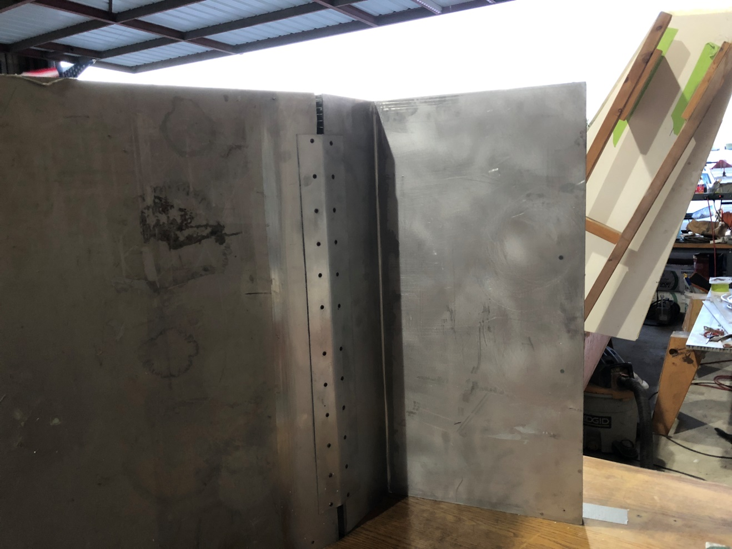
2. Backside of the Male Mold, spar edge to the right, fuselage off the edge of the photo to the left. The dark section between reinforcement and shiny aluminum Upper Deck mold is just a shadow.

He then beveled the front edge of the Upper Deck section of the Male Mold 45 degrees - the silver part of the photo above - and beveled the top edge of the short vertical honeycomb section above the seat to match and Bondoed the two together – at 90 degrees (I see screws used to help hold the angle until Bondo cured) – see the side portion Velum plan. We took the Velum and drew the front seat and vertical section and then we clamped the Velum Upper Deck and drew the lines there too. I’ll try to call the three parts you are creating I. the Outer Frame, II. the Removable Section and III. the Toilet Seat – hinged at the back over the Toilet Seat hole in the Upper Deck. There are reinforcements to be added to the glass and foam along the way, carefully measured and prepared if they are to work right.

OK with the Male Mold constructed, you add the lines from the second Velum, the larger one, I sent you. Dave drew the Outer Frame's perimeter on Velum, it represents the Upper Deck (including "Toilet Seat"), vertical section and the seat back the entire bulkhead. (Those in the US can come use his Male Mold and do the layups.)
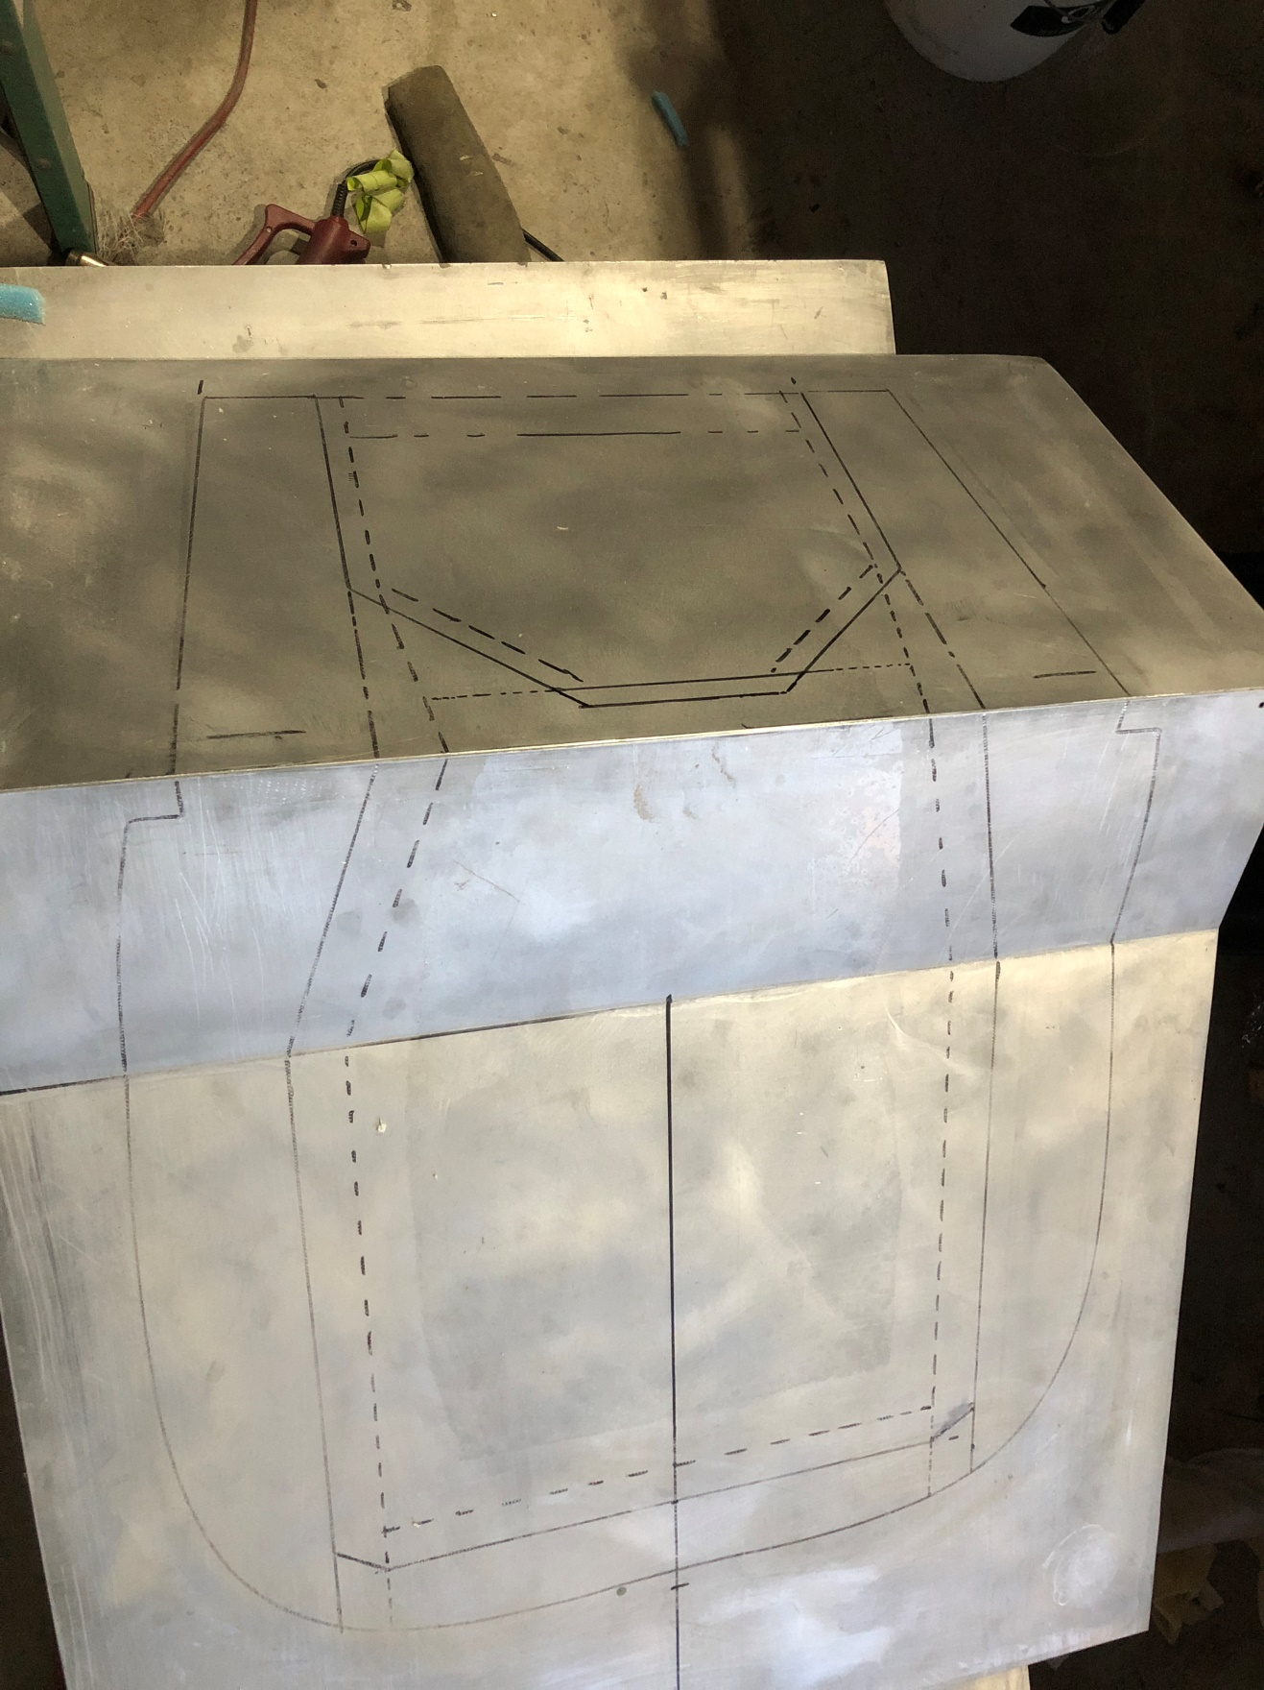
3. These marks help you make the parts in stages.

The dashed line is the cut line – where the Outer Frame Ends. Presuming you lay this in pieces, don’t run the corners of the dashed line sections to double the glass – try to make it remain at 6 plies at all points by making some pieces short of the overlapping corners. With the second layups laying over the dashed line, there will be a small joggle in the second layup where the first 3 plies of glass of the Removable Section are placed and the second prepared foam goes just up to that joggle on the flat part of the 3 ply layup, nearly to the dashed line.

Going from the first line, the outside perimeter, the next line is the line where the Outer Frame foam tapers to nothing, then the dashed cut line referred to above and then the center line. The location of the MG30s and their reinforcements aren’t shown, nor their 4 lines of nutplates.

Here is a top view – same lines with toilet seat junction added:
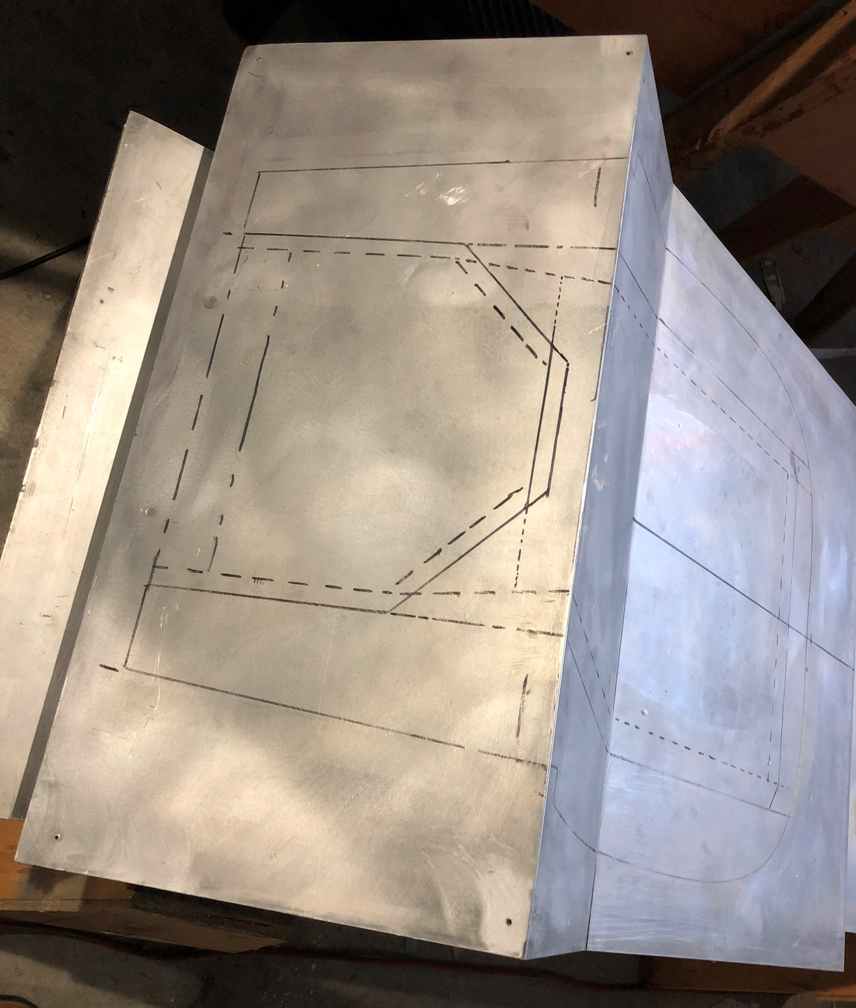
4. The top section of the Male Mold with lines added. You need to measure the distance between the MG30s and draw on this mold the location of the MG30s on the seat section too.

On this drawing the lines from the outside in are the line of the longerons, the next line shows the edge of the tapered foam for the rear 2/3rds. The next line is a dashed line showing the cut line of the Outer Frame which goes all the way to the spar. The angled (45 degree) line is the edge of the foam on the Upper Deck section of the Removable Section (part of the second layup). The dashed angled line is the cut line of the Removable section and roughly where the tapered Toilet Set foam starts.

Not shown, the places where the top deck foam is cut out to place reinforcements essential to the passenger shoulder belt anchors, the places cut out for the gear spring and the tops of the A/H arms near the longerons.

The picture 5 is to give you the goal (in this case before creating raised sections in the top deck for the gear spring and A/H arms at full retract):
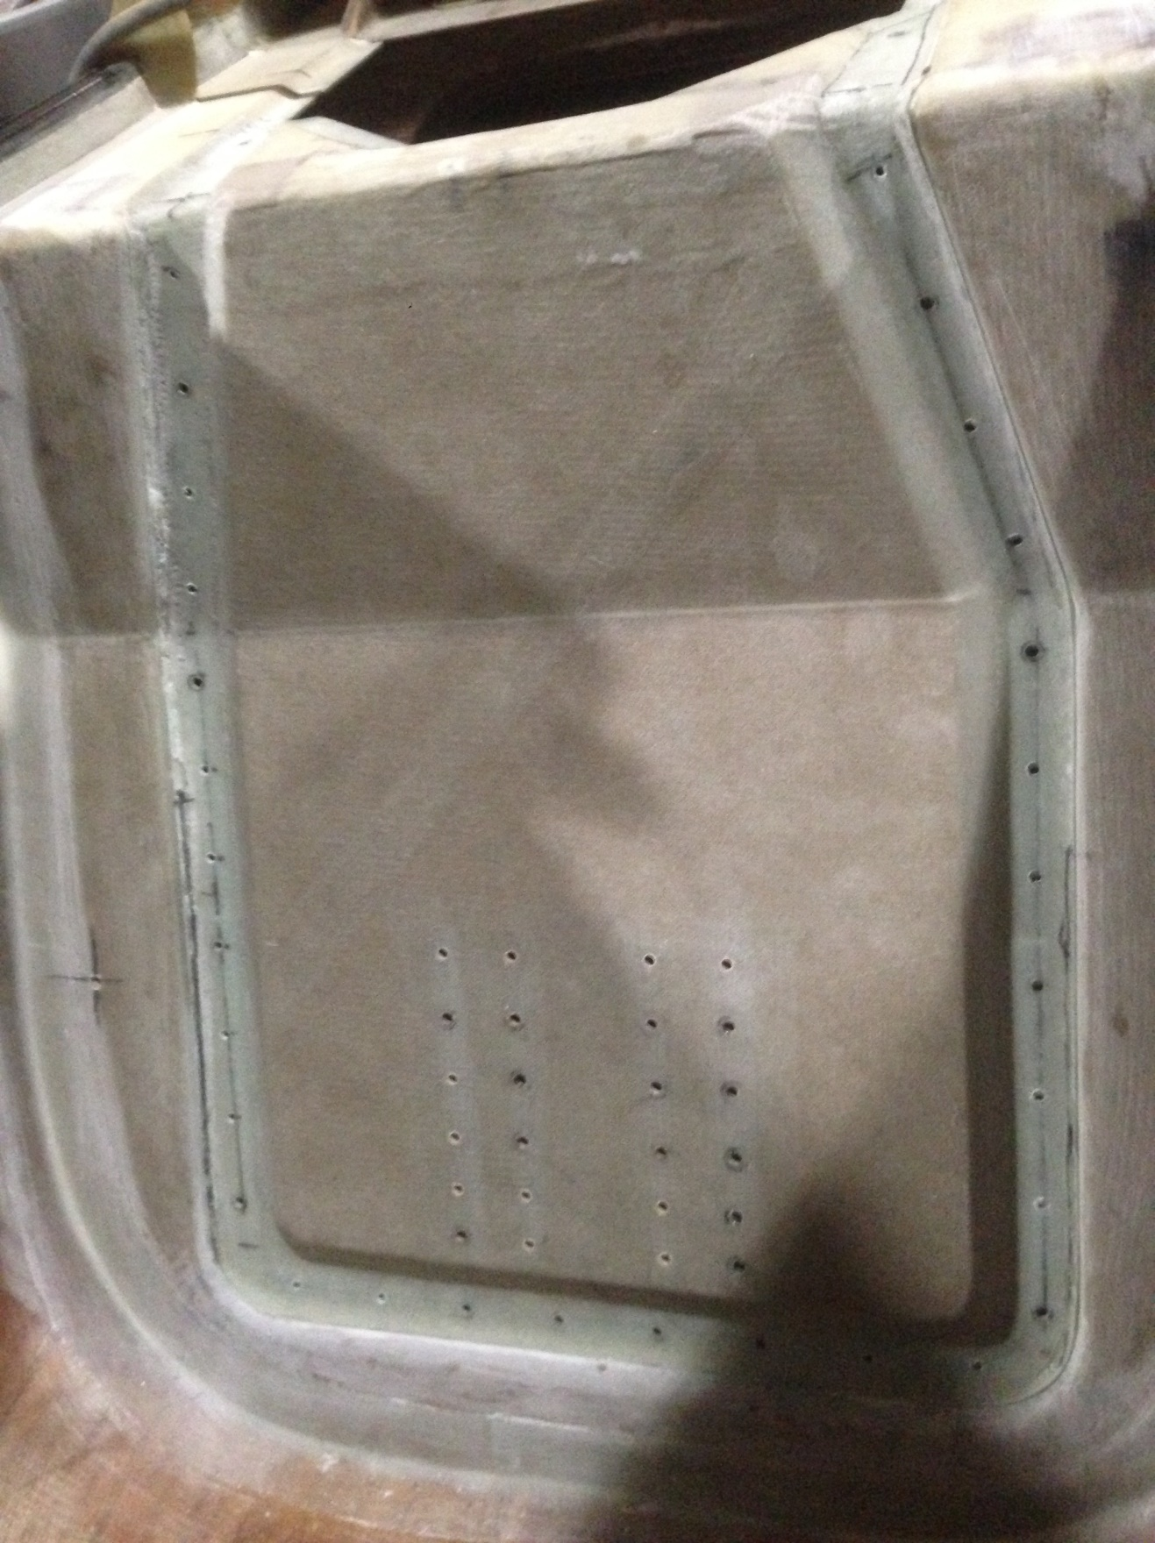
5. The entire bulkhead (no Toilet Seat, the raised covers over the spring and A/H arms in full retract), with Removable section and MG30 reinforcements located but without screws.

DO NOT use this as the next step – this photo is here to show you a close up of where you will eventually go. You haven’t trimmed the Outer Frame yet and a whole lot of other steps. Less than obvious is that there are hard points right in the layups for the 4 rows of screw holes that show through like this (there are 24 holes in this example):
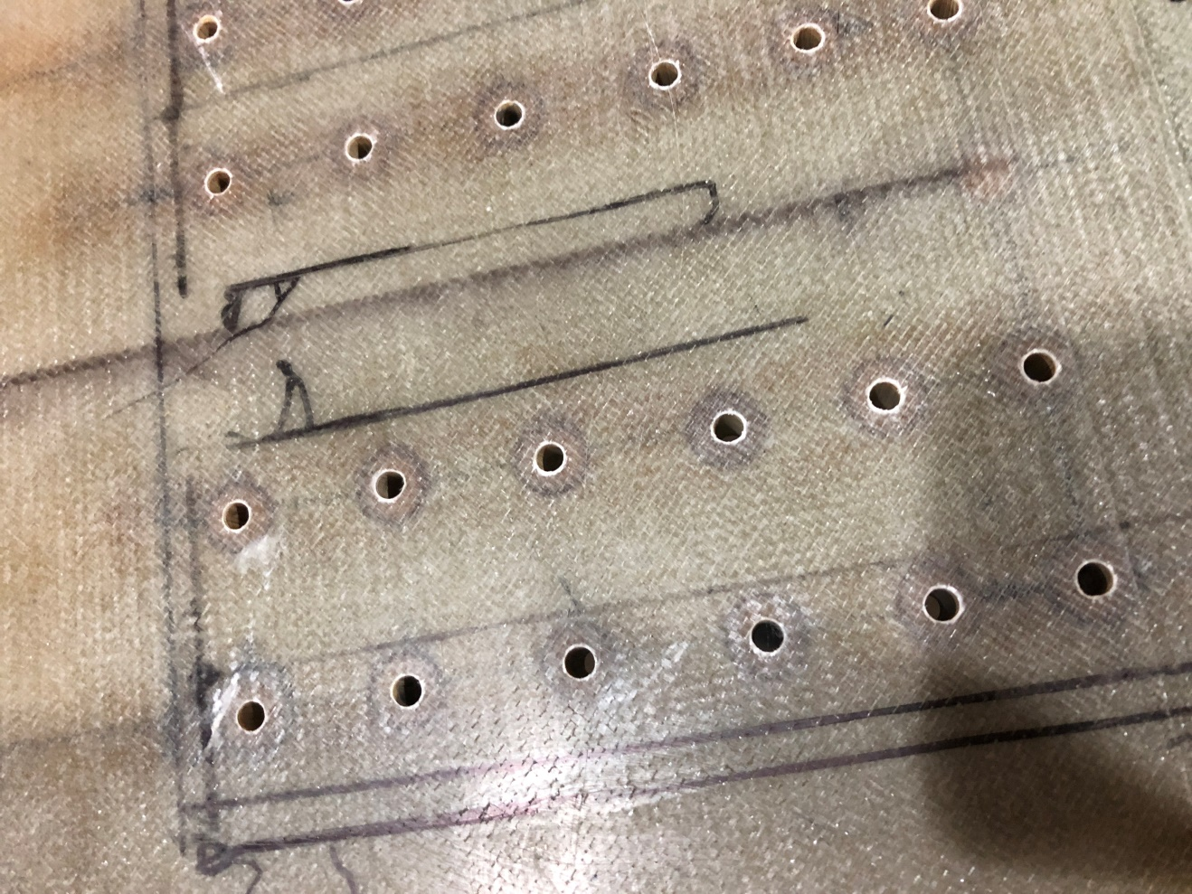
6. The center lines drawn for the MG30s are not shown in either shot but would be between each pair of rows of reinforcement holes here – note the dark ~1” plugs that are as thick as the foam in the seat itself.

Introduction of three layups:
You organize your materials and prepare them, BID, Teflon Tape, vacuum bagging stuff and reinforcements for that layup. You use the Male Mold for 3 different vacuum bagged layups during which you add reinforcements for seat belts, reinforcements for the angle 1/8th inch aluminum angle that holds the seat belt anchor bolts and reinforcements for the parts of the seat where the MG30 loads will go. You finish the three different vacuum bag layups, attach the Removable Section to the Outer frame by nutplates and screws and then you trim the entire bulkhead, making sure the Upper Deck is long enough to clear the front edge of the retracted gear (you move the entire bulkhead forward enough to give the raised gear about ¼” more space in the seat area than the prior seat bulkhead did. Then you cut out holes in the Upper Deck and create raised sections over the main gear spring across the rear and the A/H arms as they rise above the Upper Deck along the sides, create the tabs for the MG30 to seat back connection, add the nutplates and screws there and then micro and tape the entire bulkhead, fully assembled into the fuselage. [Dave, how can you place the edge against the spar if you don’t have the cutouts in the Upper Deck done – or conversely how can you make the cutouts in the Upper Deck if you haven’t figured out how far forward the Upper Deck is from the spar?]
Materials and Preparation:
You carefully apply mold release on the Male Mold, then redo the lines so they transfer to your parts. You can use West System Epoxy and this is such a complex set of layups you should use slow hardener. You cut out the foam pieces before each layup and taper them and lay the reinforcement pieces on top and cut out the foam as described below, you cut out and trial fit and carefully stack your BID pieces, trial fit your Teflon tape on the Male Mold and create the many reinforcement pieces, including rounding the edge to match the foam at the intersection of the vertical section and the top deck. Dave suggests you use 5 minute epoxy thickened with micro to join the foam that goes front and top of the top deck edge before doing the actual layups. He also suggests a simple row of holes in the pieces of foam to let out the epoxy under vacuum. The foam on the top deck is made of ¼” 4 lb PVC foam, the foam facing forward and in the seat facing mostly forward, is made of ½ to ¾” 4 lb PVC. You also cut out and trial fit the release film, the vacuum bag material and the bleeder. You should have 4 rolls of bag seal tape.
We have no photo of the Outer Frame foam in the first layup, but see photo 10 for the general idea to help you make the Outer Frame foam pieces. You then make up 4 2”x2”x¼” Phenolic or G10 hard points (NOT WOOD), round the leading edge of the top deck. Two of these are for the second layup.
To prepare for the second layup you make the 24 thicker MG30 related reinforcement circles or drums – they are as thick as the thicker PVC foam you’ve chosen for the seat. Dave suggests you pick some simple hole saws to cut the MG30 related reinforcement circles as your actual width guides, use the larger of two closely sized hole saws, no less than ¾” in diameter to cut out the reinforcements from flat bar (phenolic or G10) stock and sand them down to the thickness of the thicker PVC foam. Pick the next smaller hole saw and use it to cut out the foam after you have created and checked the pattern reflected in photo 6, above. Because Dave initially built the two prior seats in a different order, he hasn’t added the MG30 tab lines and reinforcement lines to the Male Mold or the seat foam in his photos, but now you need to locate the position of your MG30s relative to the drawn centerline of the Removable Section (obviously the MG30s go to the floor and the Removable Section starts about 2 inches above that) and then identify where the ¾” glass to glass tab edges will go so you can draw four lines for the reinforcements that will be in conjunction with tabs and nutplates put in later. I’d mark the MG30s right on the Male Mold so you can see the marks through the first layer of 3 ply BID. Then when you trial fit the foam, you transfer those marks to the foam, add horizontal tick marks every 1.5” to indicate where you will drill pilot holes and install nutplates eventually. Then drill the 20 or 24 phenolic circles described, with the next smaller hole saw.
For each lay up you put down 3 plies of BID, then the foam and reinforcements (layup 1 and 2) and then the last 3 plies of BID and vacuum bag. Layups 2 and 3 lay on the edge of the prior layups, placed back on the mold.
Before the first layup, you lay 2 of the 4 rectangular reinforcements on top of the foam and razor cut out the foam to recess the reinforcements in the leading edge of the Upper Deck, rounding the front edge – the foam gets rounded too. Virtually all foam edges facing the cut line are beveled at about a 45 degree angle. (You do not bevel the outside of the Outer Frame to fuselage side, bottom, longerons and spar end here. The reinforcements drop in, right on the first 3 plies and match the foam for top deck and seat.
You already have the Berkut original "Toilet Seat part" in your flat stock - it describes the separation (the perimeter) of the Toilet Seat which overlaps the Outer Frame’s glass to glass section by ¾” for the sides and forward edge. That original part is helpful to look at in understanding the marks you have made on the Male Mold. Dave, does the original Toilet Seat part have the raised portions for spring and A/H arms? The final connections between parts will, by design, have some little ¾” valleys, or depressions (as in photo 11 & 17) running along the joints, your passenger won’t feel them as they are quite easily handled by the upholstery.
There is the dashed inward cut line on the Male Mold which shows the Outer Frame’s intrusion into the seat, vertical and top deck. The Removable Section overlaps the Outer Frame and is more than just the removable seat, it includes the vertical section above the seat, the front of the Upper Deck and includes it’s own reinforced corners that are later bolted to the angle iron that runs across that top corner behind the vertical section and under the leading edge of the top deck. Only the middle portion of the seat and Upper Deck will be removable. You make the Toilet Seat on the Male Mold but the Toilet Seat is technically not removable after you hinge it to the spar. For the non-removable part which I’ve been calling the “Outer Frame”, you need to leave the sides of the Toilet Seat frame, the outer parts of the forward facing bulkhead and the edges of the seat bulkhead in that whole Outer Frame and you lay it up first – it is kind of a large conformal “U” shape, from spar at the rear around the entire bulkhead to the spar on the other side. The frame needs to be as big as the fuselage it fits into, so you make the foam (and both 3 BID parts of the layup) extend beyond the outer line by ¼” to ½” and later trim the entire bulkhead down to fit. The glass to glass section of the Removable Section overlaps that glass to glass section of the Outer Frame, the glass to glass sections of the Toilet seat overlay the Outer Frame on the sides and the Removable Section. Each glass to glass section of the Outer Frame and later for the Removable Section is a total of 6 BID plies for sufficient strength – 3 BID plies laid right on the Male Mold side and 3 BID plies round out each layup. Obviously the successive layups will have glass to glass section laid up on the 6 ply BID thickness of the Outer Frame glass to glass section already present in the Outer Frame on the mold when you get to the second vacuum bagging.
So as you build the foam pieces they go from the second solid line on the Male Mold for the Outer Frame layup and extend beyond the outer solid line. When you go to the next stage the foam pieces start at the joggle just inside the dashed line on the Removable Section for the second layup, including the top deck.
- The Outer Frame Layup:
You lay down the first 3 plies of BID on the 45 degrees from beyond the outer line to and slightly beyond the dashed line, right on the Male Mold. Be sure you have at least ½” of extra BID, foam and BID at the spar line. Keep moving with this layup.
Then you place the Outer Frame foam with the beveled edge on the BID right up to the second solid line and insert the 2 rounded reinforcement pieces.
Then you lay down the second set of 3 plies of BID of the Outer Frame again wider than the outer fuselage lines (the whole to be trimmed much later to fit the fuselage/longerons/spar after final construction of the entire bulkhead). The second layup goes ¾” beyond the beveled foam and beyond the dashed line. Then place your Teflon take and Vacuum Bag.
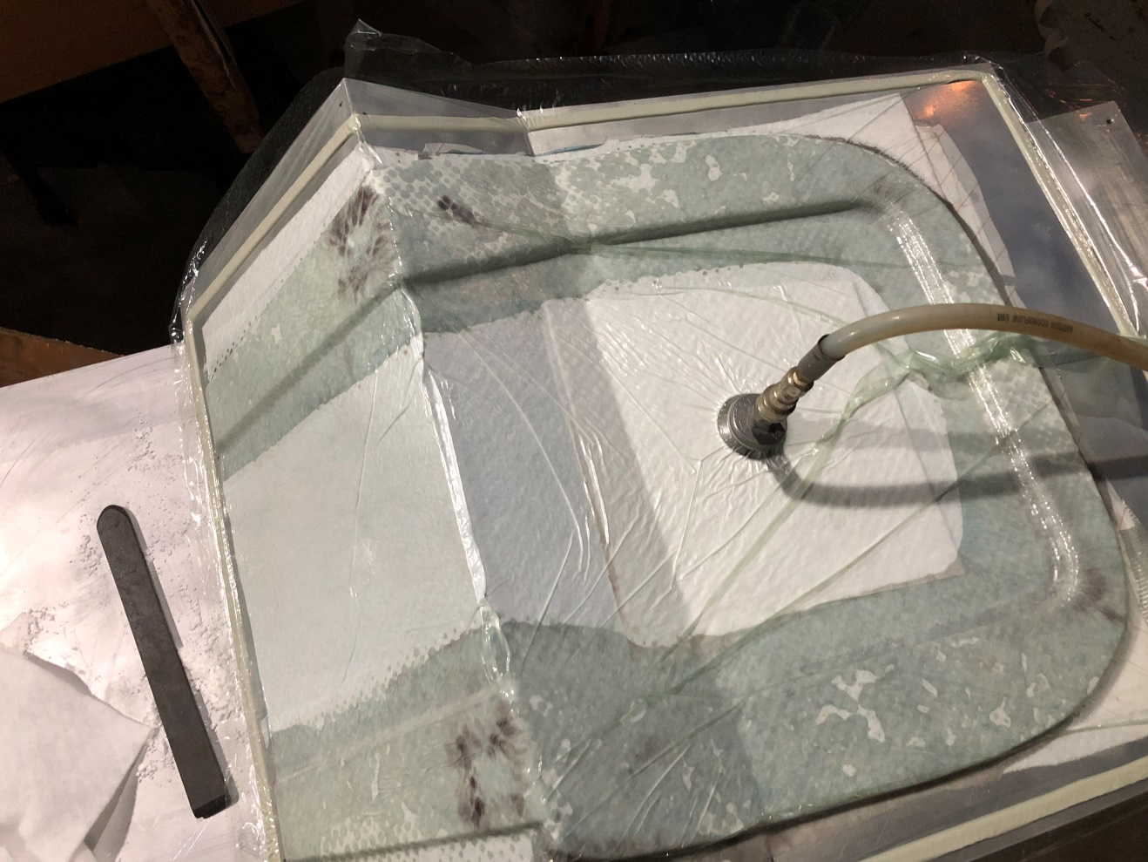
7. The Upper Deck is to the left, the bottom of the fuselage to the right. Note the dark 2”x2” phenolic reinforcements peeping through the bagging material the sharp corner rounded.

Basically, the cut line is near the edge of the whiter section in the middle of the above photo – you remove the cured piece, trim that ¾” edge to the cut line, smooth any rough spots on that glass to glass edge and place it back on the mold for the next step. This is my fuzzy picture of the finished unit with the Removable Section removed at a later stage:
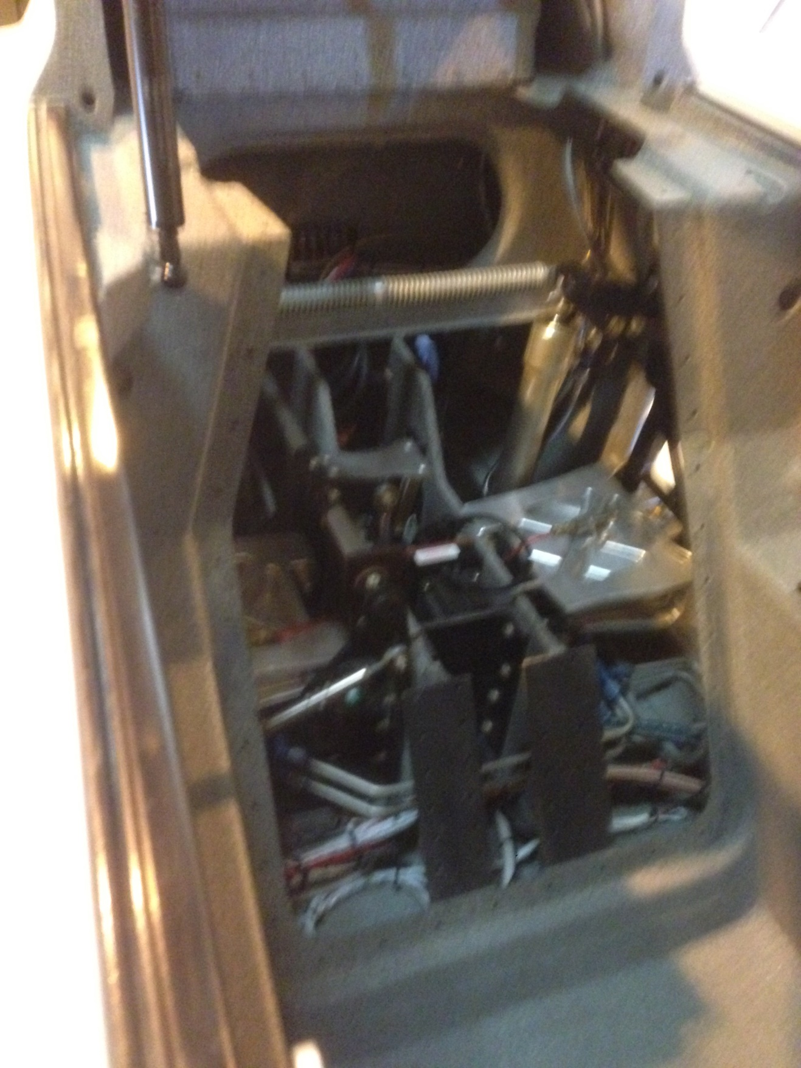
8. A finished Removable Frame – armrests in place

- The Removable Section Layup:

You already have the extra pair of 2”x2”x¼” phenolic or G10 hard points, rounded on the forward edge to put on the top deck of the Male Mold – Dave’s later photo #10 shows the foam cut away for this…you can see that the sides of these two hard points will need to be beveled in two more directions to match both the horizontal and vertical foam it sits within.
Right on the foam, you should have marked out the line for the holes about 1.5” apart vertically starting just above the ¾” glass to glass section and ¾” to each side of the center of the two MG30 lines you have drawn. You should have something like 24 holes cut out of the foam where you will place the reinforcement circles (or drums or plugs). You need hard points above both sides of each MG30, (eventually there will be 4 lines of nutplates, 4 lines of screws, two of those lines, one inboard and outboard of each MG30 line. With these reinforcements cut and ready to place in holes in the foam, and with all 6 BID plies of BID cut on the 45 for the second layup (all the way up to the Toilet Seat) the Teflon tape ready to go, all the vacuum bag materials to go over the new layup area and the already built Outer Frame, you are almost ready mix epoxy.
When all that preparation is done, you put Teflon tape over most of the Outer Frame and particularly on the Glass to Glass section of the Outer Frame and down onto the Male Mold. Dave used some release tape (in the photos) and it didn’t work that well, so he hopes you use Teflon tape.

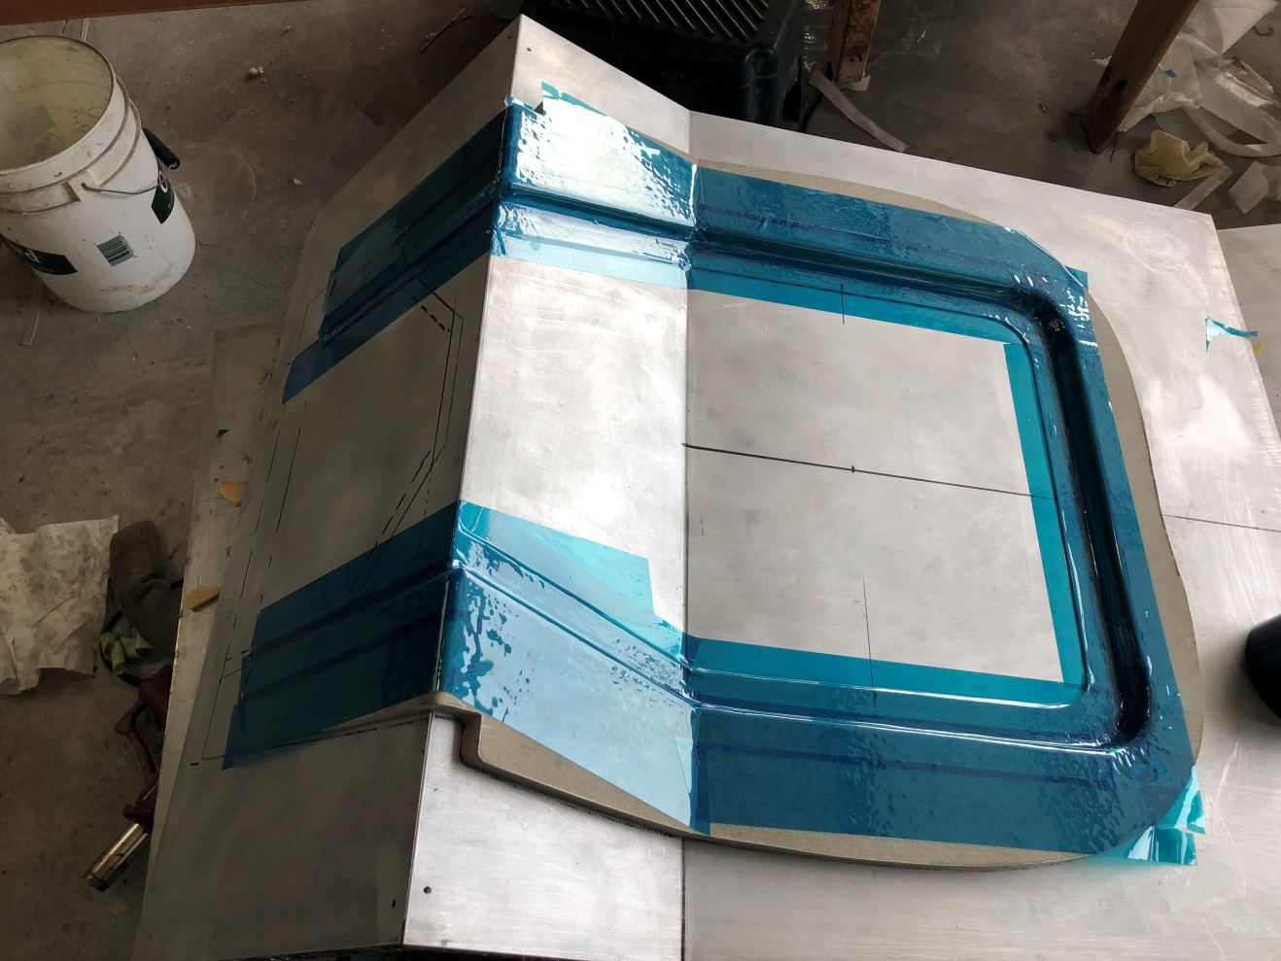
9. Here the Outer Frame – both side glassed and all cured, trimmed and installed back on the Male Mold and the intersection is to be protected by Teflon tape where this blue tape is located.

Dave’s next photo does shows the trial placement of the foam for the entire Removable section:
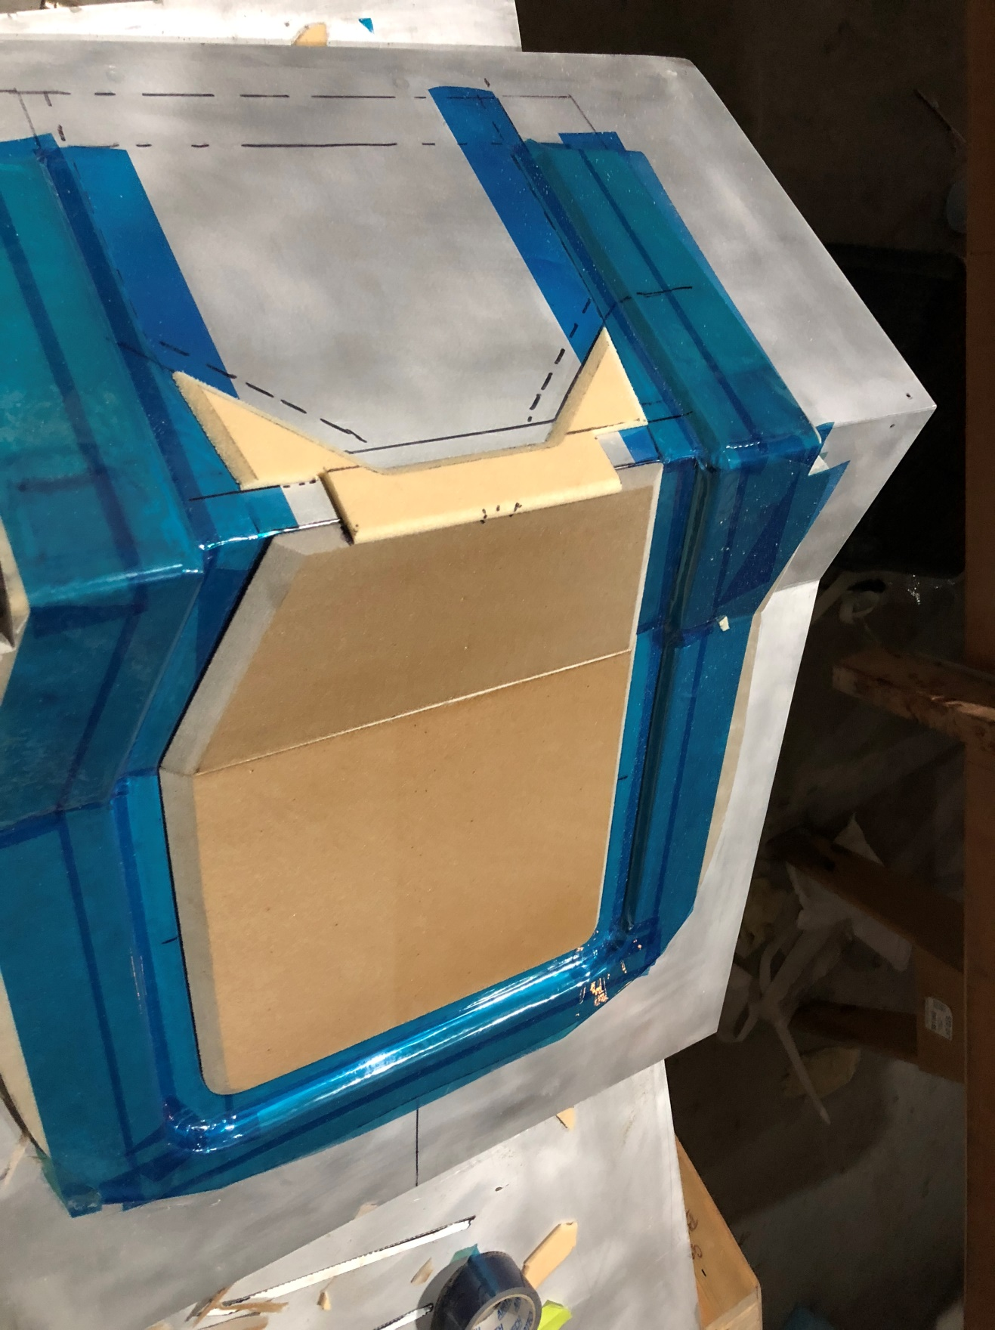*
10. Dave has left the 2”x2” square reinforcements out of this photo, but I think there is some more shaping needed to conform them to the bevels of the thicker foam on the vertical and thinner foam on the top deck foam shown.
You apply the first 3 plies of BID from a little way up the Outer Frame beveled section right across to the Outer Frame beveled section on the other side to be sure you cover the ¾” glass to glass section of the Outer Frame, all the way up and over the 90 degree bend onto the Upper Deck, beyond the line that will be the opening under the Toilet Seat (the seat will overlap the glass to glass section you create over onto the top deck. After you place the foam, you insert the remaining 2”x2” reinforcements in the leading edge of the Removable Section, then add the round MG30 reinforcements down the 4 vertical lines, 1 line each side of the MG30 lines you have drawn and cut out from the foam. Then you lay up the second set of 3 BID plies, again on the 45 on the whole Removable Section, all edges having ¾” of glass to glass surface, and you vacuum bag.

When cured you remove and sand all edges so that ¾” Glass to Glass sections extend to over the Outer Frame ¾” Glass to Glass sections all around, and sand the new ¾” Glass to Glass edge on the Upper Deck smooth for the next layup. You do not add any nutplates now. You place the Outer Section and align the Removable Section back on the Male Mold carefully checking the centerline and carefully drill pilot holes for nutplates all the way around the overlapping surface of the Removable Section and Outer Frame about 1.5” apart.

This front scene is not shown in Dave’s photos, but I have one of the Berkut he just finished:
11. Shown early to show you where the perimenter screw holes will go, he put the MG30 reinforcement holes closer together.

DAVE, didn’t you say to do the seat back reinforcements 1.5” apart – these look more like 1” apart…
BUT AGAIN, DO NOT PUT THE NUT PLATES ON YET – you have to put it back on the Male Mold for the last part.

- Toilet Seat Layup:
You have trimmed the toilet seat edge of the Removable Section you already built. Then you add Teflon tape and you lay up the Toilet Seat with the rear edge long on the Male Mold. 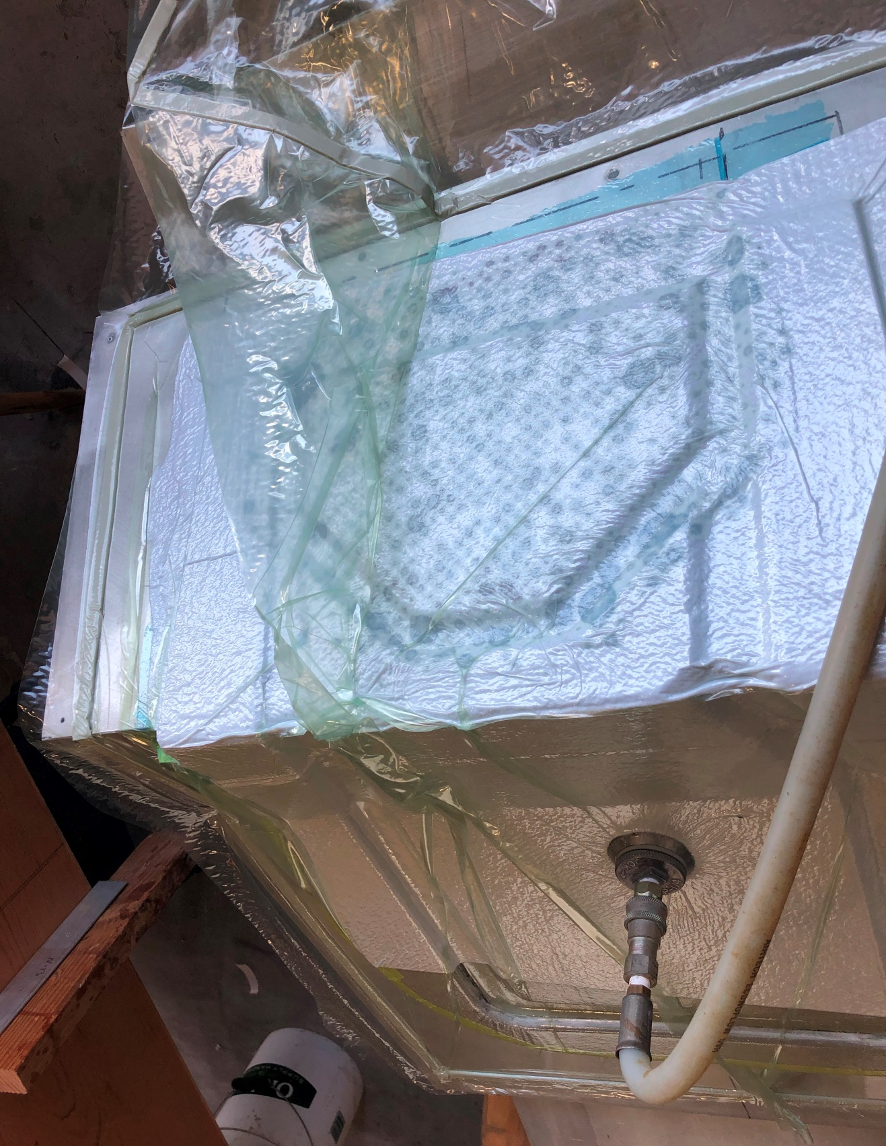
12. With this third part in the mold, you can see why nut plates are not attached to the two prior layups, they’d raise the parts off the mold.

When cured, drill 3 pilot holes in the leading edge of the toilet Seat to provide guidance when the Toilet Seat is adjusted to the Spar – then set the Toilet Seat aside. You can use the center hole later to tap threads into the aluminum cross brace for a #10 screw to keep the Toilet Seat down in flight. Install the nutplates to the back of inside inner rim of the Outer Frame and secure the Removable Section inside the Outer Frame with screws, you won’t be using the Male Mold from here out.

There is a wonderful reversible tool for doing nutplates – I don’t know where you get it – but maybe Aircraft Spruce has them – here are the two sides of the head:
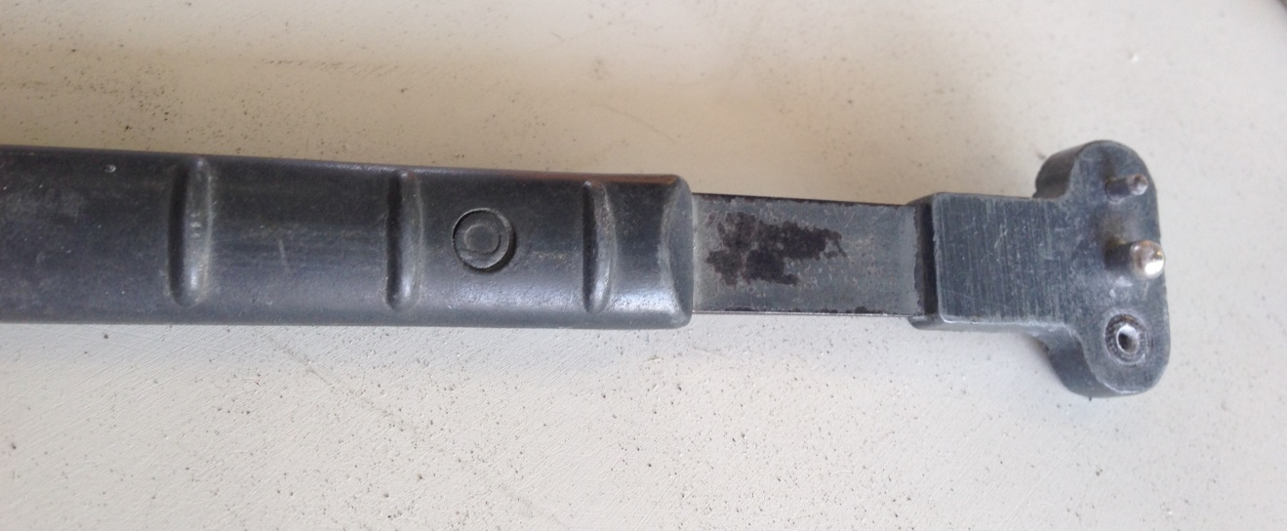
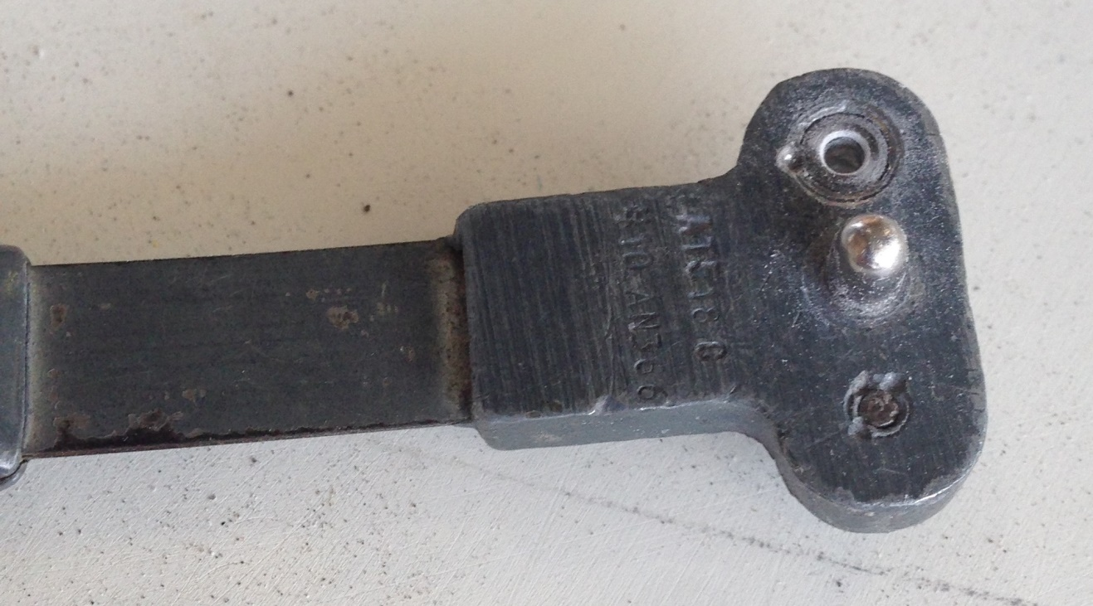
13 & 14 Nut plate tool

IV. Trim the entire perimeter to fit inside the fuselage leaving the spar edge to last. This is done with the Entire Bulkhead, with the Removable Section secured to the Outer Frame, the Toilet Seat set aside. You obviously have to trim a little at a time, trial fitting where the fuselage is wider and sliding it aft until the Upper Deck reaches the spar and is horizontal in reference to the longerons.

- Adjust overall length of Upper Deck:
Dave found that the molded design he built, when it reached the spar in the original bulkhead position, slightly impacted the main gear legs at the upper castings in full retraction – so he suggests when you are trimming the fuselage and longeron edge of the Outer Frame to fit the fuselage that you delay trimming the rear edge of Outer Frame and trim the Toilet Seat last. Put the plane up on stands, gear up. Start by sliding the entire Outer Frame and Removable Section on the floor about ¼” to ½” forward of the original seat position and check clearance with the entire gear system when retracted. You’ll find that the Gear Spring and the upper A&H arms will keep the upper deck from dropping down to the spar, but concentrate first on the forward side of the retracted gear and where the seat will be if you give yourself ¼” of clearance ahead of the forward upper edge of the main gear. Then you trim the trailing edge of the Outer Frame to the spar there. The Upper Deck itself should be horizontal, to get it horizontal, you will need to lower the gear again and using the upper longerons as a horizontal reference, placing the upper deck’s upper skin in line with the upper skin of the spar as your elevation. As you slide the Entire Bulkhead aft through this whole process, you will likely need to trim the outer perimeter of the entire bulkhead a little too as the fuselage narrows, so leave the Removable Section firmly screwed to the Outer Frame.

When you check the Upper Deck length to clear the forward side of the main gear by ¼” where it is closest to the seat, you cut off the Outer Frame rear edge (both tips) to a length that allows you to retain as much cockpit space as the gear allows. (You will eventually trim the toilet seat.) In other words, by the amount you ended up lengthening the top deck, you will also be moving the entire bulkhead forward on the floor (compared to the old seat bulkhead location) – it won’t be much, just enough to clear the main gear by ¼” when retracted. After all parts (except the Toilet Seat) are built and check fitted, you remove and cut back the lower skin of the Outer Frame ¾”, taper the ¼” foam so you can make a rear glass to glass edge of a full ¾” on both tips, leaving the top 3 BID skin and add 3 plies lapping onto the underside to complete that glass to glass edge. Later you glass the Outer Frame to the spar, top and bottom, but not yet.

- The pockets in the Outer Frame and Toilet seat for the Gear Spring and A/H Arms in retract.

With the gear up, the A/H Arms would smack the underside of the Outer Frame and Toilet Seat near the upper longerons and the Spring that comes up with them would rise back near the spar as well. Look again at Photo 8 back near the spar – you can see a raised section of the Outer Frame – that section was not created on the Male Mold – first with the gear nearly up, you need to cut the top of the Outer Frame and Toilet seat where the upper gear parts are going to touch. Give yourself a ¼” clearance around these three areas, until the Outer Frame and remaining Toilet Seat fit flat as the Upper Deck. Then you duct tape a ¼” of foam over the A/H arms and cut a plastic pipe in half lengthwise and put it over the Spring, cover it with duct tape and lay up the raised portions of the Outer Frame and Toilet Seat, laying 3 plies of BID on the top side, pull the layup free when cured, sand the underside of each and lay up 3 more plies of BID from the inside skin of your new parts to the outer skin of Outer Frame and Toilet Seat. Run the gear to full up with the Entire Bulkhead in position to see there are no gear parts hitting the bulkhead anywhere. Dave do you do the trailing edge glass to glass and beveled foam before or after this step?

VII. The Tabs from MG30 to seat – vital strength:
Before you finally install the Entire Bulkhead, you build the “tabs” (reinforcements) to join the seat to the MG30s with double rows of screws and nutplates.

Place the Entire Bulkhead (Removable Section screwed into place) into final position (gear up and down as you need), go in through the gear holes or the Toilet Seat hole and mark the two MG30 bulkhead locations on the back of the Removable Section and remove the Entire Bulkhead – confirm you have the lines on the front of the seat for the MG30s about where they are on the rear of the seat and that the reinforcement disks will be fully engaged. Place Duct Tape on the back of the seat from well over an inch beyond the MG30 marks you made there and lay up the 3 plies of BID across the entire section – extend the 3 plies of BID the whole way from at least 1 inch outboard of one MG30 line (covering all the reinforcement circles or drums you placed in the seat) and to at least 1 inch beyond the other MG30 line.

Then you build up the MG30s to meet the seat using stiff micro because you introduced a gap by moving the Entire Bulkhead forward to avoid the main gear’s leading edge impacting the seat. 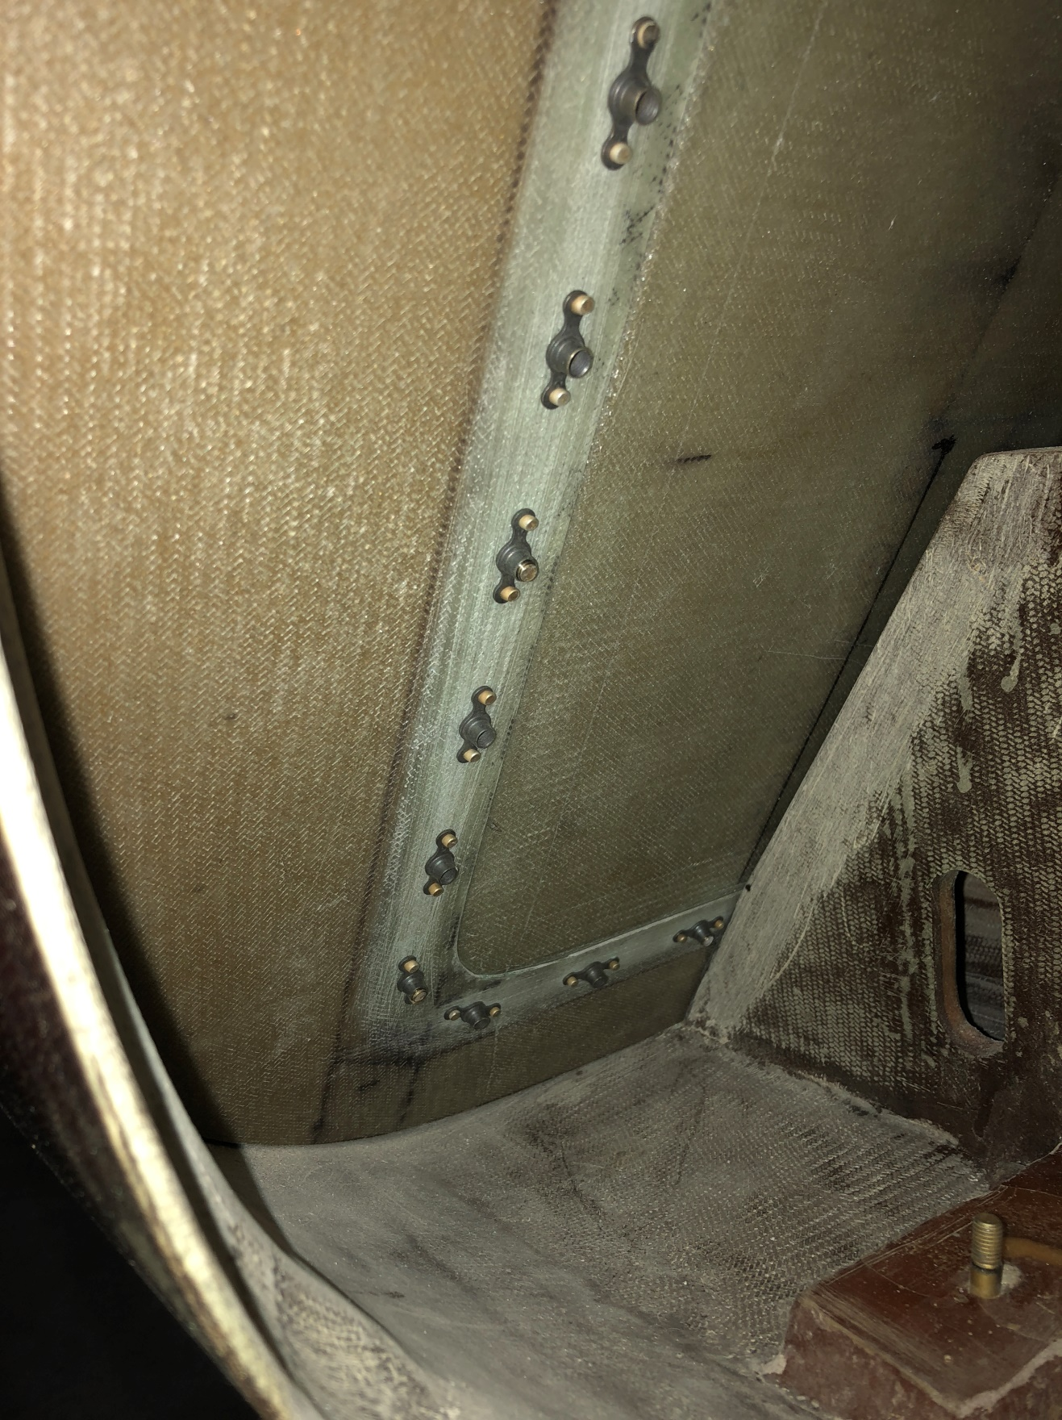
15. In this case the Duct Tape has not been applied to the seat back yet.

Then you add T tabs from the MG30 outsides to the seat back mounted glass on the duct tape, with the Entire Bulkhead in final position – and some wooden laths to hold it fully aft. Imagine this BID rectangle, the inside tapes first go on the outer sides of the MG30s, creating each outboard tab, then after you cut the center out of that 3 ply BID rectangle you get what you can see in photo 8, and add 3 ply BID tapes on the inside of the MG30s to the new two smaller rectangles shown, matching those on the outside of the MG30s. You also put 6 ply tapes between the MG30s and the Outer Frame below the opening above the fuselage floor to add strength to the MG30. When cured, you common drill through the phenolic hard points installed in the Removable Section (seat section) and on through these finished 6 ply tabs, install the nutplates on the back of these tabs (as in photo 16). So 4 rows of nutplates running 1.5” apart vertically. Dave, your photo showed them a 1” apart as above.
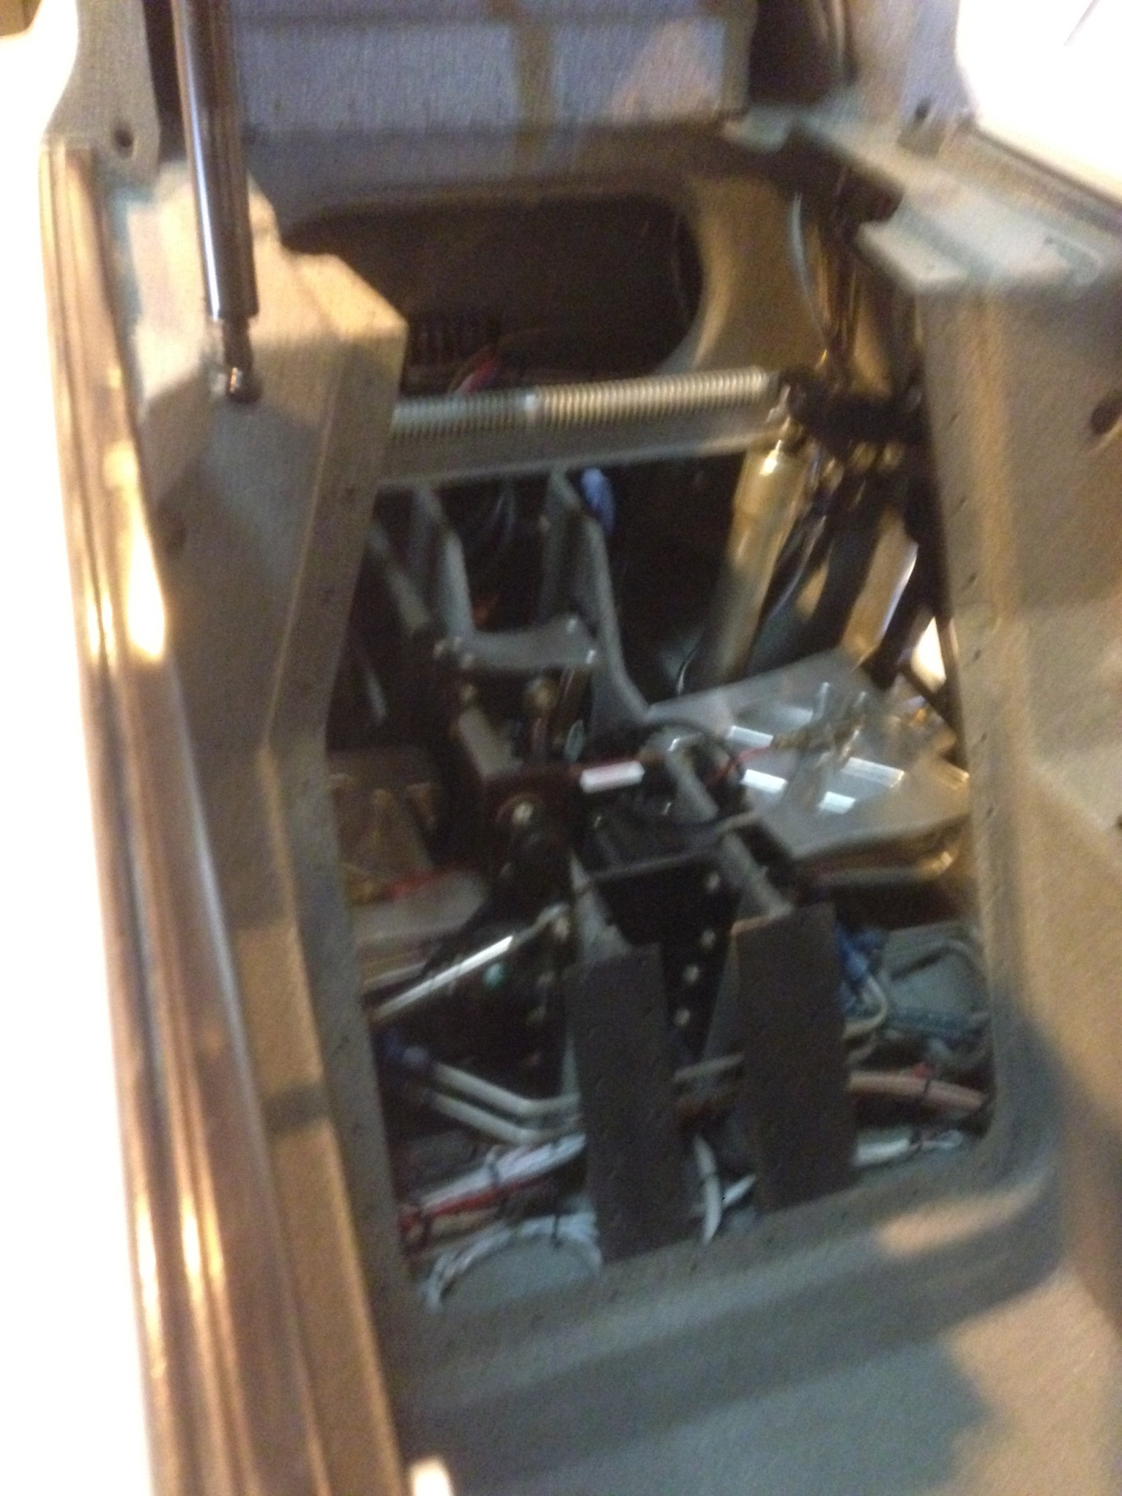8. Photo again out of focus – note the completed MG30 tabs, the original rectangle cut into two pieces (and the bolt holes you can’t see in the dark tabs in this photo).

Below is what the final picture looks like (you can see the inside tab of the far MG30:
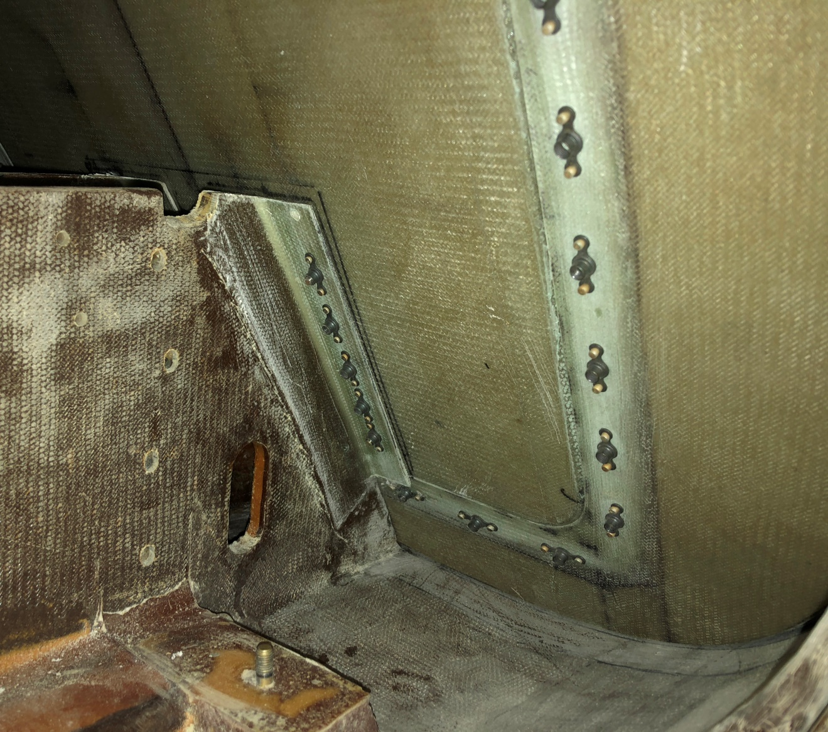
16. The nut plates on the MG30 tabs. (20 in this case)

VIII: Taping the Entire Bulkhead to the Fuselage
The Entire Bulkhead has been fitted, removed and replaced a few times. Now you place it in position just like the other bulkheads you have installed, first egg out a little of the foam so you have a micro edge. Be sure to leave the Removable Section screwed firmly to the Outer Frame as you fit it, and when you have reached all the places with tapes you can without removing the Removable Section and tape the Outer Frame to the spar both sides, let it cure and then you remove the Removable Section and sand for and tape the remainder of the connections of fuselage/longerons and the Outer Frame. Because the MG30 to Outer Frame also needs special reinforcement you also run some 6 ply BID tapes from the MG30 to the bottom of the Outer Frame too, taking care not to fill the nut plates nearby with epoxy. You may need micro as Dave did here before you tape:
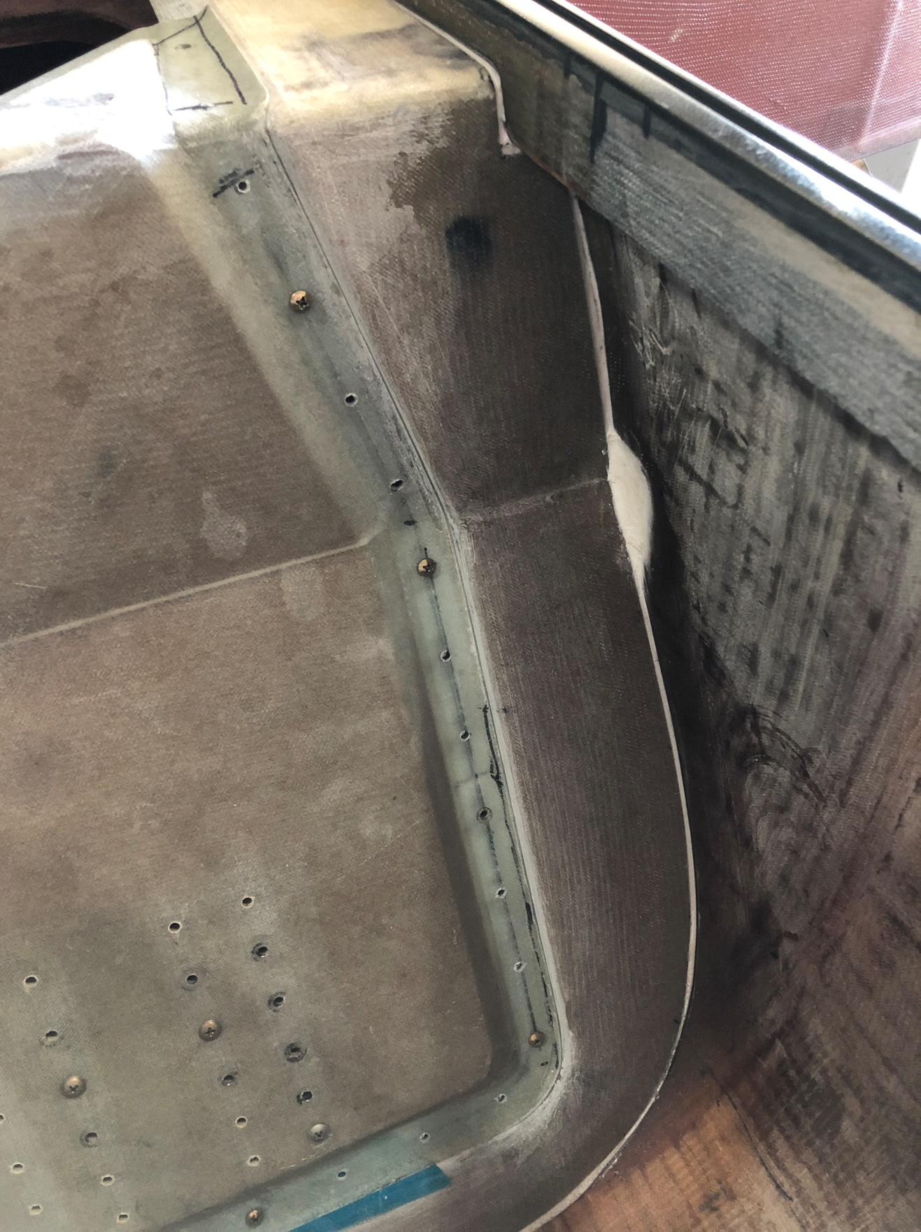
17. Final fitting of the entire bulkhead, using micro.

VIII: The Toilet Seat to spar connection:
After all parts (except the Toilet Seat) are built (and the Outer Bulkhead modified and installed, the Toilet Seat modified to clear the gear, you use the guide holes to trim and fit the Toilet Seat all the way to the spar. You cut back the lower skin of the upper Toilet seat edge along the spar edge, taper the ¼” foam, if any left so you can make a rear glass to glass edge there a full ¾”, leaving the top skin 3 of the plies and add 3 plies lapping onto the underside of the Toilet Seat to complete that glass to glass edge.

When cured you place a 2” wide hinge on the Toilet seat, first rivet it with hard pop rivets to the 6 ply trailing edge of the Toilet Seat, drill the holes (smaller than the screws) through the leading edge of the spar (The actual spar cap is further aft) and insert self-tapping ¼” long screws to hold the toilet seat.

Then you are done.

