>
So how do you mount a return line into a closed strake insuring fuel does not leak into the foam? Seemed tough with the strake open.
______________________________________________________________________________________________________________

You could use the same technique I used when I retrofitted vents in my Velocity, just invert it as shown here.
.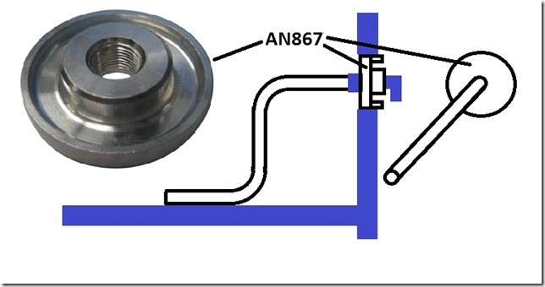
Using a hole-saw. cut a hole through the fuselage side of the strake skin big enough for a welding flange of the appropriate size.
Clean out the foam using a drill and a wire brush attachment until you have a good bonding surface on the exposed glass.
You’ll need to cut a hole in the center large enough to accommodate the AN fitting. The pilot drill bit will retain the waste if you use a hole saw of roughly 7/8”.
Tap the inner side of the welding flange with the same pipe thread as the outer enough to get a AN Fitting on the inside of the tank.
Add a “S” shaped piece of aluminum tubing on the inside AN fitting.
When you flox the welding flange in place, rotate it until you feel it hit the bottom of the tank.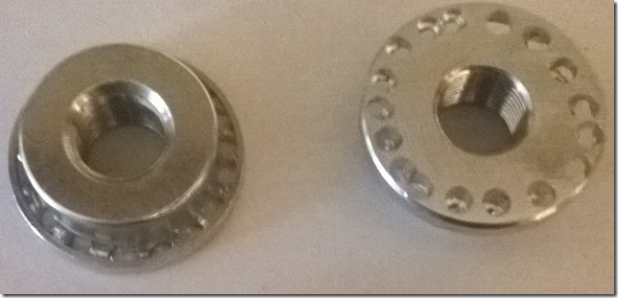
It also helps if you drill holes in the low portion of the perimeter of the flange to form flox rivets.

After doing this in my Velocity I would definitely consider this approach to be viable.

T Mann

