This was a question started by Ryszard Zadow Who runs the Rutan Aircraft Flying Experience Museum (RutanAFE@gmail.com) He has summarized it and includes some other deep water feats – like Australia-New Zealand.

David Orr: I’ve always considered the North Atlantic or any deep sea crossing in a single kind of stupid – the stupidest was the crossing of the Southern Oceans by Dick and Mike – I was tempted to cross when I owned a Defiant for 12 years but was too busy with family and career. My earlier notes are in library item 29SIII3 Nov 2013: Discussion on flying the North Atlantic.
These folks have flown the Atlantic twice:
PATRICK C. & LINDA ELLIOTT 33 Smoke Lane, Reigate, Surrey RH2 7HJ England 1737-243074 l.p@talk21.com Long-EZ:G-LGEZ 900 hrs O-320-D3G Dunsfold Aerodrome [EGTD]
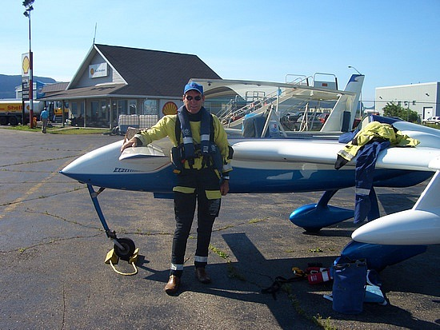
Library item 29SIII5 Sep 2011: Round-the-Worlders the Elliotts – by Rousseau
Prior Member of Central States: JUAN R. RIVERA 3611 Hunters Sound, San Antonio, TX 78230 210-492-8022 210-289-1517 was: San Diego, CA Long-EZ:N7047Q 975 lbs 1050 hrs O-320 California/Florida to Europe Sep '89 (Kit Plane Nov 1990 pg 52) Castroville Airport (T89)
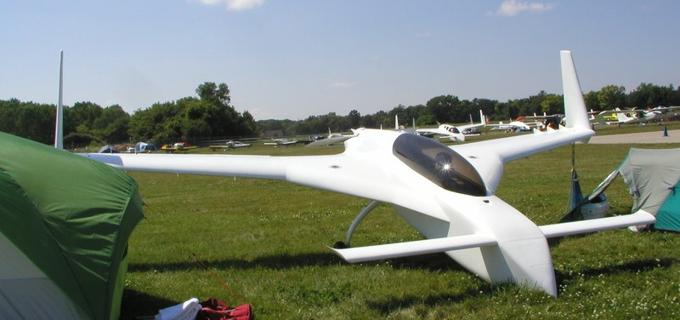
29Kit Plane Nov 1990, page 52: "Atlantic Long-EZ Crossing".

Varieze:N24RW 3900 hrs. flew to Ireland and back. TOLCHIN M.D., SIDNEY “BADWEATHER” 9804 Grandview Dr., La Mesa, CA 91941-5622 619-448-9222 Retired USN, Neurosurgeon, Antartic survival.

Article 29EM2: Jul 1999: Crossing the Atlantic in an EZ in 1987 by Sid Tolchin

Article 29SIII9 Dec 2009 Flight to Shannon by Sid Tolchin

This guy flew to Europe from South America and then to Oshkosh:
DeBERDT, ANDRE JOSEPH Long-EZ: DeRegistered: PP-ZAD flew to OSH a couple of times, crashed and died in Chile or Peru doing aerobatics over a runway

3CS24: Jul 1995, Central States issue 39 pgs 22,23: "Brazil to Dakar, Senegal in a Long -EZ by Andre Debert.

3CS45: Apr 1996, Central States issue 42 pg24: “PP-ZAD to Europe and USA” (part 2) Andre Debert. If you look up the prior month – please scan me a copy.

25CS4: Jul 1996, Central States issue 43 pg 27: "Condolences" on death of Debert in Chile.

3CS35: Jan 1998, Central States issue 49 pg 18: "Andre DeBerdt Honored (Posthumously)".

MIGUEZ, LUIZ CARLOS C.P. Moved from:70, San Jose dos Campos, S.P. Brazil 55-12-321-6410 Long-EZ:PP-ZEZ O-235 115 hp, my notes say he has flown Atlantic both ways

Probably one of the first:
Long-EZ:N388TT 900 hrs O-235 was KOCH, JOHN R. Rt 1 Box 505, Rockford, WA 99030 206-291-3109 Flew the North Atlantic both ways. worked for Spokane Airways 509-838-3658 near Spokane Airport I had the impression he had friends in other Long-EZs, but have not confirmed.

MELVILL, MICHAEL W. “SPACEMAN” & SALLY mike.melvill@gmail.com 661-289-2273 TombiSally@Gmail.com sally@zenmods.com 24120 Jacaranda Dr., Bear Valley Springs, Tehachapi, CA 93561-8309 661-972-5608(Mcell) 661-821-0782 661-821-1805(H) slongez@gmail.com Long-EZ:N26MS 4500 hrs
3SA29 Jan 1998, page 44: "Mike and Dick's 'Round The World EAA

Friendship Tour, by Mike Melvill.
Mike also flew the Proteus to the Paris Airshow and returned

And then there’s the Jet powered non-stop Round The World flight flown by Steve Fossett:
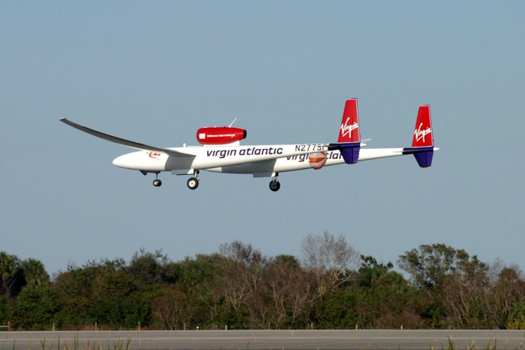

RICHARD RUTAN “GLOBE TROTTER” 4305 E. Mullan Trail Rd., Coeur d’ Alene, Idaho 83814 805-828-7547(cell) dick@dickrutan.com Long-EZ-B:N169SH IO-360-F1A6 3,826 hrs, Around the Southern Oceans as well as the Voyager with Mike Melvill.
JEANA YEAGER now in Texas also flew around the world with Dick:

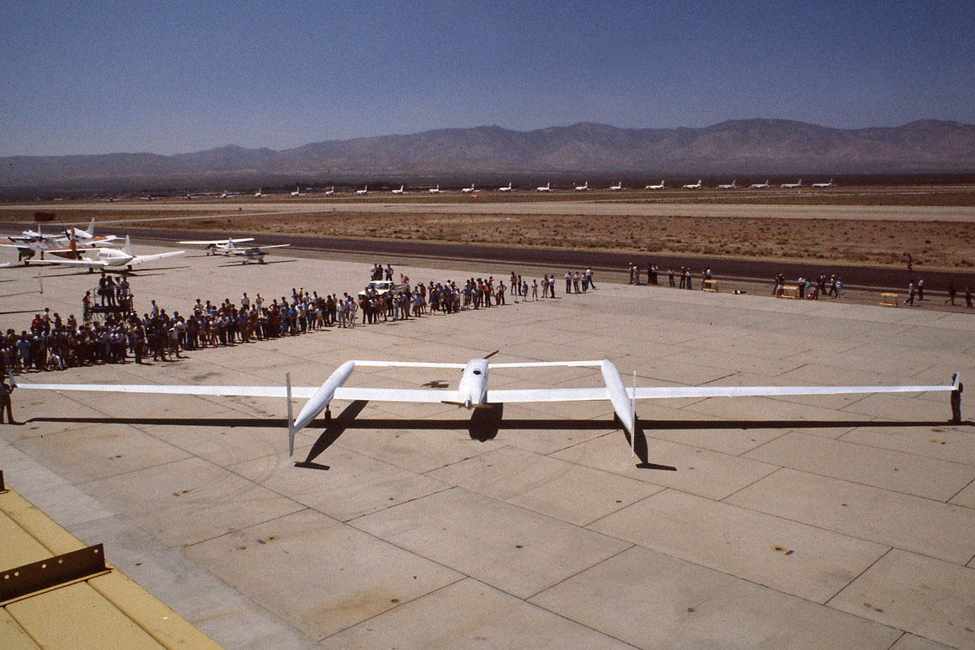
Canard Pusher issue 53 Oct 1987, page 2: Special copy of Canard Pusher page on Round the World flight.

Hans Schmidt went around the world in HB-YCT using the more efficient West to East route, then did the reverse, East to West then across and down to South America and then back to Europe – last I have an article.
Hans Schmidt changed to a more traditional design that was not stall-proof for his next crossing and crashed on takeoff - died:
SCHMIDT, HANS GEORG Weidstrasse 346 or 13, 5525 Fischbach, Switzerland Canard Pusher issue 52 pg 1 Switz-South Africa, Canard Pusher Issue 54 pgs 19-26, Switz-South America's Cape Horn 1 Millenium Flight? Canard Pusher issue 61 pg19 www.millenniumflight.com Crashed and killed on takeoff for OSH’07 at LSZR Airport The Long-EZ is owned by another man now

Library item 29MS49 7/07 Blurb on Hans Georg Schmid World Record Flights
Library item 29SA7 Jul’99, Page 23-30: South America ’98 (Part 2) by Hans G. Schmidt – Ecuador to Europe.
And there is a Starship based in Europe – suspect it flew there. Registration: N8244L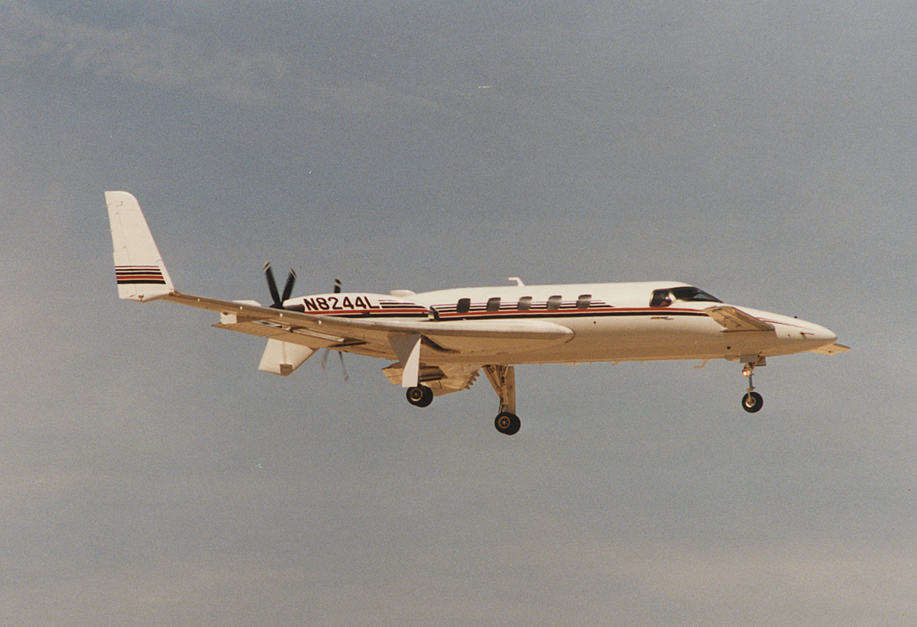One time Owner: Radio Flyer, LLC Location: Germany Prior owner?: MOEHLE, ECKHARD Papa eckhard.moehle@mfw.aero Info@mfw.aero

Not a Rutan design: Last checked FAA 2016: TOPP, BRUCE D. 6912 Weston Ln N., Osseo, MN 55311-2955 bdtopp@comcast.net DeRegistered: Velocity XLFG:N125TP IO-540 Flew to Europe 10/09

Someone else mentioned Yair Gil Tel Aviv, Israel goldcozy@gmail.com ensys@netvision.net.il Cozy IV:4X-AYG Building lighter weight Cozy IV http://yairgil.gassner.co.il/indexHigh.htm who actually lost his nose wheel in Iceland on the way to the US, got a quick replacement and continued on – flew it home too, I believe.
This seems harder to me than the cross-Atlantic flights: McCrea shipped his Long-EZ to Europe and then flew to Capetown, South Africa: McCREA, CHARLES RAY Jr. 484 Lake Park Ave #49, Oakland, CA 94610-2730 510-406-4212(Cell)
If you have been tempted to do the North Atlantic – I have a lot more articles:
27AP14: Apr 1999, page 163, "Recklessness or skill?" - flying the Atlantic single engine - other hostile environments.
27AP15: Feb 1999, page 61, “Atlantic adventure – Coming to America in a TBM 700”.
29FA8: Aug 1992, page 1,: "Gone Swimming Yet?" about ditching in the North Atlantic." and "Build your own Personal Survival Kit".
29IF1: Sep 1985, page 6: "Light Aircraft Transatlantic Flying, II".
29KP7: Jun 1996, page 26: “Flight of the Lightning – Two Texas Adventurers fly a homebuilt to Europe and back.” By Geoffrey P. Jones.
29MS6: Spr 1989: "Survival Equipment Source List".
29MS46: Dec 2008 AOPA Internet “Artic Rescue saves ferry pilots.”(C337)
29MS47: Apr’09: Boulder, CO to Qatar in a C172 by Ken Gross
29PP4: Apr 1990, page 12: "Masochismo Over The Big Water - Probable joy, possible terror: A day in the life of a seasoned ferry pilot."
29PP5: May? 1990, page 14: "Jump The Big Pond - Ferrying the Atlantic: a nitty gritty diary of 81-mph gusts in Newfound-land, lethal winter weather, and thousands of miles of flight--over water--all alone.
29PP6: Jun? 1990, page 14: "Jump The Big Pond II - Across the Mediterranean and thousands of years of history...with no time to sightsee".
29SA2: Apr 1986, Page 57: "Atlantic Crossing...In A Pitts?"
29SA6: Oct 2000, page 62: “Earth Rounders – Little Airplanes and a great big world” by Budd Davisson.

