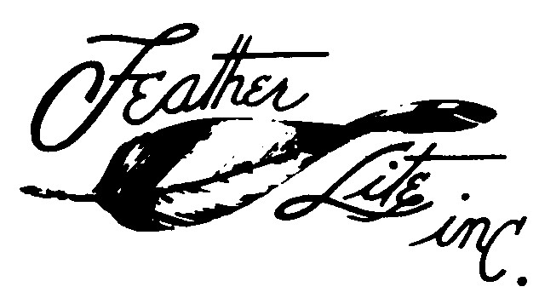
1327 South State Street,
Ukiah, CA 95482
Phone 707-462-2939 e-mail: featherlite@pacific.net
Michael Dilley

VARI EZE PARTS PRICE LIST

May 1 2016

COMMENTS DESCRIPTION QTY. PER PRICE
AIRCRAFT EACH
Main Landing Gear Strut 1 633.00 Nose Gear Strut 1 109.00
* Engine Cowl Glass Top & Bottom Set 1 626.00
Cowl End Ribs set 2ea 1 78.00
Cowl Inlet 1 98.00
Wheel Pants 3,5 x 5 set 1 267.00
NG 30 Cover 1 39.00
Pre Cut Foam Cores Canard 1 300.00
Strut Cover SC 1 39.00
Nose Wheel Cover NB 1 39.00 Requires cowl modification NACA Inlet 1 94.00
Carb. Air Box Kit 1 239.00
Baggage Pod Set 1 642.00 Nose Bumper Rubber 1 22.00
Space Saver Panel 1 74.00

A check or money order is required to process orders.
California residents add 7.25 % sales tax..
Contact us for a freight quote
Substantial delivery fees are incurred for residential truck delivery. Please include a telephone number, a mailing and a street address.
Please allow 30 days for delivery, we will expedite when possible.
We will discuss questions regarding our products by phone mail or email.

*Items must be shippecd by trcuck.

