-Fuel Sights, Indicators & Probes:
- Curt Boyll VE 111JK May 2012: Vance's Fuel Sight Gauges are perfect for my extremely simple airplane, ...no vacuum- driven instruments. ...sight gauges require ...simple calibration (painted stripes), no additional wiring, no electrical power, no panel space, and they simply cannot fail to indicate fuel levels. Craning my neck around ..not required, ...I use ... hand- held mirror ... same small mirror that I ...use to also make sure I'm not on fire...like everyone does, right?
-Jack Fox - Long EZ 56JF May 2012: I aimed 2 spy cams at my sight gauges and connected them to my AV8OR. No more kinks in the "old" neck, and no invasion into the tanks. I keep the mirror handy just in case.

-------- Original Message -------- Subject: Re: [c-a] Fuel sight gauges
Date: Fri, 13 Apr 2012 08:14:10 -0400
From: Harley Dixon <harley@AgelessWings.com>
To: jon_yap08 <jon_yap08@yahoo.com>
CC: canard-aviators@yahoogroups.com

...Vance Atkinson has them. www.atkinsonfuelgauges.com [sight gauges]
-------- Original Message --------
Subject: Re: [c-a] Fuel levels
Date: Mon, 25 Jun 2012 05:57:03 -0700
From: Al Wick <alwick@juno.com>
To: <canard-aviators@yahoogroups.com>

...see Nick's site?
www.nickugolini.com <http://www.nickugolini.com>

http://nickugolini.com/Website/Fuel%20Probes/Fuelprobes.htm

-------- Original Message --------
Subject: Re: [c-a] Fuel levels
Date: Mon, 25 Jun 2012 11:12:08 -0400 (EDT)
From: ARGOLDMAN@aol.com
To: canard-aviators@yahoogroups.com

Nick U has developed ...capacitance probes for the Cozy/Long. ...you do need a cap-volt converter, however. ...they are quite small, and require minimal surgery to an already constructed tank...

-------- Original Message --------
Subject: Re: [c-a] Fuel levels
Date: Tue, 26 Jun 2012 08:50:04 -0600
From: Burrall L Sanders <craftsman@freeflightcomposites.com>
To: <canard-aviators@yahoogroups.com>

...most people may not agree ...but I’ll take the sight gauges any day over electric. ...lighter, more reliable and don’t lie...equivalent of opening the filler cap and sticking the tank. ...

-------- Original Message --------
Subject: Re: [c-a] Fuel levels
Date: Tue, 26 Jun 2012 10:53:59 -0400
From: Hicks, Wayne <wayne.hicks@zeltech.com>
To: 'craftsman@freeflightcomposites.com' <craftsman@freeflightcomposites.com>, 'canard-aviators@yahoogroups.com' <canard-aviators@yahoogroups.com>

...There are occasions when the sight gages are covered up by luggage.

-------- Original Message --------
Subject: Re: [c-a] Fuel levels
Date: Tue, 26 Jun 2012 21:17:50 -0000
From: Silvereagle <dndnhrd@gmail.com>
To: canard-aviators@yahoogroups.com

I have LED's that illuminate when there is 5 galls left in the tank, ...24 years they have worked fine
Silvereagle LongEZ 93EZ

-------- Original Message --------
Subject: Re: [c-a] Revisiting the fuel gauge situation
Date: Wed, 27 Jun 2012 16:48:17 -0700
From: Elwood Johnson <ejandlinda@earthlink.net>
To: ezcopilot@fairpoint.net <ezcopilot@fairpoint.net>
CC: canard-aviators@yahoogroups.com

velcro the mirror inside the strake near your hands...

-------- Original Message --------
Subject: Re: [c-a] Fuel levels
Date: Wed, 27 Jun 2012 19:38:49 -0700
From: Marc J. Zeitlin <marc_zeitlin@alum.mit.edu>
Reply-To: marc_zeitlin@alum.mit.edu
To: canard <canard-aviators@yahoogroups.com>

...
> Soo the sight gauges have it?

They are certainly the first fuel indication system that should be in our aircraft, yes. I would also recommend a fuel flow sensor and totalizer (in an engine monitor) and fuel level sensors (also feeding the engine monitor). The monitor will have alarms that will continually keep track of your fuel levels when you lapse in looking at the sight gauges. While the complexity of the system will be higher than having only sight gauges, the system will be far safer and far more reliable in allowing you to know your fuel quantity on board in all circumstances.
Marc J. Zeitlin mailto:marc_zeitlin@alum.mit.edu

-------- Original Message --------
Subject: [c-a] Fuel sight gauges
Date: Sat, 1 Sep 2012 07:58:54 -0500
From: Dave Anderson <usaf_david@yahoo.com>
To: canard-aviators@yahoogroups.com

...found these ... with my project. .... Envelope says they are from Vance Atkinson. ... Dave

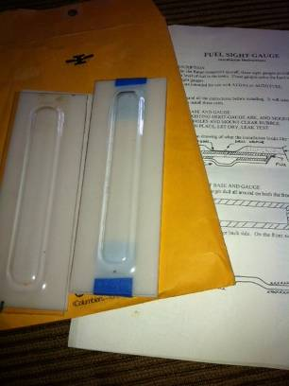

-------- Original Message --------
Subject: Re: [c-a] Fuel sight gauges
Date: Sat, 01 Sep 2012 09:22:29 -0400
From: Harley Dixon <harley@AgelessWings.com>
To: Dave Anderson <usaf_david@yahoo.com>
CC: canard-aviators@yahoogroups.com

Oh, yeah! Only way to go! .... dozens if not hundreds of others here. ... I don't see either the little orange float balls that go inside, or the inserts that go in the holes you'll drill in the tanks to keep them from closing up on you. ... contact Jack and he'll get them to you. ... want to light them up at night, there is a light option available as well. ...contact him ... www.atkinsonfuelgauges.com/
Harley Dixon Long EZ N28EZ

-------- Original Message --------
Subject: Re: [c-a] Fuel sight gauges
Date: Sat, 1 Sep 2012 09:41:59 -0700
From: Marc Borom <borommarc@earthlink.net>
To: Dave Anderson <usaf_david@yahoo.com>, Harley <harley@AgelessWings.com>
CC: <canard-aviators@yahoogroups.com>

Do not use the white inserts. ... auto fuel that has alcohol in it, the white things will turn to mush and block the fuel access holes. I ... applied aluminum tape to the reflection area. ... grit-blasted the inside surface of the fuel gauge. The wetted portions becomes transparent and the unwetted portion remains opaque. ... easy to see the fuel line. Marc Borom LongEZ - N966EZ

*From:* Henry Hallam <mailto:henry@pericynthion.org>
*Sent:* Thursday, December 13, 2012 4:36 PM
*To:* S. Ramirez <mailto:simon@synchdes.com>
*Cc:* canard-aviators@yahoogroups.com
<mailto:canard-aviators@yahoogroups.com> ;
cozy_builders@googlegroups.com <mailto:cozy_builders@googlegroups.com>
*Subject:* Re: COZY: Re: [c-a] EZE-Tug - Follow Up

I know several canardians already use mini video cameras for monitoring fuel sight gauges from the cockpit. ...
- Henry

-------- Original Message --------
Subject: [c-a] Lighted fuel gauges....
Date: Thu, 20 Dec 2012 09:24:24 -0600
From: vance atkinson <nostromo56@tx.rr.com>
To: Canard Aviators <canard-aviators@yahoogroups.com>, Cozy Builders
<cozy_builders@googlegroups.com>

Several people have asked what my lighted fuel gauges look like when using the LED. ....picture... has the aluminum backing plate allowing use of auto fuel with ethanol instead of the white plastic one which was limited to AV gas only.
...
You can retrofit the tiny LEDs in your gauges if you want to upgrade your already installed ones. Kinda a PITA... but doable. If you cant see the picture below, email me and Ill send one.
Vance Atkinson.

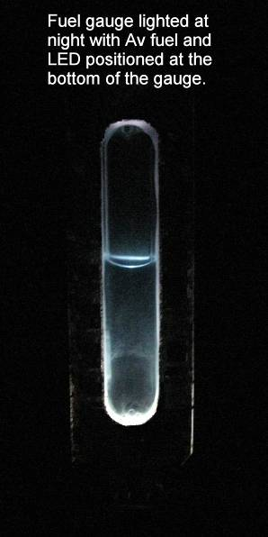

-------- Original Message --------
Subject: Re: COZY: Re: [c-a] EZE-Tug - Follow Up
Date: Fri, 14 Dec 2012 10:23:51 -0500 (EST)
From: trcsmith <TRCSmith@aol.com>
To: ejandlinda@earthlink.net, henry@pericynthion.org
CC: simon@synchdes.com, canard-aviators@yahoogroups.com,
cozy_builders@googlegroups.com

Allen Holmes has a camera that keeps an eye on the fuel gauges. Nice setup! Allen Holmes at jamesallenholmes@yahoo.com
Tom Smith A&P Long-EZ N12TS Cell-707-592-0869 KVCB KJ6PZN

David Orr 3/21: Atkinson has a metal backing now, so the white backing plastic is no longer used – with it’s concern.

