Paul Saccani, Western Australia has failing Varieze gear:
“I have a sick Varieze I did not build. It was written off after a landing accident in the eighties and repaired years later.
It has the original four attach fittings per side. I noticed the angle on my main gear had changed, on inspection the forward attach brackets had pulled out and a poorly conceived glass repair had separated, whilst the forward tabs on the gear had broken away from the top glass wrap and then pulled the lower wrap away from the gear leg. The bolts have also pulled through the stringers/longerons to some extent. A remarkably graceful failure.
I'd really appreciate any comments on tricks to use, the repair scheme and any information that can be offered on the drawings I don't have.
It would seem logical to take the opportunity to use the Longeze attachment method instead of just putting the same old fittings. But I don't have the Varieze drawings A3 and A5 for the original structure, let alone the Longeze drawings that cover the same area, or information on the bolts specified and so on.
The first thing I want to do is cut holes on the outside skin so I can access the bolt heads and then remove the bolts holding the attach brackets. Then remove the failed glass repair to the 15 ply layup on the inside of the fuselage. There is damage to the wooden stringers/longerons from bolts puling though that might best be dealt with by flox, though a scarfed repair might be needed. I want to take out the urethane and replace with divinylcell before laying a new 15 BID layup in the side of the hellhole compartment. Then fabricate some new Longeze brackets and attach using AN970 washers on the bolt heads.
To keep it simple, remembering that I am in Western Australia and aviation materials can be scarce, I thought I would use some 4130N tube sized to go over whatever bolt is used through the gear tabs and cut to suit whatever distance the brackets end up apart. Use temporary plywood tabs glued to the leg to line up the gear, build up the outside 'strap' of 25 ply BID, drill through the plywood to transfer the hole, remove plywood and keep adding layers of BID on the inside until the tab is built up to the desired thickness. Drill though the outside to transfer the hole, then enlarge to accept the 4130N tube, with a few holes drilled through it and roughed up for flox. Use some foam filling pieces under the tube and add layers of BID between the tabs and over the tube.
That's about as far as I've figured it.
Does anyone have information on the pitfalls of *not* putting the rudder cable through the brackets? I was thinking of putting the nylaflow sheated cables in a U shaped channel resting on the brackets rather than drilling holes in the brackets.
Can anyone tell me if the old bolt holes in the fuselage could be used with Longeze style brackets?”
Several people offered help on drawings, but Marc Zeitlin had the best advice:
Paul Saccani wrote:

I'd really appreciate any comments on tricks to use, the repair scheme and any information that can be offered on the drawings I don't have.

So both the VE and LE landing gear to fuselage attach schemes are extremely sub-optimal, from a load path standpoint (basically, there isn't much of one that's robust) and these failures are WAY too common. The COZY MKIV scheme is a far better design.

In any case, I've done a VERY similar repair on a VE, by replacing the damaged wood with flox, redoing the layups that were damaged, and THEN adding 1/8" AL reinforcement plates to the interior and exterior to spread the load out - every bolt hole helps every other bolt hole, and no crushing of wood. Here are a few pics of the inside and outside of the repair I did:

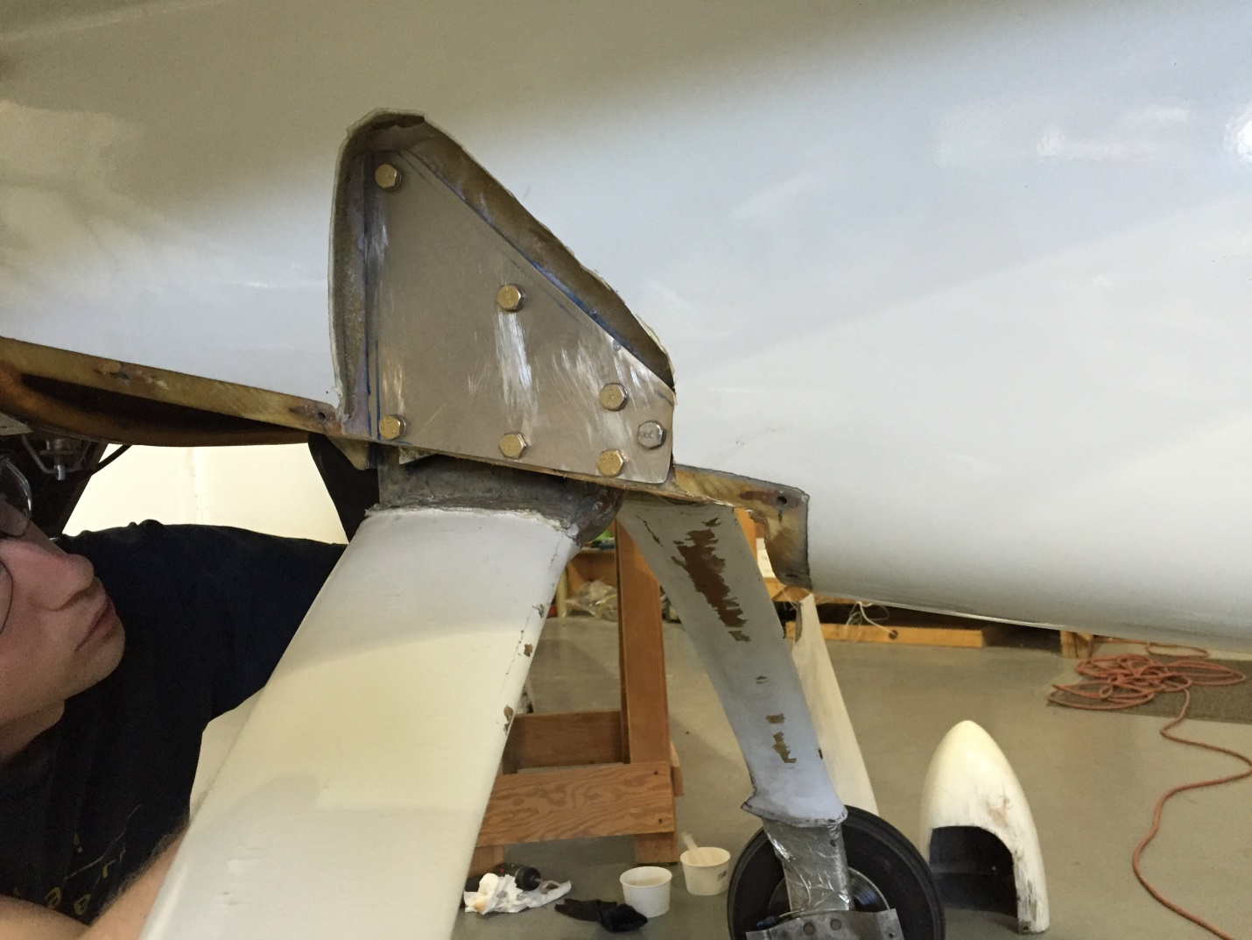

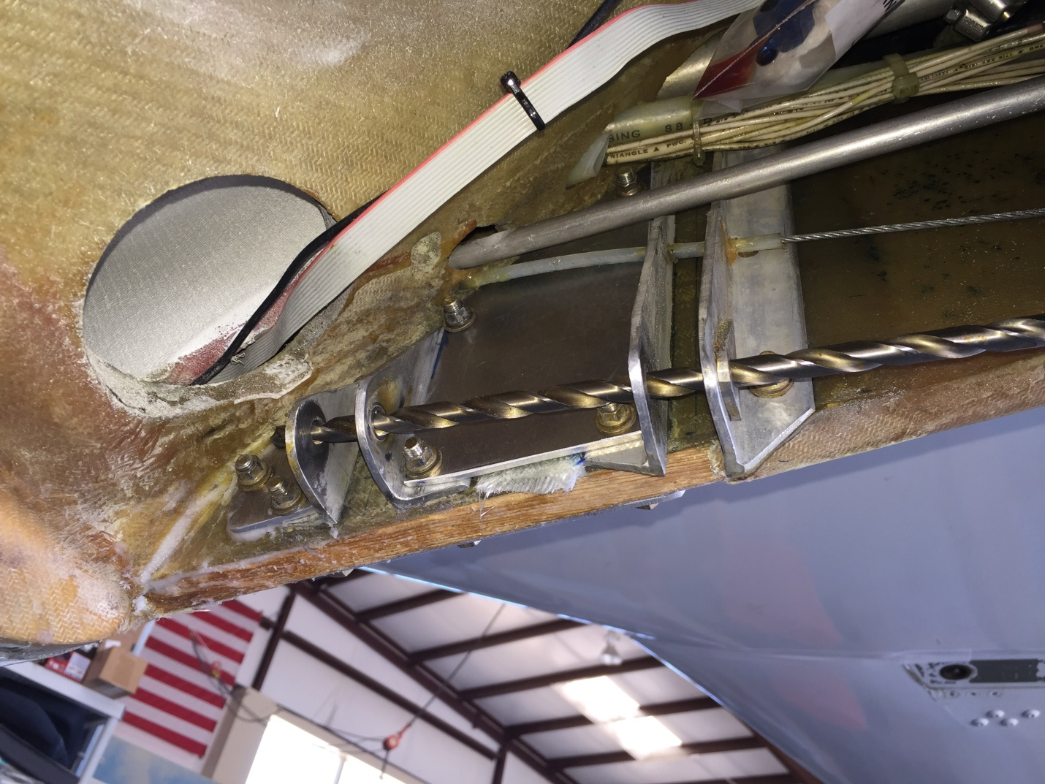

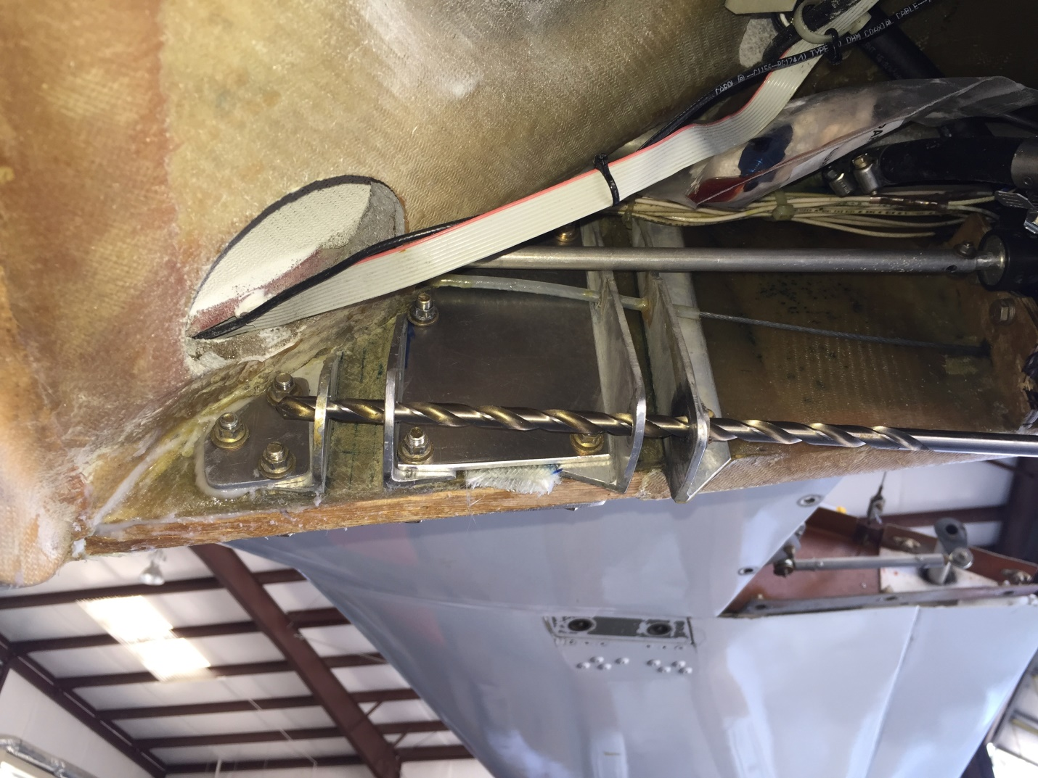
And here's a link to a directory that contains all the VE plans (and Long-EZ plans), so that you know what you're looking at and how it was originally built:

https://drive.google.com/drive/folders/0B59FTO55qP2UcXpSUmNta2dBTG8?usp=sharing

If you've got questions, let me know.

