Picture of the Month – the young men are making me feel old:
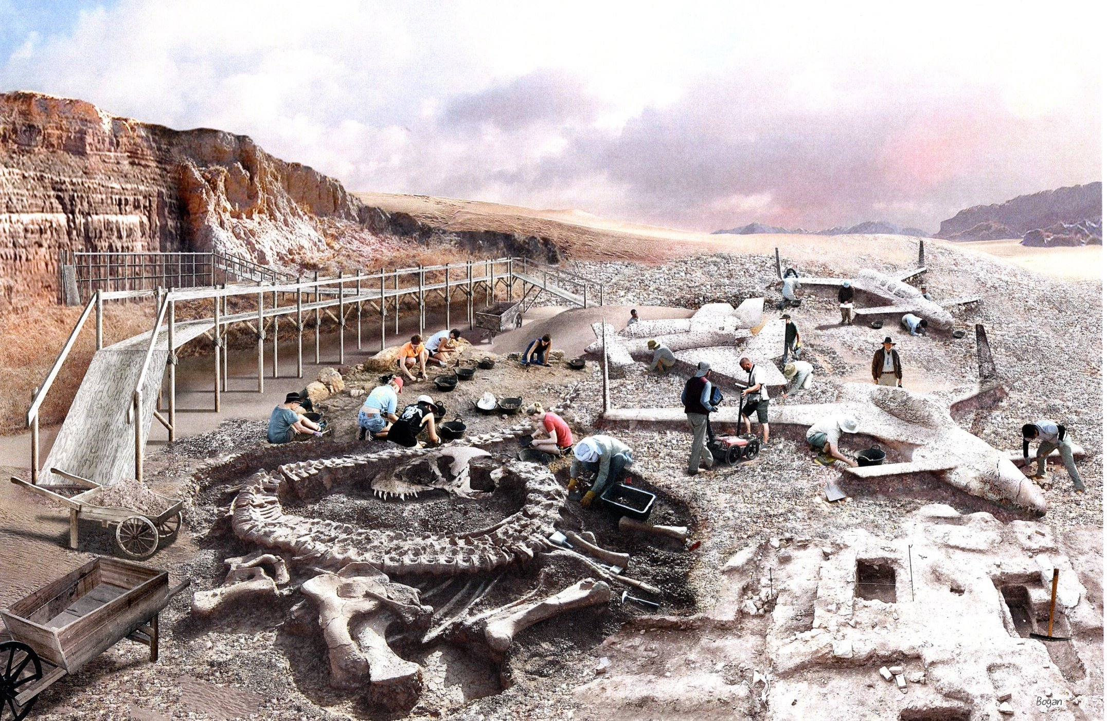
An Architectural find – now we know how long these fiberglass things last! Art work by Squadron Member Michael Shratt’s friend Tom Bogan

FAA Developments:

RUTAN TIME:

To the topic of a Variviggen going to the Smithsonian, Burt commented: “Nice. The EAA museum has the prototype VV. I flew it to a grass field near Hales corners in the 70s, where EAA had their Original museum. In 2010 I offered the Boomerang to the Smithsonian. They refused, saying it was not historical.”

Promoting the Breed:

CALENDAR - Canard Events in RED:

Post-Flyin Contact information:

Non-Builder owner advice:
In Memorium:

Builder’s Help Desk:

Key Maintenance Tip:

Requests to Individual Members:

What the flyers are doing:

Formation:

New members:

New area code in the address list:
Already a member:

Already a member:

Joining:

Joining:

Changes in E-mail:

New Address:

One Off Canards:

Added to the Electronic Squadron library:
29MS76 Nov/Dec’19 pg 7 So You Want To Fly in New Zealand part 1 by Gary Schank So Cal Pilot’s Association
29MS77 Nov/Dec’79 pg 12 “One Approach, Three Landings, Sightseeing, and Lunch! By Ray W. Stratton SoCal Pilots about Southern California Logistics Airport (KVCV) (former George AFB)

Oh and Trivia:
From Last issue:

