A Varieze guy asked how to get the taper pins removed to get the wing off a Varieze - and Mike Melvill responded:

“The Varieze has two pairs of tapered steel plugs, held in place by two AN-4 bolts. The tapered plugs fit very tightly into matched tapered holes in the aluminum 1/8” thick wing attach fittings. These plugs should be greased liberally when installed to prevent corrosion as well as to facilitate removal. The holes are reamed in matched pairs with a morse taper reamer. To remove them without damaging the aluminum wing fittings, a heavy weight should be held in place over a short thick walled tube that backs up the hammer blows that may be needed to break the morse taper plugs loose. If this is not done correctly, the wing attach fittings (alum. plates could be distorted and not usable anymore!!) There are no replacement aluminum fittings available since Brock closed his doors, so this is a super serious problem!”

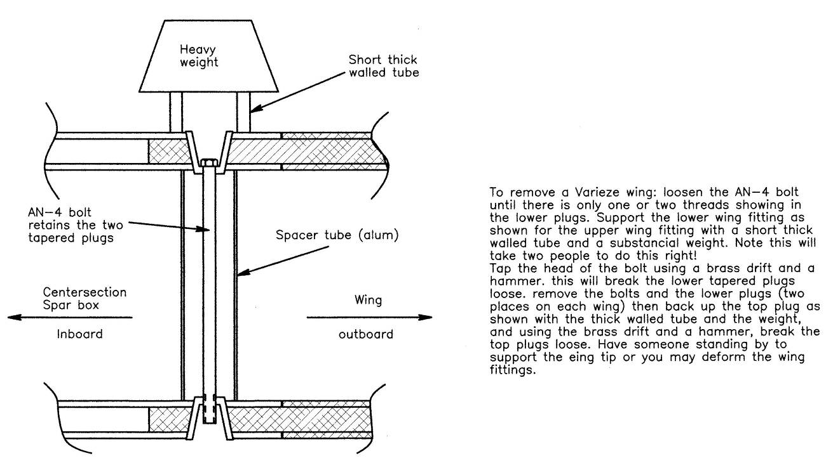

Also, and just as serious, there have been several Variezes that have had severe corrosion in these aluminum wing fittings, particularly if these planes were stored and flown near an ocean coast line. Hawaii, Florida, California and Connecticut are some of the areas where we have seen this happen. The corrosion is not generally visible from the outside. You have to carefully inspect in between and all around these 1/8” thick aluminum plates to find it, but it could be bad enough to cause a structural failure so it is something to be very cautious about. This all came to light a long time ago and RAF put out a serious “AD” with photos of the inter-granular corrosion that can destroy the Varieze wing fittings. One of the problems is that there are so many Variezes that have been sold to pilots who don’t receive the Newsletters or indeed the news. This was reported in every news media we could think of including Sport Aviation.

I will try to find those photos and the AD and email them to you so you can put this info out there as well. I have enclosed a drawing to hopefully make the removal of a Varieze wing easier to understand. -Mike

However an Ohio member then retorted: “ARGH! NEVER use a hammer to push the taper plugs out!! The shock transmits directly to the glass layup tying the fittings to the spar. Press them out with a bolt & nut arrangement to presses them out as you tighten the nut. I think Hertzler had an article on that in a back CSA Newsletter.”

