Topic 12: Cutting back (forward) the sides of the cowl around the cooling air exit.
Beagle’s aerodynamicist says that the cooling intake and cooling exhaust area should match somewhat in cross-section. Where to measure is part of the issue. If you have a NACA with a wing shaped lip, you measure at the leading edge as the air going over the wing speeds up. Measuring at the back end can be a bit confusing – with cowl lips, aft baffles, flow guides and even the aft cylinder tops. Here’s one way of increasing the area of the cooling exhaust area.
7/9/2019: Dave has cut back the cowls for O-540 Berkuts he's handled and found that drag has not increased, and cooling is even better.
5/9/2021: Topic 12 & 15 update: Cut-back cowl and exhaust tip kickouts: I had Custom Aircraft create 3 into 1 exhaust as in prior reports – Dave made them fit the Cozy cowls on my O-540 Cozy. However, they were kind of long and leaving a lot of smudge on the 2 blade prop, so when I decided to cut back the rear edge of the cowl on the Cozy to see if it would enhance cooling the pipes were fully 4” longer than you’d expect. Here’s Dave’s cut-back O-540 Cowls:
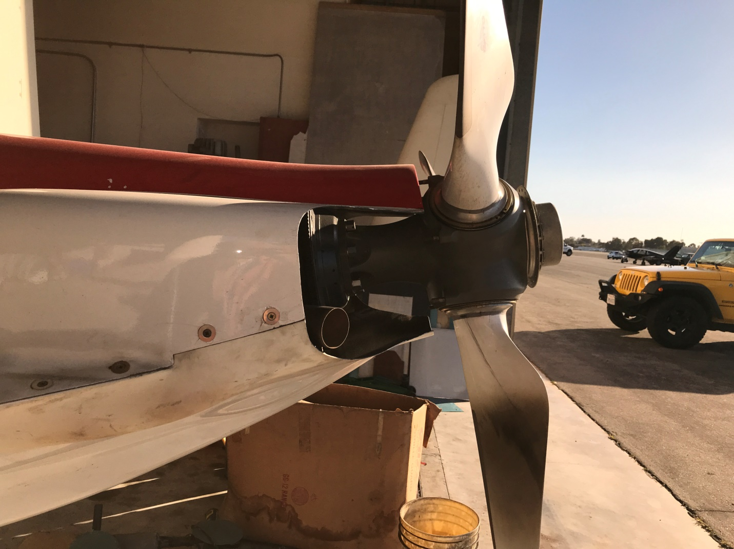
The Cozy IV cowls are just a bit wider than the Berkut cowls and I haven’t yet reduced the exit to the 1 2” pipe instead of the original 3 1.75” pipes – he suggested I borrow his $45 laser level in its vertical mode (the below is looking up at the cowl): 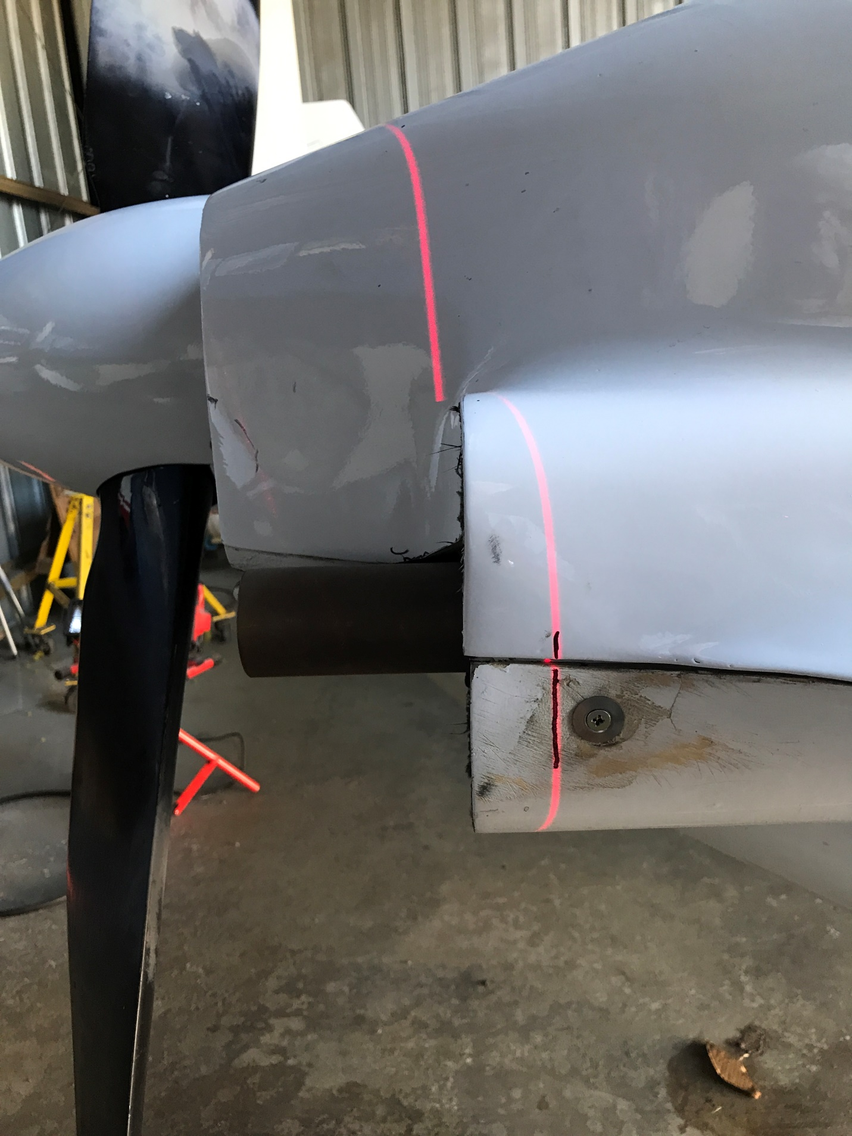 I drew a line on the cowl and used a cutter and cut my Cozy IV cowls back similarly (pardon the dust - this photo taken more level):
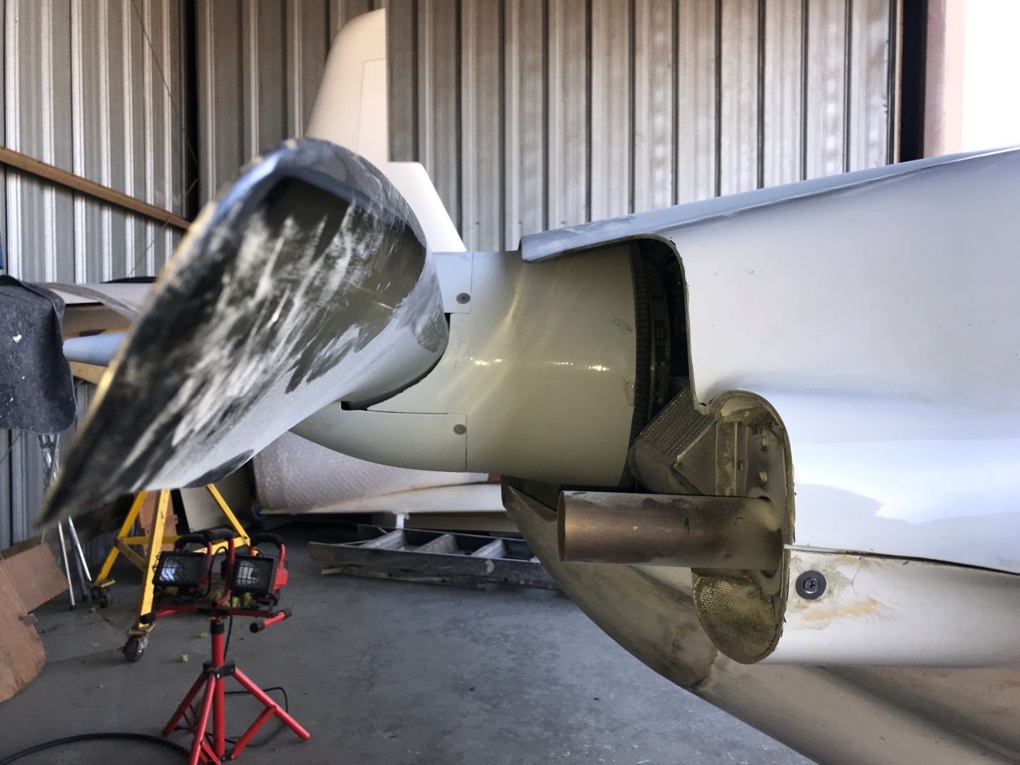
The wing is just in the wrong place for the laser to be aimed for both the top cowl and the bottom cowl – however, if you do this with the wings off, it will be easier.
I test flew it and didn’t see much balancing in temperatures that were favoring the #5 & #6 and disfavoring #2 and #1 at that stage. However, Dave is adding kickouts to the pipes for me and then at least the exhaust will be impacting the prop further away and further out the prop where the prop is moving faster…

