Doug Ashby, San Tan Valley, AZ asked: “Where do you locate the Davenport PT on a Cozy MK IV? I’ve kept a copy of the Davenport PT .pdf on file and now would like to position this in the Cozy Mark IV. I noticed the .pdf pictures gives reference to the Long EZ plans. [top of left console L.E. Plans Pg 16.3] Was this originally placed on the left side of the L.E.fuselage? On the Cozy Mark IV, would this go in the same position and in place of the two spring pitch trim location (RT side center by the nose wheel) that is called for in the plans or over on the left against the fuselage?
One builder mentioned that the plans built spring type pitch trim design location for the MK IV ‘does clutter up valuable space.’ ”

Bulent Aliev, Titusville, FL: “I put mine on the right side, hard up against the right side of the nose gear cover.”

Trevor Howard, Edmonton, AB: “The actuator attaches to a modified (lengthened) version of the manual pitch trim lever, so I can use it for manual pitch trim if the actuator ever fails or I lose power (kudos to Keith Spreuer for this idea).”

Bill Allen, Hextable, Kent, UK: “I kept the manual trim system with the Davenport leaf spring….”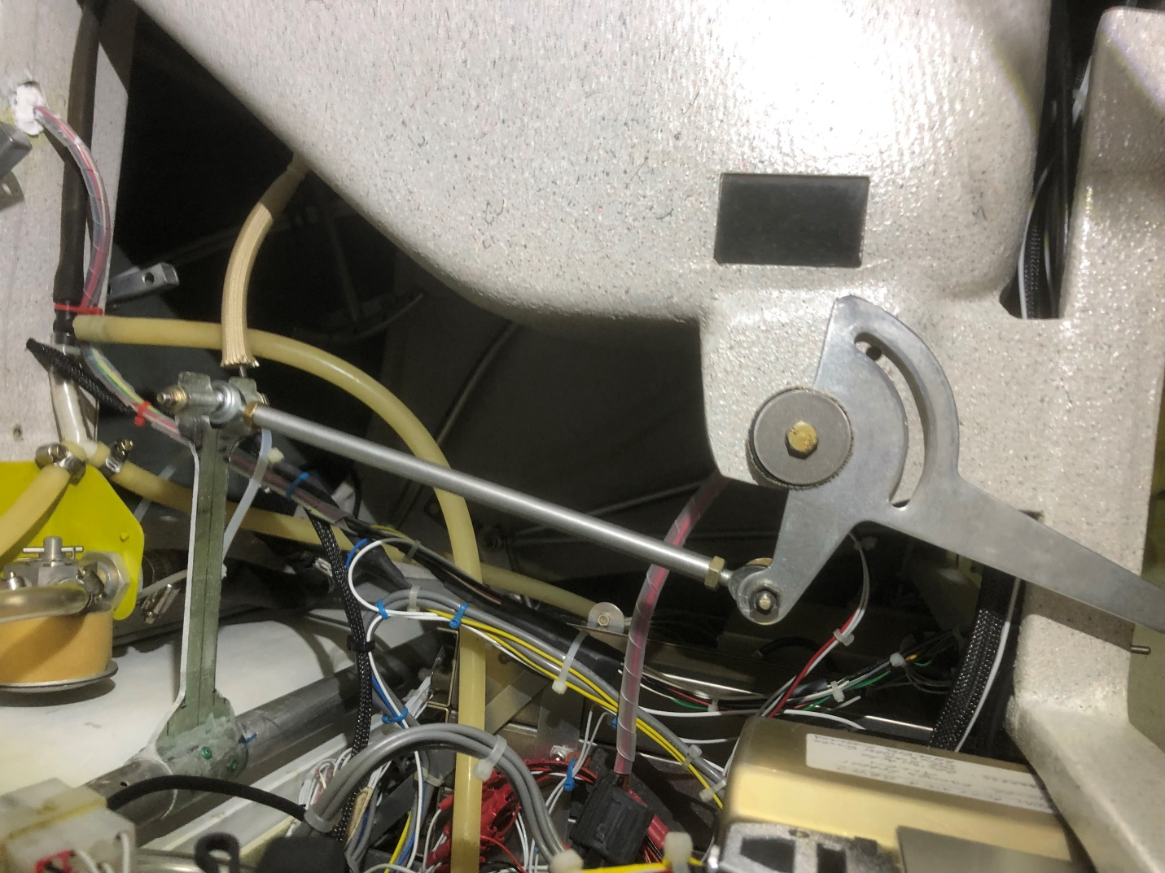
Here’s another version passed on by Doug Ashby: “When I got everything assembled in the hangar, I found an interference between the elevator inboard counter-weight and the Vance pitch trim system I'd build a few years ago to his specs. The problem was the location I'd picked for anchoring the actuator to F22 and would require movement of about 1/2". I'm not sure how I didn't find this before, but part of the reason is that I kept the pitch trim actuator safely stored in a cabinet after I'd done the initial proof that it ran, without connecting it to the elevator push rods coming from the joystick. I should have completely connected everything, but was doing too many things at the time... Lesson: finish things. I'd opened up the hole in the IP a little to enable the trim actuator spring housing to come through in addition to the push rod on the pilot side, but it now looked like needed more clearance here, and I was growing uncomfortable with the smoothness of the actuator motor, which had been sitting for a couple of years. In the meantime, there was significant debate on the list associated with a failure mode in this pitch trim system that might prevent recovery from an uncontrolled full extension of the actuator. Many have been flying with this system for many hours, and I wasn't originally thinking of changing, but after some internal debate, I started pursuit of the Davenport spring approach which would shift the whole pitch trim to the centerline area behind the IP. I got a lot of help from Rick Hall, who'd been through about 4 iterations optimizing the spring recently for his Cozy MKIV. Since work was taking me up near where Rick flies, he loaned me the jigs for making a spring and even made an initial one to his current configuration for me to try. Thanks so much Rick! My implementation shown below.

Ray Allen servo connected to Davenport spring for pitch trim. All wired up to hat switch (not visible in this view) on the center console just forward of the throttle lever.

Davenport spring prior to epoxy bonding to elevator torque tube (showing the 8x1/8" rivet positions) later flox bond the spring to tube and pop the rivets.

Glassing the actuator bracket to the nose wheel cover (surface sanded down to bare glass prior). Edges will be trimmed and everything painted later. Wrench on top is just weighting the whole thing down for good bond.”
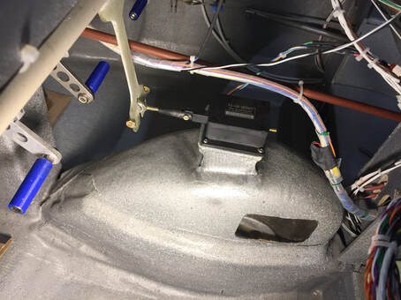
This is the Scott Fish implementation of the above: “Good to hear from you, and it sounds like you have a good plan. No matter what you do, make it fun (though work) along the way. The short responses are:

a) I like my pitch trim a lot, but it took some tuning to get the right stroke on the actuator to work well with the spring stiffness and length of the Davenport spring I have.

b) For me, I ended up switching to a longer (4”) stroke Firgelli class actuator because I wanted to un-stiffen the spring I’d built and needed this longer stroke to accommodate the full movement of the spring AND get the force needed at both the upper and lower extremes of movement (which I do use for different loading conditions).

For instance when I’m by myself with not a lot of fuel, I need full up elevator pressure to trim the canard at top speed. However, when I have heavy load and coming in for landing at ~75 kts, I need good deflection down elevator with high force there too.

My recommendation, would be to press on with other big parts of the Cozy and come back to this pitch trim later. You may be more happy getting the progress behind you on these bigger parts, and it will give you time to further contemplate exactly which setup you want to use there. I was making adjustments (changed the actuator) during Phase I, so it’s never too late to work on this area, based on real flight conditions in your bird.”

