Vince Berardino, Yuma, AZ:
“After pouring over/through the MT installation manuals they have, I've come to the conclusion that they aren't exactly the best reads.
That said, I am specifically wondering if there is a parts diagram that shows the bits/pieces of the prop hub to crankshaft flange...? When I install the prop, is there a certain gasket or O-ring that should be there? I still need to look in my propeller crate to see if such a thing is already there, but I'm trying to get my ducks lined up in a row before doing one job 3 times.”
William Hunter, Aguila, AZ:
“I Removed and replaced my propeller THREE TIMES...so yes I now know how to do it on a Lycoming.
Here is my solicited advice:
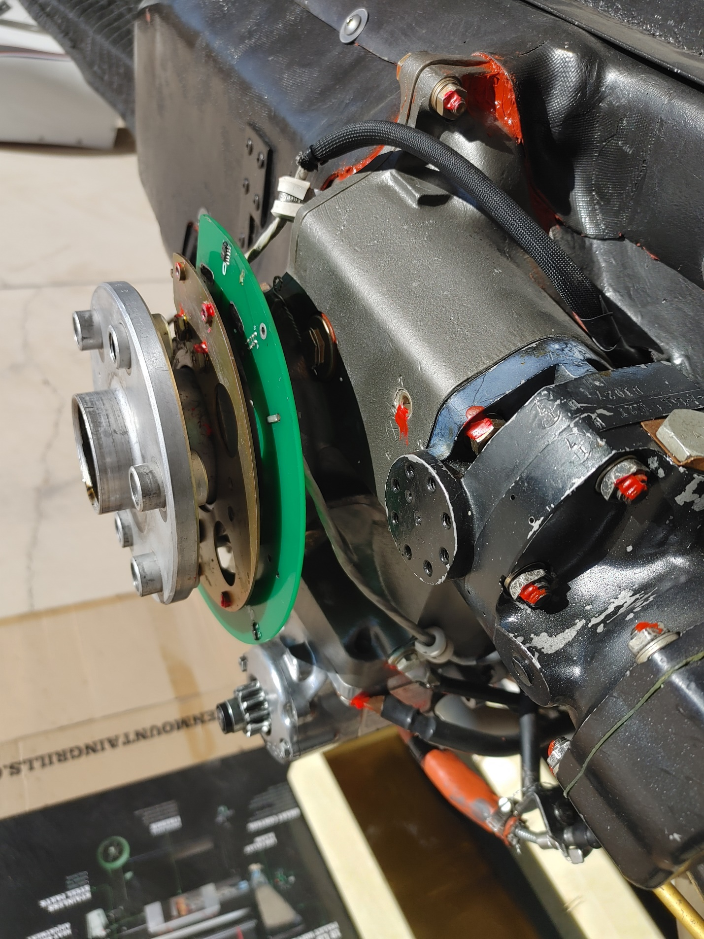
-Yes there is an O ring and it should come with the propeller. If not it is at AS PN O-RING A1633-11 (N0674 2-228)
-I oiled up the O ring before I installed it just to ensure that the O ring slid into the propeller hub.
-As discussed on this forum ala'Bob...DO NOT lube up the bolt holes on the propeller hub because the bolt torque specs are for dry. The torque specs for the 1/2" 20 UNF stop nuts for engines with less than 300 HP is 63 - 66 ftlb and for engines with more than 300 HP is 81 - 85 ftlb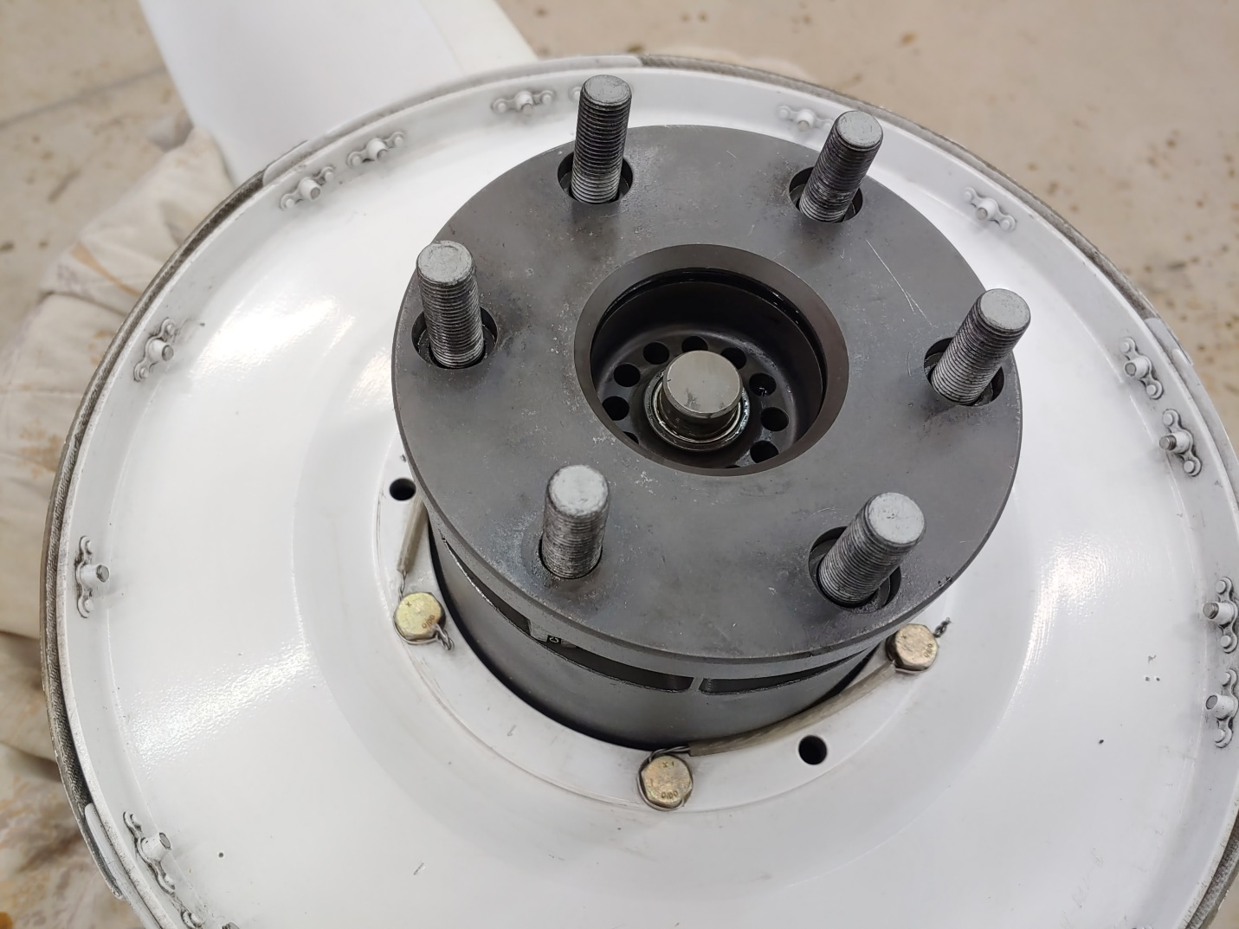
-Twice I had the help from my daughters holding the propeller and the third time it was easier to use an engine hoist with a nylon strap and I did it by myself.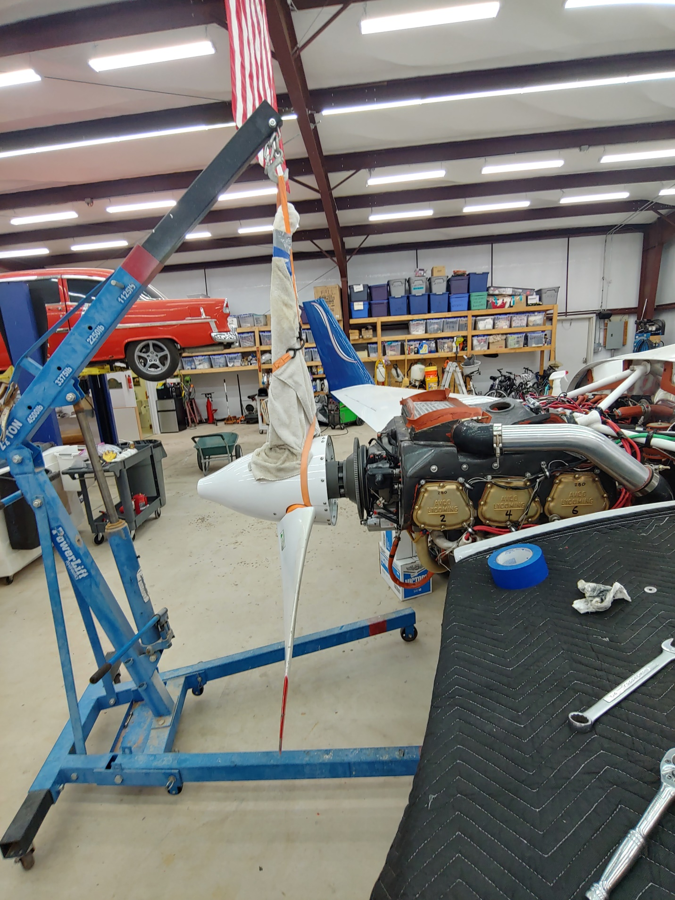
-Remember to put on a new alternator belt on the flywheel before installing the propeller
-On the Lyc crankshaft flange there is one bolt hole that is different than the others and there is a like sized hole in the propeller hub
-The attachment bolts will need a crowfoot wrench to tighten so here is a sheet on how to use a crowfoot wrench.
I made my own crowfoot wrench by welding a 1/2 inch drive to an old wrench and then later I doubled up the wrenches so that there are two wrenches side by side to add some extra surface area to mate with the bolt heads because I was afraid I would strip out the bolt head.
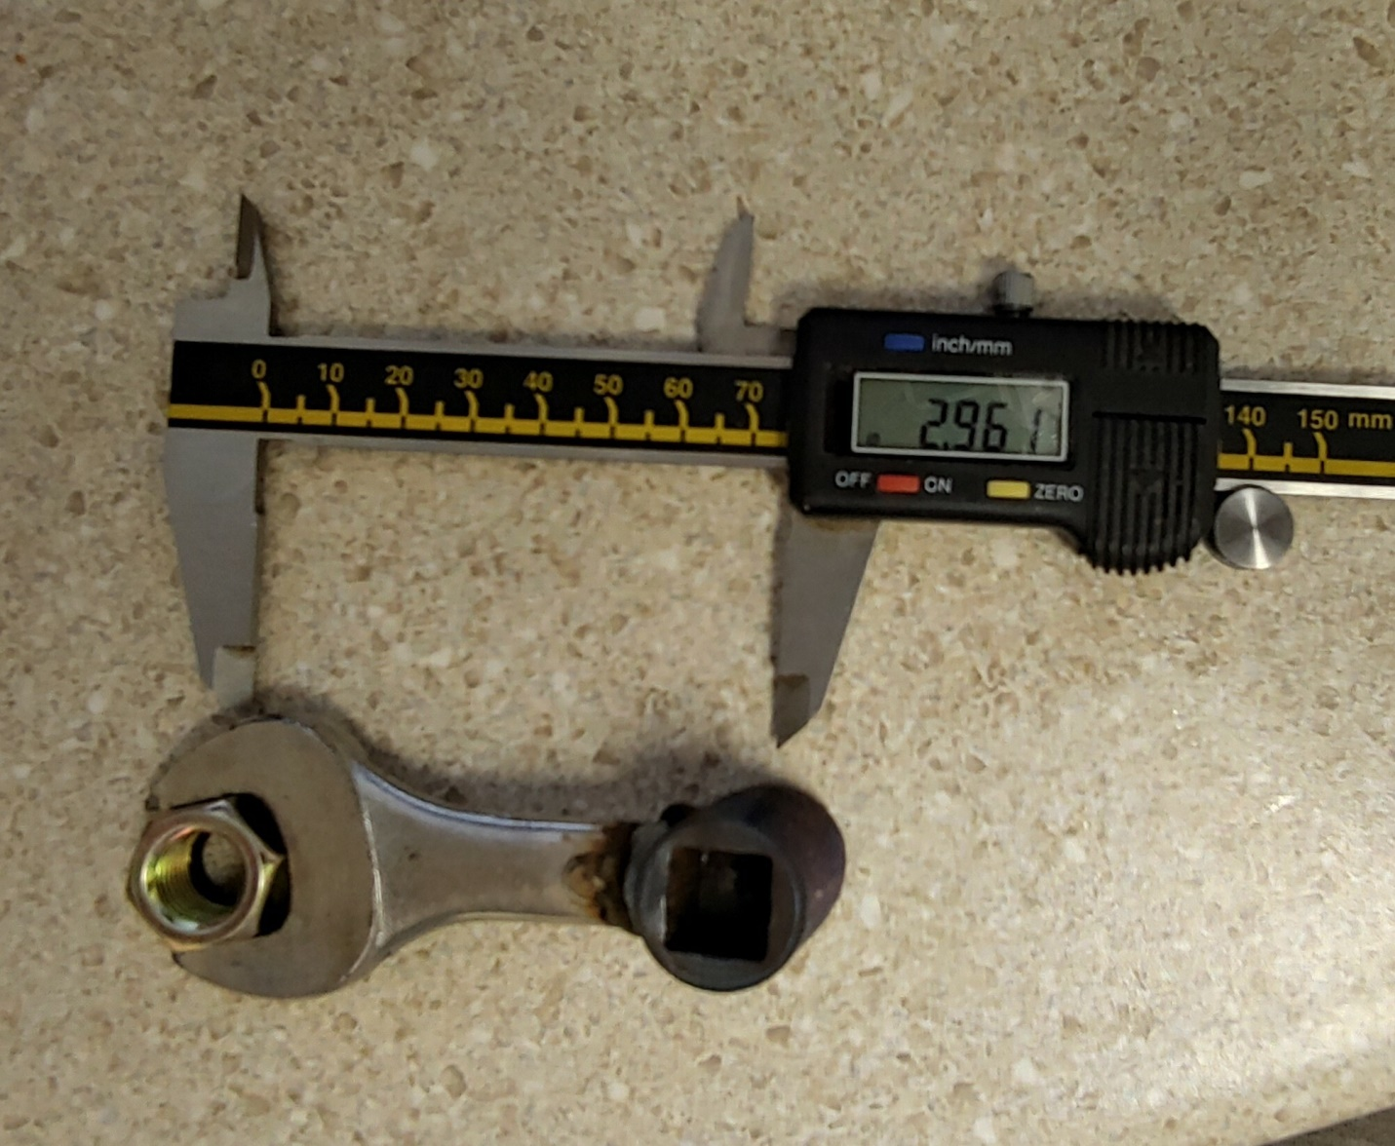
-The "bolts" (they are really threaded rods with a through pin that has a hole through the center of the pin that is used for the safety wire) and when you tighten the bolts they will almost always stop at the point where the pin hole points straight into the hub and it will be difficult to get the safety wire through so mark the bolt head at the location where it was torqued down and then you can unscrew it far enough to get the safety wire through and then wrench the bolt head back to the location it was before
-Because of the hub design you can only turn the bolts about 1/2 a turn before it bottoms out inside the hug so then you have to go to all of the other bolts and turn them 1/2 turn and keep working your way around each bolt 1/2 turn at a time to install the propeller hub.

Beagle: if you need to blow the photos up – here they are:Attachment(s):
1216201332_HDR.jpg (6.4 MB)
20200530_155351_HDR.jpg (3.6 MB)
20200531_184603_HDR.jpg (3.9 MB)
20200601_132606_HDR_2.jpg (573.4 KB)
20200601_123314_HDR.jpg (6.1 MB)
VELOCITY_EQUIPMENT_PROPELLER_Bolts_Torque_Value.docx (194.8 KB)

