A Manifold, answer to fuel venting from single vent tanks from Ken Walsh:

“Why not use a small manifold to tie the two vent lines together, then elbow up and return to the opposite side? The manifolds are available from McMaster-Carr as part number 5469K111, for $16.36. The elbow up makes it so that any fuel that comes up form one vent will preferentially go to the other tank, but the two vents tied to the top mean you siphon break either side. In the photo the lower two lines are the vent lines from the tanks, and the upper lines go to the overboard drains which are located in the armpits under the wings, right at the spar.

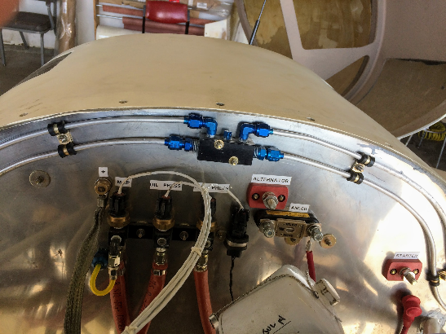
Very little mass penalty, a little cost in some extra fittings. I've never once seen a drop of fuel come out of my vents with this setup.”

