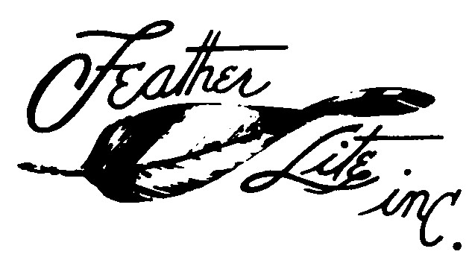
1327 South State Street,
Ukiah, CA 95482
Phone 707-462-2939 e-mail: featherlite@pacific.net
Michael Dilley

Defiant Parts Price List

May 1 2016

COMMENTS DESCRIPTION QTY. PER PRICE
AIRCRAFT EACH

* Main Landing Gear Strut 1 1385.00
* Engine Cowl Glass Front & Rear Set 1 1832.00

Wheel Pants Set 600 X 6 1 381.00

A check or money order is required to process orders.
California residents add 7.25 % sales tax..
Contact us for a freight quote
Substantial delivery fees are incurred for residential truck delivery. Please include a telephone number, a mailing and a street address.
Please allow 30 days for delivery, we will expedite when possible.
We will discuss questions regarding our products by phone mail or email.

*Items must be shippecd by trcuck.

