Also from the Velocity group: “A few weeks ago I was doing research for a friend looking for a Velocity, and ran across someone with a really nice graphic for their control stick functions:
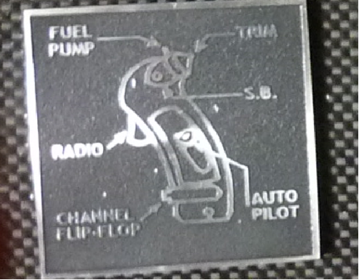
Does anyone know where or how I could go about getting something like this made?
He was told to try http://www.machineplatesonline.com/ Another guy said Aircraft Engravers LLC. I had another company called SET Graphics engrave labels right on the stick.

Our member Jorge Bujanda had a more elegant solution: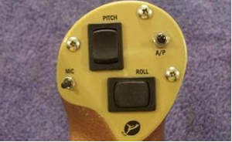
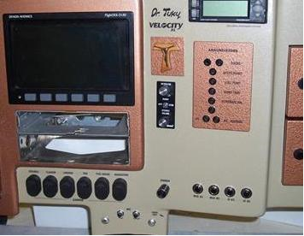
“I used transparent decal paper for laser printers for all my interior labels and graphics. It comes in letter size. I made all of them in MS Word where everything can be sized to fit. I painted my panel and parts, installed the decals and then sprayed a clear coat over them. The decal paper is so thin that you really have to look very closely to detect it.

I believe I paid about $15 for 10 pages and used just a couple. You can easily come up with the design of your control stick and print it for your panel instead of a metal plate.”

