Discussion of the Ronneberg Nose, Davenport Nose and related options.
I found the wrecked Davenport Long-EZ for Devin Ronneberg. Dave Ronneberg liked the Davenport nose so much (but it was full of blue foam - 4" in places - robbing the nose of any useable space). So, he took molds off it, created a 4 piece nose - top and bottom nose and a door laid up in the top, and a nose gear stick cover that he laid up in the bottom. It fits right to the standard Long-EZ fuselage. 3 photos below. He recently spent many hours building a set of 4 parts for a new builder and it was expensive - but beautiful. I took photos of the nose parts he made for the new builder and have not located them in my computer. You can talk to the builder if you want the price - I didn't get that detail but Dave told me he cut hours to get to the price...and I don't doubt it - amazing how developing and working on your son's nose molds and nose is a labor of love...the first 3 photos are Devin Ronneberg's Long-EZ nose – the Davenport nose. 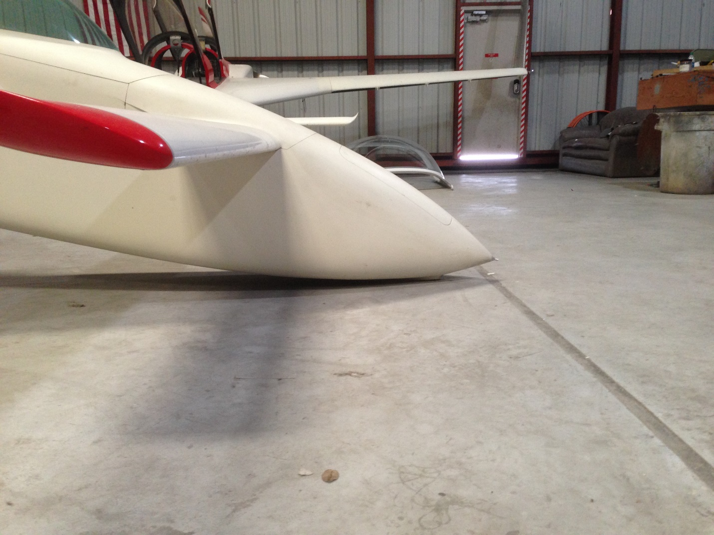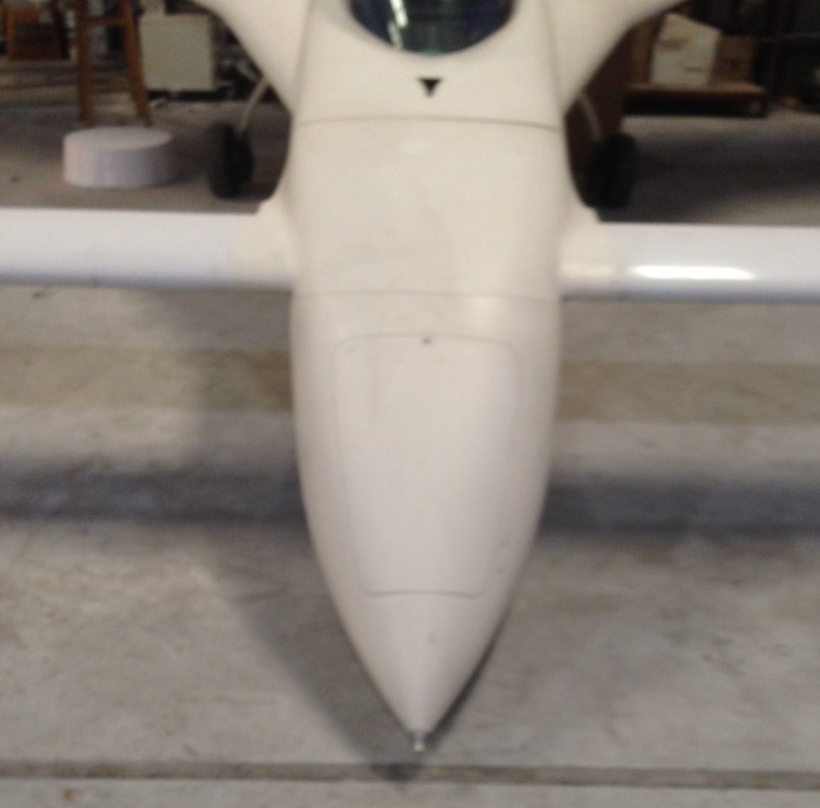Sorry for the fuzzy look.
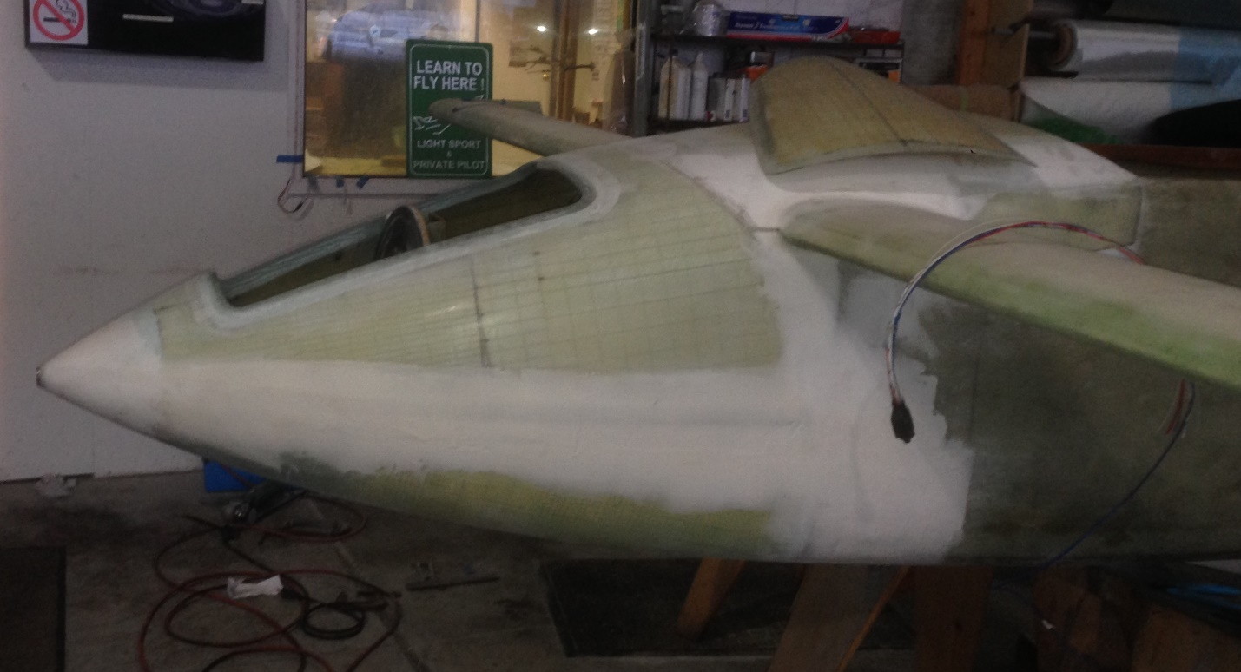Door is sitting on the top of the canard cover – another Ronneberg modification from the Berkut.
Well, Sam Kreidel lofted the Berkut on a big computer at Rockwell. I don't have plans for the Berkut nose, and Dave isn't set up to create that nose for the smaller Long-EZ - the Berkut fuselage is about 3" wider than the Long-EZ, my Berkut nose is the red and white photo as you see.
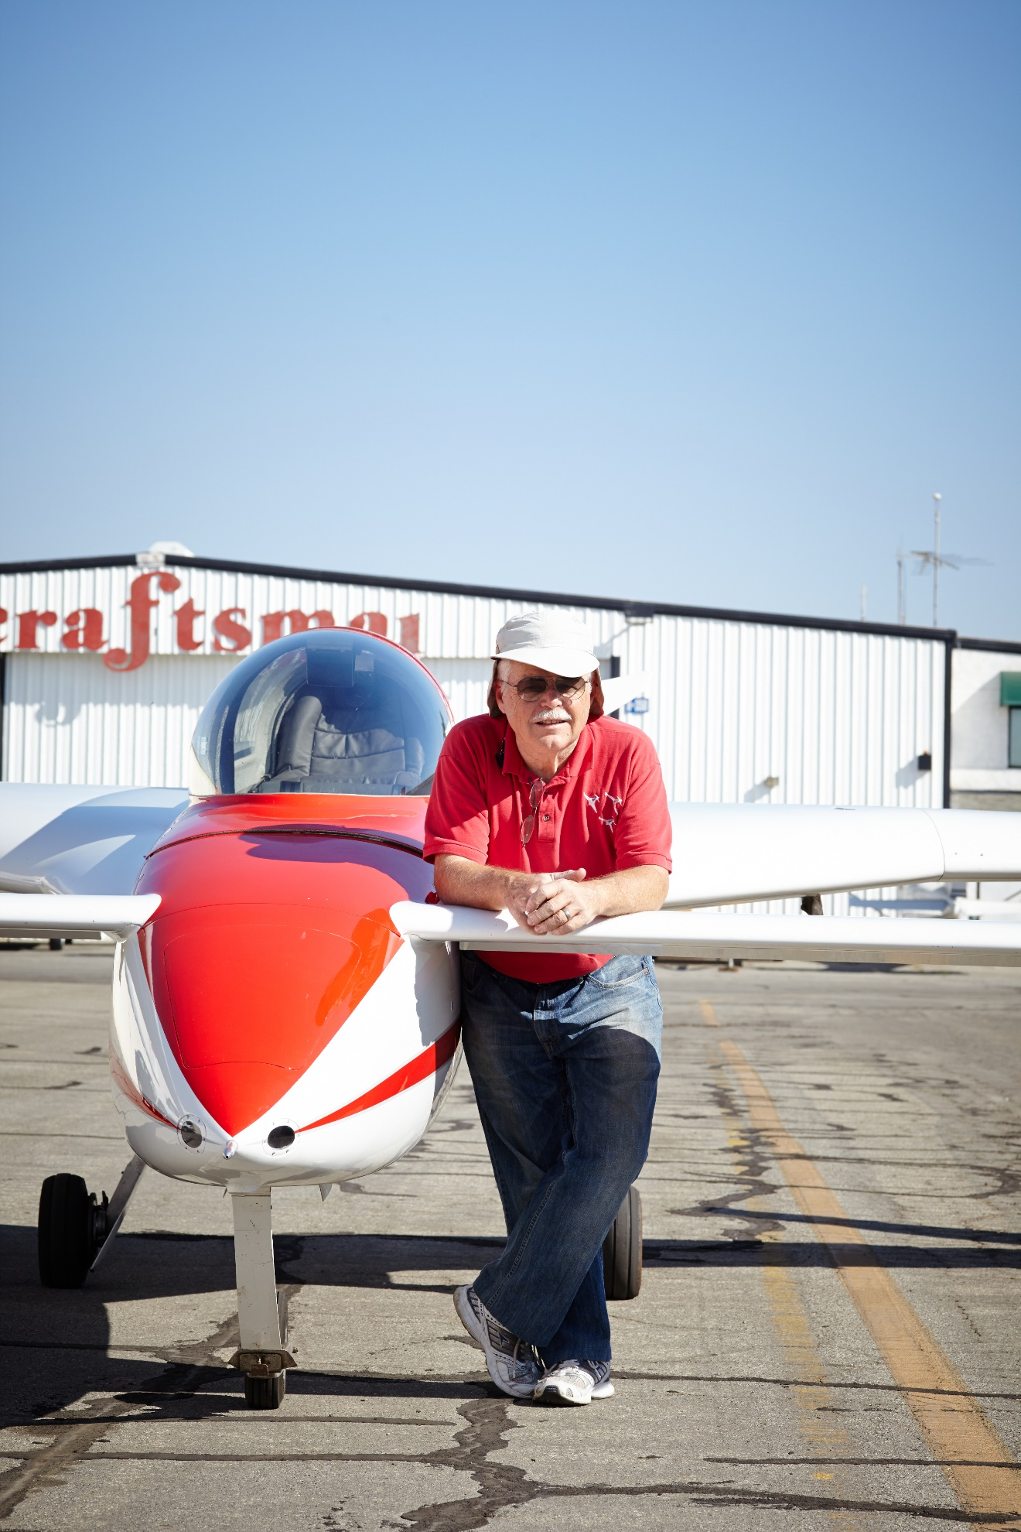
As to the Cobb/Ronneberg nose - I can do simple nose bulkhead template, nose door template, top curve and side curve templates and sketch of the hinges Eric Cobb designed on a poster card and provide those and the instructions and scribbled sketches I made - I've sent this out about 40 times. The instructions are a document I can send. When you have it you can tell I'm not a draftsman. (I charge $10 plus postage for the templates.) The next 2 photos are Ronneberg nose equipped Long-EZ. The plane won the Wright Award for the year it was finished - a master work - now on the Gulf Coast. I have dozens of other Ronneberg nose equipped Long-EZ photos.
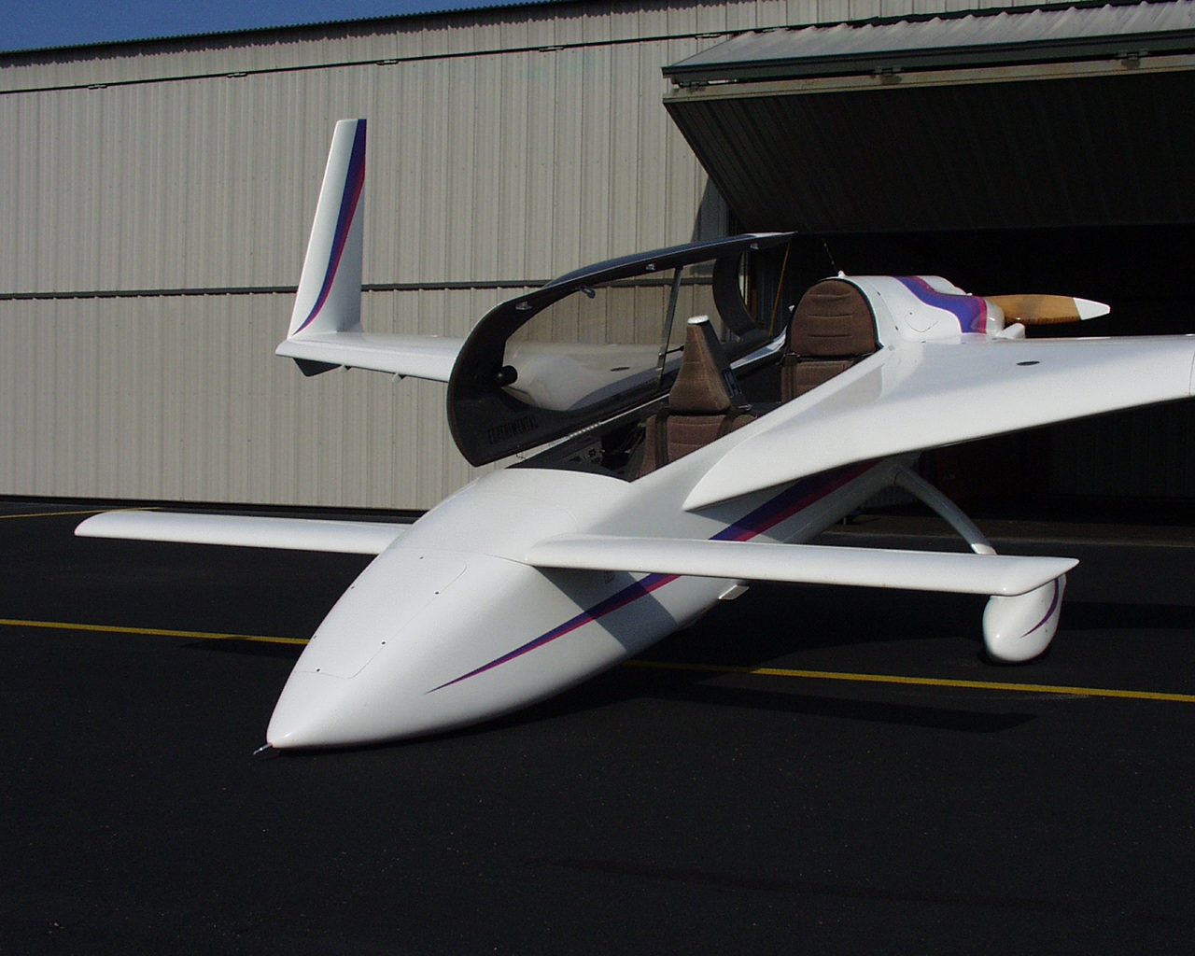
Another Ronneberg nose out of Santa Monica “doing sex” as we called it, parked under the other.
You'll need scrap blue foam, 2-part Urethane foam, mostly to join the other foam - micro between blocks causes rough spots when carving, I like to have a $20 Japanese draw saw, a good Surfoam tool, and all the finishing tools you use for wings and fuselage to prepare for paint.
Dave can create a lovely pitot that can be filled with a Cessna pitot heat element and with that you will need a phenolic tube in which to install the pitot* (Dave can make it removable for service with a simple set of depressions and an O-ring - on my planes, the Ronneberg pitot is extremely valuable as a lift handle - I can lift the nose there and that is much easier than standing by the fuselage and lifting the plane by raising the canard to move it around. 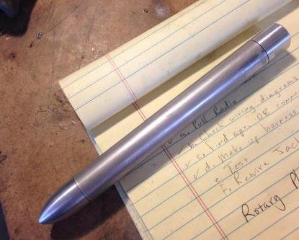 Without heating element.

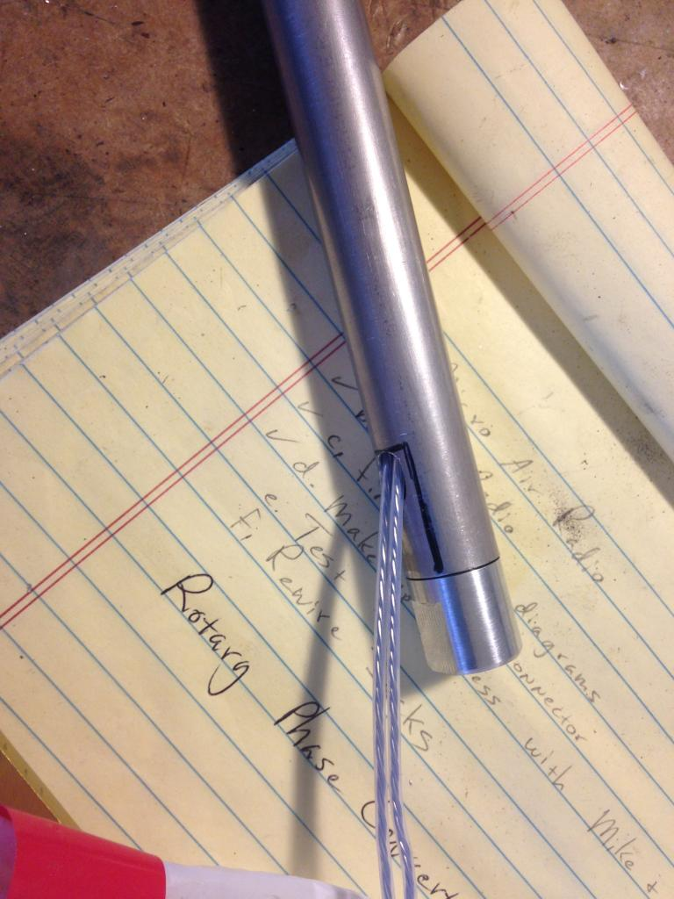With a Cessna heating element ($150? 10 years ago)
If you don't like the drop down Rutan light - which is a drag device when you want airborne visual enhancement for others in busy areas - you might build in some landing lights in this bigger nose and - some put the landing light in the lower winglets (we got rid of those for a knot or two's performance) or on the nose gear leg - but again, putting the nose gear down in busy traffic other than landing is another drag device. Some put it in the strake with a big light block - ala large Vortilon - to keep the light from reaching you and in the cockpit - but it might light up the end of your canard at night... See my little light portholes in the Red/White Berkut shot.
*I really don’t see the great need for a pitot tube heater when you have a stall proof plane. Sure, you might have to rely on GPS speed, but is it worth it unless you fly IFR a lot?
David

