About the SkiGull May 2014
RUTAN TIME:
Burt’s comment – after his local request for help: Thought you guys might like to peek into the effort for my last airplane, which might be an offered homebuilt kit. SkiGull is designed to cross oceans, is fully compatible with seawater, and is STOL operating from water/grass/snow/dirt/hard-surfaces. It uses car gas and is intended to go anywhere without ever visiting an airport (well, I might make an exception with KOSH).

To his local guys May 7: Thursday afternoon I will be ready to layup one of the most interesting composite parts of my career. It is about 5 ft x 7 ft and on a single part it includes most of the critical structure of the SkiGull: main fuselage bulkhead, main inboard wing spar, main pylon spar, sponson wing main spars, sponson bulkheads, Pneumatic actuator mount, ski stop mount, wing fold component mounts, and the sponson wing strut mounts. The checklist for fabrication has 165 steps, many of them designating several placements of Cf unidirectional tow. It is the largest and most complex part in the airplane. It will likely take 5 to 8 hours to build. I really do need help mixing epoxy, placing fabric and tow and blending in the epoxy matrix. We plan to start about noon. If you can join us, be sure to bring clothes and shoes that are ok to ruin with epoxy stains. Again, thanks for your help in the past…… There are about 25 layups in the airplane that are impractical to do with one person, so having your help is critical to getting it flying this year.

Snapshots taken of the tool during layout are attached:

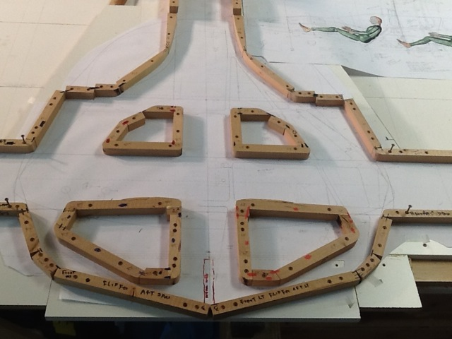
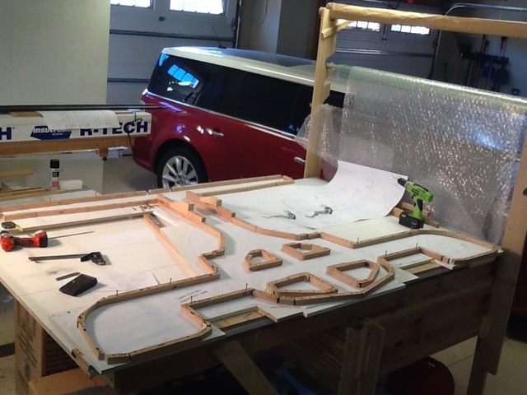
also a pix of John Stolpp and Chuck Tasca taken during a wing spar layup last month. 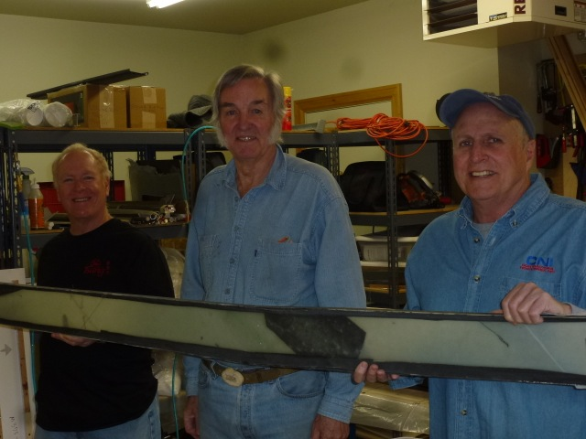

Added note Dec’14:

Burt Rutan is making great progress on his new one -
“SkiGull structure will be done in March, it should fly in summer 2015. It will be seawater compatible, STOL into water, grass, snow, dirt, etc. Cruise at 170kt. Range for Hawaii-to Coeur d’Alene. I plan to explore the world with it and have found a way to do a 1-year exploration trip, all in good weather. Hope it works.”

