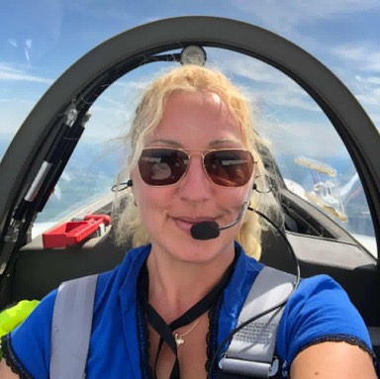

A few months ago, at the Kanab fly-in a friend, Izzy Briggs, asked me if I wanted to do some transition training in the new RAFE Varieze. What a crazy question...of course the answer would be yes!

He just donated it to RAFE in Covington and needed help flying it to Kanab and then for one last condition inspection in Tehachapi. We decided to do the checkout in Mojave- where the original #1 Varieze built by Burt Rutan took its first flight.

So we left Kanab on a beautiful flight. When flying through Trona Gap, my phone went black a couple of times, and I could not get it working. So after the second time I told Izzy and he said the same thing happened to his phone. Probably due to HIRTA says one of my cave diving friends. (This should have thrown up a red flag for later flight)

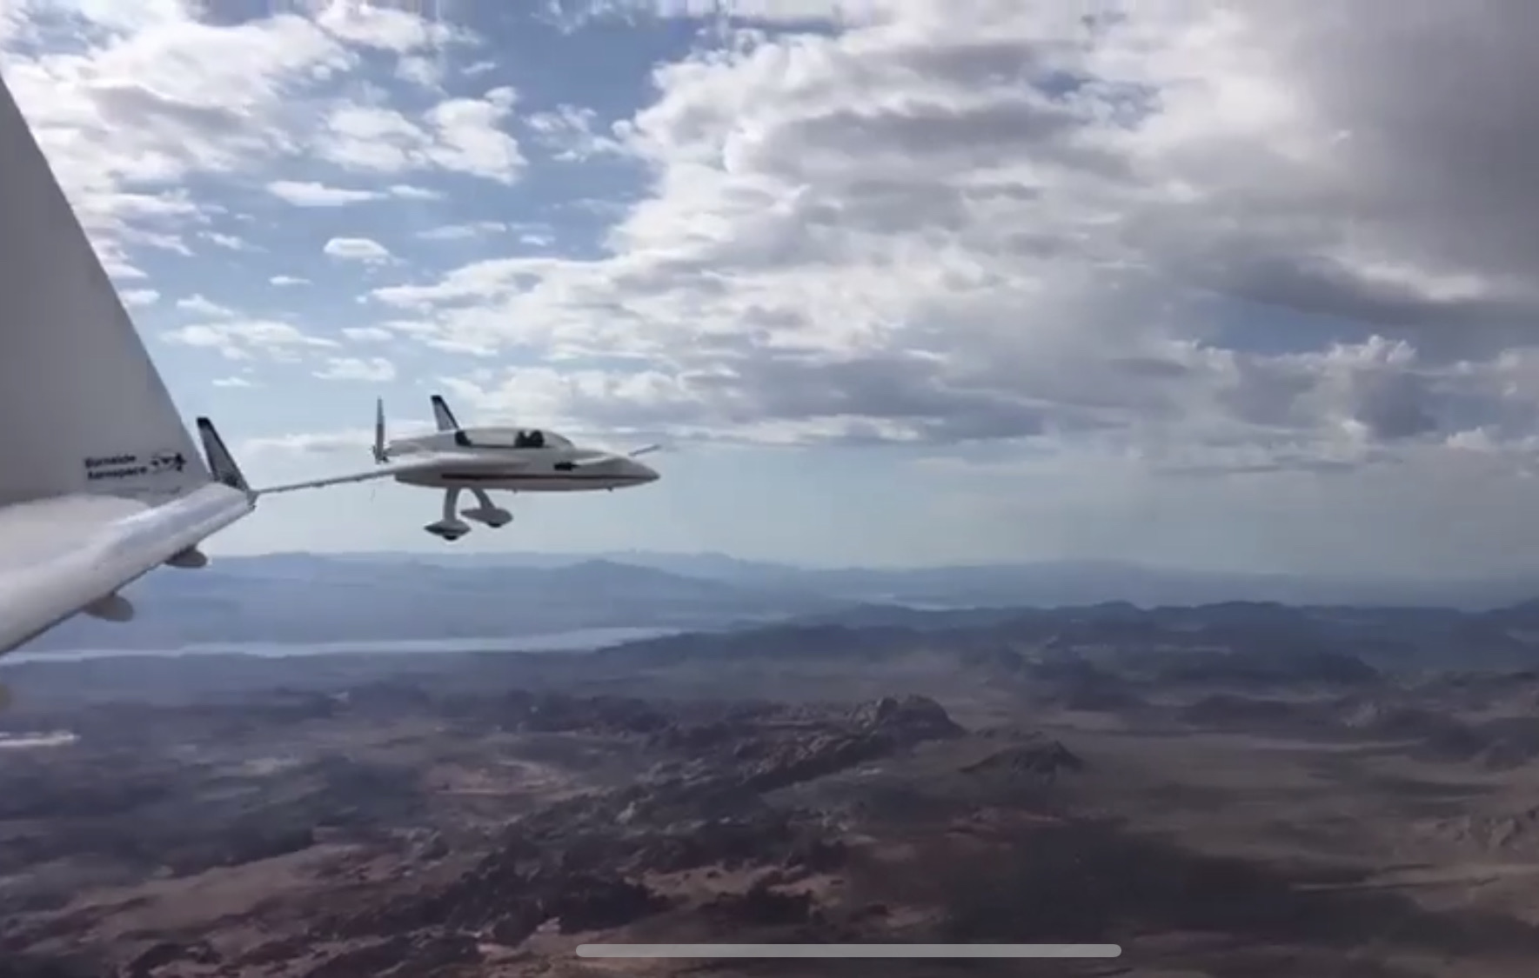
When we got to Mojave, I walked through the hallways looking at all the historical photographs of Rutan aircraft test flights and of course also the spaceship, and really had to fight to control my emotions, it really was a treat to see them, especially as I have been Burt’s and Dick’s biggest fan for over 10 years now (pretty much since I started as a student pilot. All the Rutan designs are so sexy in my eyes - but also efficient and environmentally friendly), I have no words that can properly express my feelings.
I even found a model of one of the Southern air aircraft on display there, which was funny since I have just gotten a job with them.

We found a briefing room, set up and went over all the basics- paperwork, maintenance items, weight and balance etc. My friend’s aircraft was customized to him, which threw the weight and balance off a bit, but not to worry- after watching me sweat the W&B calculations out by hand, he whips out his little flash drive and throws in some numbers with my weight added and Viola- no ballast needed!

Next we went out to the aircraft to learn all the avionics and the special starting procedure. It was a bit different because of the fuel injection instead of carburetor, but not difficult.

There was a trick to closing the canopy but after a couple of tries I got it closed and locked. He waved me on my way, said good luck and tested his handheld radio to make sure I can hear him. By chance, Zach Reeder was there fueling up in his so he got to watch the first takeoff too.
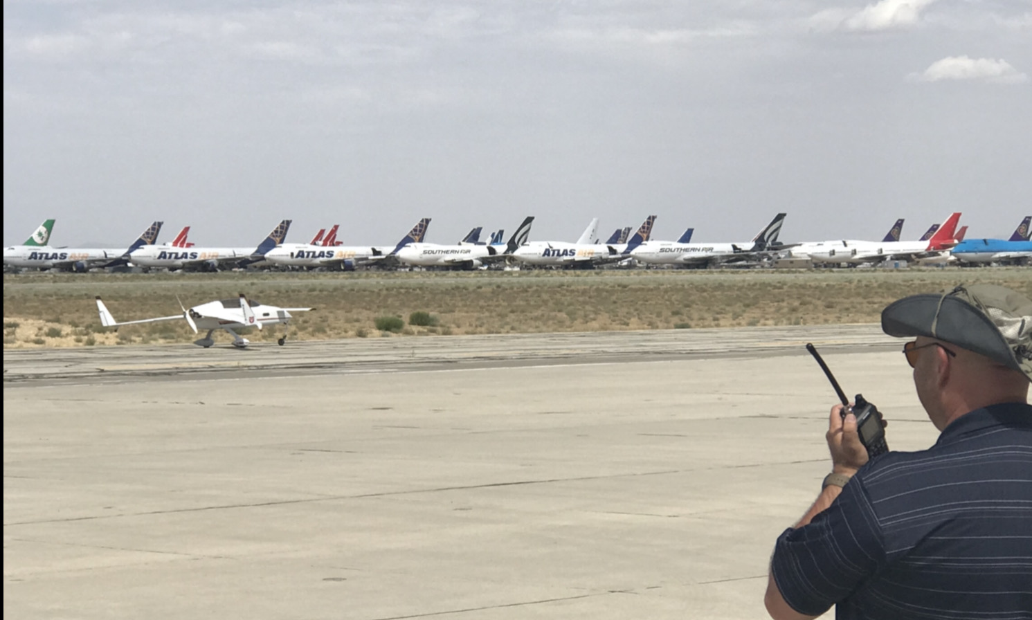
I decided to take the long runway, even though there was a 15-knot direct crosswind. It would allow me to do a couple of stop and go’s on the runway instead of having to go all the way around twice. I have done this before in several tailwheel aircraft checkouts and since the airport was closed and no other traffic was in the pattern, I felt I would not be inconveniencing anyone by doing this and I felt 100% safe doing this or wouldn’t have done it.

As usual on a first flight in anything, my mind was racing and Adrenaline pumping, but I focused on what I was about to do, I taxied onto the runway, shoved the throttle full forward and prayed to Jesus that I didn’t screw anything up, I was actually 100% confident as I always am of course - and as we all are- right? My friend had an induction fire, due to over-priming when he was starting up in Covington so of course I was picturing that in the back of my mind the whole time.

The plan was my usual; take off, pick a spot to do some stalls, slow flight and some simulated approaches up high to get used to the airplane. Full power stall was the most fun. I had to try it 3 times to believe it. This thing just kept climbing like a rocket. I almost felt like I should have brought my parachute for this, but it climbed so high, so fast, that I would have had a whole century and more than enough energy to work through any issues if there were some. After a few practice approaches over California City Municipal Airport, I heard Izzy on the radio advising he was about to take off in the other aircraft to shoot a few pictures and videos of my first landing at Mojave. I don’t even have a pic of my first solo because my school’s (Langley Flying school in Canada) camera broke that day and it was before the time of iPhones, so I think I will frame this one and pretend it’s my first solo…at least it’s a first solo in a real airplane, not the Cherokee I used to own... well... other than my super cool solo in Covington, TN in a Long-EZ, my long forgotten passion from 10 years ago, when Beagle gave me an intro flight in a Berkut to Big Bear, Catalina Island and then to Chino to meet John the Flying fish and try his Long-EZ (he had dual control- front and back, perfectly safe).

After a couple patterns, Izzy asked me if I’m ready to go to Tehachapi. He figured saying it would be easier to just go, rather than shut everything down and restart a super hot motor.
We did not brief the flight or the airport, but it was only about 15 minutes away so I told him I would do one more landing, stop for a couple of minutes just to quickly jot down some basic airport info, frequencies etc., throw it into Foreflight in my iPhone and go. (I guess I already forgot about our phone issues flying through Trona Gap…I have a 5-minute memory…great for some things, not so great for others).

We were going as a flight anyway, he was leading, so no need to worry, I’ll just follow him if have to (I am a bit lazy - my evil inner voice said, and I was tired enough to listen). Usually I also load the fight, no matter how short or long into my iPad but for such a short flight I figured I didn’t need it, plus he was circling impatiently above Mojave, so I didn’t want to upset him, by letting him wait too long.

So off I went, joined up on his wing above and on our way to our destination airport. At the top of climb out my phone went black- OF COURSE!!!. No matter, the airport was near, no big deal. Well, Izzy decided to break it off and once again circle above, after I announced I had the airport or something that ‘looked like it but wasn’t’ would be a better more proper representation.

I announced on the CTAF my intentions on the CTAF, confidently crossed midfield and made a beautiful approach to landing. It looked like I have an audience of guys on the ground watching me, but wait a minute... This airport looks really bad, it’s a lot smaller and crappier than I was expecting, strange...and I’m on final to runway 27. I remembered it’s supposed to be either runway 29 or runway 11 NOT runway 27 for sure... so I quickly glance at my scribbles, indeed that’s what the note says as well. Did I write it down wrong because I was in a rush? Am I tired and just seeing things? No it really says 27…
Now Izzy is calling me to watch out for an aircraft taxiing into position on the runway but I see none....hammam even more confusion.
Unsure what’s going on I decided to just go around, circle above the airport and figure it out.
Again, Izzy calls on the radio saying he doesn’t see me going around or and what the hell is going on. I was very carefully scanning for him above, since we don’t see each other and I’m climbing up to about his altitude and wouldn’t you know it... there is another airport just 2 NM south. Who the heck puts two airports so super close together?

As I get closer, I can see the numbers match to what I was expecting and also what my scribbly note says, now that I am definitely distrusting second guessing my memory.

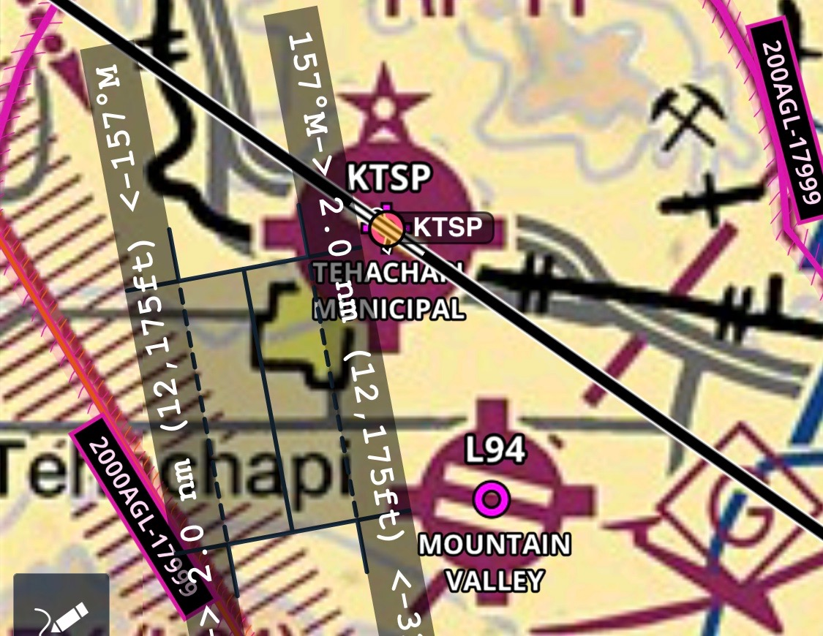

Well, another perfect approach, this time with the right number under my nose to a much nicer looking airport with a prettier runway, just as I had pictured in my head and no group of judges watching lol.
The other airport was a glider airport just 2 miles south called Mountain Valley, nice and long- 4,890’ but only 36’ wide and a little rough looking. Although I was curious if those guys watching had numbers in their laps to rate my landing, I’m glad I went around and gave myself some time to assess the situation and end the flight without the embarrassment of landing at the wrong airport. Thinking back now however, an extra landing in RAFE’s awesome airplane would have been worth it!
What lesson was learned? Take the time to properly plan and do it consistently the way you’re used to, the way it works. Never compromise for any reason, unless it’s an emergency and if in doubt- GO AROUND! There is no shame in going around.

