Topic 7. All Canards - Better headset jack mounting:
7/9/2019: Dave Ronneberg and Chris Randall have invented a little pair of pockets to tilt the head set jacks along the seat backs, front and rear so the plugs and jacks are not as vulnerable to things falling on them, interfering with glove box lids and elbows. A tidy fix. (the photo below shows two samples, one for the more raked front seat and the other for the less raked rear seat. Chris Randall has not yet duplicated this effort with molds.)
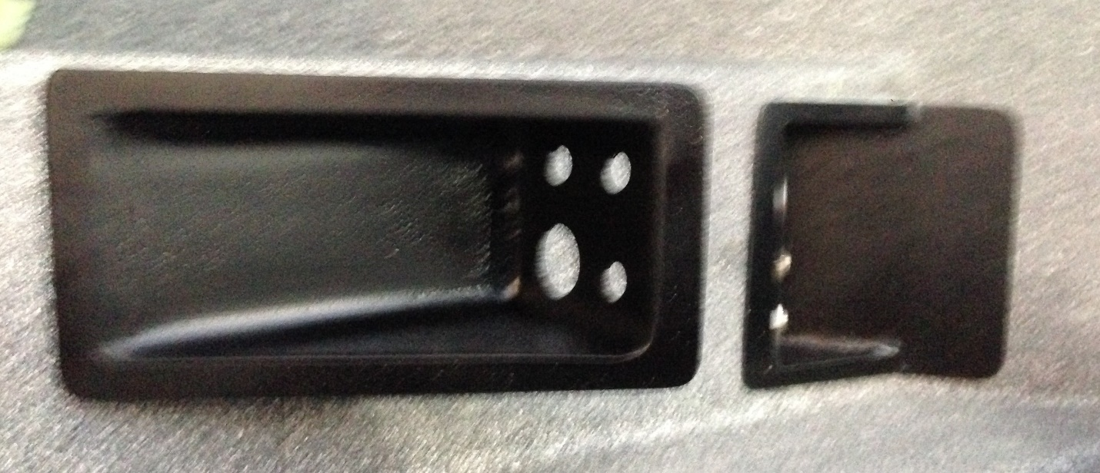
See also: 22SIII23 Jan’18 Chris Randall’s advice on wiring headset jacks and PTT buttons.
As of 3/1/22 Chris had not made the molds for this and will do so in the future.
10/27/2020: I’ve had no success getting Chris Randall to mfg. these angled sockets for the head sets. I have some simple photos if anyone wants to take on the job.

