The Surprise at Catalina:
Landing at Catalina I put the nose down, got the usual vibration and when I braked harder than I do for longer runways and just as the weight came on it, the nose gear fork broke. The electric nose gear stayed fully up, and the grounding sound made me think the nose gear leg was being ground down as I've seen so many times before on other lose wheel situations. (What is nice is that the pilot can actually steer the plane while coming to a stop. The same happens when you have a mechanical nose gear up – you can steer along during the grinding along of your nose pad. What you can call the Rutan Secondary Landing System when talking to the FAA on the telephone if it happens in front of a tower. As an aside, I’ve slowly come to the opinion that heavy braking while the nose is on the ground might actually reduce nose damage – cutting the grinding distance much more, despite loading the nose more during the reduced run.) But my electric nose gear stayed up though.

A passing pilot saw the nose wheel depart and tracked it out into the weeds about 100 ft to the right of the runway and immediately brought it to me. (I’ve heard several of you have lost your nose wheels.) The guy helped me lift nose and push to the parking spot - amazing how we rely on that nose wheel for moving the plane around!
I later took off the nut and shimmy dampener washers and slid off the fork:

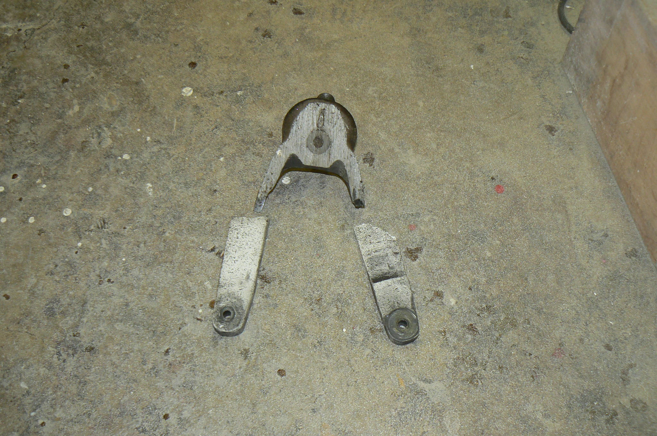
The three parts of the fork – looking up the ground down vertical shaft
of the base of the nose fork. The arms stayed with the nose wheel.

The base of the fork and vertical tube was worn down to about half thickness. The fork arms stayed with the wheel, one side trapping the wheel – the undamaged tire rotated about 40% of one revolution while in contact with the fork arm before both left the plane. I called for rescue to a few friends – almost all of whom have lost a nose wheel at Catalina and won’t land there. So my wife and I got a ride from Avalon back to John Wayne an hour after my event in a local instructor’s Twin Cessna.
But rough runway or not, I’m pretty sure that the shimmy dampener torque had eased and the new tire excited it more. Jim Emons, looking at one fracture surface found an area of polishing which would indicate a prior crack and fatigue damage in the fork arm. He’s found a lot of failures in this Brock part, usually from improper torque dampening and Jim builds a more substantial fork for sale – I paid $290 for his part along with a longer axle bolt, his spacers that avoid the rubber on the bearings and the machinist’s work on his new fork. Jim had to have his machinist cut out more of the base of the fork for my new AeroClassic nose tire tread. I offered to return to Chin Sheng nose tires to adjust to his beefier fork but Mr. Emons actually prefers the heavier duty nose tire which he says is common on the Cozy aircraft and his nose fork stock is from now on going to be modified for the larger nose tire. He greased my bearings, installed the wheel with a longer axle bolt and sent me on my way.

Reinstallation and torque:
I’m reminded of one guy who said he doesn’t fly to islands because of the nightmare of getting back a damaged plane. I got a one way senior ticket for 9:50 am catamaran from Dana Point to Avalon ($34), rode the 12 pm Airport van up to the airport ($21) and added my new fork, torqued to the right 4 lb tension, in about 15 minutes – I used a bulky package to prop the nose about 10” off the ground to make the pivot hole accessible for the fork tube to go in. The Airport took pity on me saying they were not going to give me two overnight charges when I had no plan to stay there. I was relieved also because on first departing I had not checked my prop for nose wheel caused damage. The nose wheel and fork arms had not hit any part of the plane, thank goodness.

Sorry this photo of Emons’s new fork is out of focus – the Emons part is polished and the arms considerably thicker:
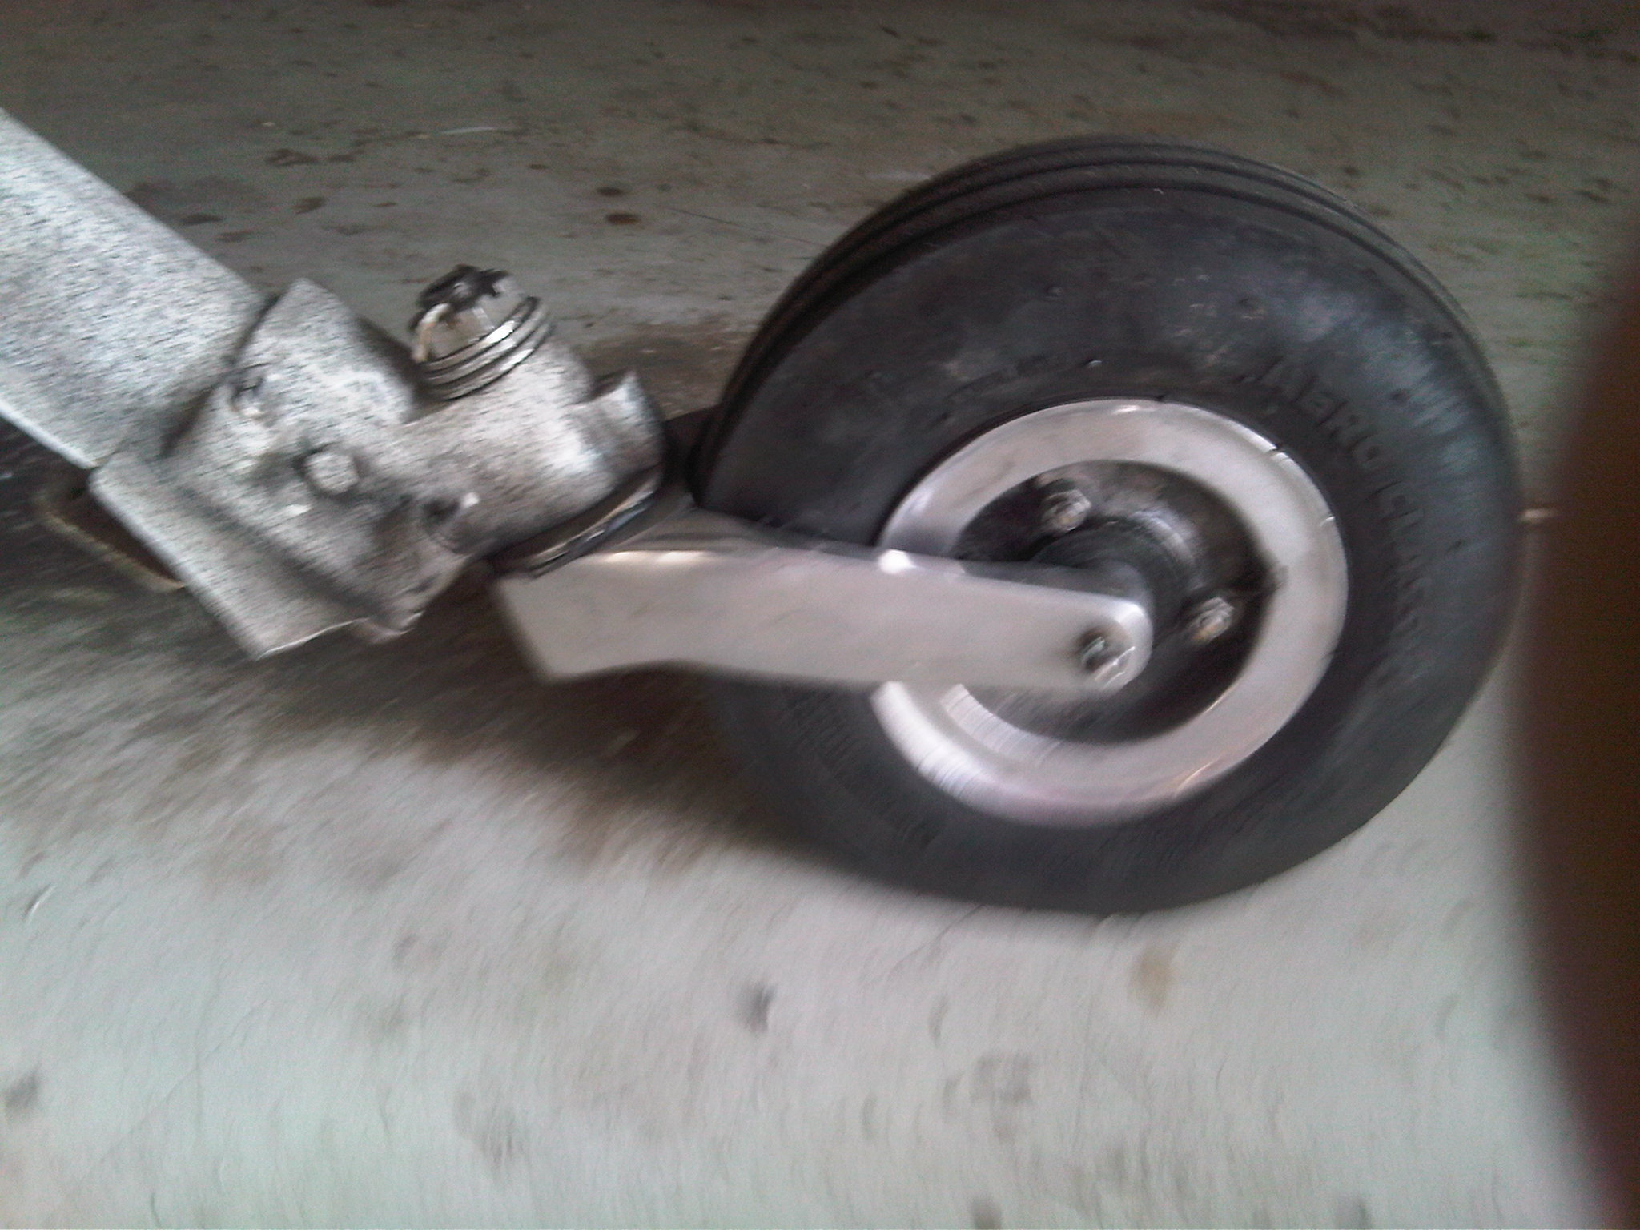

Pre-loading the nose wheel bearings, modifying spacers.
Jim said that he finds that just about everyone who has the spacers in the nose wheel bearings – a Brock part NG401A-5 suffers from a flaw in design – the inboard surface of the part actually traps the rubber seal from the wheel bearings when you attempt to pre-loading the bearings – as the rubber ages you loose the bearing tension. He highly recommends having a machinist take off the inboard shoulder of the spacers so they fit inside the rubber seals. He points out something I’ve not always understood fully – that you should preload all your wheel bearings and he uses a rule of thumb – if properly preloaded, if you can only spin the tire about one turn with a firm hand, you’ve preloaded the bearings properly. He was horrified to find that in my installation there was a piece of tubing inserted to keep the Brock spacers apart – which I suppose would prevent damage to the seals, but would prevent any pre-loading of the bearings too. Without preload, in addition to more wear on the bearings, the inner race will turn on the spacers, wearing them down as well.

With last month's discussion of nose forks I was asked by one flier where he could get a spare nose gear - the NG401A from Brock's catalogue. The spares are not showing up much any more - so I checked with Wilhelmson:

“The NG401A is on the price page of our Web Site with a photo. The price is $430 plus $15 shipping & insurance.”
We have a project owner who is a machinist – and he’ll make a beautiful machined set of parts, out of billet, not castings – gorgeous work : ‘$600 set up and ready to go + shipping via UPS or Fedex whichever the buyer prefers. If he orders the Spruce 4" front wheel (part no. 06-00842 copy of the Gerdes) and has it sent to me I'll set up the bearing inserts for proper end play at no extra charge.”

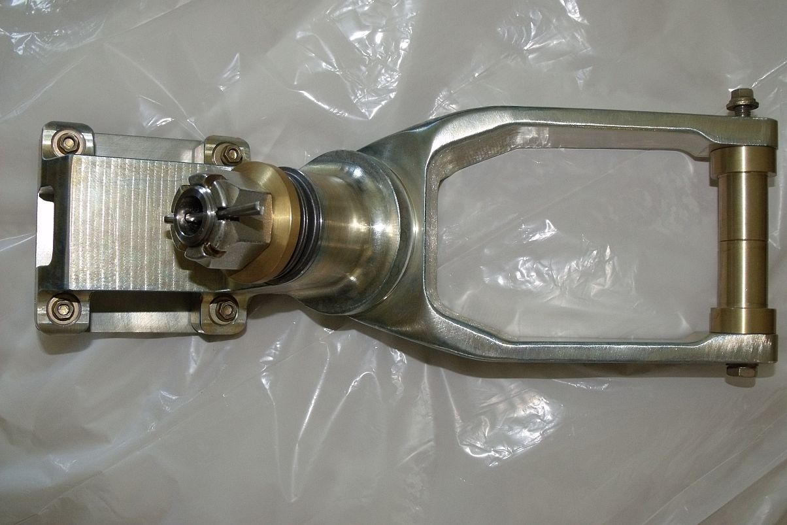

Add On 2/13:
More on nose gear buzzing and failure of Brock nose fork: by Jay Land
I had a little drama tonight with 37 RG (Varieze), my NG16 nose wheel fork broke on roll out about 1 inch above where the wheel retaining bolt hole is located...
The landing was fine although the subsequent taxiing was a bit complicated…Here are the pics after dismounting.

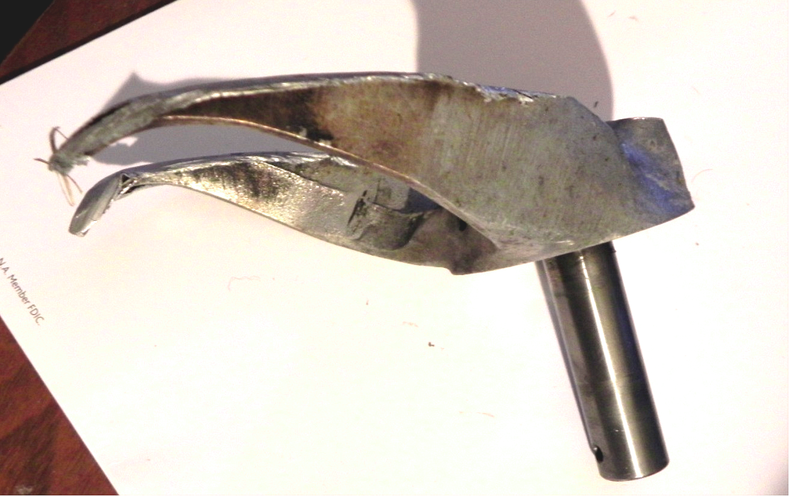
The side of the fork with the castellated nut in the wheel photos appears to have a slight casting defect barely discernible in the photo... (See arrow)
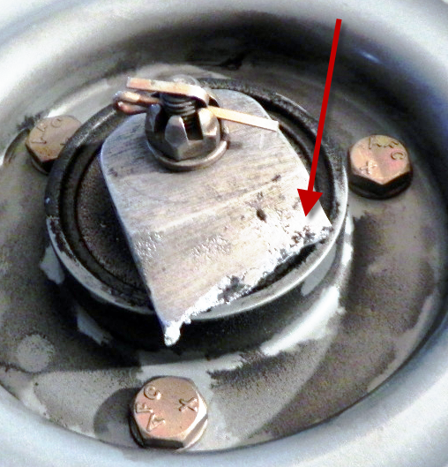
Now, I preflighted the plane before first takeoff yesterday and checked the nosegear swinging drag with my foot and felt normal resistance... (Beagle: You guys with electric nose gear don’t find this check convenient – beware.) I have never flown the plane with the nosegear fork swinging freely with no resistance. I have never had a "shimmy" situation like the CPs refer too although when I reach rotation speed on takeoff I hear a buzzing starting to come from the nosegear wheel. On landing there is generally nothing...This buzzing is likely the wheel simply spinning too fast and buzzing.... Beagle: I got that buzzing too before mine failed. (Discussion on replacement sources in prior mailings. And I suggested balancing tires with Harbor Freight motorcycle tire balancer – and he replied: “I used a lawnmower blade balancer.”

Add On 1/14:
Berkut Guru is test man for Tony Malfa- check his address and phone: 256 Paseo Del Lago Cir., Henderson, NV 89074 702-736-7485(O) Tony@canardgear.com tonyslongez@cox.net

Tony is creating milled nose forks – and in Redmon responds: “I’ve alpha/beta tested the assembly, and have nothing but high marks for the finished product! You can see/read more about my installation on the Berkut 13 Facebook page here:

https://www.facebook.com/media/set/?set=a.586761291403263.1073741830.400851249994269&type=1

Besides better material specs, there were many upgrades incorporated – added clearance for valve stem caps, corrosion protected and user serviceable/replicable pre-drilled AN bolt for pivot shaft, stainless steel bolt head retainer to protect bolt head pocket walls from marring, etc. And the machining itself is top notch. You’ll see what I’m talking about from the pics.

Anyway, you can order yours directly from Tony via his website:
www.canardgear.com $375
http://www.canardgear.com/landing-gear.html (bottom of page)

This makes three sources of stronger forks – Jim Emons produces a larger cross-section cast fork that is heat treated and polished, with bell washers – last I checked $300.

