Paul Saccani on Burt’s simple test rigs:

That was Burt’s practical way to avoid the cost and complications of a wind tunnel, but gather the same information. Later, scaled to full size;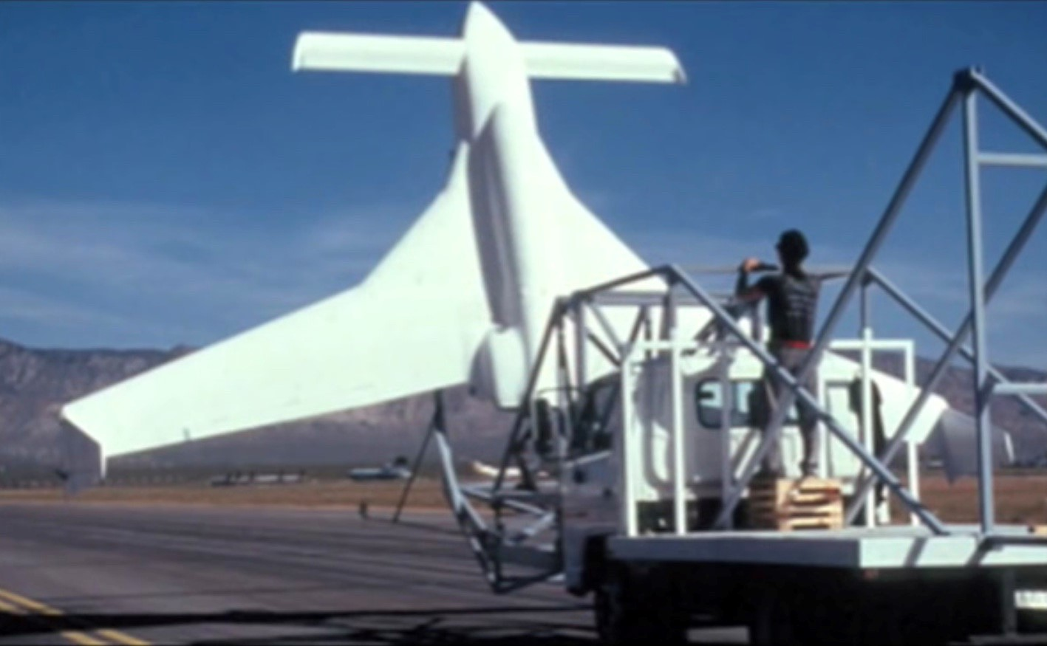
A wind tunnel to do the same testing would likely have cost more than USD 10 million to build. However, the now retired Langley tunnel, which was used by NASA for other tests on the Varieze could probably have been hired, but this would still be likely to have cost more and taken much longer. The same basic method was later used for investigation of Spaceship one high altitude - high speed tailplane stall.
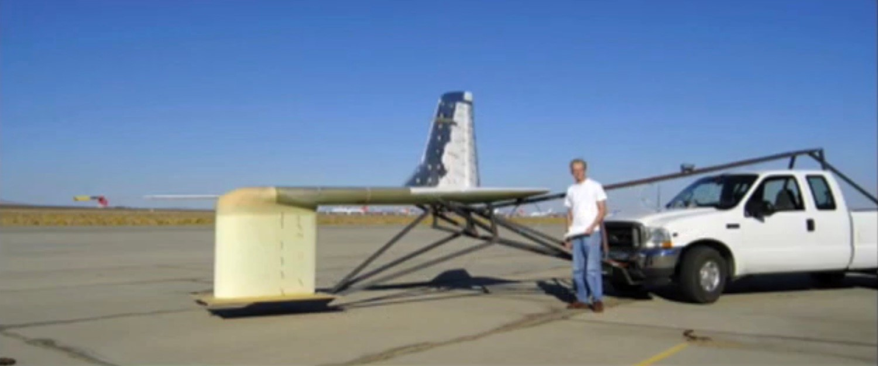
Here is a picture of the Vari Viggen test rig, attached to a different car: 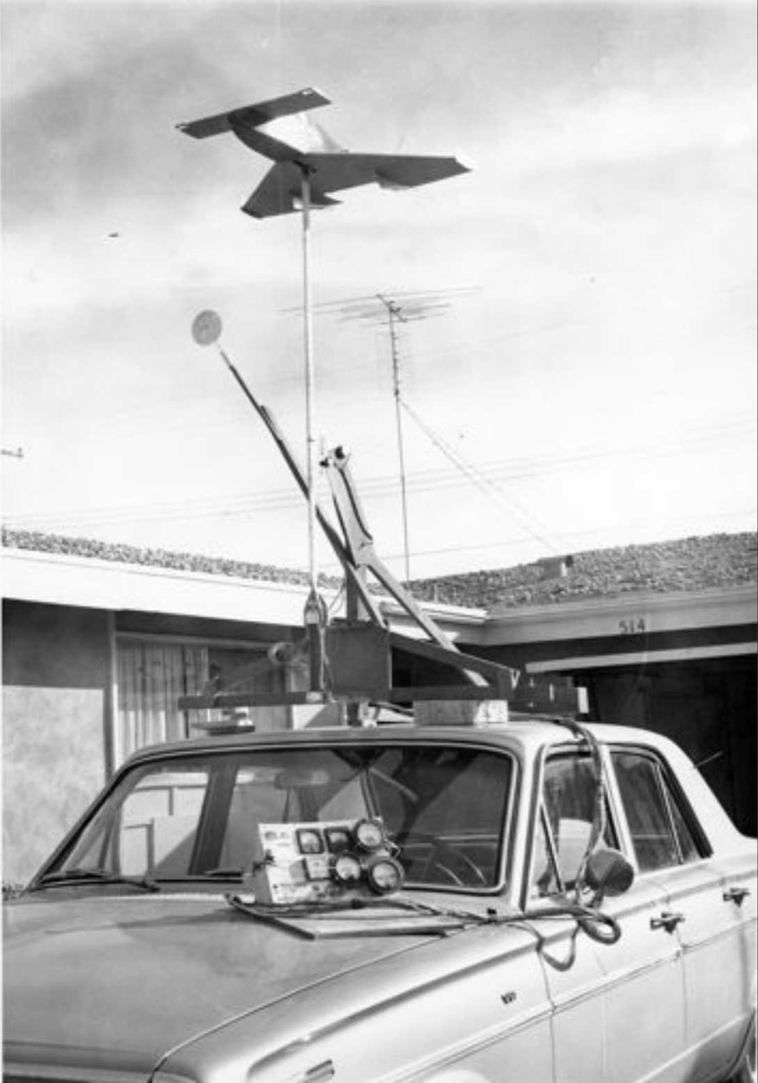
The artwork (added below) is more accurate than the photo for the car used, which was actually a Dodge Dart station wagon, with a roof rack to which the test rig and radio controlled model was attached.

